SPEAKING HEAD PRO EDITION 2000

Repository

Idea
We wanted to make something cool with wearable sensors, but it turned out to be too difficult and then we decided to do this instead.

Motivation
Everybody knows it's fun to use cardboard boxes to scare people.

Technologies
- Raspberry Pi v1 B
- Tower Pro 9g servo
- HC-09 ultrasonic sensor measuring distance
- Cardboard box
- World class Python and Bash scripts
- Lots of sweat and tears
- Lost of appetite
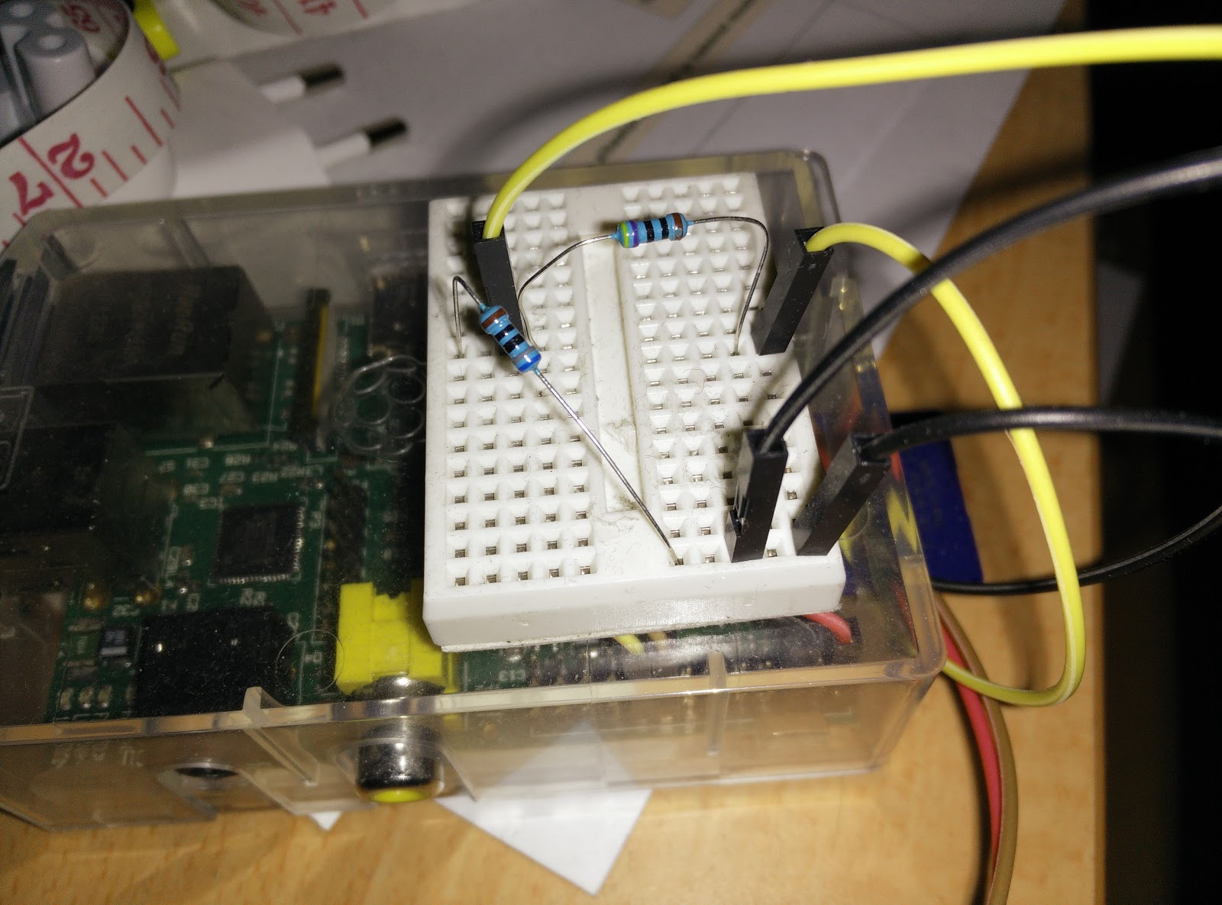

User interface
You don't need a user interface when you have a talking Duke Nukem.

Functionalities
When someone comes too close (less than 1 meter (3 feet 3.37 inches)) Cardboard-Duke shouts randomly one of 11 shouts and his mouth moves while he talks. There is a delay of 8 seconds to prevent him from shouting all the time when someone is close.

Issues
We had issues with our first plan, Track Activities Pro 2000 because we couldn't get the needed pieces together.
Cardboard Duke was co-operative the whole time, no reported issues with it.

