Smart Dorms
Team Members
Group Member | Student Number
Askar Serikov | xxx
Daniel Schurholz | xxx
Orsola Fejzo | 0528705
Valeria Cedillo | 0528695

What is Smart Dorms?
Smart Dorms is a fast and practical technological solution that helps students and the housing companies to adopt a more sustainable behavior. It consists of automated sensors and actuators that can be installed in any student residence, as well as remote control tools that allow the reduction of energy consumption while having a positive impact on the environment.

Vision
To automate daily tasks by transforming the daily home routine into more sustainable through practical and easy to implement solutions.

Scenario
Edwin leaves his flat early morning every day to go to university and he never checks the thermostat valve level of the radiator. After a long day in the university, he comes back home, goes to his room and turns the lights on to drop his stuff to afterwards go the kitchen to start cooking with his flatmate without turning the lights off again. After a couple of minutes cooking, the kitchen becomes overheated, so they usually open the window to cool down and ventilate the space, but they don’t adjust the temperature of the radiator.
Since the students are usually in a hurry to arrive on time to class, quite often it happens that they leave the lights of the common areas on, or the lights of the rooms. Especially during spring, when there’s more sunlight it’s really common that while they’re getting ready to go to school, they don’t perceive if the light is coming from the window or if the light bulb is on.

Idea and Motivations
Since the university residences have a fixed rent price and do not charge for the consumption of services, the students are not motivated to pay special attention to the use of them, hence, generating high costs by not making conscious use of the electric appliances.
These residences present plenty improvement opportunities through automation and the integration on IoT systems. Firstly, the lighting system is not automated, switching lights on/off is entirely manual, as a consequence, lights that have been forgotten on when out of the residence, increase the wasted energy. The same scenario can be seen in the laundry room, e.g. air driers can run more than necessary because there is no way to detect if the clothes are dry or not.
Except energy consumption, there are improvement possibilities even for water wastage and waste separation, which is currently not supervised.
Through an automated system, it is aimed to remotely control and monitor the flat appliances, as well as make up for people's negligence by automatically adjusting the devices' operation mode when necessary.

Features
- Accessibility
- Portability
- Scalability
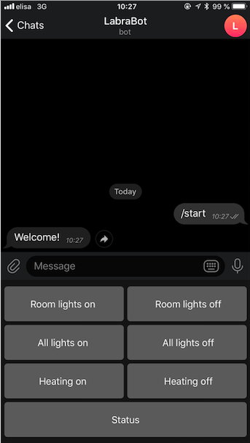
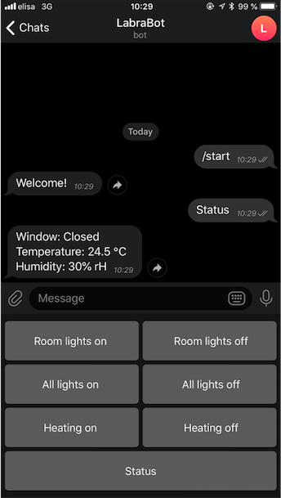

Technology
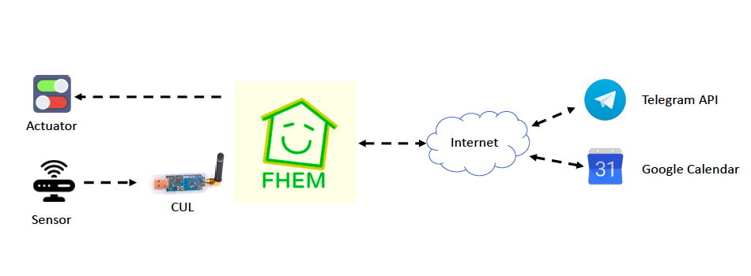

Solutions
- Automatic lights’ control:
  - The user is able to control remotely with a smartphone and Telegram app.
  - Motion detector will detect movement in the house to turn on/off lights automatically
- Controlled heating
- Optimization of the laundry room consumption
- Waste management
- Smart showering system

