Group 3: Pied Piper
Name | Student ID
Amir RAHAFROUZ | 0000
An PHAM | 0000
Meruyert NURGAZY | 0000
Sunnat SAMADOV | 0000

Problem Description
The importance of the concept of sustainability is increasing everyday; while the world population is increasing and the overall quantity of natural resources is decreasing. Built environments and the building sector is the area which uses an important amount of energy and materials that are produced by world resources.
Shopping centers are one of the most common structures in the world, which are developing continuously in the last decades. So the concept of sustainability in shopping center design has become a major problem. On the other hand, public awareness of environmental issues is growing around the world, and the environmental profile of a shopping mall forms an increasingly important part of its overall reputation.
Shopping malls which incorporate environmental considerations into their business operations will benefit from a better corporate image which helps distinguish them in the marketplace as forward - looking and responsible businesses who are sensitive to environmental issues. This project aims to make design proposals in shopping center public interiors to achieve more sustainable shopping centers.

Motivation
There are a number of areas which can be automated inside shopping centre in order to reduce energy consumption and consequently reduce carbon emissions.
- Increase energy efficiency
  - Efficient scheduling
  - Zoning and motion detection
  - Renewable energy sources
- Efficient lighting
  - Use of daylight
  - Different light levels
  - Reflection (mirror, heliostat)
- Cooling & Ventilation
- Water management
- Waste management
- Smart logistics

Project Vision

1. LIGHTING
Daylight: Energy consumption in shopping mall buildings, which have huge volumes and great number of users can be decreased by using day lighting. Studies found that average European city has more than 1500 sunny hours annually[1]. According to [2] annual electricity consumption of shopping centre is 21000 GJ and 25% of it is used for lighting[3]. Hence 21000GJ x 0.25 = 5250GJ energy is consumed yearly for lighting. (1.25GJ per hour) If we consider average mall's total number of operational hours per week as 80 hours, we receive approximately 4200 hours per year. And during 1500 hours out of operational 4200 hours shopping centres can use sunlight for lighting. If hypothetically consider that 30% of area in shopping centre can receive sunlight, the energy consumption can be found by the following formula: 1500h * 0.7 + (4200-1500)h = 3750h of energy use, 3750h * 1.25GJ = 4687.5GJ, means energy savings
5250 - 4687.5GJ = 562GJ.
Therefore, approximately 10.7% yearly saving on lighting electricity consumption can be reached just by shutting down lighting in the areas with windows during sunny days.
Mirror reflection: The simple use of mirrors in buildings is obvious. Since a mirror reflects light with virtually no loss, well-placed mirrors could be used to reflect the light, doubling the amount of ambient light in a room. Bulbs of half the normal wattage could be used, or half the number of fixtures could be used with no loss in light level. The potential energy savings would be enormous (50% in this simple example). Hypothetically, 50% of electricity saving is
21000GJ * 0.50 = 10500GJ
In addition to amplifying indoor light level, mirrors can be used for daylighting and heating. A heliostat is a device that includes a mirror, usually a plane mirror, which turns so as to keep reflecting sunlight toward a predetermined target, compensating for the sun's apparent motions in the sky [4].
Zoning and motion sensing: According to the motion detected certain zones will be activated and light level will be increased in these areas.

2. COOLING AND VENTILATION
Choosing the right shape, orientation, size of window and wisely exploiting thermal gradient inside the zones can lead to air movement which can partially or totally assure the required air change rates to maintain indoor air quality. On the other hand a smart natural air flowing can help to reduce overheating and dissipate hotness inside the massive layers of the envelope during the coolest hours of the night. Researchers found that shopping malls spend 21% of total energy demand for cooling and 12% for ventilation purposes [5].
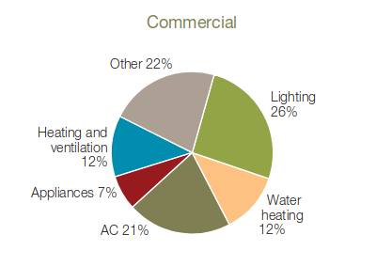Figure 1. Use of energy by commercial sector
As displayed in Figure 1, heating and ventilation plus air conditioning needs shares ⅓ of total energy demand pattern of commercial buildings.
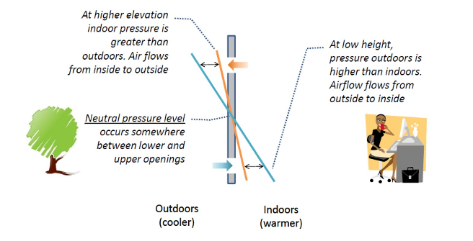
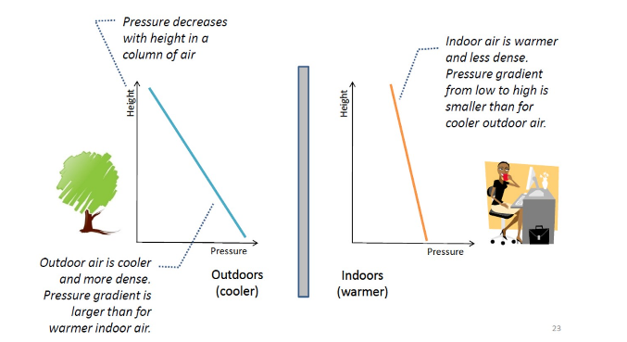
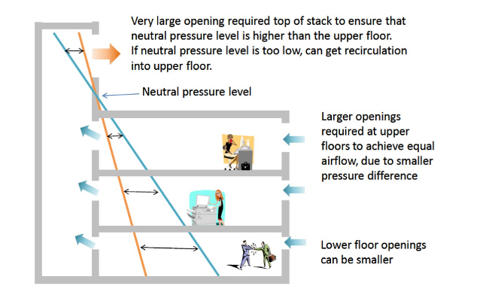
Research findings state that by using natural ventilation, overheating degree hours from April to October can be decreased by 27%, while air changes provided by natural ventilation reach 23% of total occupied hours and 83% of total closing hours in the same time period. Outcomes would be more reliable if wind data from a local weather station would be adopted [5]. If we consider working hours of shopping centre as 12h, then: 0.5*83+0.5*23 = 53% electricity usage for cooling can be reduced. As mentioned above, if we assume 21000GJ energy consumption of a mall, then ⅓ for heating and cooling is:
21000GJ / 3 = 7000 GJ.
By using natural ventilation we could reduce this number to:
7000GJ * (1-0.53) = 3290 GJ.
Amount of energy reduction would be:
7000GJ - 3290GJ = 3710GJ.

3. WATER MANAGEMENT
Harvesting rainwater and storing can help to control and decrease water consumption in shopping centres. Rainwater can be used for heat exchange, fountains inside and outside of malls and to flush the toilets and feed the urinals. a A pump and control system and some additional filtration must be installed to achieve the necessary flow of water. Studies found that usage of rainwater could reduce water consumption by 30% and save up to £612,000 in a 30 year timespan [7].

4. WASTE MANAGEMENT
197 million adults visit a shopping center each month in USA [6], while one shopping centre in London has 21 million annual visitor [7]. Hence, due to the increasing popularity and exponentially growing size of shopping centres, waste management in malls became a crucial problem. We propose to install an automated vacuum waste collection system, which is used in a city scale, but not in a smaller scale. However, the recent models of shopping malls can be considered as small cities. Therefore automation of waste management could have a number of benefits when installed in shopping centres/malls including:
- Waste storage space in lettable areas is significantly reduced as waste bins are automatically emptied as soon as they fill
- Manual handling and collection of waste including associated costs and insurances are almost eliminated.
- Reduced waste disposal costs with improved recycling.
- The systems are scalable and inlets can be easily added or relocated with centre expansions/renovations.
- Improved ‘green image’ as centre management are seen as leaders in green technology.
Installation of such system will reduce cost for waste management by twice and payback time for it is 5 years.

5. RENEWABLE ENERGY
Solar rooftops can be installed to maximize energy efficiency. American researchers found that electricity produced by rooftop panels on big box stores and shopping centers could offset the annual electricity use of these buildings by 42%, saving these businesses $8.2 billion annually on their electricity bills [8]. The typical solar payback period in the U.S. is between 6 and 8 years. If cost of installing solar is $20,000 and the system is going to save $2,500 a year on foregone energy bills, then solar panel payback or “break-even point” will be 8 years ($20,000/$2,500 = 8)[9].

6. OPTIMIZED SCHEDULING
Most shopping malls are only open about for about 12 hours per day, yet they are consuming energy 24/7. While some operations (such as security and refrigeration) may be necessary around-the-clock, others are not. Therefore, switches could be used to turn off all lighting and HVAC systems during night. We assume that optimized scheduling should give us 10% of electricity reduction which will be:
21000GJ * 0.1 = 2100 GJ

7. INTERNAL LOGISTICS
Automation of internal logistics one of the key areas which could make shopping mall smarter and more sustainable. Most of the stores operating in shopping centers have similar patterns of interactions with third-party operators. For example, each store needs packaging to be delivered, ordering cleaning service and handling stock management, etc.

Solution - Pros & Cons
1. Benefits
- Overall energy consumption reduction is around 16872 GJ:
562GJ(Daylight) + 10500GJ(Mirrors) + 3710 GJ(Natural Ventilation) + 2100 GJ(Optimized Scheduling) = 16872 GJ.
In percentage we reduce 80%:
16872/21000 * 100% = 80%
- Average electricity cost in Europe is 0.20euro per kWh, while 21000GJ ~= 5833333 kWh.
Therefore 5.833.333 * 0.20 = 1.166.666 euros can be saved.
In terms of carbon footprint, 752 tonnes of carbon emissions will be saved yearly.
- Average shopping mall is sized 40.000 m2. Sensors are needed for every 100m2 and 400 sensors are needed from each type.
Equipment | Price (€) | Quantity | Overall cost(€)
Motion detector | 70 | 400 | 28.000
Light dimmer | 40 | 400 | 16.000
Temperature/Humidity Sensor | 55 | 400 | 22.000
FHEM Server | 300 | 20 | 6000
Mirrors | 1/m2 | 10.000m2 | 10.000
Heliostats | 100 | 100 | 10.000
Solar panels | 300 | 5000 | 1.500.000
Overall, around 1.600.000€ investment is needed for electricity automation. As a result:
- 10.7% lighting electricity savings on daylight.
- ~50% electricity savings by mirrors and heliostats.
- ~30% water consumption savings on rainwater harvesting.
- ~42% energy bills savings with solar panels.
2. Drawbacks
- Dependent on location
- Not feasible to integrate to existing malls
- Dependent on climate conditions of the region
- Long term payback

System Architecture
The shopping mall would be facilitated with sensors to provide data on user movement, air condition (light, temperature, humidity) along with automatic heating/lighting controlling system.
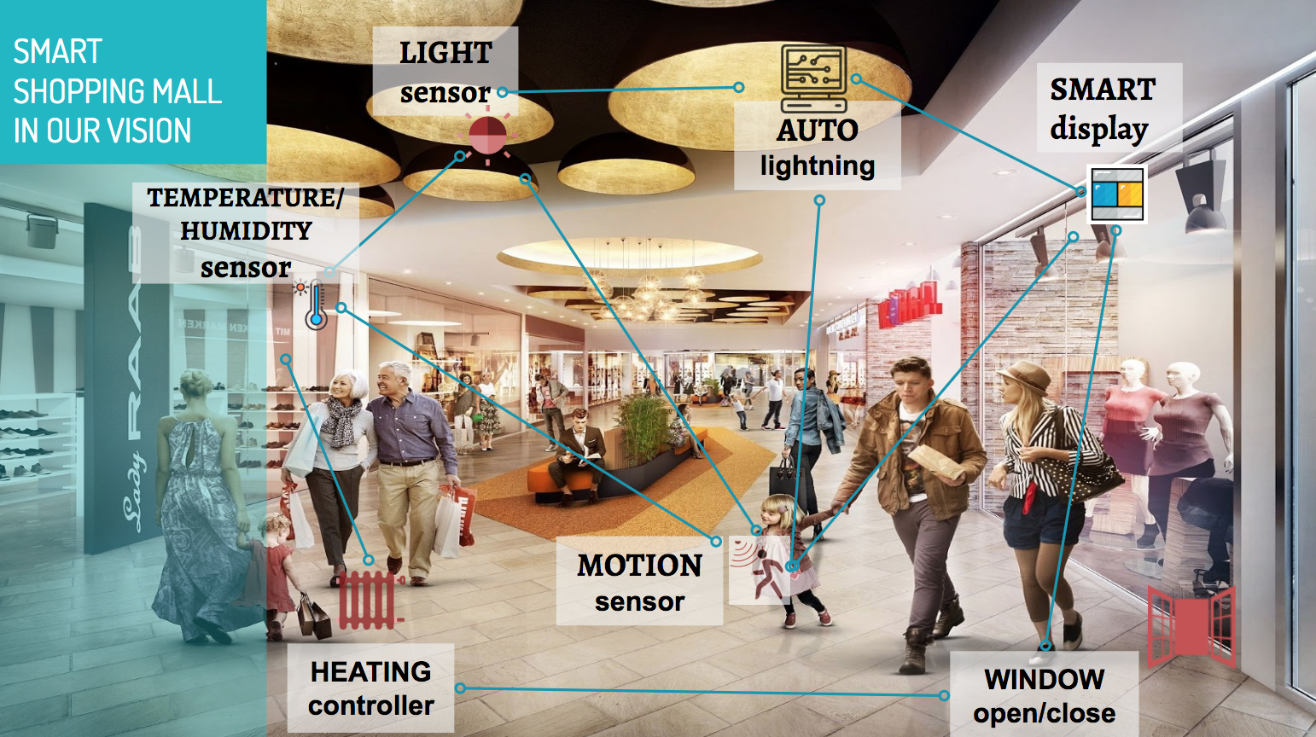Smart Shopping Mall Concept
In order to demonstrate the scenarios of a smart shopping mall, we've implemented the following architecture:
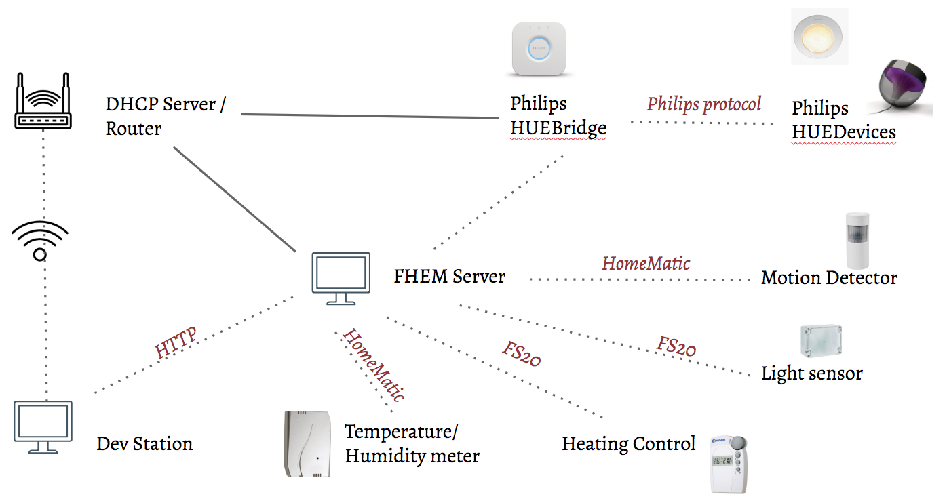System architecture
Using FHEM server, we've connected with sensors (HomeMatic temperature/humidity and motion sensors, FS20 Light Sensor and Heating Controller) and Philips smart lights. The DHCP server has also been set up to provide connections between development station, FHEM server and Philips HUEBridge (to control Philips HUE devices).

Implementation
We've implemented 3 scenarios:
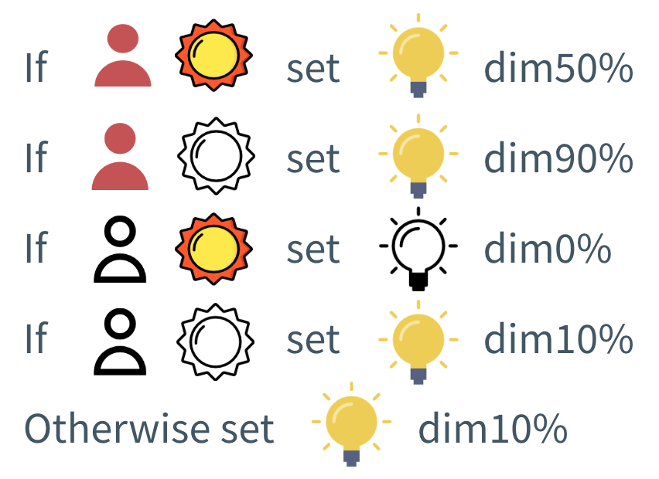
1. Adjust the lighting system based on user movement, natural light and temperature inside the shopping mall.
- If if the area is busy (people are moving around), the light should be on and its brightness will be adjusted based on current light level.
- On the other hand, the area is empty and the current light brightness is at normal rate, we turn of the lights, otherwise if it's pretty dark, the light is turned on at a minimum brightness (dim10%).

2. Change color of lights according to temperature:
Warm color (yellowish) is used when the temperature is considered cold (under a threshold) and vice versa, cold color (blueish) is used when the temperature is above comfortable threshold.
3. Reaction in case of wasting energy from using heater:
When the heater is turned on and window is opening, the window should be closed immediately in order not to waste energy from the heating activity. In the context of the lab, we didn't have window open/close controller, so we used a blinking lamp signal instead to simulate this reaction.
/*
Adjust the light according to movement and brightness
PhilipsBridgeofUS_HUEDevice1: a Philips light.
*/
define motion_light_dim notify motion_detector:.*|light_sensor:.* {
my $motion = ReadingsVal("motion_detector","state",0);
my $br = ReadingsVal("light_sensor","state",0);
if (($motion eq "noMotion") && ($br eq "on")) {
fhem "set PhilipsBridgeofUS_HUEDevice1 dim0%";
}
elsif (($motion eq "noMotion") && ($br eq "off")) {
fhem "set PhilipsBridgeofUS_HUEDevice1 dim10%";
}
elsif (($motion eq "motion") && ($br eq "on")) {
fhem "set PhilipsBridgeofUS_HUEDevice1 dim50%";
}
elsif (($motion eq "motion") && ($br eq "off")) {
fhem "set PhilipsBridgeofUS_HUEDevice1 dim90%";
} else {
fhem "set PhilipsBridgeofUS_HUEDevice1 dim10%";
}
}
/*
Adjust light color according to temperature
HM_tempmeter: name of temperature meter.
PhilipsBridgeofUS_HUEDevice1: a Philips light.
*/
define temp_color notify HM_tempmeter {
my $ps_Val = ReadingsVal("HM_tempmeter","temperature",0);
my $dim = ReadingsVal("PhilipsBridgeofUS_HUEDevice1", "state", 0);
if ($ps_Val > 26.0) {
fhem "set PhilipsBridgeofUS_HUEDevice1 rgb EAFF30";
} else {
fhem "set PhilipsBridgeofUS_HUEDevice1 rgb BAE1FF";
}
# this is to reset the light to its current dim level.
fhem "set PhilipsBridgeofUS_HUEDevice1 $dim";
}
/*
Notify if window is open when heater is on
FHT_2563: name of the heater controller.
PhilipsBridgeofUS_HUEDevice2: name of a Philips light
*/
define noti_door_open notify HM_doorsensor {
my $door = ReadingsVal("HM_doorsensor", "state", 0);
my $heater = ReadingsVal("FHT_2563", "actuator", 0);
if ($door eq "open" && $heater ne "0%") {
fhem "set PhilipsBridgeofUS_HUEDevice2 blink 10";
} else {
fhem "set PhilipsBridgeofUS_HUEDevice2 off";
}
}

Protocol for Home Automation
Discuss one protocol here

Documentation
Include presentation, report and poster here

References
- https://www.currentresults.com/Weather/Europe/Cities/sunshine-annual-average.php
- https://sites.ualberta.ca/~deyoung/myweb/mallenergy.pdf
- http://www.eurac.edu/en/research/technologies/renewableenergy/publications/Documents/Tesi_Giuseppe_Gentile.pdf
- https://en.wikipedia.org/wiki/Heliostat
- http://www.eurac.edu/en/research/technologies/renewableenergy/publications/Documents/Tesi_Giuseppe_Gentile.pdf
- http://www.jcdecauxna.com/sites/default/files/assets/mall/documents/studies/MallPhenomenon.pdf
- http://aqua-lity.co.uk/wp-content/uploads/2012/05/White-City-Westfield-Shopping-Centre.pdf
- https://environmentamerica.org/sites/environment/files/reports/AME%20Solar%20Stores%20Feb16.pdf
- https://news.energysage.com/understanding-your-solar-panel-payback-period/

