Group 3: Pied Piper
Name | Student ID
Amir RAHAFROUZ | 0000
An PHAM | 0000
Meruyert NURGAZY | 0000
Sunnat SAMADOV | 0000

Problem Description
The importance of the concept of sustainability is increasing everyday; while the world population is increasing and the overall quantity of natural resources is decreasing. Built environments and the building sector is the area which uses an important amount of energy and materials that are produced by world resources.
Shopping centers are one of the most common structures in the world, which are developing continuously in the last decades. So the concept of sustainability in shopping center design has become a major problem. On the other hand, public awareness of environmental issues is growing around the world, and the environmental profile of a shopping mall forms an increasingly important part of its overall reputation.
Shopping malls which incorporate environmental considerations into their business operations will benefit from a better corporate image which helps distinguish them in the marketplace as forward - looking and responsible businesses who are sensitive to environmental issues. This project aims to make design proposals in shopping center public interiors to achieve more sustainable shopping centers.

Motivation
There are a number of areas which can be automated inside shopping centre in order to reduce energy consumption and consequently reduce carbon emissions.
- Increase energy efficiency
  - Efficient scheduling
  - Zoning and motion detection
  - Renewable energy sources
- Efficient lighting
  - Use of daylight
  - Different light levels
  - Reflection (mirror, heliostat)
- Cooling & Ventilation
- Water management
- Waste management
- Smart logistics

Project Vision

1. LIGHTING
Daylight: Energy consumption in shopping mall buildings, which have huge volumes and great number of users can be decreased by using day lighting. Studies found that average European city has more than 1500 sunny hours annually[1]. According to [2] annual electricity consumption of shopping centre is 21000 GJ and 25% of it is used for lighting[3]. Hence 21000GJ x 0.25 = 5250GJ energy is consumed yearly for lighting. (1.25GJ per hour) If we consider average mall's total number of operational hours per week as 80 hours, we receive approximately 4200 hours per year. And during 1500 hours out of operational 4200 hours shopping centres can use sunlight for lighting. If hypothetically consider that 30% of area in shopping centre can receive sunlight, the energy consumption can be found by the following formula: 1500h * 0.7 + (4200-1500)h = 3750h of energy use, 3750h * 1.25GJ = 4687.5GJ, means energy savings
5250 - 4687.5GJ = 562GJ.
Therefore, approximately 10.7% yearly saving on lighting electricity consumption can be reached just by shutting down lighting in the areas with windows during sunny days.
Mirror reflection: The simple use of mirrors in buildings is obvious. Since a mirror reflects light with virtually no loss, well-placed mirrors could be used to reflect the light, doubling the amount of ambient light in a room. Bulbs of half the normal wattage could be used, or half the number of fixtures could be used with no loss in light level. The potential energy savings would be enormous (50% in this simple example). Hypothetically, 50% of electricity saving is
21000GJ * 0.50 = 10500GJ
In addition to amplifying indoor light level, mirrors can be used for daylighting and heating. A heliostat is a device that includes a mirror, usually a plane mirror, which turns so as to keep reflecting sunlight toward a predetermined target, compensating for the sun's apparent motions in the sky [4].
Zoning and motion sensing: According to the motion detected certain zones will be activated and light level will be increased in these areas.

2. COOLING AND VENTILATION
Choosing the right shape, orientation, size of window and wisely exploiting thermal gradient inside the zones can lead to air movement which can partially or totally assure the required air change rates to maintain indoor air quality. On the other hand a smart natural air flowing can help to reduce overheating and dissipate hotness inside the massive layers of the envelope during the coolest hours of the night. Researchers found that shopping malls spend 21% of total energy demand for cooling and 12% for ventilation purposes [5].
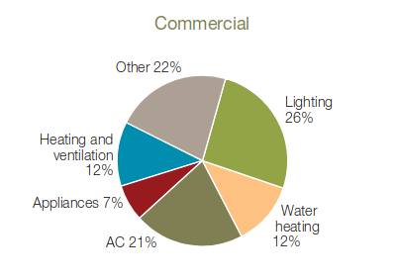Figure 1. Use of energy by commercial sector
As displayed in Figure 1, heating and ventilation plus air conditioning needs shares ⅓ of total energy demand pattern of commercial buildings.
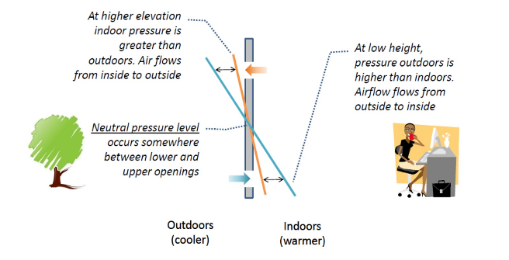
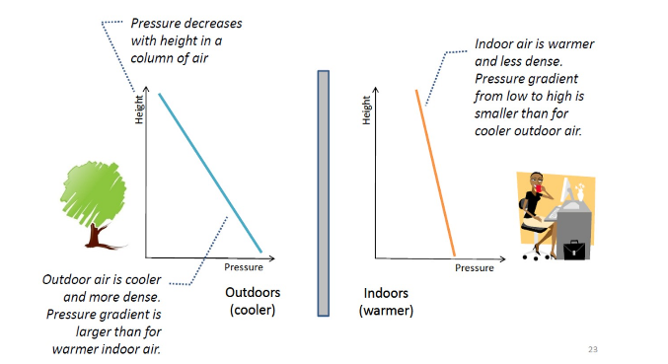
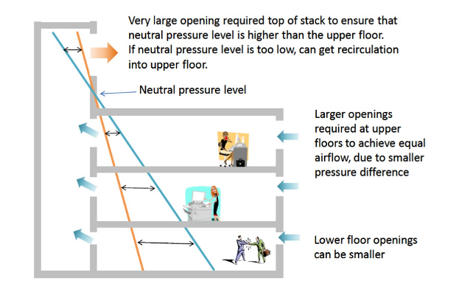
Research findings state that by using natural ventilation, overheating degree hours from April to October can be decreased by 27%, while air changes provided by natural ventilation reach 23% of total occupied hours and 83% of total closing hours in the same time period. Outcomes would be more reliable if wind data from a local weather station would be adopted [5]. If we consider working hours of shopping centre as 12h, then: 0.5*83+0.5*23 = 53% electricity usage for cooling can be reduced. As mentioned above, if we assume 21000GJ energy consumption of a mall, then ⅓ for heating and cooling is:
21000GJ / 3 = 7000 GJ.
By using natural ventilation we could reduce this number to:
7000GJ * (1-0.53) = 3290 GJ.
Amount of energy reduction would be:
7000GJ - 3290GJ = 3710GJ.

3. WATER MANAGEMENT
Harvesting rainwater and storing can help to control and decrease water consumption in shopping centres. Rainwater can be used for heat exchange, fountains inside and outside of malls and to flush the toilets and feed the urinals. a A pump and control system and some additional filtration must be installed to achieve the necessary flow of water. Studies found that usage of rainwater could reduce water consumption by 30% and save up to £612,000 in a 30 year timespan [7].

4. WASTE MANAGEMENT
197 million adults visit a shopping center each month in USA [6], while one shopping centre in London has 21 million annual visitor [7]. Hence, due to the increasing popularity and exponentially growing size of shopping centres, waste management in malls became a crucial problem. We propose to install an automated vacuum waste collection system, which is used in a city scale, but not in a smaller scale. However, the recent models of shopping malls can be considered as small cities. Therefore automation of waste management could have a number of benefits when installed in shopping centres/malls including:
- Waste storage space in lettable areas is significantly reduced as waste bins are automatically emptied as soon as they fill
- Manual handling and collection of waste including associated costs and insurances are almost eliminated.
- Reduced waste disposal costs with improved recycling.
- The systems are scalable and inlets can be easily added or relocated with centre expansions/renovations.
- Improved ‘green image’ as centre management are seen as leaders in green technology.
Installation of such system will reduce cost for waste management by twice and payback time for it is 5 years.

5. RENEWABLE ENERGY
Solar rooftops can be installed to maximize energy efficiency. American researchers found that electricity produced by rooftop panels on big box stores and shopping centers could offset the annual electricity use of these buildings by 42%, saving these businesses $8.2 billion annually on their electricity bills [8]. The typical solar payback period in the U.S. is between 6 and 8 years. If cost of installing solar is $20,000 and the system is going to save $2,500 a year on foregone energy bills, then solar panel payback or “break-even point” will be 8 years ($20,000/$2,500 = 8)[9].

6. OPTIMIZED SCHEDULING
Most shopping malls are only open about for about 12 hours per day, yet they are consuming energy 24/7. While some operations (such as security and refrigeration) may be necessary around-the-clock, others are not. Therefore, switches could be used to turn off all lighting and HVAC systems during night. We assume that optimized scheduling should give us 10% of electricity reduction which will be:
21000GJ * 0.1 = 2100 GJ

7. INTERNAL LOGISTICS
Automation of internal logistics one of the key areas which could make shopping mall smarter and more sustainable. Most of the stores operating in shopping centers have similar patterns of interactions with third-party operators. For example, each store needs packaging to be delivered, ordering cleaning service and handling stock management, etc.

Solution - Pros & Cons
1. Benefits
- Overall energy consumption reduction is around 16872 GJ:
562GJ(Daylight) + 10500GJ(Mirrors) + 3710 GJ(Natural Ventilation) + 2100 GJ(Optimized Scheduling) = 16872 GJ.
In percentage we reduce 80%:
16872/21000 * 100% = 80%
- Average electricity cost in Europe is 0.20euro per kWh, while 21000GJ ~= 5833333 kWh.
Therefore 5.833.333 * 0.20 = 1.166.666 euros can be saved.
In terms of carbon footprint, 752 tonnes of carbon emissions will be saved yearly.
- Average shopping mall is sized 40.000 m2. Sensors are needed for every 100m2 and 400 sensors are needed from each type.
Equipment | Price (€) | Quantity | Overall cost(€)
Motion detector | 70 | 400 | 28.000
Light dimmer | 40 | 400 | 16.000
Temperature/Humidity Sensor | 55 | 400 | 22.000
FHEM Server | 300 | 20 | 6000
Mirrors | 1/m2 | 10.000m2 | 10.000
Heliostats | 100 | 100 | 10.000
Solar panels | 300 | 5000 | 1.500.000
Overall, around 1.600.000€ investment is needed for electricity automation. As a result:
- 10.7% lighting electricity savings on daylight.
- ~50% electricity savings by mirrors and heliostats.
- ~30% water consumption savings on rainwater harvesting.
- ~42% energy bills savings with solar panels.
2. Drawbacks
- Dependent on location
- Not feasible to integrate to existing malls
- Dependent on climate conditions of the region
- Long term payback

System Architecture
The shopping mall would be facilitated with sensors to provide data on user movement, air condition (light, temperature, humidity) along with automatic heating/lighting controlling system.
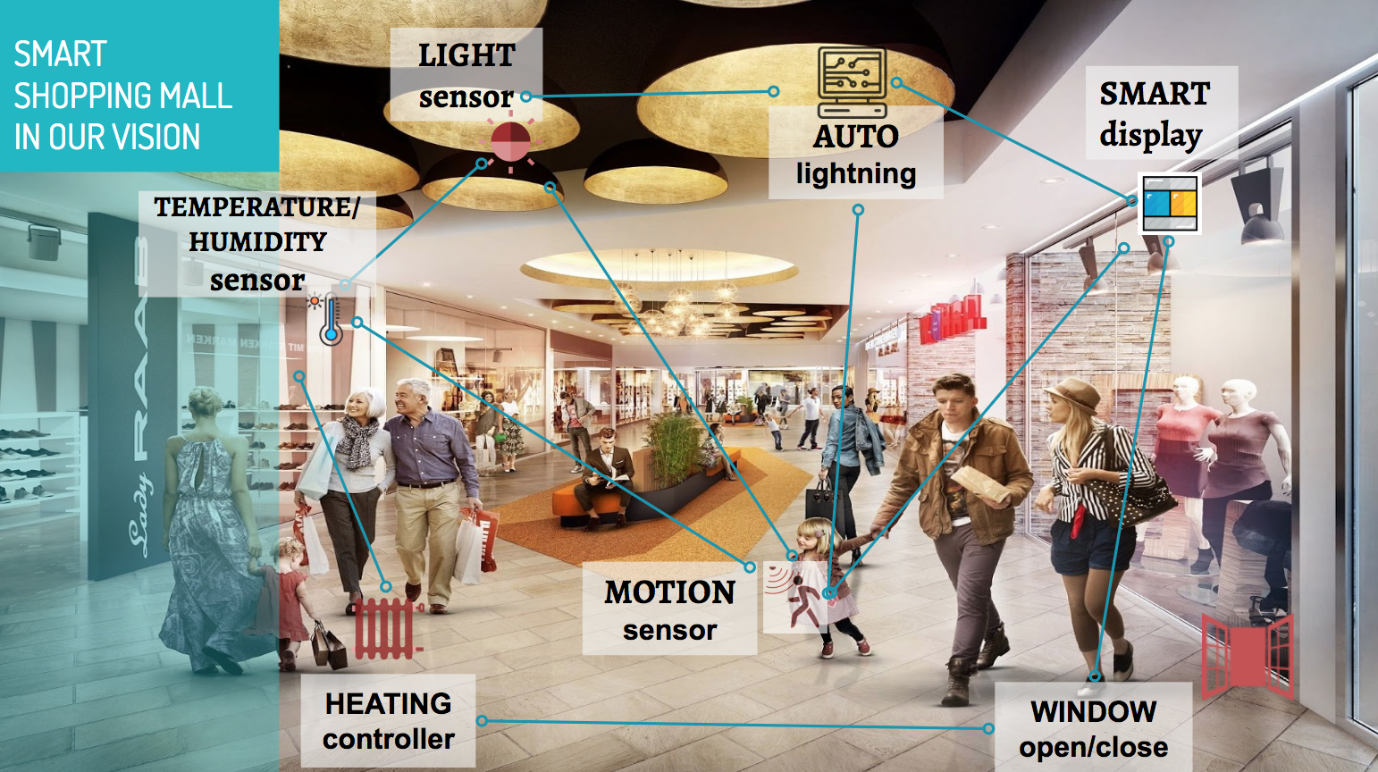Smart Shopping Mall Concept
In order to demonstrate the scenarios of a smart shopping mall, we've implemented the following architecture:
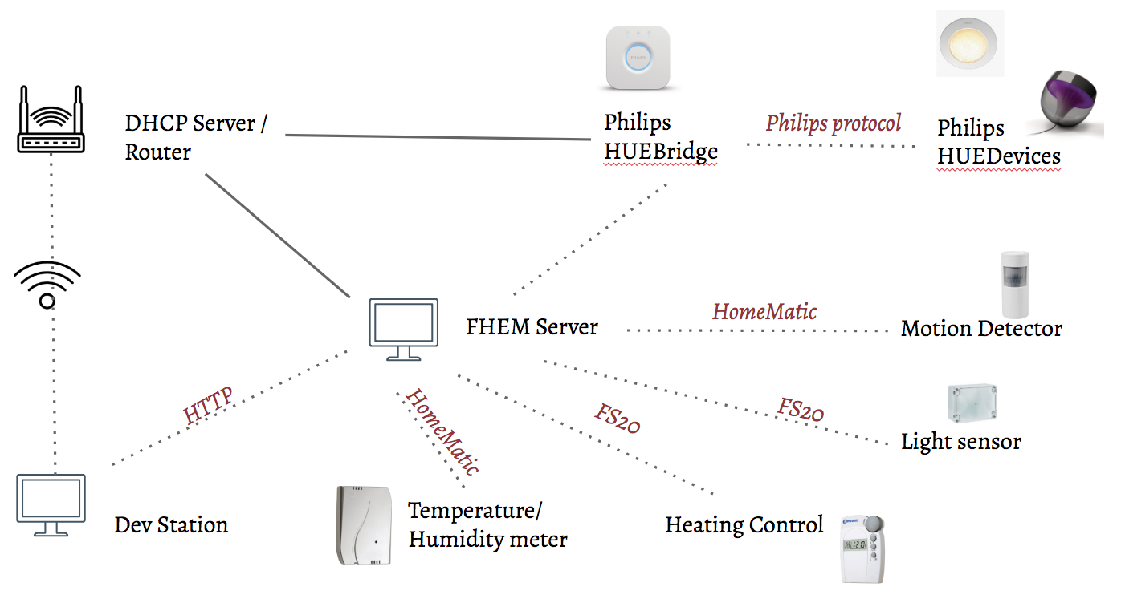System architecture
Using FHEM server, we've connected with sensors (HomeMatic temperature/humidity and motion sensors, FS20 Light Sensor and Heating Controller) and Philips smart lights. The DHCP server has also been set up to provide connections between development station, FHEM server and Philips HUEBridge (to control Philips HUE devices).

Implementation
We've implemented 3 scenarios:
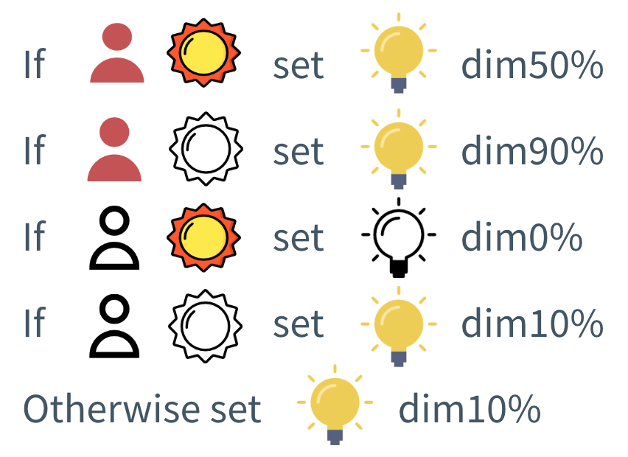
1. Adjust the lighting system based on user movement, natural light and temperature inside the shopping mall.
- If if the area is busy (people are moving around), the light should be on and its brightness will be adjusted based on current light level.
- On the other hand, the area is empty and the current light brightness is at normal rate, we turn of the lights, otherwise if it's pretty dark, the light is turned on at a minimum brightness (dim10%).

2. Change color of lights according to temperature:
Warm color (yellowish) is used when the temperature is considered cold (under a threshold) and vice versa, cold color (blueish) is used when the temperature is above comfortable threshold.
3. Reaction in case of wasting energy from using heater:
When the heater is turned on and window is opening, the window should be closed immediately in order not to waste energy from the heating activity. In the context of the lab, we didn't have window open/close controller, so we used a blinking lamp signal instead to simulate this reaction.
/*
Adjust the light according to movement and brightness
PhilipsBridgeofUS_HUEDevice1: a Philips light.
*/
define motion_light_dim notify motion_detector:.*|light_sensor:.* {
my $motion = ReadingsVal("motion_detector","state",0);
my $br = ReadingsVal("light_sensor","state",0);
if (($motion eq "noMotion") && ($br eq "on")) {
fhem "set PhilipsBridgeofUS_HUEDevice1 dim0%";
}
elsif (($motion eq "noMotion") && ($br eq "off")) {
fhem "set PhilipsBridgeofUS_HUEDevice1 dim10%";
}
elsif (($motion eq "motion") && ($br eq "on")) {
fhem "set PhilipsBridgeofUS_HUEDevice1 dim50%";
}
elsif (($motion eq "motion") && ($br eq "off")) {
fhem "set PhilipsBridgeofUS_HUEDevice1 dim90%";
} else {
fhem "set PhilipsBridgeofUS_HUEDevice1 dim10%";
}
}
/*
Adjust light color according to temperature
HM_tempmeter: name of temperature meter.
PhilipsBridgeofUS_HUEDevice1: a Philips light.
*/
define temp_color notify HM_tempmeter {
my $ps_Val = ReadingsVal("HM_tempmeter","temperature",0);
my $dim = ReadingsVal("PhilipsBridgeofUS_HUEDevice1", "state", 0);
if ($ps_Val > 26.0) {
fhem "set PhilipsBridgeofUS_HUEDevice1 rgb EAFF30";
} else {
fhem "set PhilipsBridgeofUS_HUEDevice1 rgb BAE1FF";
}
# this is to reset the light to its current dim level.
fhem "set PhilipsBridgeofUS_HUEDevice1 $dim";
}
/*
Notify if window is open when heater is on
FHT_2563: name of the heater controller.
PhilipsBridgeofUS_HUEDevice2: name of a Philips light
*/
define noti_door_open notify HM_doorsensor {
my $door = ReadingsVal("HM_doorsensor", "state", 0);
my $heater = ReadingsVal("FHT_2563", "actuator", 0);
if ($door eq "open" && $heater ne "0%") {
fhem "set PhilipsBridgeofUS_HUEDevice2 blink 10";
} else {
fhem "set PhilipsBridgeofUS_HUEDevice2 off";
}
}

Home Automation Protocol: Zigbee
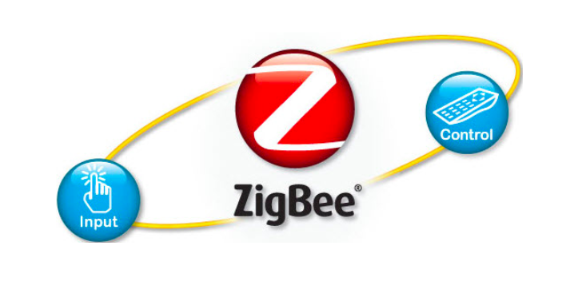

Intro
Nowadays, there are different high data rate protocols and technologies available, but none of these meet requirements of home sensors and control devices. These high data rate technologies provide wide bandwidth and low latency, but energy consumption is high. Zigbee technology is low cost, low power and it is an excellent communication candidate which makes communication best suited for embedded applications, industrial control, home automation and so on.

What is Zigbee technology?
Zigbee is the product of Zigbee Alliance and it is specifically built for control and sensor networks on IEEE 802.15.4 standard. The communication standard defines physical and MAC (Media Access Control) layers to handle many devices. The Zigbee WPAN works at 868 MHz, 902-928MHz, and 2.4 GHz frequencies. The data rate of 250 kbps is best suited for periodic as well as intermediate two-way transmission of data between sensors and controllers.

Interference Problem between ZigBee and WiFi
There are different wireless technologies that share the same 2.4 GHz frequency band. Such technologies usually operate in proximity and have to co-exist with each other. For example, WiFi uses the same frequency band that is used by ZigBee, however, WiFi uses higher power levels compared with ZigBee. When the ZigBee and WiFi use the channel at the same time, an interference problem appears which causes loss of the data packets being transmitted. This will result in retransmission in both WiFi and ZigBee until a successful transmission is achieved. This, in turn, causes delay and mitigation in the delivery ratio for both technologies. Moreover, ZigBee would wait longer to get free medium for transmission, and with the expected packet loss and retransmission, faster draining of the sensor battery is expected.
Interference Problem between ZigBee and WiFi (PDF Download Available). Available from: https://www.researchgate.net/publication/277903615_Interference_Problem_between_ZigBee_and_WiFi [accessed May 17 2018].

Zigbee Features
Zigbee is low-cost and low-powered mesh network widely deployed for controlling and monitoring applications where it covers 10-100 meters within the range. This communication system is less expensive and simpler than the other proprietary short-range wireless sensor networks as Bluetooth and Wi-Fi. Zigbee supports different network configurations for the master to master or master to slave communications. And also, it can be operated in different modes, as a result, the battery power is conserved. Zigbee networks are extendable with the use of routers and allow many nodes to interconnect with each other for building a wider area network. Most important features are:
- Support for multiple network topologies such as point-to-point, point-to-multipoint and mesh networks
- Low duty cycle – provides long battery life
- Low latency
- Direct Sequence Spread Spectrum (DSSS)
- Up to 65,000 nodes per network
- 128-bit AES encryption for secure data connections
- Collision avoidance, retries, and acknowledgments
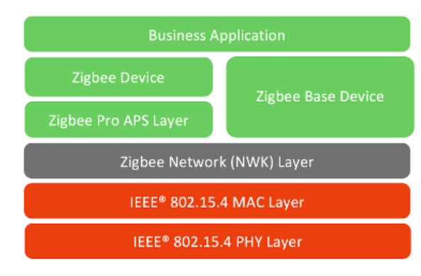

Zigbee Architecture
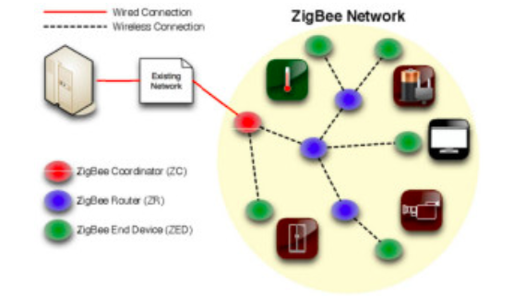
Zigbee system structure consists of three different types of devices such as Zigbee coordinator, Router and End device. Every Zigbee network must consist of at least one coordinator which acts as a root and bridge of the network. The coordinator is responsible for handling and storing the information while performing receiving and transmitting data operations. Zigbee routers act as intermediary devices that permit data to pass to and go through them to other devices. End devices have limited functionality to communicate with the parent nodes such that the battery power is saved as shown in the figure. The number of routers, coordinators and end devices depends on the type of networks such as star, tree and mesh networks. Zigbee protocol architecture consists of a stack of various layers where IEEE 802.15.4 is defined by physical and MAC layers while this protocol is completed by accumulating Zigbee’s own network and application layers.

Zigbee Protocol
Zigbee protocol architecture consists of a stack of various layers where IEEE 802.15.4 is defined by physical and MAC layers while this protocol is completed by accumulating Zigbee’s own network and application layers.

Zigbee Protocol Architecture

Physical Layer
This layer does modulation and demodulation operations upon transmitting and receiving signals respectively. This layer’s frequency, data rate and the number of channels are given below.

MAC Layer
This layer is responsible for reliable transmission of data by accessing different networks with the carrier sense multiple access collision avoidances (CSMA). This also transmits the beacon frames for synchronizing communication. Network Layer: This layer takes care of all network related operations such as network setup, end device connection, and disconnection to network, routing, device configurations, etc.

Application Support Sub-layer
This layer enables the services necessary for Zigbee device object and application objects to interface with the network layers for data managing services. This layer is responsible for matching two devices according to their services and needs.

Application Framework
It provides two types of data services as a key-value pair and generic message services. A generic message is a developer-defined structure, whereas the key-value pair is used for getting attributes within the application objects. ZDO provides an interface between application objects and APS layer in Zigbee devices. It is responsible for detecting, initiating and binding other devices to the network.

Zigbee Packet
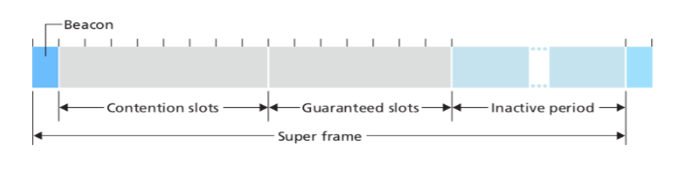
Zigbee networks can be configured in many different ways. Let’s consider the simple case of a single full-function device controlling multiple reduced-function devices in a time-slotted manner using beacon frames. Figure 6.17 shows the case where the Zigbee network divides time into recurring superframes, each of which begins with a beacon frame. Each beacon frame divides the superframe into an active period (during which devices may transmit) and an inactive period (during which all devices, including the controller, can sleep and thus conserve power). The active period consists of 16 timeslots, some of which are used by devices in a CSMA/CA random access manner, and some of which are allocated by the controller to specific devices, thus providing guaranteed channel access for those devices. More details about Zigbee networks can be found at [Baronti 2007, IEEE 802.15.4 2012].

Zigbee Operation Modes
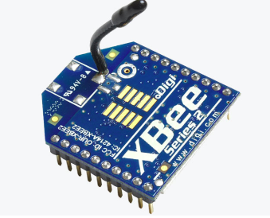
Zigbee two-way data is transferred in two modes: Non-beacon mode and Beacon mode. In a beacon mode, the coordinators and routers continuously monitor the active state of incoming data hence more power is consumed. In this mode, the routers and coordinators do not sleep because at any time any node can wake up and communicate. However, it requires more power supply and its overall power consumption is low because most of the devices are in an inactive state for over long periods in the network. In a beacon mode, when there is no data communication from end devices, then the routers and coordinators enter into the sleep state. Periodically this coordinator wakes up and transmits the beacons to the routers in the network. These beacon networks are work for time slots which means, they operate when the communication needed results in lower duty cycles and longer battery usage. These beacon and non-beacon modes of Zigbee can manage periodic (sensors data), intermittent (Light switches) and repetitive data types.

Zigbee Topologies
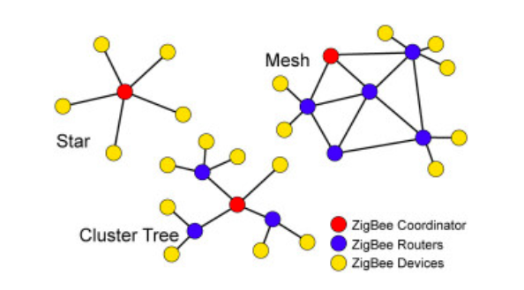
Zigbee supports several network topologies; however, the most commonly used configurations are the star, mesh and cluster tree topologies. Any topology consists of one or more coordinator. In a star topology, the network consists of one coordinator which is responsible for initiating and managing the devices over the network. All other devices are called end devices that directly communicate with the coordinator. This is used in industries where all the endpoint devices are needed to communicate with the central controller, and this topology is simple and easy to deploy. In mesh and tree topologies, the Zigbee network is extended with several routers where the coordinator is responsible for staring them. These structures allow any device to communicate with any other adjacent node for providing redundancy to the data. If any node fails, the information is routed automatically to other devices by these topologies. As the redundancy is the main factor in industries, hence mesh topology is mostly used. In a cluster-tree network, each cluster consists of a coordinator with leaf nodes, and these coordinators are connected to parent coordinator which initiates the entire network.

Zigbee Use-cases

Industrial Automation
In manufacturing and production industries, a communication link continually monitors various parameters and critical equipment. Hence Zigbee considerably reduces this communication cost as well as optimizes the control process for greater reliability.

Home Automation
Zigbee is perfectly suited for controlling home appliances remotely as a lighting system control, appliance control, heating and cooling system control, safety equipment operations and control, surveillance, and so on. Smart Metering: Zigbee remote operations in smart metering include energy consumption response, pricing support, security overpower theft, etc.

Smart Grid Monitoring
Zigbee operations in this smart grid involve remote temperature monitoring, fault locating, reactive power management, and so on. This is all about a brief description of Zigbee technology’s architecture, operations modes, configurations, and applications. We hope that we have given you enough content on this title, for you to understand it better. We are pioneers in developing Zigbee based projects. For further help and technical assistance, you can contact us by commenting below.

Poster
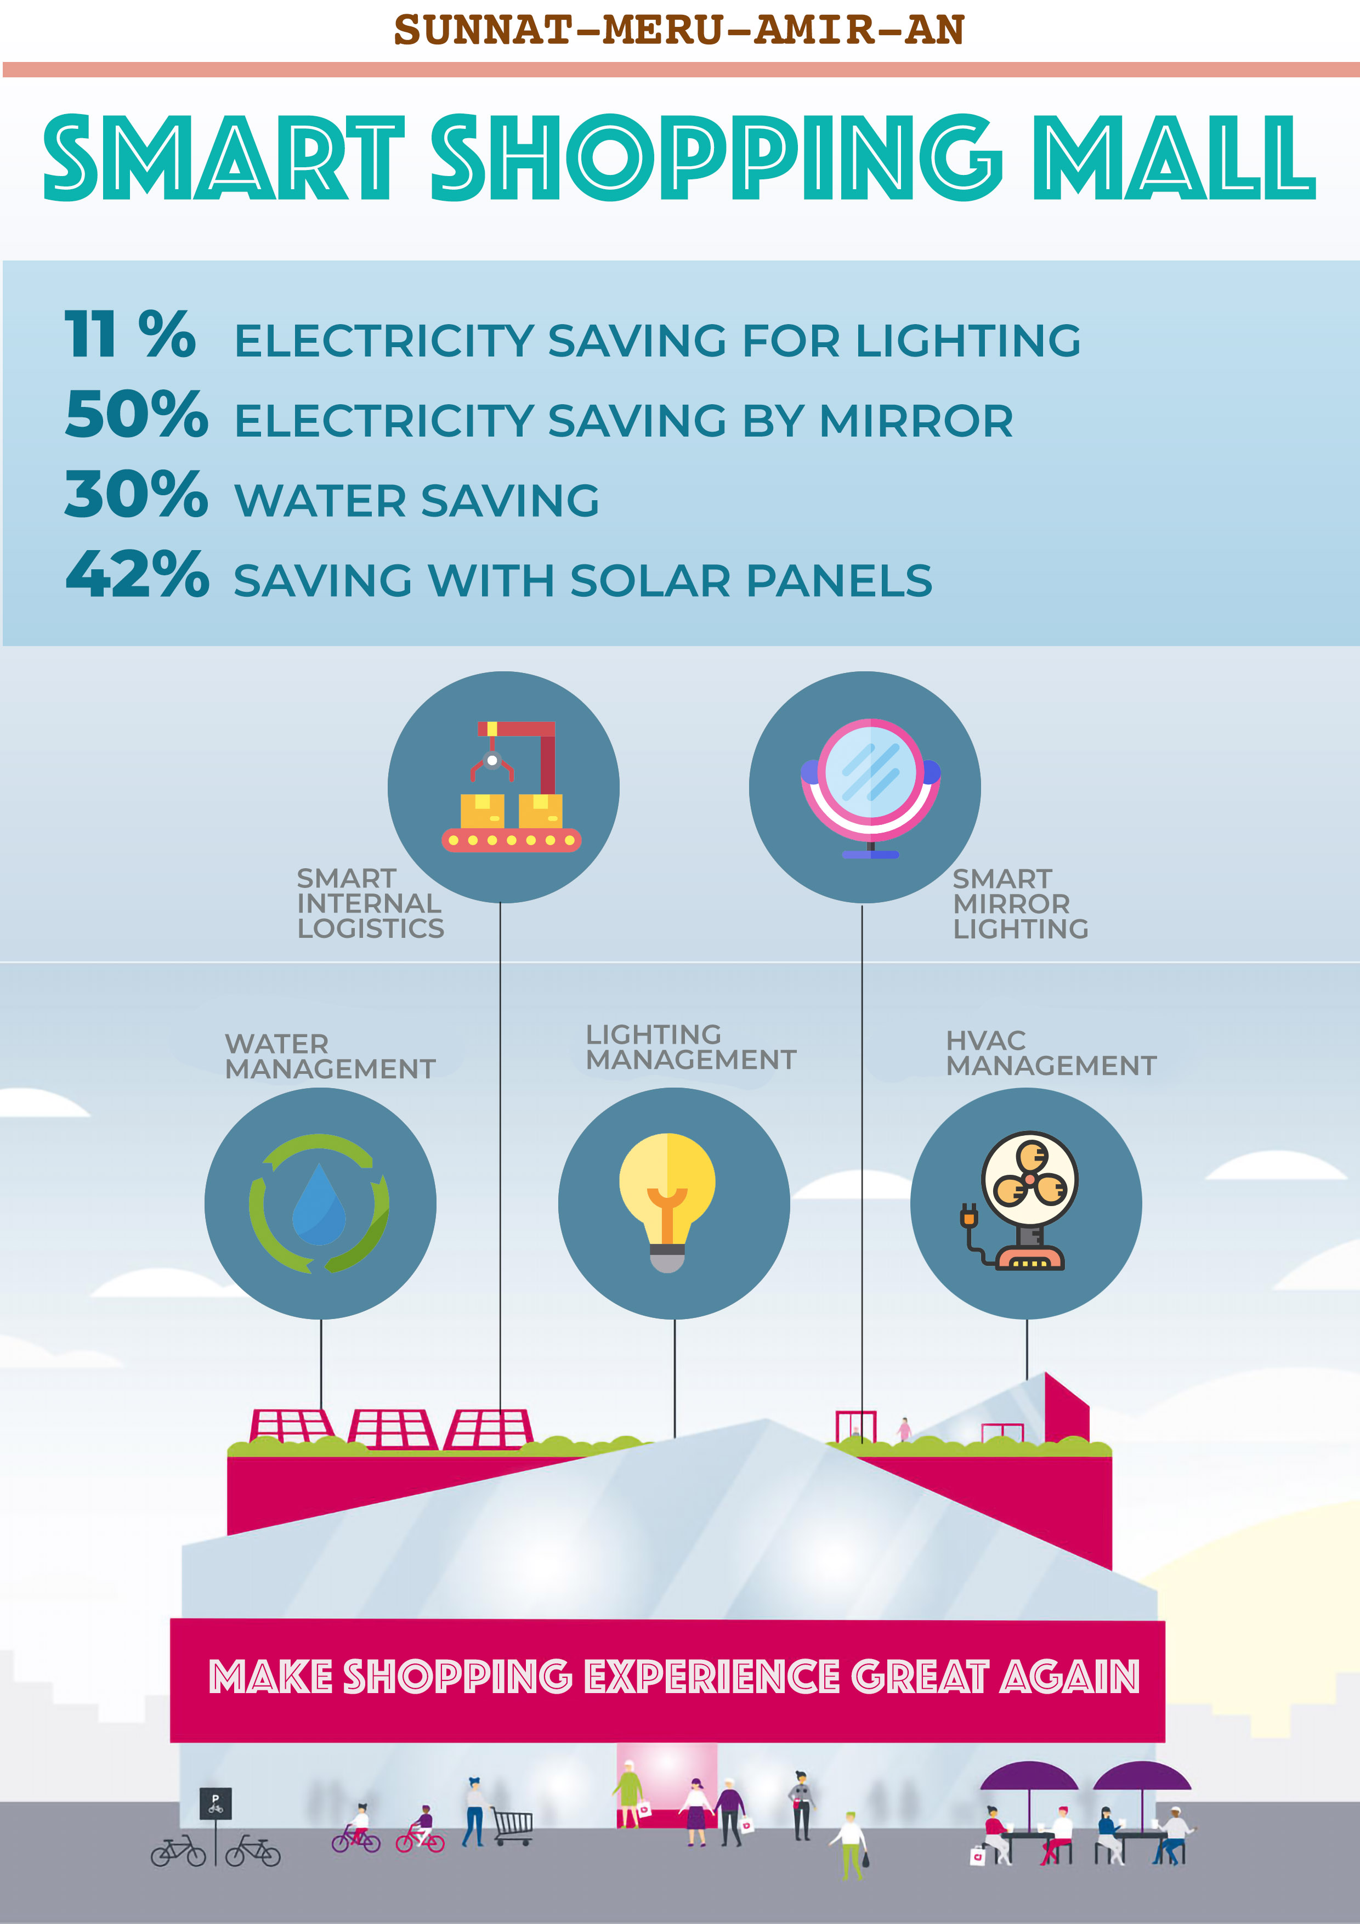

Presentation
Our presentation

References
- https://www.currentresults.com/Weather/Europe/Cities/sunshine-annual-average.php
- https://sites.ualberta.ca/~deyoung/myweb/mallenergy.pdf
- http://www.eurac.edu/en/research/technologies/renewableenergy/publications/Documents/Tesi_Giuseppe_Gentile.pdf
- https://en.wikipedia.org/wiki/Heliostat
- http://www.eurac.edu/en/research/technologies/renewableenergy/publications/Documents/Tesi_Giuseppe_Gentile.pdf
- http://www.jcdecauxna.com/sites/default/files/assets/mall/documents/studies/MallPhenomenon.pdf
- http://aqua-lity.co.uk/wp-content/uploads/2012/05/White-City-Westfield-Shopping-Centre.pdf
- https://environmentamerica.org/sites/environment/files/reports/AME%20Solar%20Stores%20Feb16.pdf
- https://news.energysage.com/understanding-your-solar-panel-payback-period/

