Economical
Economical dimensions takes a look into how your product is affecting society in a commercial or economical way. Here you will be asking yourself if you have innovated something new, something of value. Have you changed or improved a certain way of governing?
You should think of immediate direct effects that your application is having on the economy and governance, but also think how effects from other dimensions are interconnected and to which effect will they lead to, in tier 2 or tier 3.
- Is the product changing how the global or local economy will be conducted?
- Is the product greately contributing (positively or negatively) to the economy?
- Have you made governing easier or harder?
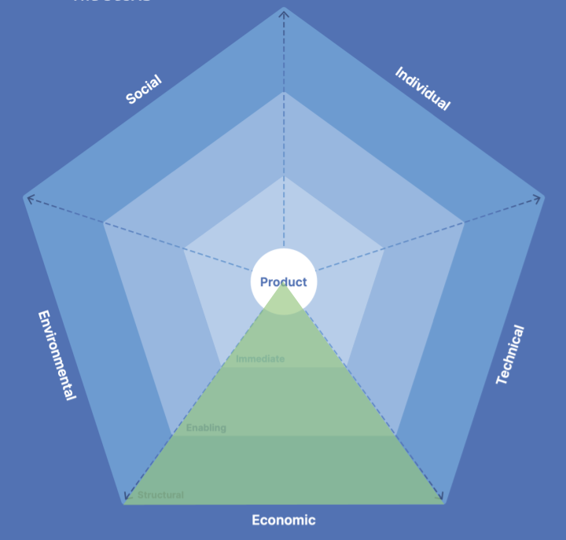
Think of the following categories and the questions listed below that could help you in assessing how the product is affecting the economical dimension of sustainability:
- Value
  - What value is the product producing out of its features?
  - Could these features be monetized?
  - Could there be any economical benefit - not necessarily only in terms of money, but resources or other material benefits or accomplishments.
    - Does your products use lead to building a road for example (even though its not a road-building application)?
- Customer Relationship Management
  - How is the product affecting the relationship with customers?
  - Think of Facebook, how are they dealing with complaints?
  - How is this product doing it?
- Supply Chain
  - Have you altered how businesses are being supplied?
  - How will your product affect business that is using it?
  - How does your supply chain affect your business?
  - Are there any perceivable benefits from this product in the supply chain?
- Governance
  - Is your product altering the means of decision making inside an already existing system?
  - Or is your product introducing a completely new system?
  - Think of how blockchain altered decision making, or think of ticketing systems such as Jira or Trello which altered the processes of development and decision makings within domain of project managements.
- Innovation
  - Is the product introducing something new on the tech scene?
  - Is the product introducing any innovation on the market that has not existed before.
  - Were the innovations worth it? Is there any economical benefit behind it?
  - Think of what new has Facebook introduced - they revolutionized the way people are communicating online.
  - Similarly goes for apps such as WhatsApp, people could start messaging for free over internet, they disrupted SMSs business completely.
  - Is your product disrupting any other business domain with its innovativness?

