Impact Assessment

SusAF - Sustainability Awareness Framework
SusAF helps you in assessing the sustainability effects of a product, by guiding you through steps and in that way helping you to see both the positive and negative effects that it has. You will find as much as possible of the effects and grade them based on their impact and effect. Finally, you will be able to see the big image, and how those effects are interconnected and how they affect the planet, society and each one of us. You will be able to improve your product, as the final goal is to create sustainable and responsible products. What SusAF focuses on is:
- Determining the sustainability impacts and effects of IT products and services across five dimensions: social, individual, environmental, economic, and technical. This involved the examination of these impacts through three orders of effect: direct, indirect, and systemic.
- Promoting discussions about the expected effects of IT products and services.
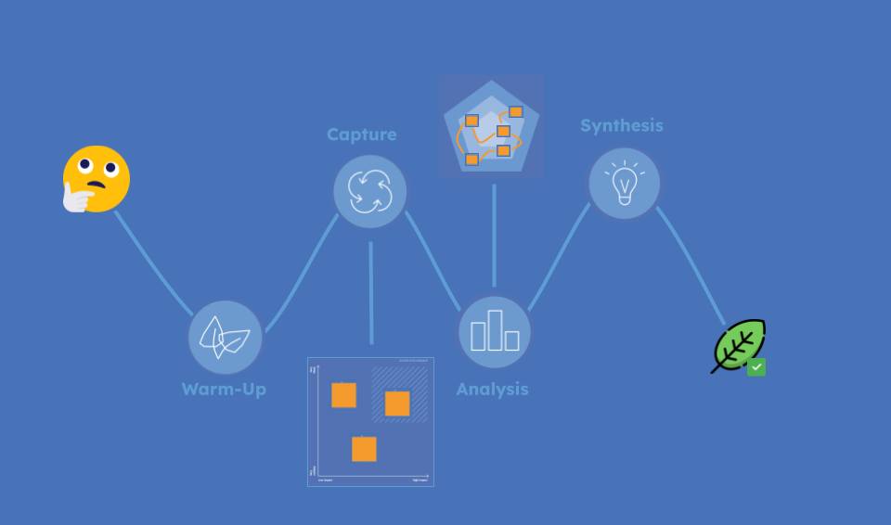

Key Elements in Susaf
The 5 dimensions of Sustainability :
- The Environmental dimension is about conserving natural resources and protect global ecosystems to support health and wellbeing, now and in the future
- The Economic dimension is concerned with finance, profit, investment
- The Social dimension covers relationships between individuals and groups.
- The Individual dimension focus on o the maintenance of individual human capital
- The Technical dimension refers to maintenance and evolution, resilience of IT products, services or software systems.

Susaf Process

Warm-Up
The idea behind this phase is to warm-up. You should start thinking about the product and scratching the surface of its sustainability. Get familiar with the product, and what your team thinks about it. First of all, just try to describe the product that you will be analyzing.
What is it used for? What is its main feature, or a couple of them? Who uses this product? Why do they use it? How does the product help in any way? Do you see something obviously good or obviously bad about it?
Discuss within the team, brainstorm and write down the ideas. The following two questions should be answered in the next 20-30 minutes.
- Describe the product with its main features and main contributions.
  - Overall, high level explanation
  - The first thing that you think of when you think of the product
- What are the out-of-the-box known sustainability effects?
  - Positive and negative effects that you can perceive in the product just by thinking of it, and having a short discussion
  - For example, Facebook’s obvious sustainability effects are that it allows you to connect with people, to chat with friends and family, to share pictures
  - This is what you know just by thinking of Facebook
  - No need to overthink at this point, or to try to find causes of it
  - Just everything that pops into your mind

Capture
In this phase you should collect and categorize the potential effects of the IT product regarding sustainability.
You should start looking through one of the sustainability dimensions and read the questions related to every sub-category of that dimension.
Then, write down the first effects that come to mind in your notes sheets, it shouldn't take you more than one minute. To do that, consider the effects of the product, its working process, and its business model.
Write the Positive effects on blue cards and the negative effects on orange ones to separate them, then present all your ideas and discuss them within your team. And remember:
- Quality over quantity
- Do not judge
- Do not worry if you are not able to comment on all ideas
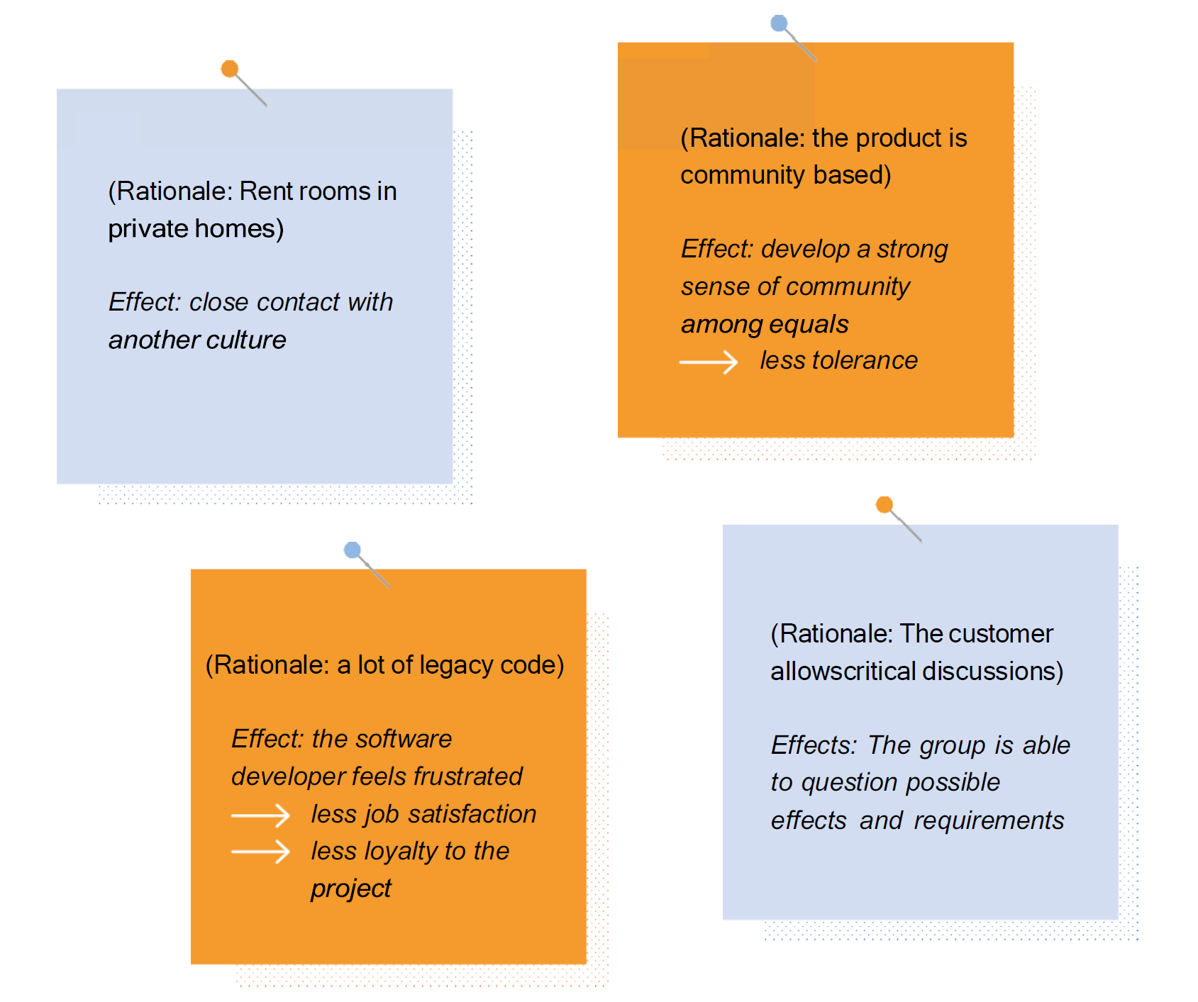
After gathering all your effects, decide which ideas are worth capturing and focussing on. The chosen ideas can then be classified in the SUSAF diagram based on their likelihood and the level of their impact
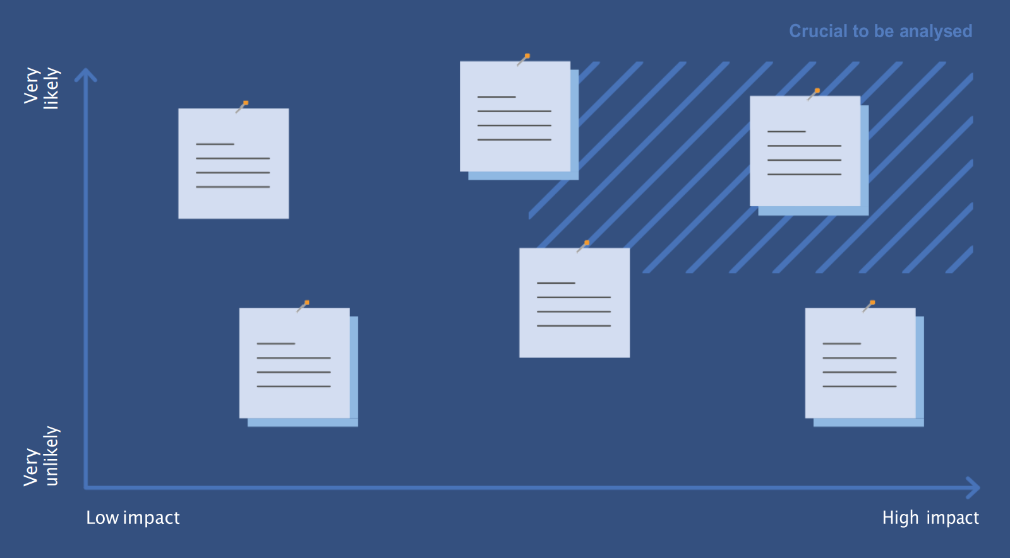

Analysis
Before going into this phase, you should know about First, Second and Third order effects (which are described in the SUSAF book). But in simple words first order effects are immediate or direct consequences of an action, second order effects are Indirect consequences that follow the first order effects, and finally third order effects are the long-term changes that can significantly alter the environment in which the initial action took place.
In this phase, you should try to “relate” the short and long term effects of each dimension (that we have already discovered in the previous phases) to get the chain of effects.
Think from this perspective, that you want to know the broader implications of your IT product/service. Having a chain of effects can help you prevent unintended outcomes, strategic planning and robust decision making.
First mention the effects (from likelihood and impact matrix) in specific dimensions and order a susad diagram, and then try to see what each effect leads to. And if one effect leads to another we connect them using an arrow.
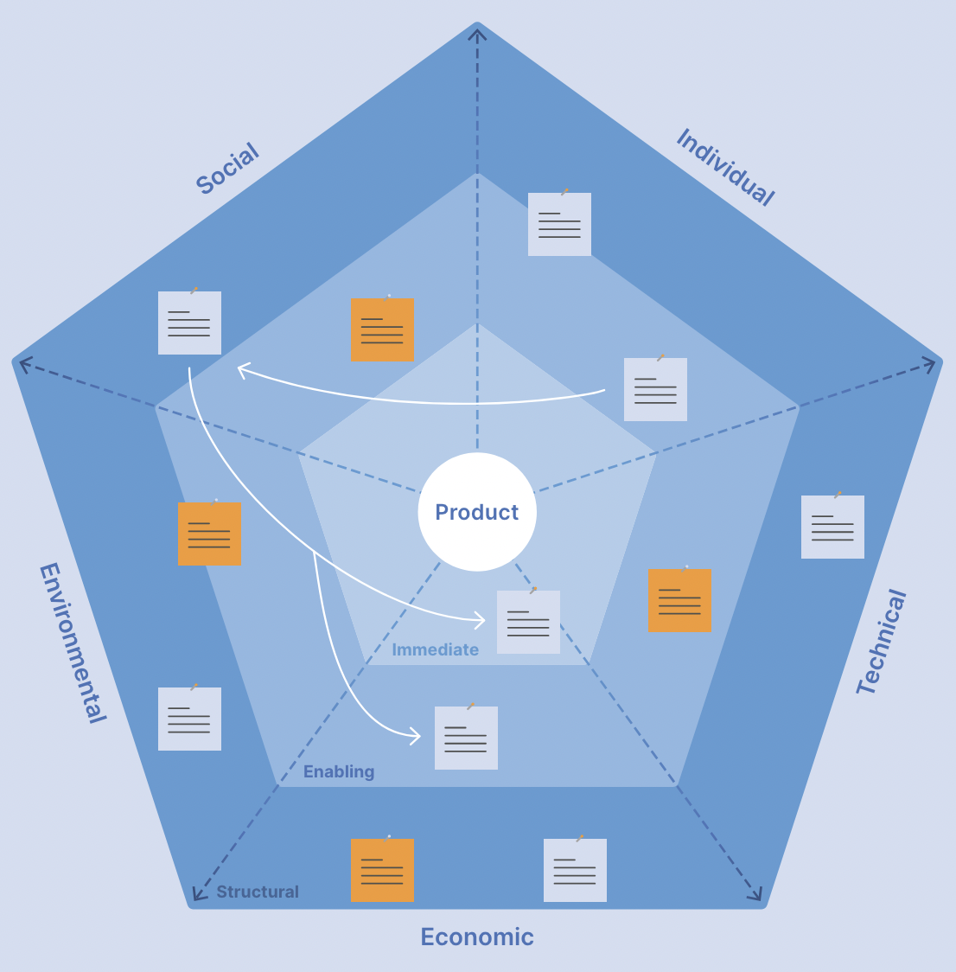

Synthesis
In this phase, you should try to find challenges and opportunities and think about how to utilize opportunities and how to deal with challenges.
For example, i am taking IT product “ChatGPT” to identify opportunities, threats in different dimensions and what actions can be taken for them.
Social Dimension
Opportunity: Foster collaboration and communication among users and developers
Threat: Over-reliance on ChatGPT may diminish users' critical thinking abilities, resulting in dependency and potential cognitive drawbacks.
Action to Harness Opportunity: Develop community forums like stackoverflow.
Action to Mitigate Threat: Implement advanced fact-checking and source-verification algorithms within the AI to reduce the risk of disseminating misinformation.
Economic Dimension
Opportunity: Tap into a lucrative B2B market tailoring ChatGPT for specific enterprise needs.
Threat: Job displacement due to automation and AI.
Action to Harness Opportunity: Offer customized solutions for customer service, data analysis, and automation needs for enterprises.
Action to Mitigate Threat: Develop re-skilling programs for affected employees and invest in new job creation that AI and automation can bring.

