The winners wikipage

This hackathon
Idea
We are creating a tool for managing the sign-up for the hackathon.
1) Users should be able to create a profile with some personal details, academic background, skills and interests
2) Users should be able to join teams
3) Users should be able to view the existing teams

OLD
https://excalidraw.com/#room=aa45b775f4991b2a9825,mZCutLbejXBiwi-HpTDSYQ
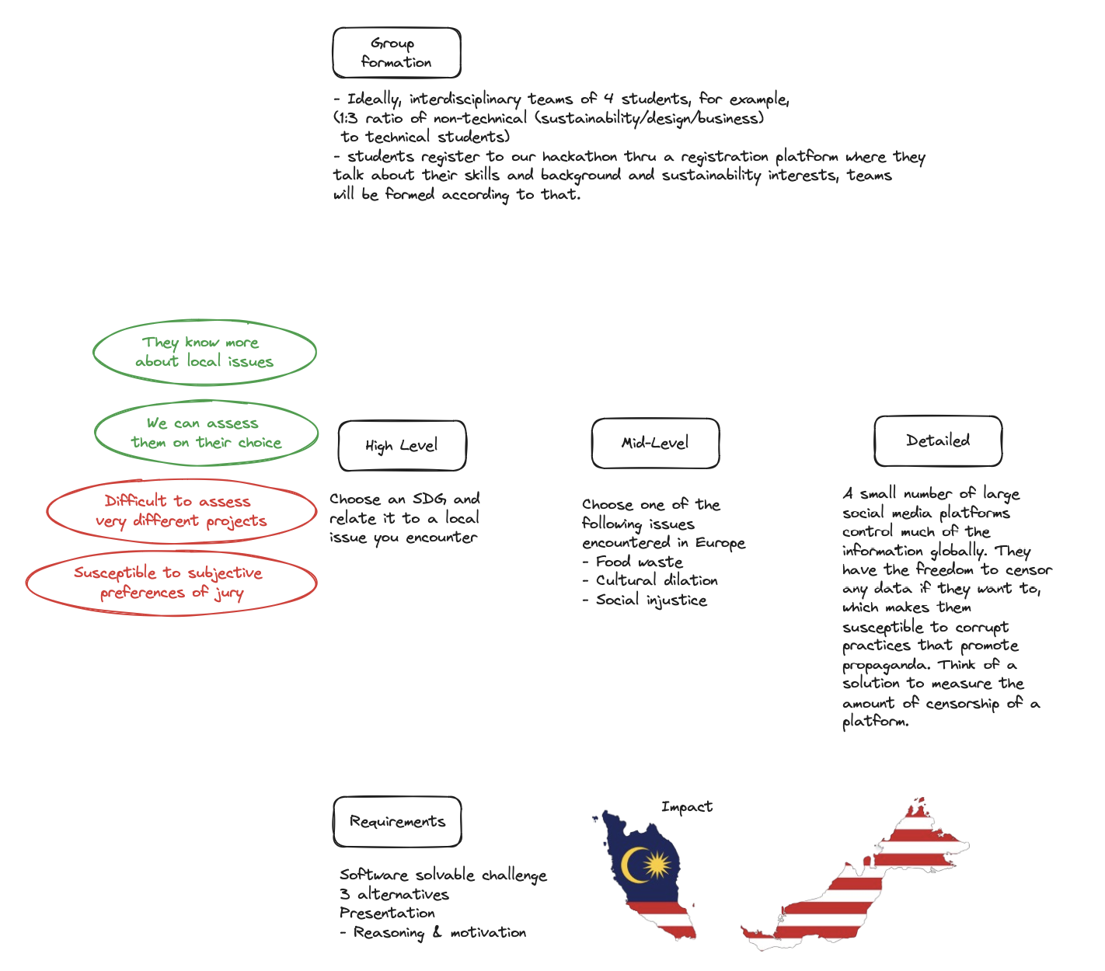

Hosting
Just like backend, frontend project has to be hosted so that the users could access it online. Instead of hosting your project locally, it is best to deploy your web app online so that it would be accessible.
Netlify allows extremely easy and beginner friendly deployment options for frontend projects. Just follow the steps below and your app will be online in no time!

Netlify - Practical Beginner’s Tutorial

Registration on Netlify
1) Go to https://www.netlify.com
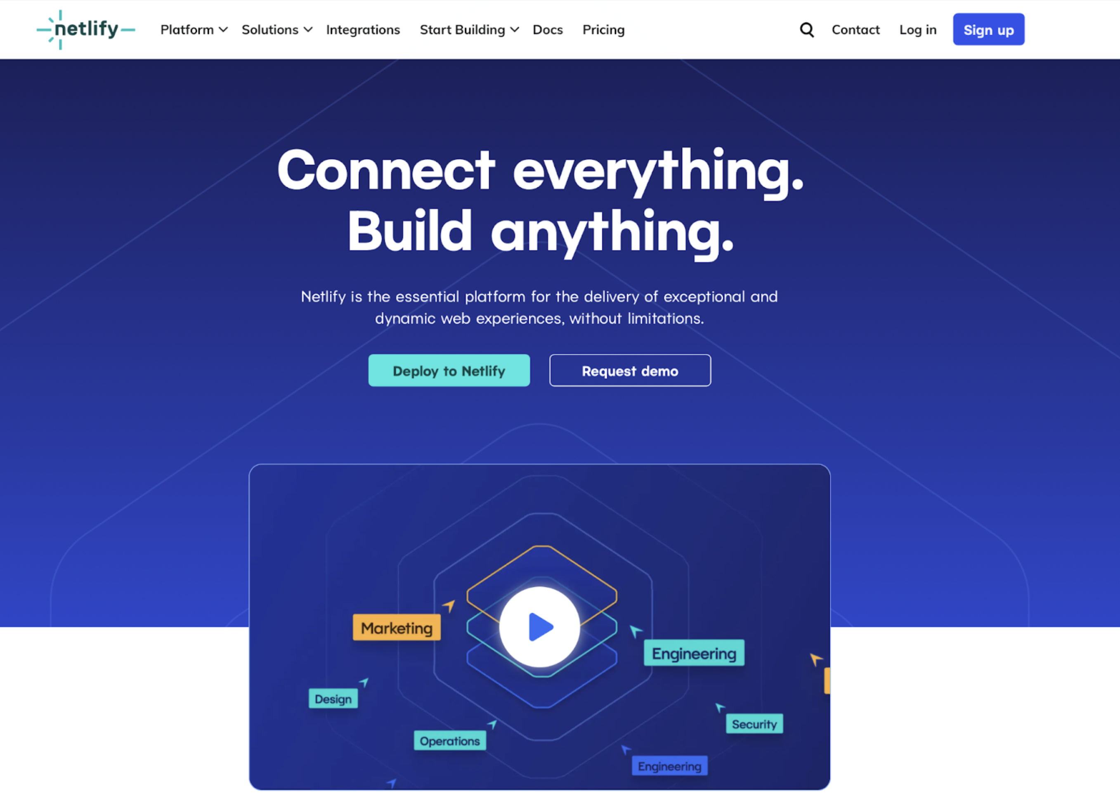
2) Register using your email and use password generator because Netlify has high requirements for password strength.
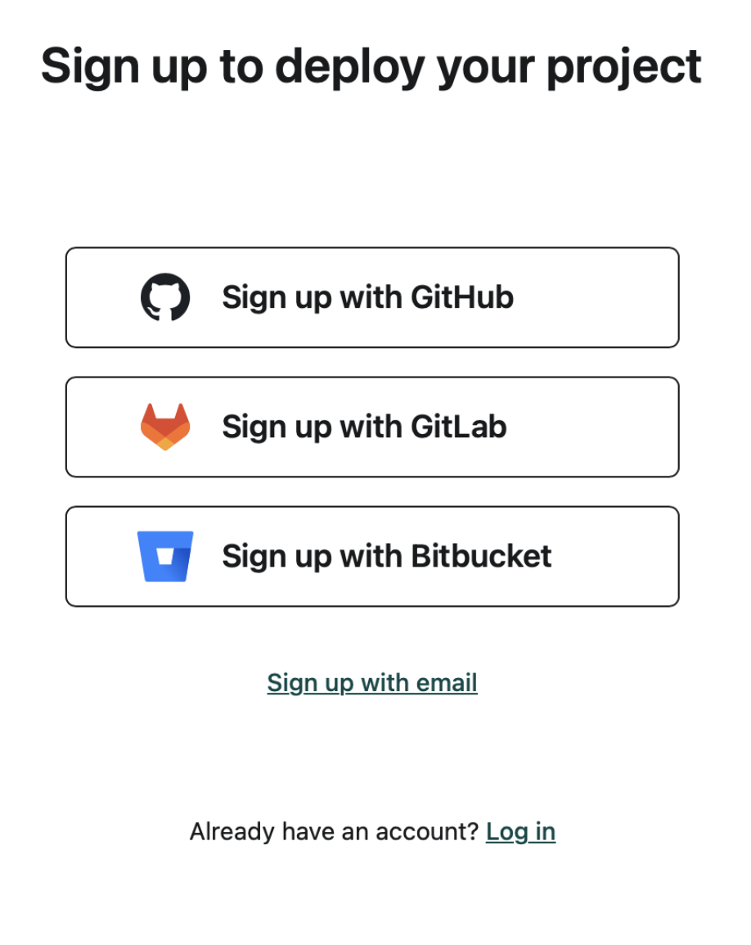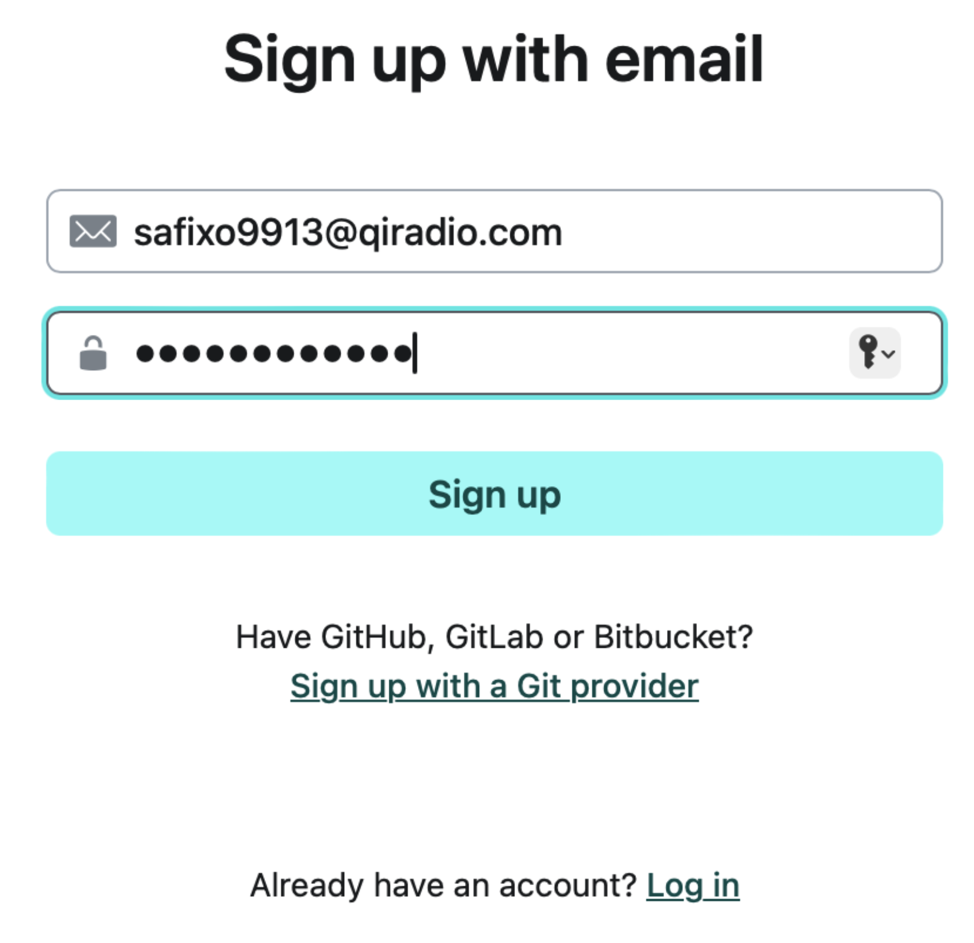
3) Verify Netlify’s email that you received in your email inbox and login
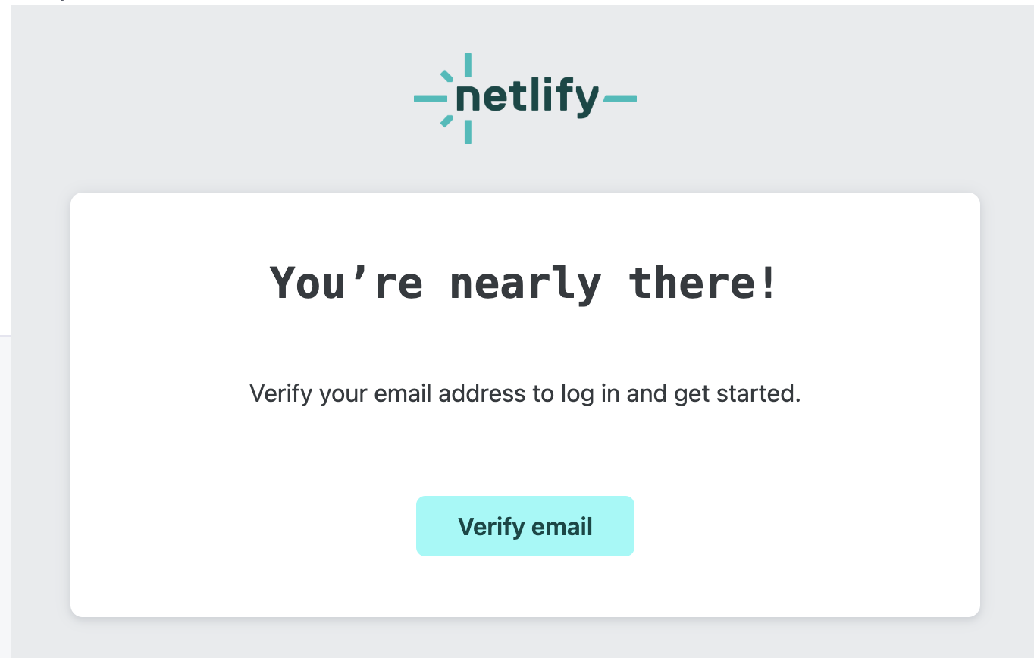
4) Fill up the questionnaire (what you answer does not really matter)
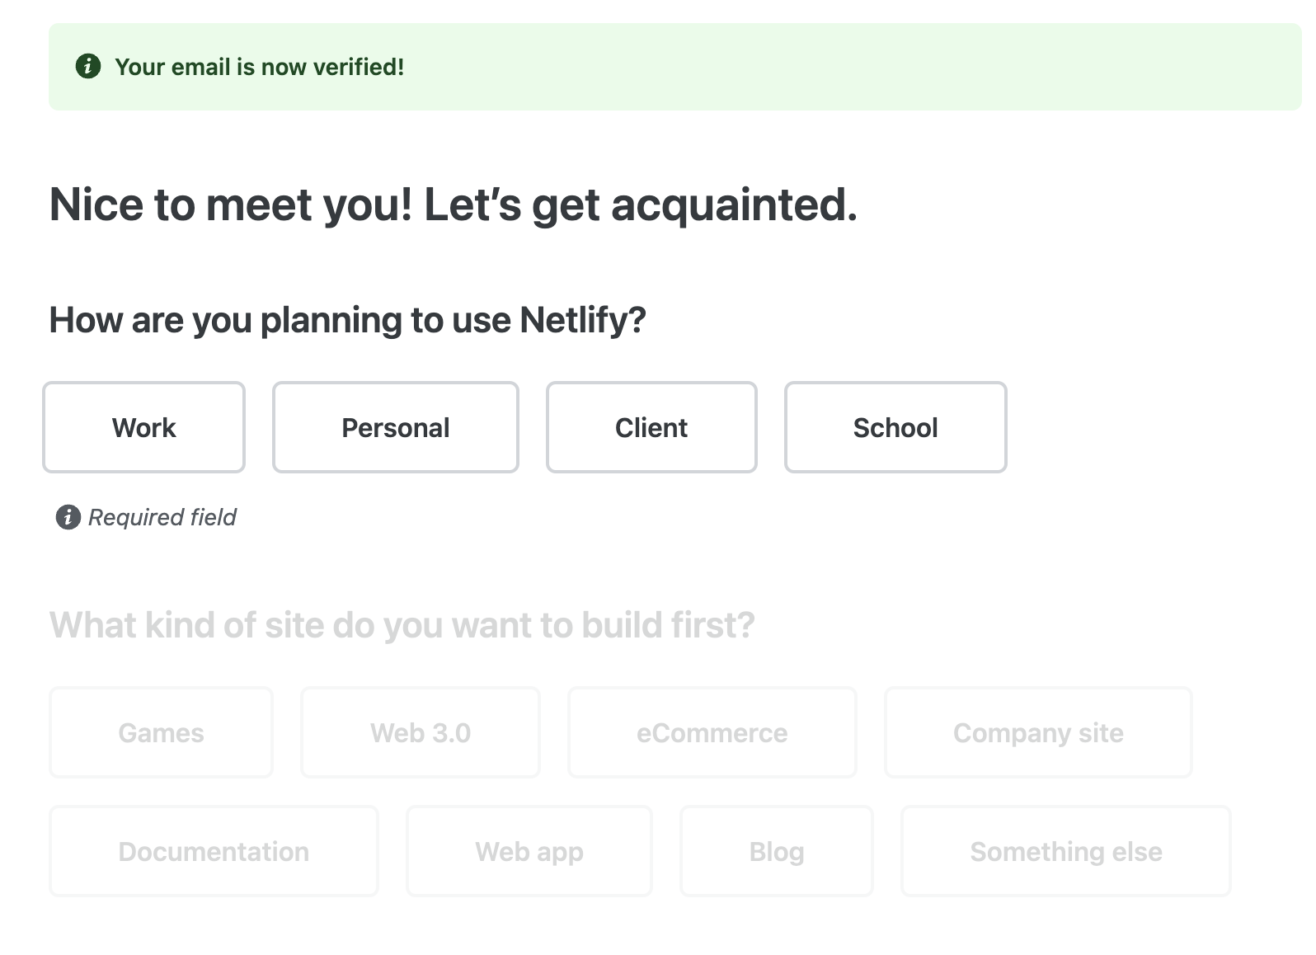
5) Skip the step about deploying a website
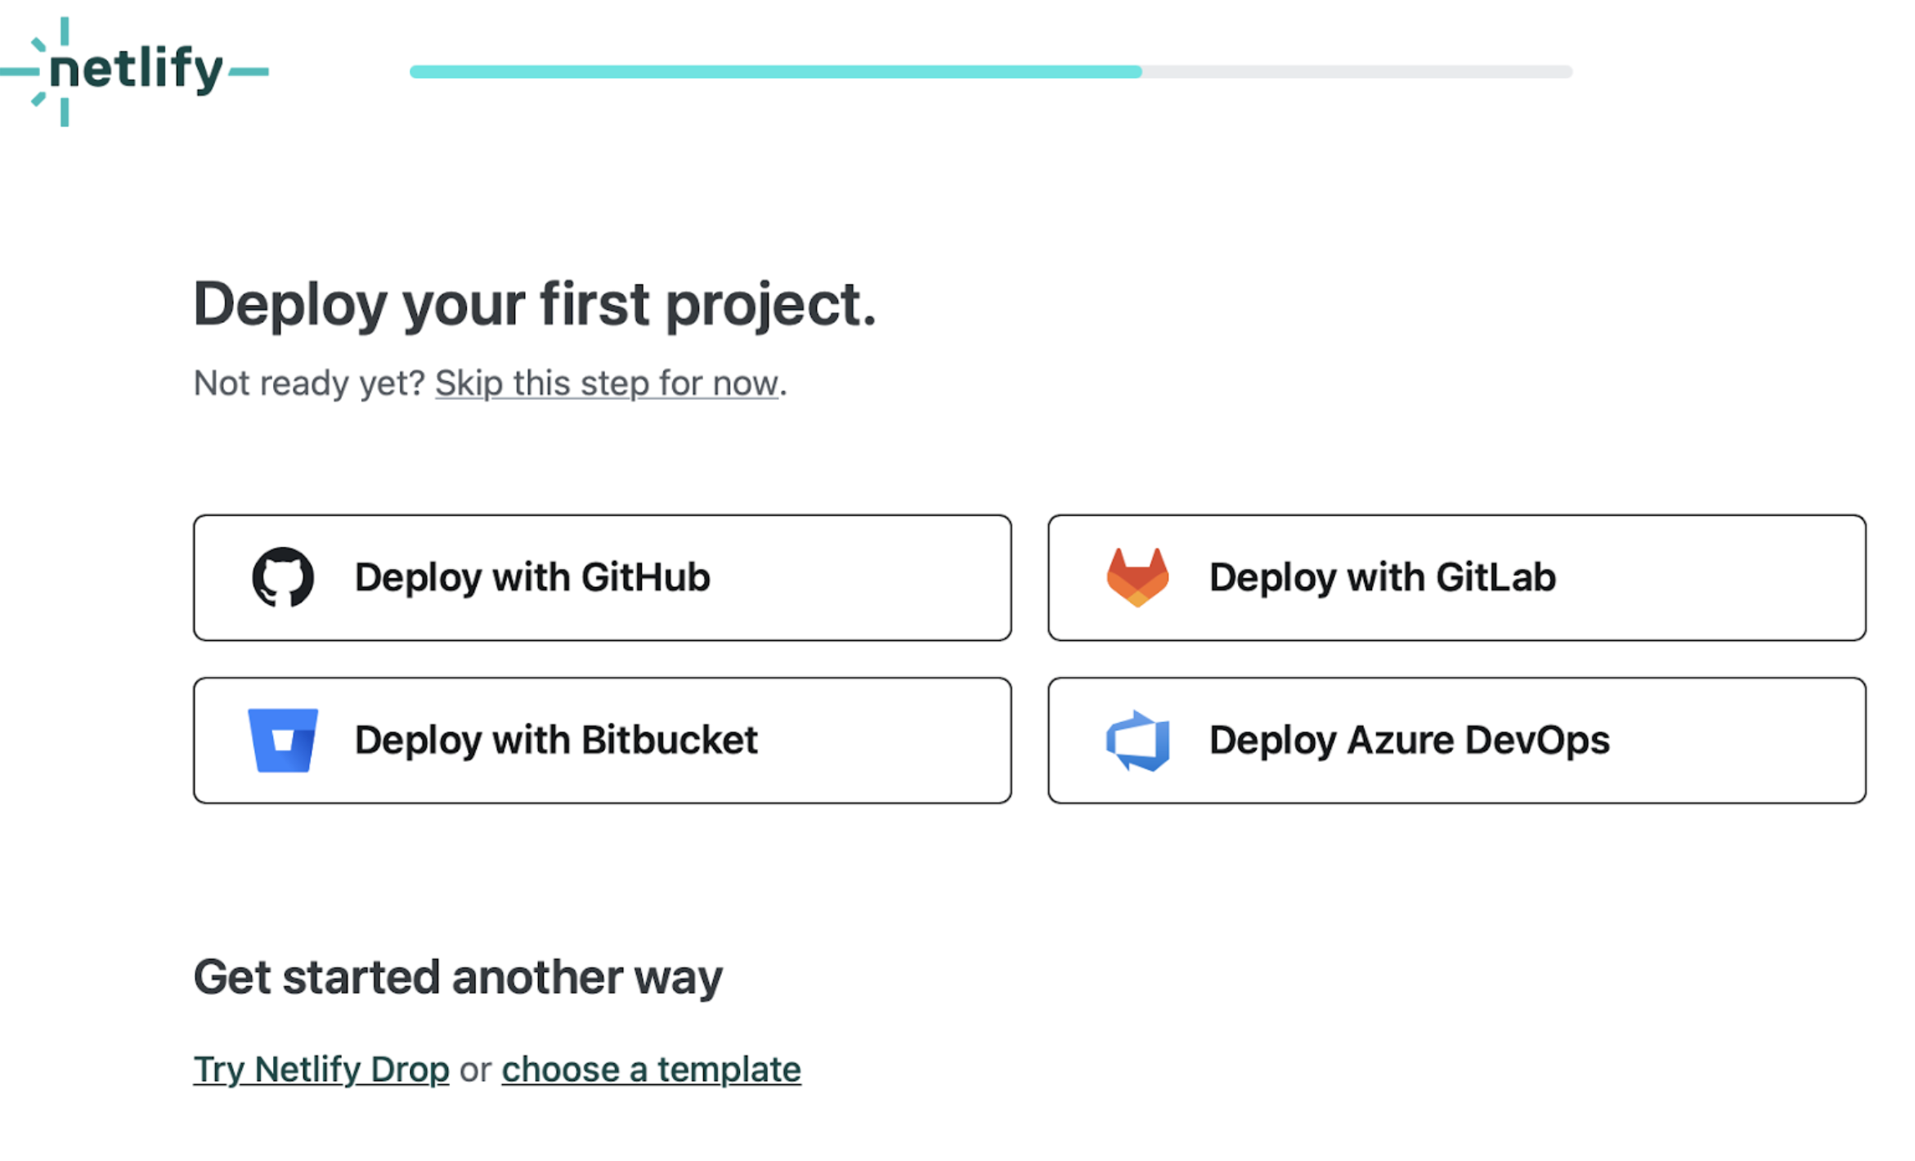

Deployment on Netlify
6) Go to the Sites tab and opt for manual deployment it is the most beginner-friendly and most straightforward
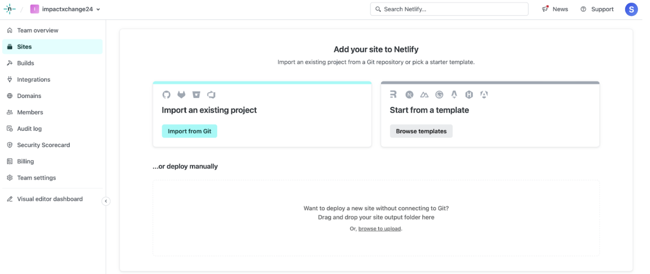
7) Open your folder containing the project folder and drag and drop the containing folder into the designated place for manual deployment
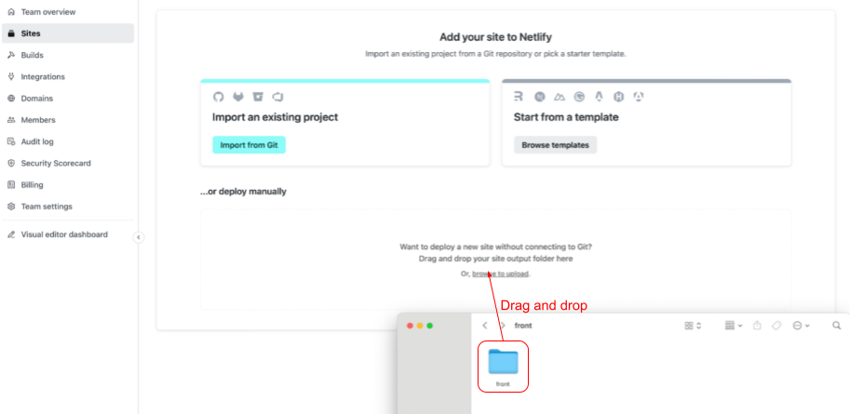
8) If you do it well, your website will be uploaded in no time!
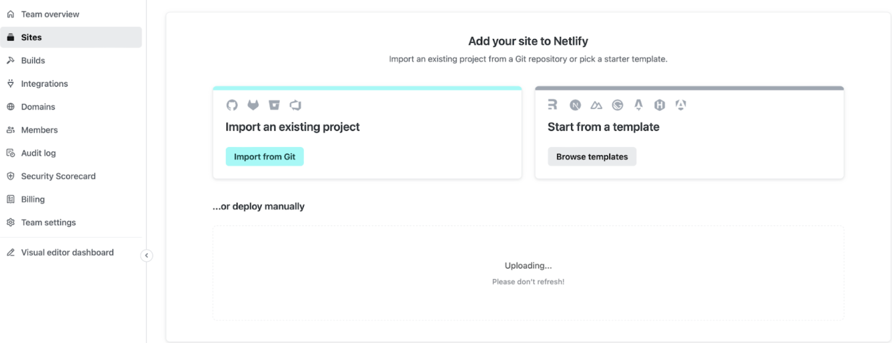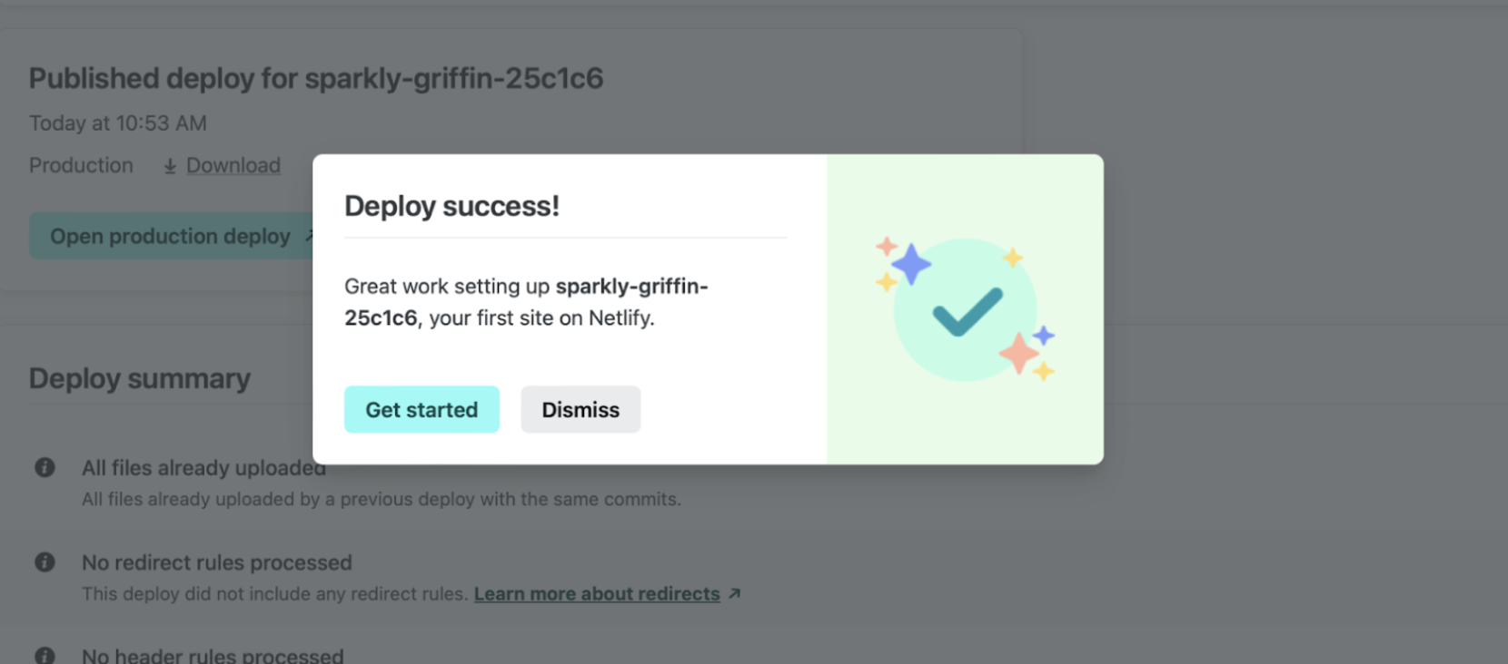
9) You can see information about your deployment
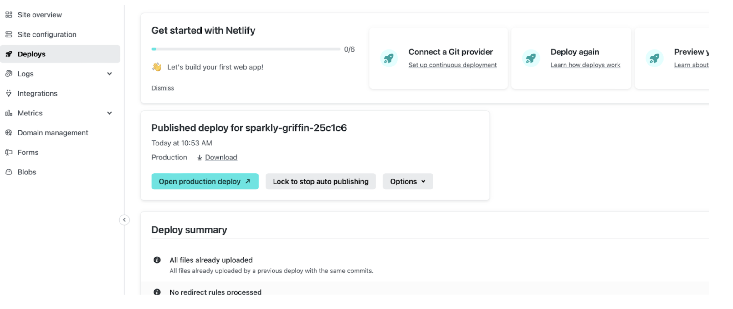
10) Go to the Site configuration tab and click on the link of your deployed website or app
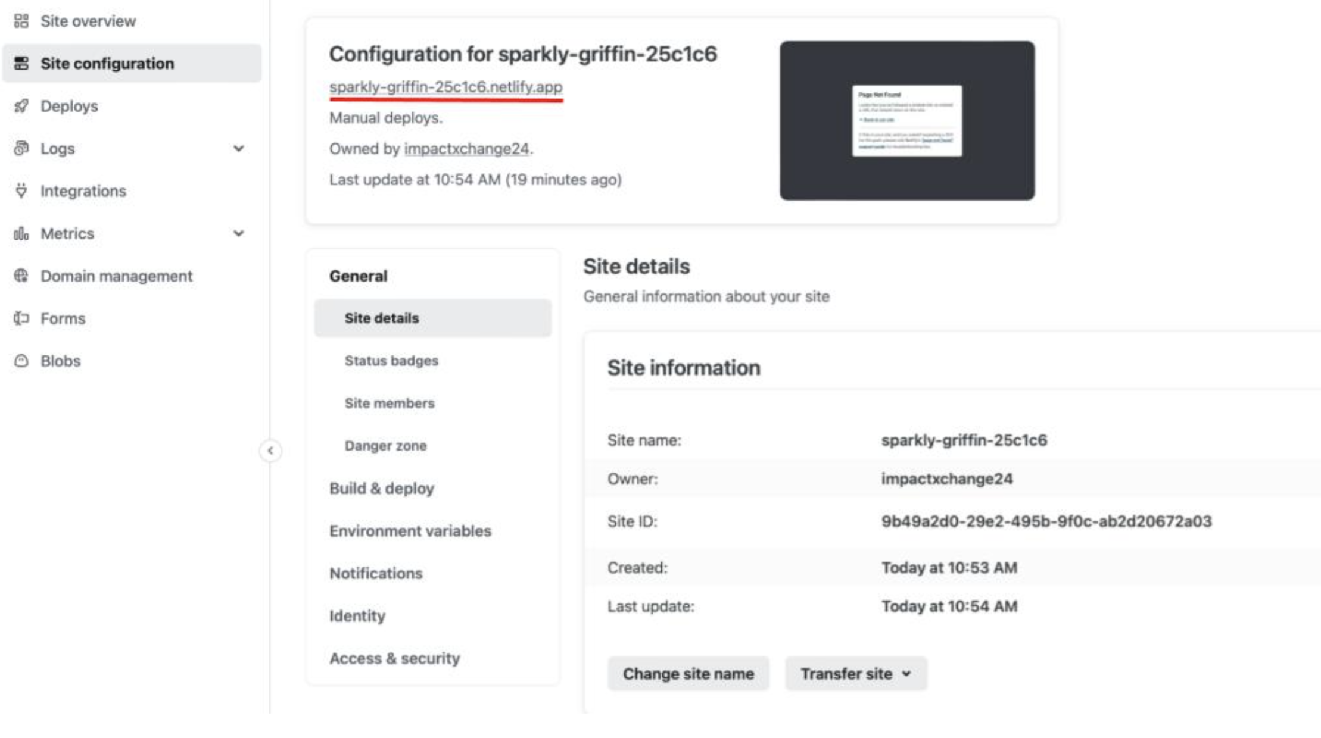
11) Enjoy using your newly deployed app
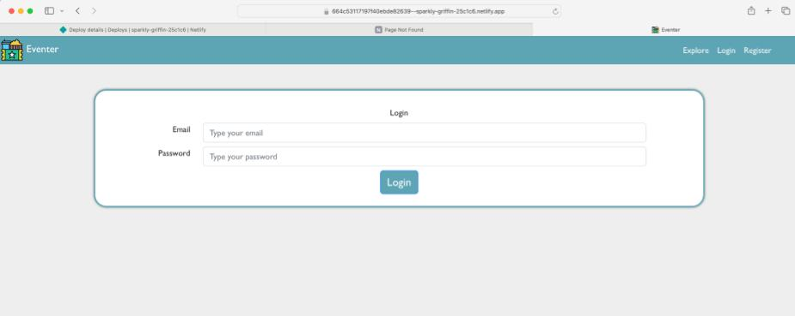
12) For further deployment and development go to Deploys tab and continue with manual drag and drop deployment of your project.
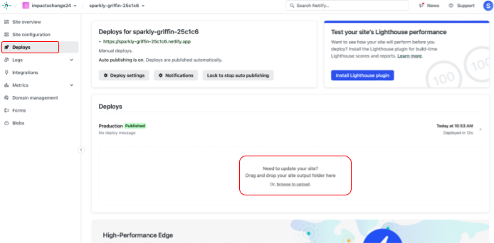
If GitHub is used:
Netlify tutorial page
Netlify tutorial video

