Tech requirements for the Hackathon participants
The ImpactXchange hackathon requires teams to consider both backend and frontend solutions. The backend is implemented in some cloud service and frontend consist of both mobile as well as web interface to the solution.
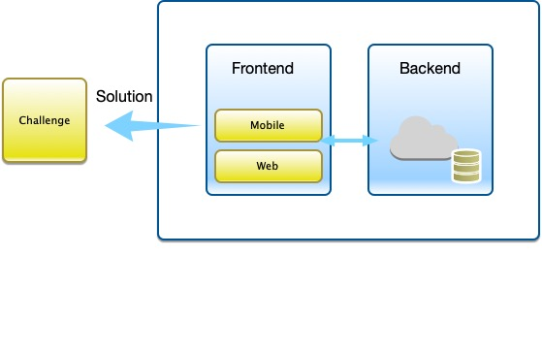 Technical requirements

