Comprehensive Guide to Setting Up the Backend of the Application


Objective
The backend is the backbone of the application, handling data processing, storage, authentication, and communication between the mobile and web apps. It should be designed in a manner such that it is scalable, secure, and efficient to handle potentially large volumes of data and user interactions. This guideline will assist in setting up, configuring, and understanding the technologies required for the backend portion of this hackathon.

Components of the Backend
Component | Description
API Service | Exposes endpoints for the mobile and web apps to interact with the backend.
Database | Stores user data, food waste records, recipes, tips, and other relevant information.
Authentication | Manages user registration, login, and authorization.
Data Processing | Handles business logic, data validation, and processing.
Cloud Provider | Ensures scalability, reliability, and provides additional services like serverless computing, storage, and security.

Technology Stack
The diagram below shows an overview of the cloud infrastructure. We will be using Google cloud and the two main services will be Google App Engine for deploying the web frontend and the API and Google Storage for handling data. Firebase will be used as the main database and GCS will be used for saving photos, pdfs, videos and other types of files.
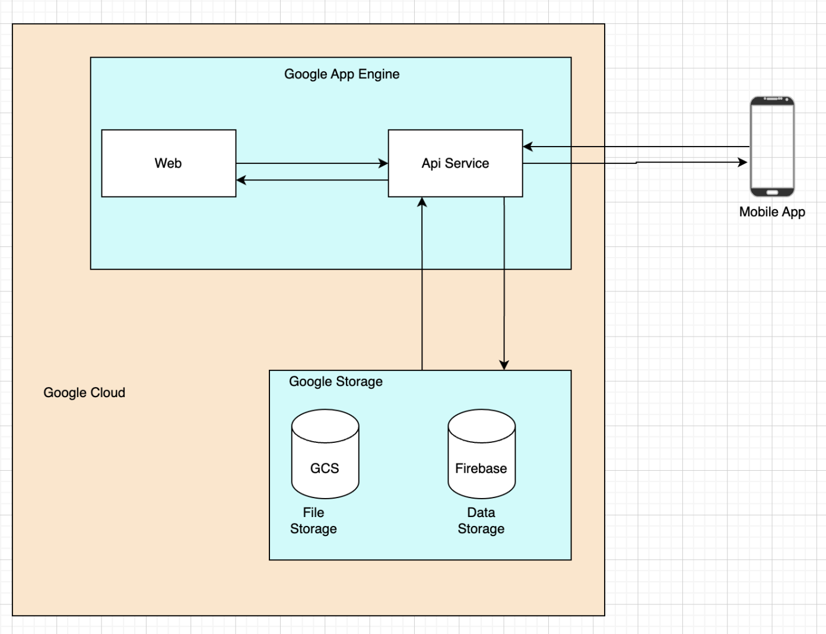

Cloud Provider (Google Cloud)
We will be using Google Cloud because it has excellent machine learning and data analytics services, competitive pricing and a slightly easier learning curve than AWS and AZURE for beginners.
Google also offers $300 USD credits to use on any of their services for newly created accounts. It has been verified with Google support that this offer will still be valid in August, in Malaysia.

API Frameworks
In the table below, we provide a list of popular frameworks that can be used to build the API service. You are free to use any framework of your choice however we recommend using express.js (node.js) for its simplicity, speed, and extensive middleware options. Our tutorial will be focused on express.js.
Framework | Description
Express.JS (Node.JS) | Lightweight, fast, large community, easy to get started
Django (Python) | Batteries included framework, built in admin panel, ORM
SpringBoot (Java) | Enterprise grade, robust ecosystem, strong security

Authentication
We will be using Firebase authentication. It is easy to implement and supports various authentication methods. The tutorial will show how to integrate Firebase Authentication into an Express.js backend.

Tutorial

Google Cloud Account Set Up
→ Sign in and set Up A Billing Account
Note: You have to link your bank card to the console for the purpose of setting up more parameters but you will NOT be charged anything for the free trial account.
- Go to the Google Cloud Console and sign in.
- Click on the Try For Free button in the middle of the page to set up your 300$ free credits account
- Select your country and click on Agree & Continue
- Set your Account Type to individual, add your name and address, input your bank card information, then click on Strat Free
- Click Continue on the window that appears to get prompted to a new identity verification tab.
- Verify your identity by entering the code received on your bank application along with the temporary charge of 1eu
Note: Don't click on the button Activate Full Account as this will change your free trial account into a normal account that gets charged for it's usage
→ Create a New Project
1. Go back to your main console page
2. Click on the box appearing at the left of the search bar
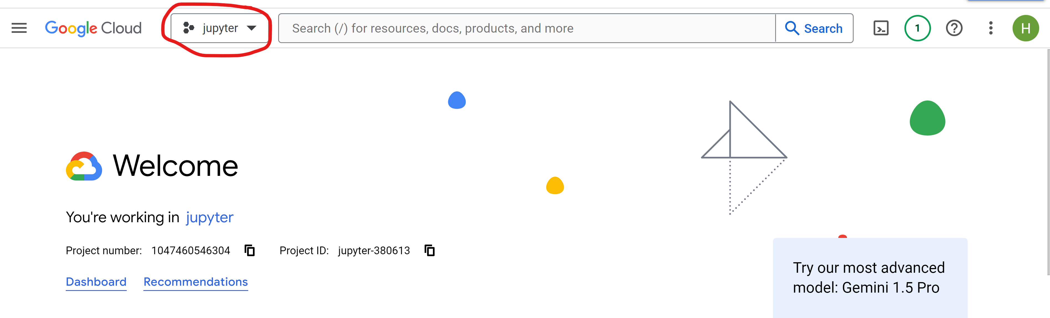
3. Click on “Select a project” at the top right and then click on “New Project”.
4. Choose a unique project name and select the desired organization if applicable.
5. Once the project is created, go to the notification icon and select the project you have just created
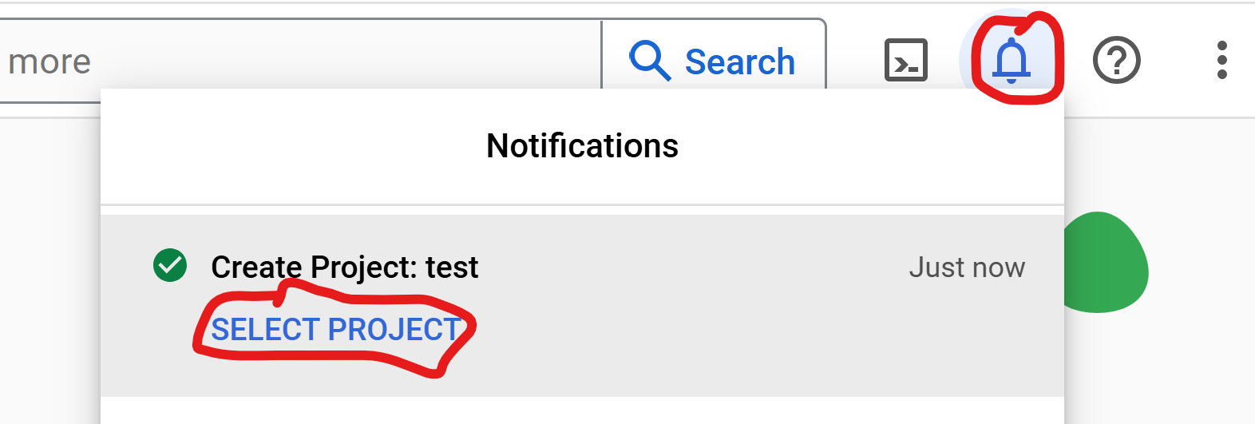
6. Note down the Project ID that appears in the middle of the screen for future reference.
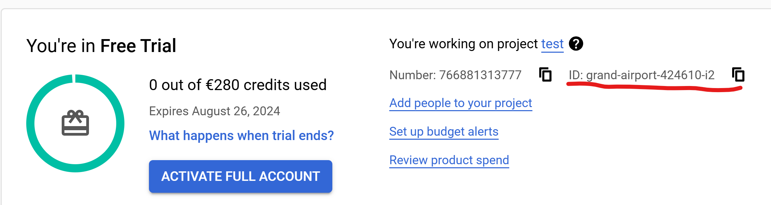
→ Enable Required APIs
- Go to the search bar at the top of the screen and navigate to Library APIs & Services. (Note: If the page fails to load, clear your browser's cache and cookies, try a different browser, or check if you have some enabled extensions interfering)
- Search for Cloud Storage API and enable the Cloud Storage by Google Enterprise API.
- Go back to the API library, search for App Engine Admin API, and enable the App Engine Admin API by Google Enterprise API.
→ Set Up Cloud Storage
- Click on Google Cloud at the top left of the page to go back to the main page of your project, go to the search bar again and navigate to Cloud Storage.
- Click on + Create to make a new bucket.
- Choose a unique name and select the desired region.
- Leave other settings as default and create the bucket.

Create an API Service
→ Install Node JS
We recommend using NVM (Node Version Manager). It makes it easy for managing multiple Node.js versions on the same machine. It works across macOS, Linux, and Windows (with nvm-windows).
- Mac and Linux
curl -o- https://raw.githubusercontent.com/nvm-sh/nvm/v0.39.1/install.sh | bash
source ~/.nvm/nvm.sh
nvm install node
- Windows
- Download ‘nvm-setup.zip’ from the nvm-windows releases page.
- Extract the contents and run the nvm-setup.exe installer.
- Open your Command Prompt and install Node.js:
nvm install latest
nvm use latest
- Verify the Installation (for all machine types)
node -v
npm -v
→ Create Express.js NodeJS Backend
- Initialize a new nodejs project
Create a folder for your project - for this tutorial we will call it waste-backend and initialize a new node application.
mkdir waste-backend
cd waste-backend
npm init -y
- Install Initial Dependencies
Install the basic dependencies to get started with your node js project
npm install express axios cors body-parser
- Express.js, or simply Express, is a back end web application framework for building RESTful APIs with Node.js
- Axios is a node js client that helps you make http requests. You will be using this to send information to and from the frontend
- Cors is It is used to enable cross-origin requests in web applications. This is essential for APIs that are accessed from a different domain than the one serving the client application.
- Body Parser It is used to parse JSON, raw, text, and URL-encoded form data submitted in HTTP requests. This is essential for handling form submissions and JSON payloads in your APIs.
→ Install GCP CLI
- Make sure that you are in the root directoryyour Node app in the terminal, if not, run 'cd *name of your root directory*'.
- Install the Google Cloud SDK following the instructions at Google Cloud SDK Installation Guide. (Note:When asked if you want to log in, input yes and log in to the google cloud account you are using)
- Go back to your Command Prompt and enter the numeric choice associated with your project
→ Set-Up Service Account
- Go back to your cloud console through Google Cloud Console.
- Navigate through the search bar to Service Accounts IAM & Admin.
- Click on Create Service Account.
- Provide an appropriate name and description for the service account. For instance, use github-ci-cd as it will be utilized for Github CI/CD.
- Click Continue on the 2nd step without needing to modify any default information
- Click on Done
- Scroll down to the service accounts available, click on the three dots of the one you just created and select Manage keys.
- Scroll, Click Add Key → Create New Key.
- Choose the JSON key type and securely download it. Remember, this key grants access to Google Cloud resources, so keep it safely saved.

Version Control
→ Using GitHub
- Create a Github account or use an existing one.
- Create a new repository, leave all the selected parameters at default
- Initialize Git in API Service
- Go to your Command Pronpmt an run 'git init'
- Go back to your created Github Repository, scroll down to …or push an existing repository from the command line, and copy the code displayed in your Command Prompt

Integrating Firebase Authentication WIth Our API Service
→ Install Firebase Admin SDK
Install the firebase-admin plugin from npm in your Command Prompt
npm install firebase-admin
→ Initialize Firebase Admin SDK
In Visual Studio, open the folder you have been working on (In this example it is Waste-Backend), create a file named auth.js in your project’s root directory and enter the code below:
const admin = require('firebase-admin');
const serviceAccount = require('./path/to/serviceAccountKey.json');
admin.initializeApp({
credential: admin.credential.cert(serviceAccount),
});
async function verifyToken(token) {
try {
const decodedToken = await admin.auth().verifyIdToken(token);
return decodedToken;
} catch (error) {
throw new Error('Authentication failed');
}
}
module.exports = { verifyToken };
→ Creating Express.js Server with Authentication Endpoints
Create a file named index.js in your projects root directory and enter the code below:
const express = require('express');
const { verifyToken } = require('./auth');
const admin = require('firebase-admin');
const app = express();
const PORT = process.env.PORT || 3000;
app.use(express.json());
// Endpoint for user registration
app.post('/register', async (req, res) => {
const { email, password } = req.body;
try {
const user = await admin.auth().createUser({
email,
password,
});
res.status(201).send(user);
} catch (error) {
res.status(400).send(error.message);
}
});
// Endpoint for user login (generates custom token)
app.post('/login', async (req, res) => {
const { email, password } = req.body;
try {
const user = await admin.auth().getUserByEmail(email);
// Normally, you would verify the password here
// Since Firebase Admin SDK does not handle password verification, this is just for demonstration
const token = await admin.auth().createCustomToken(user.uid);
res.status(200).send({ token });
} catch (error) {
res.status(400).send(error.message);
}
});
// Middleware to protect routes
app.use(async (req, res, next) => {
const token = req.headers.authorization?.split(' ')[1];
if (token) {
try {
req.user = await verifyToken(token);
next();
} catch (error) {
res.status(401).send('Unauthorized');
}
} else {
res.status(401).send('Unauthorized');
}
});
// Protected route example
app.get('/profile', (req, res) => {
res.send(`Hello ${req.user.email}`);
});
app.listen(PORT, () => {
console.log(`Server is running on port ${PORT}`);
});
This will allow you to create endpoints that can be used by the frontend to send or access data. The following URLs can be used to access the different endpoints.
Note: Additional resources on how to use firebase authentication with your backend and frontend can be found in the Additional Resources section.

Deploying API Service to Google Cloud
→ Create app.yaml
To deploy the app we need to create a configuration file in our project's root directory. This file has to be a yaml file as per Google’s recommendation. For the purpose of this tutorial we will create a file called app.yaml in our root directory and add the settings and routing for Google App Engine.
- The app.yaml file configures settings and routing for Google App Engine applications.
- Keep the app.yaml in your project's root directory alongside your source code.
# [START app_yaml]
runtime: nodejs20
entrypoint: node index.js
# [END app_yaml]
Notes:
- runtime: Specifies the runtime environment (e.g., nodejs20)
- service: Defines the service name, typically a project-specific prefix or subdomain.
- entrypoint: By default App Engine expects server.js as the entry point but if your app uses anything else then you specify that here.
→ Deploy your App Locally
- Close your command prompt and open it again
- Run 'gcloud to make sure that everything is connected
- Navigate to your project folder 'cd waste-backend'
- Run the command 'gcloud init'
- Select '1' to re-initialize the configuration [default] with new settings
- Select the email account that you are using in your Cloud Console to perform operations for this configuration
- Pick the number allocated to your project
- Deploy your Node app by executing the command in root directory of your project
gcloud app deploy
5. Choose a region where you want your App Engine Application to be located

Additional Resources
Title | Link
How to deploy Node JS to Google Cloud | https://dev.to/rushi-patel/deploy-node-js-project-to-google-app-engine-with-github-actions-cicd-a-complete-guide-3od9
Google Cloud tutorial | Cloud Computing, Hosting Services, and APIs | Google Cloud
Python FastAPI tutorial | https://realpython.com/fastapi-python-web-apis/
Integrating cloud SQL into your Node JS app | GitHub - GoogleCloudPlatform/cloud-sql-nodejs-connector: A JavaScript library for connecting securely to your Cloud SQL instances
Getting started with NodeJS, Google Cloud, Firebase and Cloud Storage | https://cloud.google.com/nodejs/getting-started

Partners
- Lappeenranta-Lahti University of Technology
- Sunway University
- Turku University

