EcoGrader
Provides very comprehensive detailed results with suggestions on how to improve the website’s carbon emissions
Benefit: Very good and comprehensive suggestions on how to improve
Pricing: Free
Results look like this:
Shows results split in three different dimensions / criteria:
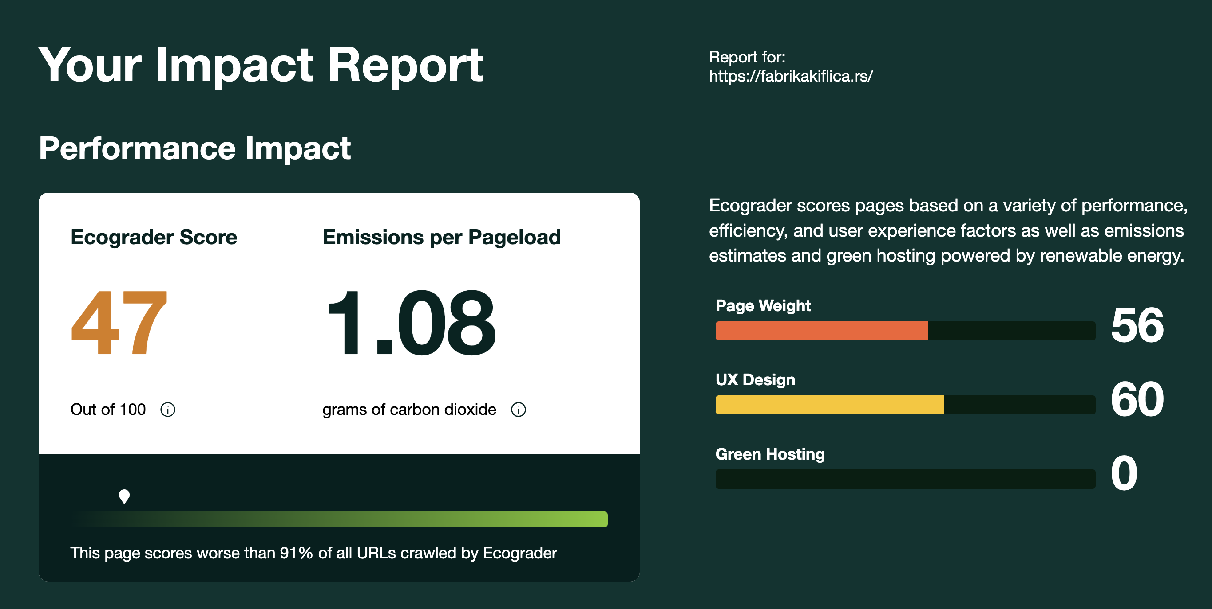
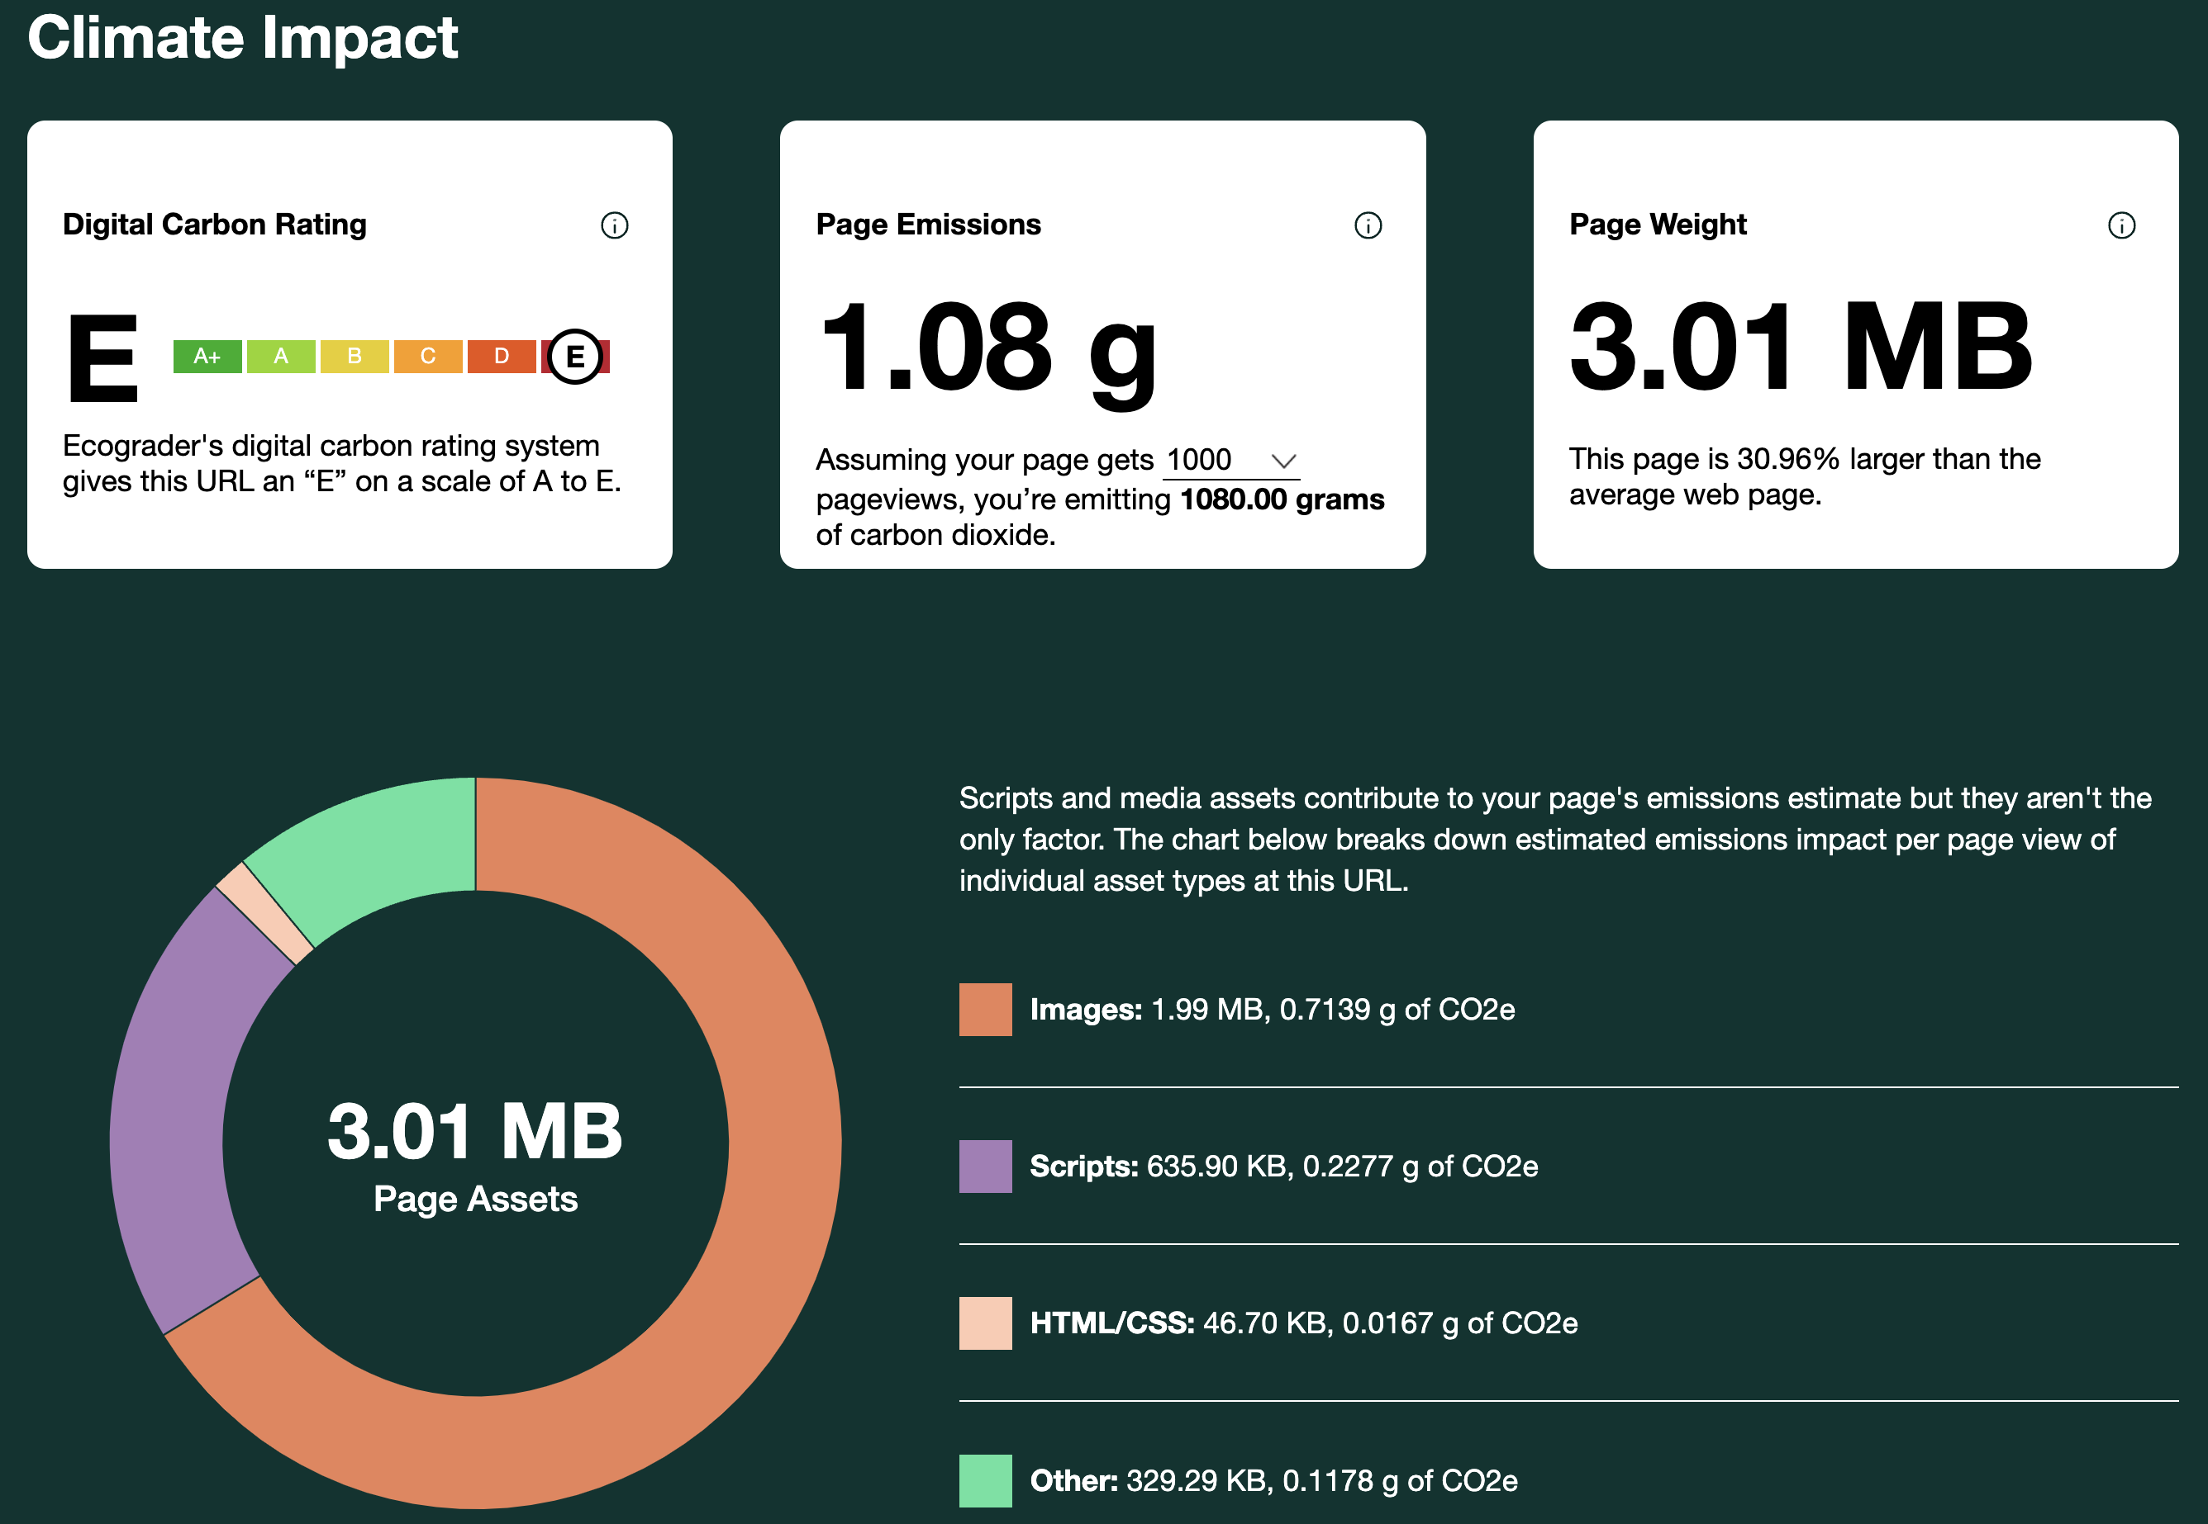
Very extensive analysis, and multiple different sub-categories with explanations and suggestions on how to improve your website's performance and emissions.
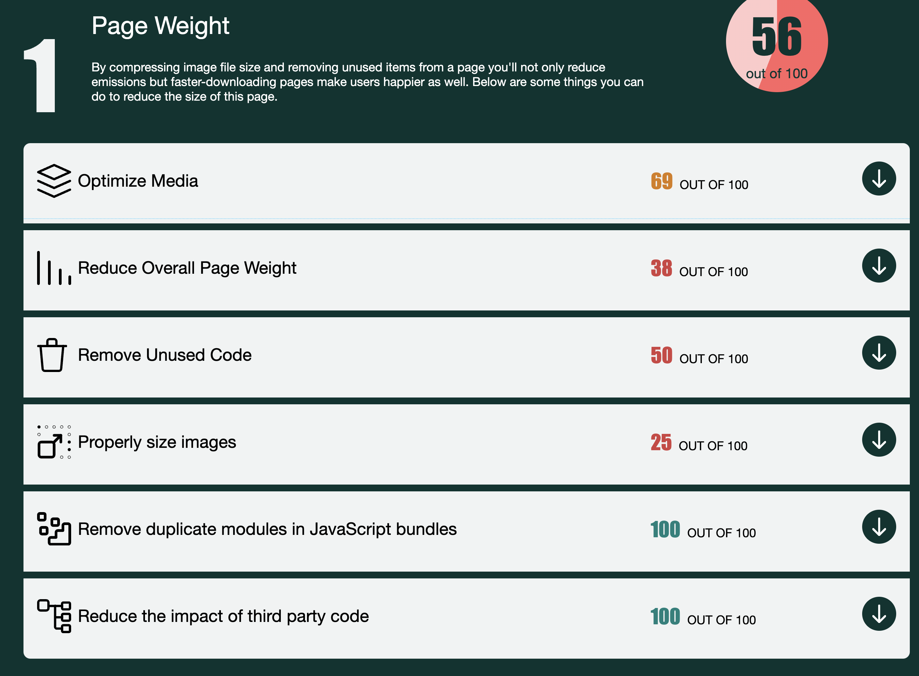
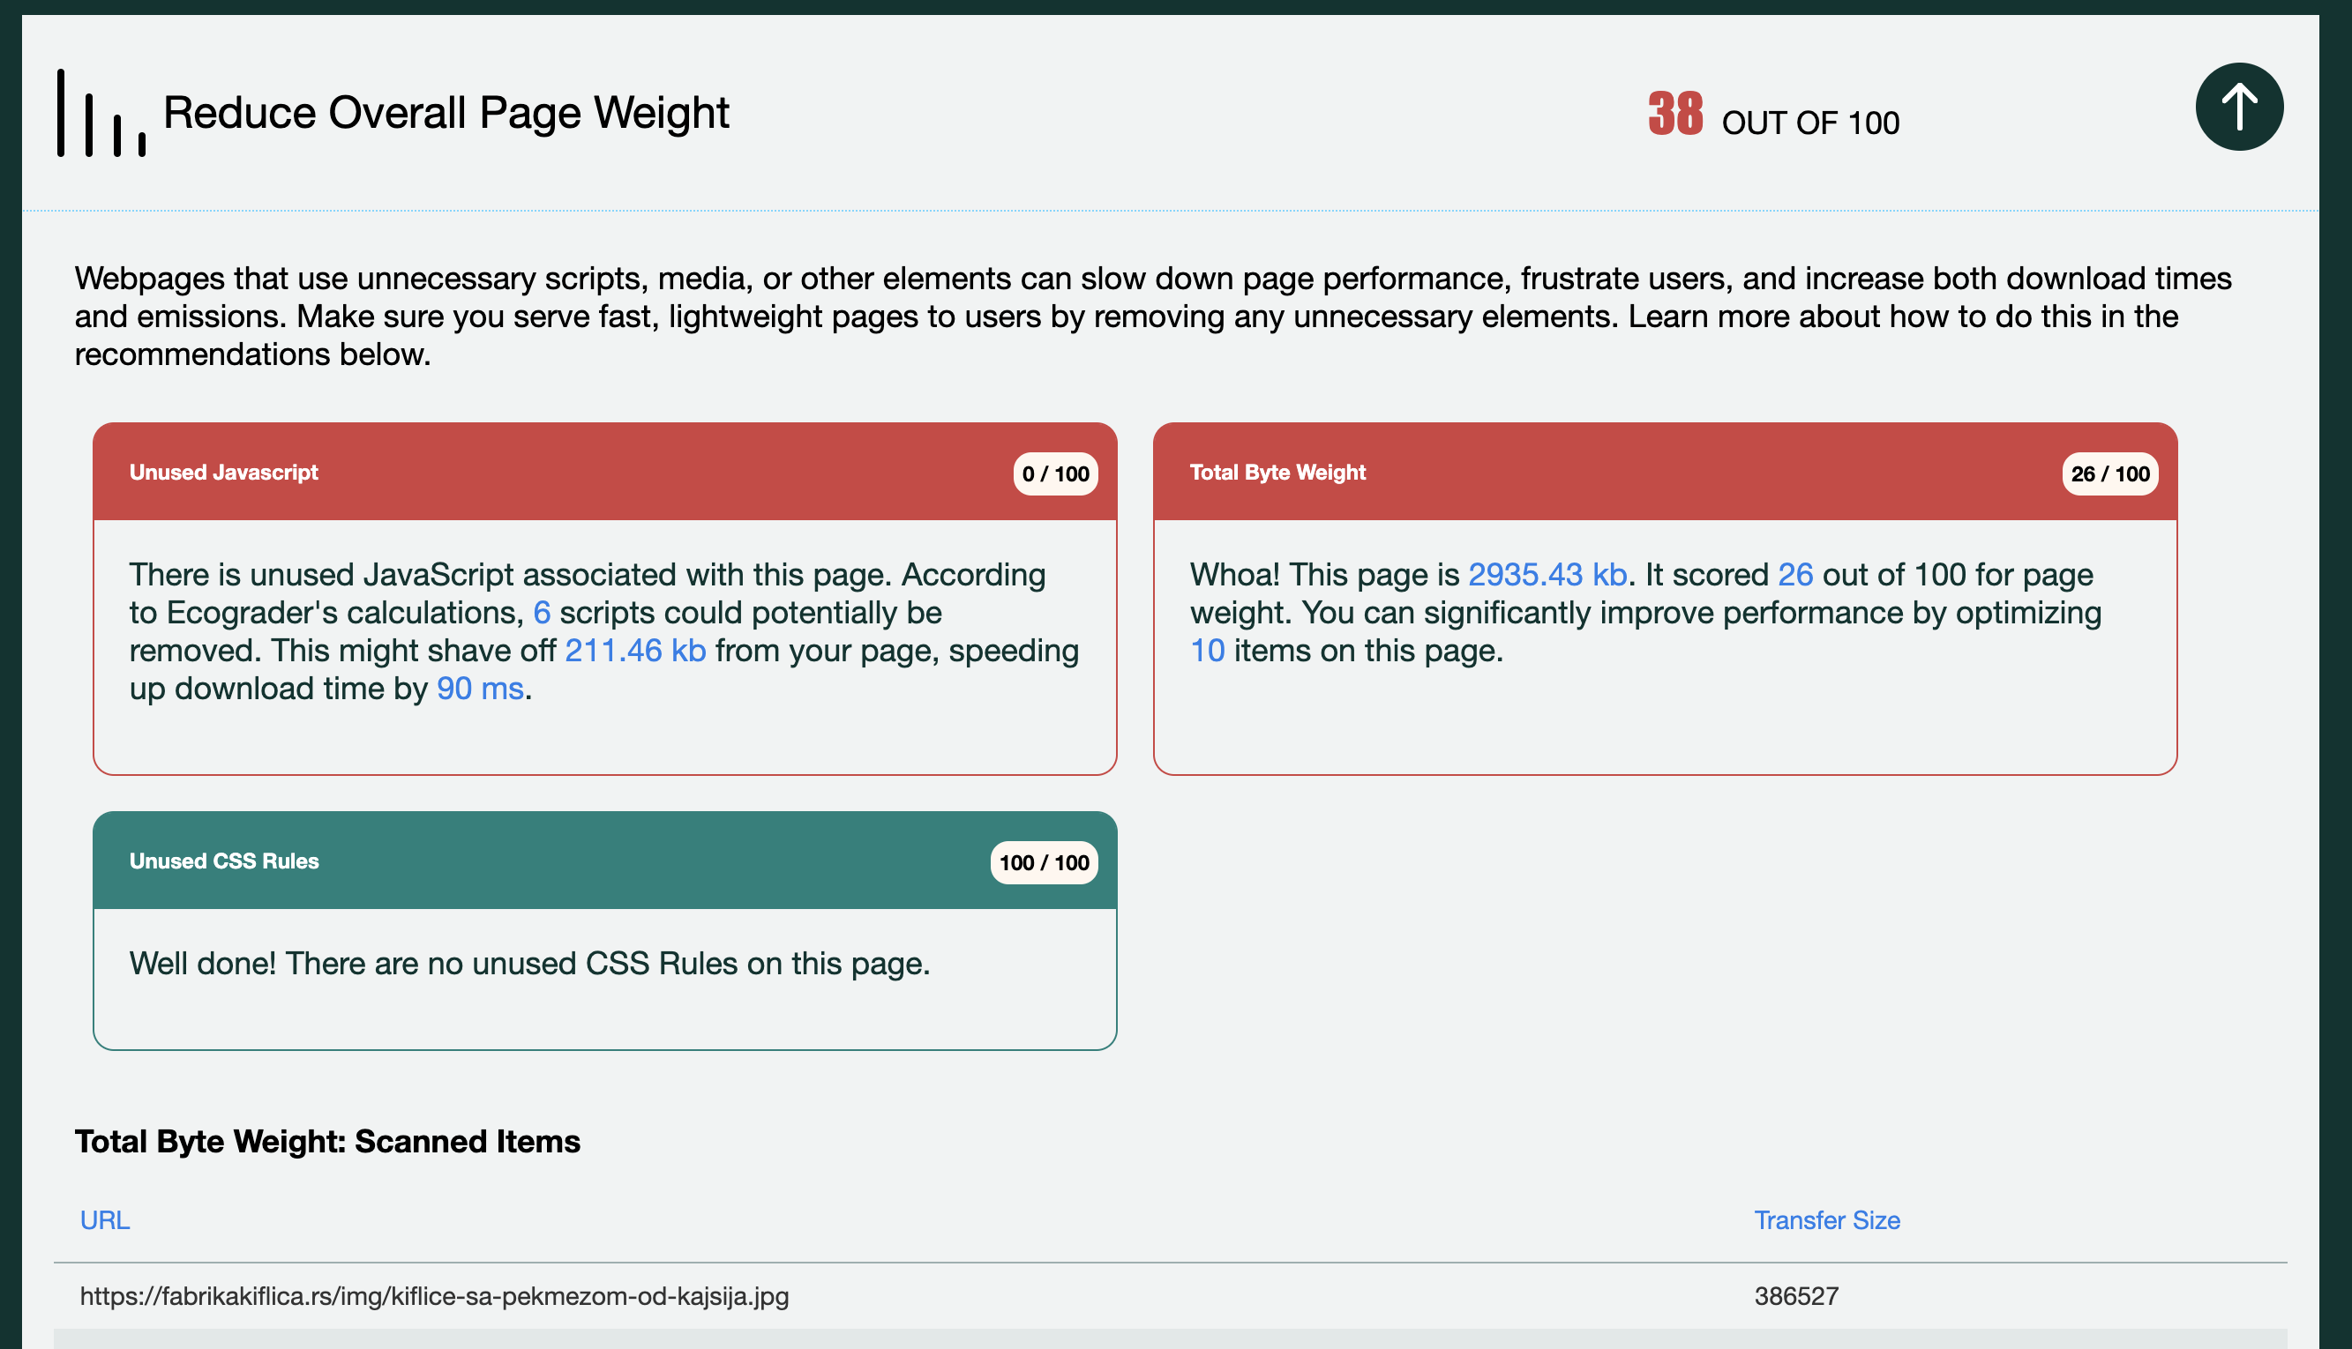
Besides environmental impact (emissions) it also analyses the societal dimension of sustainability. EcoGrader analyses the accessibility and how well the UX design was implemented.
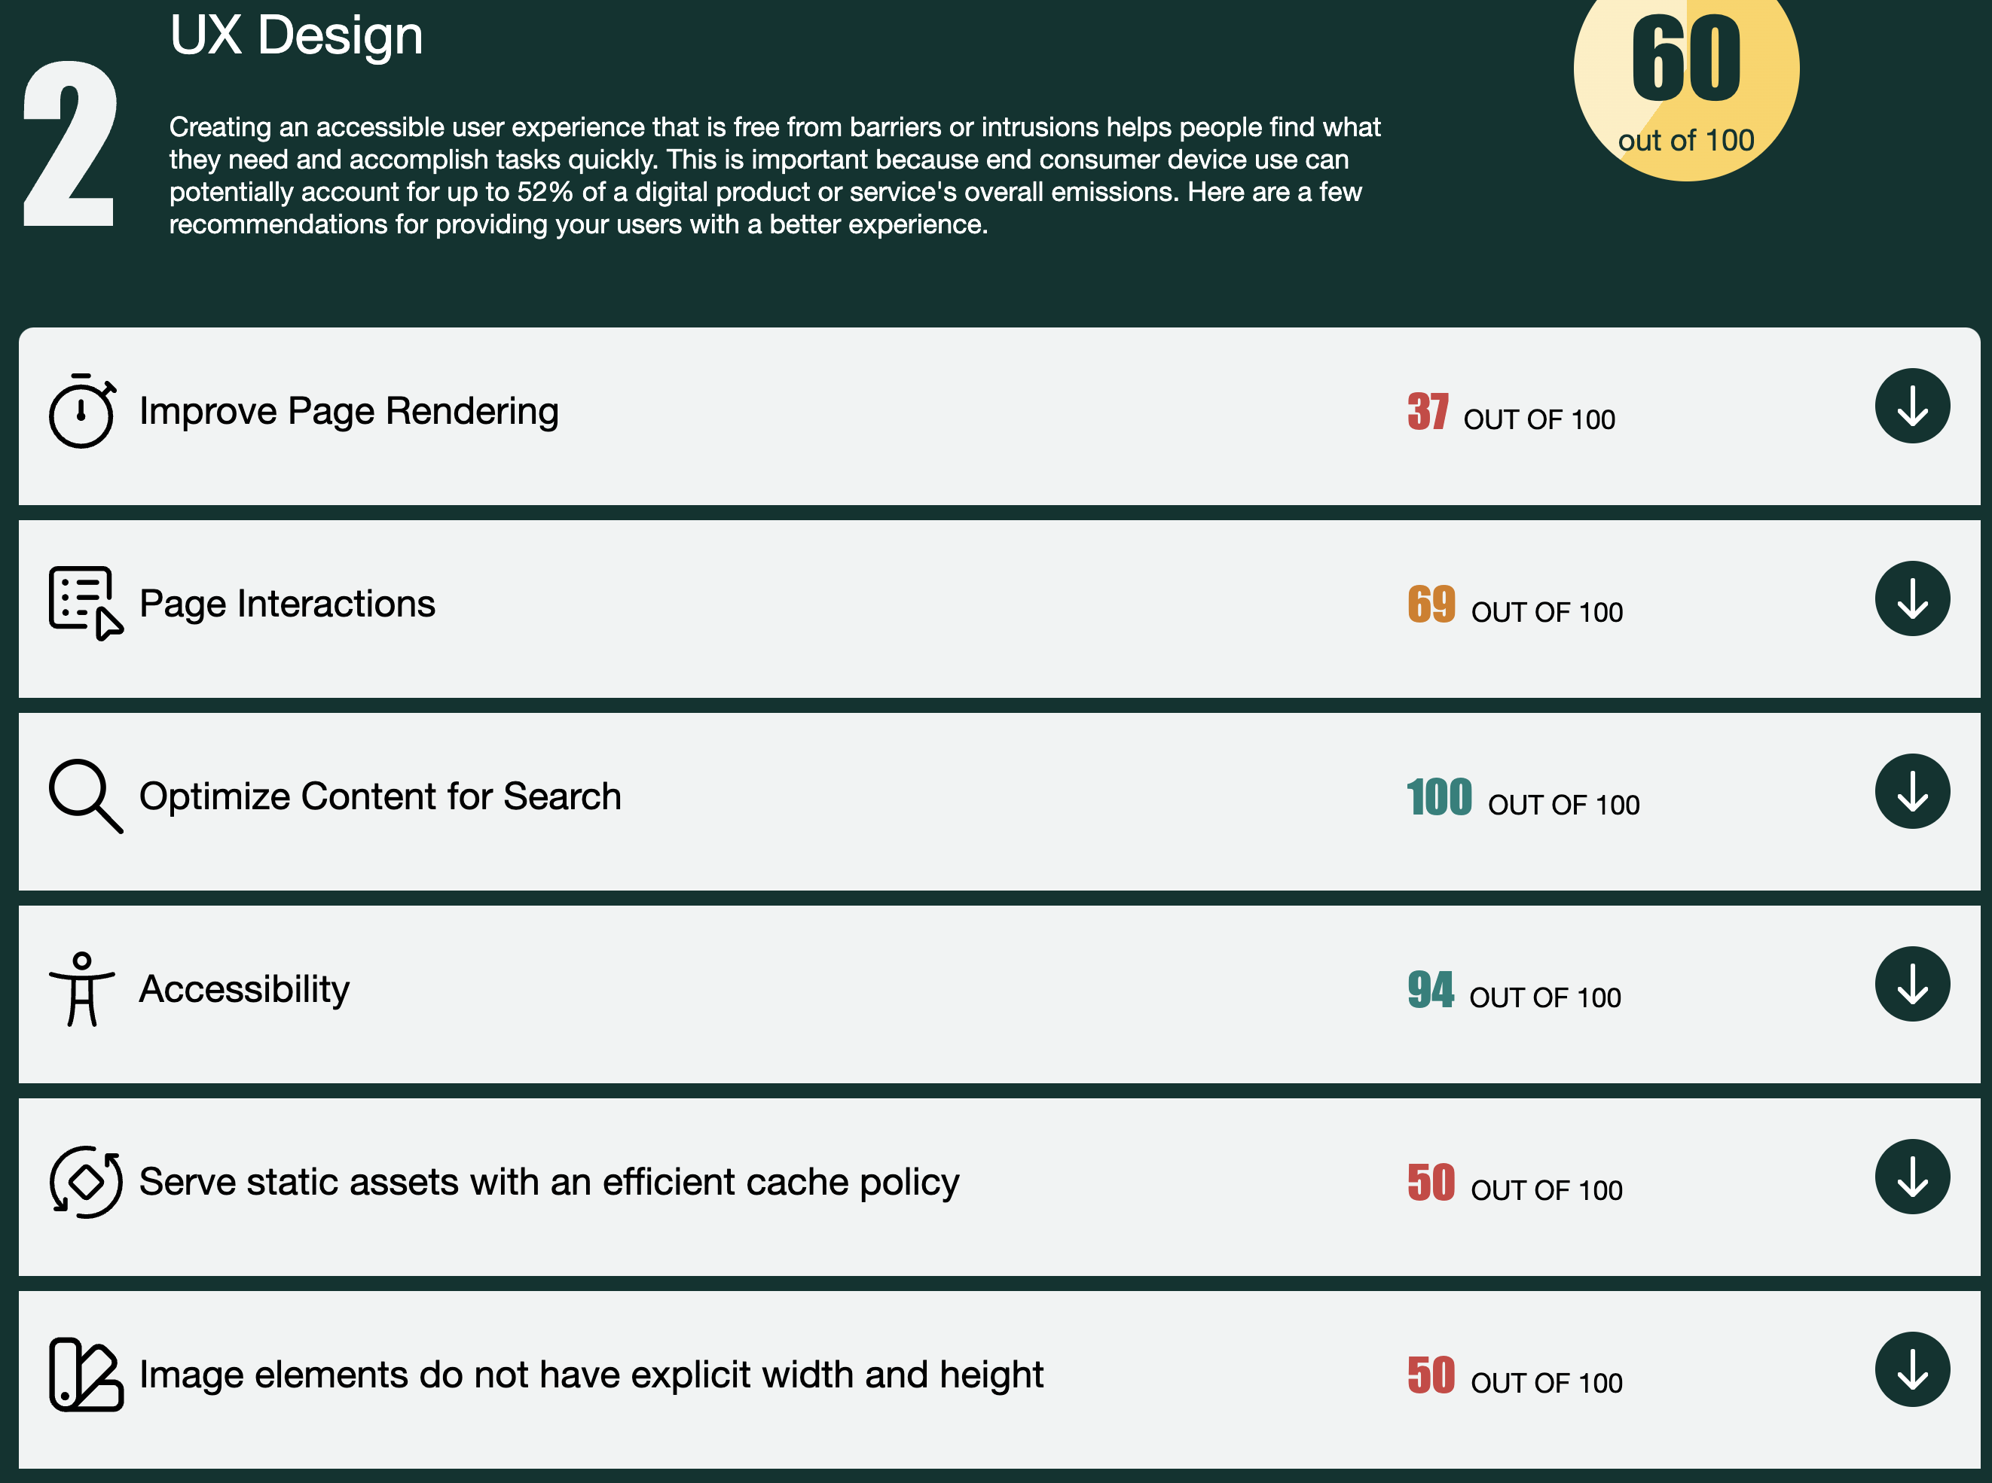
It even checks how green is the hosting option on which the website is running.


