What is Globemallow?
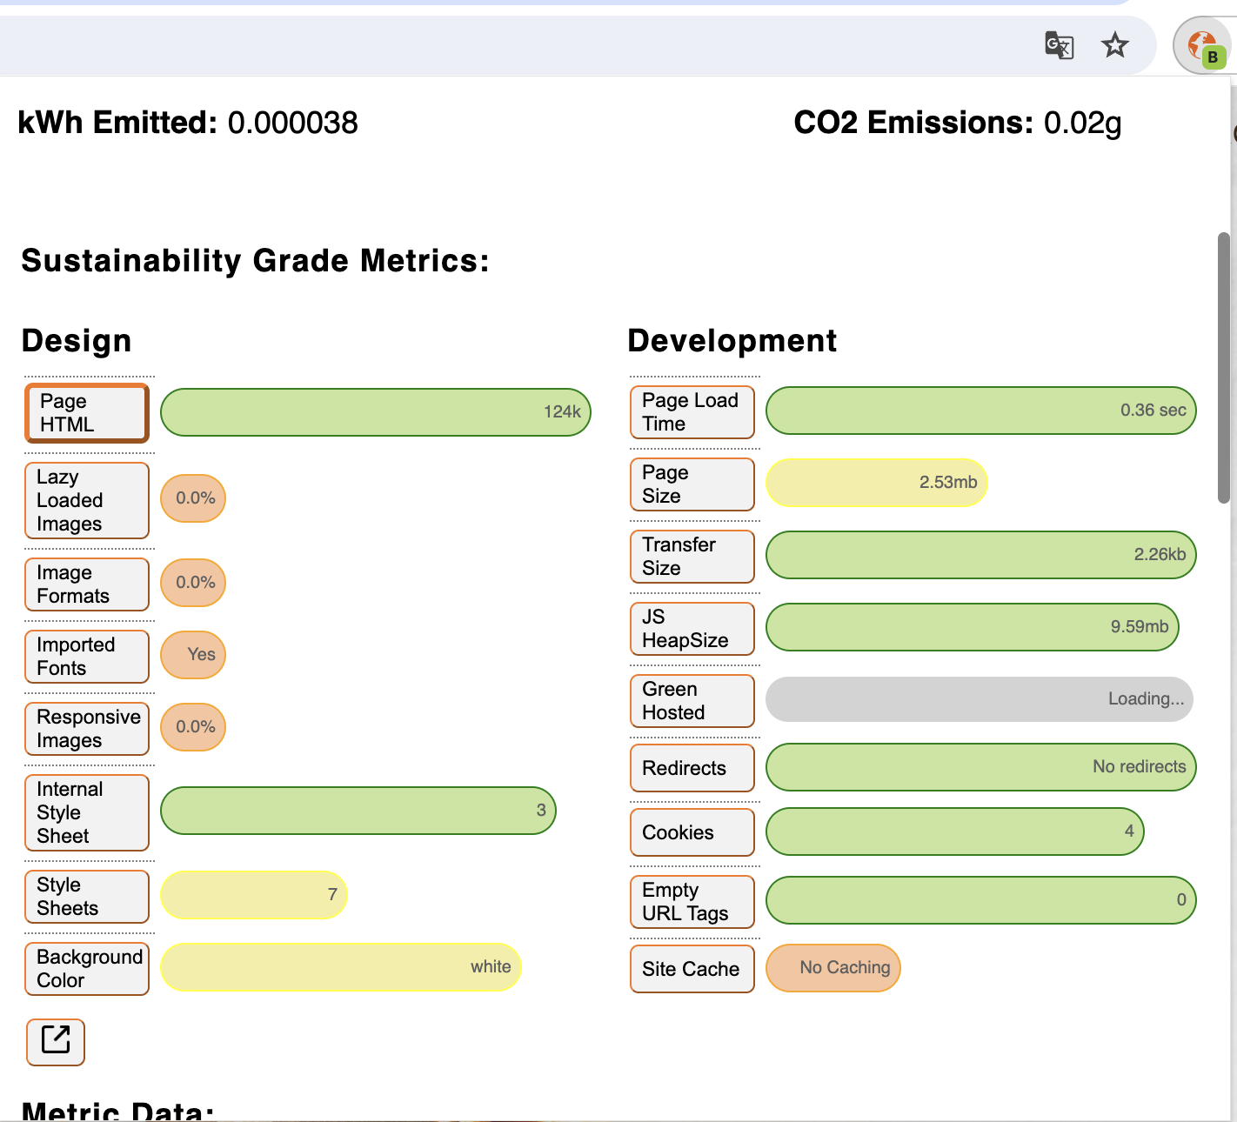
Globemallow is a browser extension that produces detailed sustainability reports on the energy consumption and estimated carbon output of any webpage.

How is Web Sustainability Measured?
- Energy Consumption: The primary factor is the electricity consumption of bytes transferred.
- CO2 Emissions: Energy consumption data is used to estimate the carbon footprint of the website.

Why Use Globemallow?
- Extension Format: View reports directly on the page without opening a new tab or window.
- Detailed Reports: Break down elements of the page contributing to power consumption and the overall digital footprint.
- Sustainability Grade: Each site tested receives a grade to quickly see its overall digital footprint.
- Suggested Improvements: Recommendations are provided for each element, highlighting where sites excel or fall short.

How the Sustainability Grade is Calculated:
- Page Weight: Total size of the page uploaded to the server.
- Background Color: Darker backgrounds consume less energy.
- Image Format and Size: Some formats are more energy-intensive than others.
- Green Hosting: Hosting that uses renewable energy sources scores higher.
- Redirects: Redirects consume unnecessary energy.

