Green Algorithms
Green Algorithms - https://www.green-algorithms.org
Green Algorithms is a tool that developers can use to better understand the sustainability related impacts the algorithms they develop have.
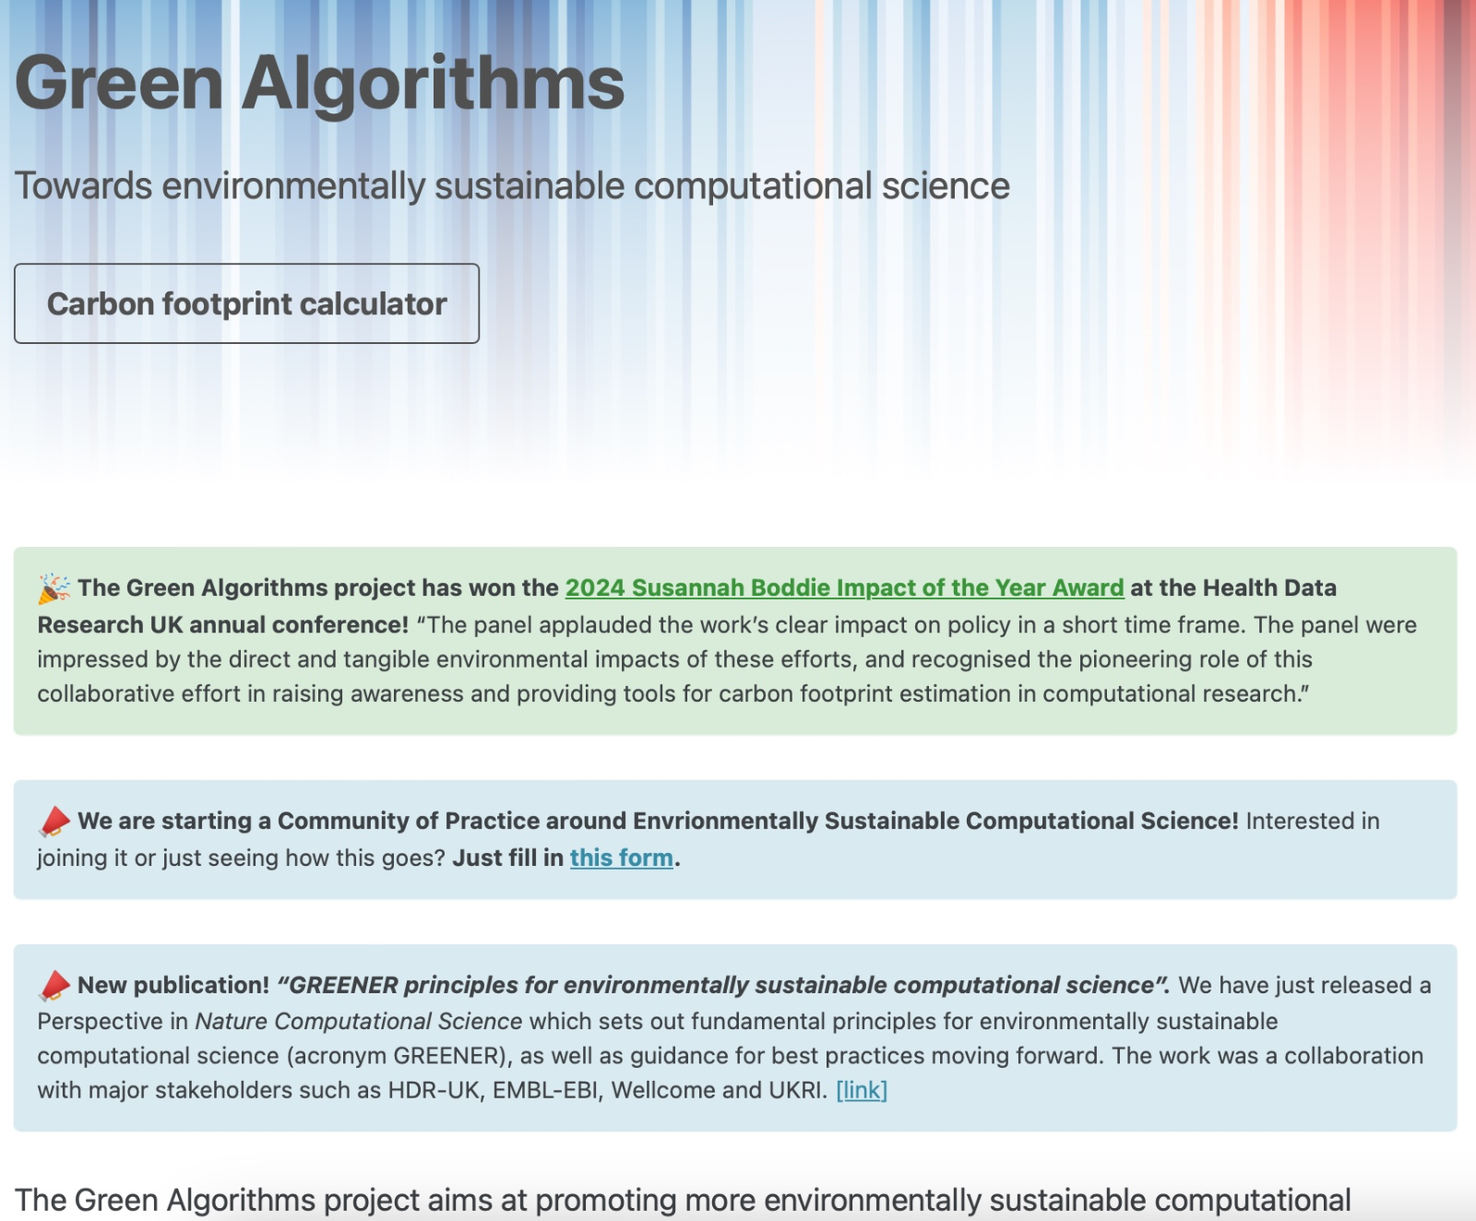
Green Algorithms Calculator - http://calculator.green-algorithms.org
Along with guidelines on how to design algorithms such that the carbon footprint is limited, it also provides a calculator that individuals can use to learn more about the impacts of their specific algorithm (show below)
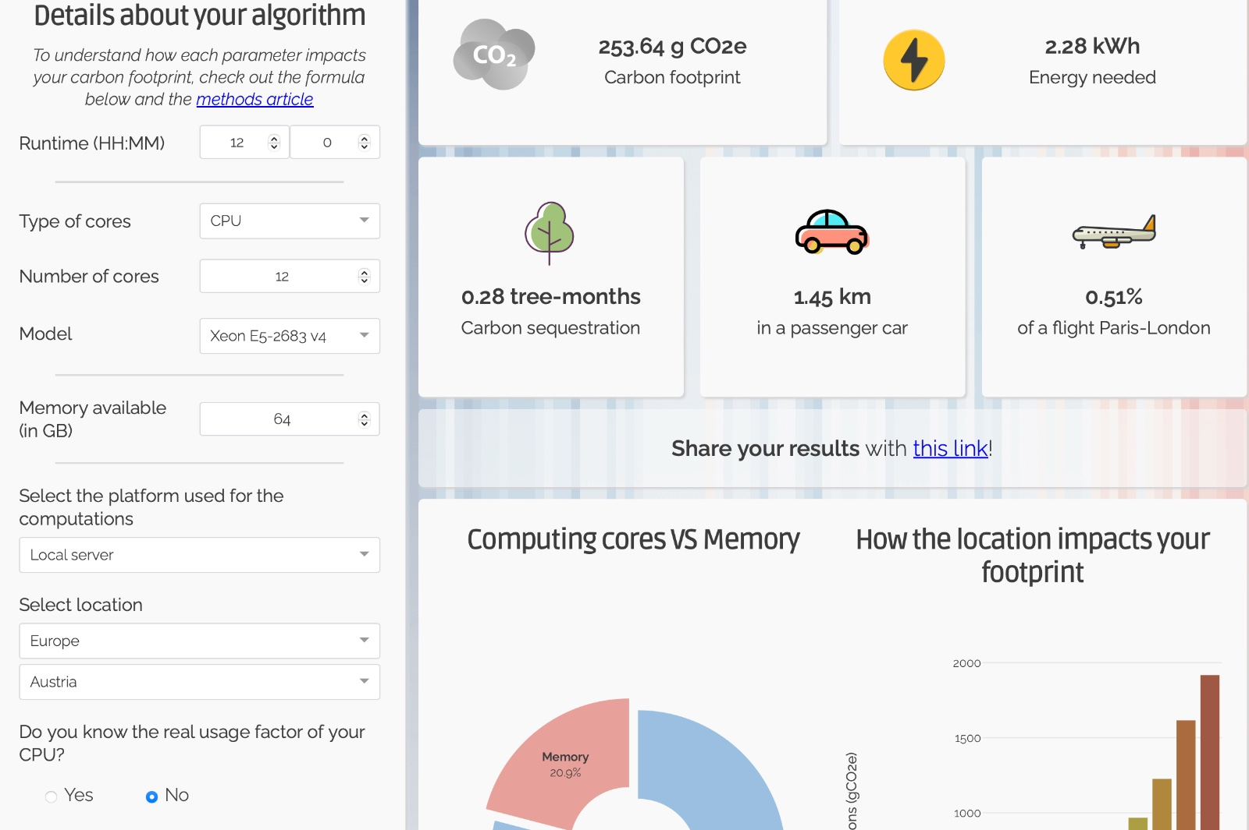
This can be customized as needed, even as far as defining the country the algorithm will be used in, and the specifics of the machine it is running on.

