Green Measuring tools for Backend Support
> KPI | > Metric | > Tools | > Sustainability Dimension
 |  |  | > Env | > Eco | > Soc | > Ind | > Tech
> Energy Efficiency | > Energy per user/transaction | > Google Cloud Monitoring | > X | > X |  |  | > X
 |  | > DataDog | > X
 |  | > CO2.js | > X | > X |  | > X | > X
> Carbon Footprint | > Carbon per user/transaction | > CO2.js | > X | > X |  | > X | > X
 |  | > Google Cloud Footprint | > X | > X |  |  | > X
 |  | > Code Carbon (only for python) | > X | > X |  | > X | > X
> Resource Utilization | > CPU usage Memory Usage | > Containerization | > X | > X |  | > X | > X
 |  | > DataDog | > X | > X |  | > X | > X
> Green Hosting | > % of servers hosted on renewable energy | > Google Cloud | > X | > X | > X | > X | > X
Google Cloud Monitoring: A tool used to provide insight regarding how resources are used, as well as well as data related to the performance and status of the application
Datadog: A tool that can be used with Google Cloud Monitoring for further insight regarding the cloud infrastructure, service(s), and application(s).
- Comprehensive Monitoring
- Automated Alerts and Responses
- Dashboards
Google Carbon Footprint: Measure, report, and reduce your cloud carbon emissions.
- Dual-reporting of both location-based and market-based emissions
- In-console dashboard
- Exports to BigQuery
- Location-based emission reduction estimates
→ Carbon Footprint data is integrated with unattended project recommender, which provides you with estimates of the location-based emission reductions you could achieve by removing idle projects.
Containerization: Containerization promotes sustainability by enhancing resource utilization, reducing energy consumption, optimizing infrastructure management, and ensuring efficient application deployment.

Demonstration

CO2.js
CO2.js is a JavaScript library that allows developers to estimate the emissions associated with their apps, websites and software.
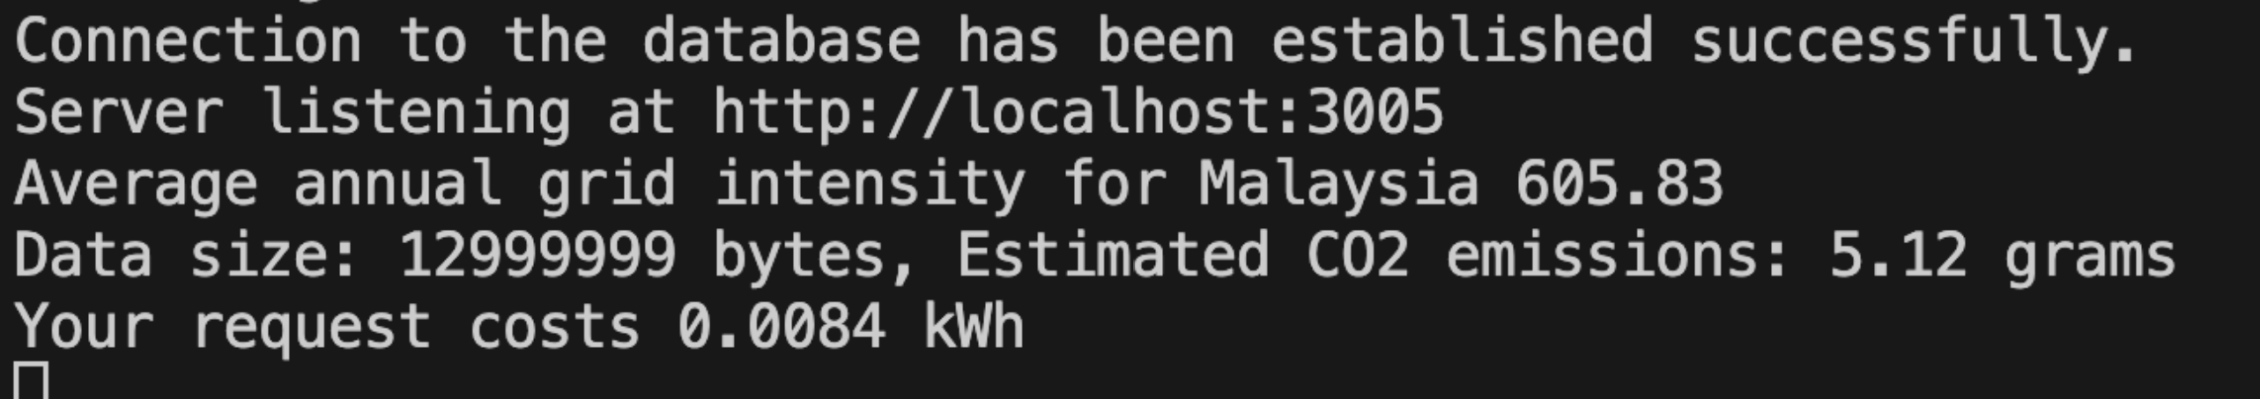

Why Google Cloud for Green Hosting?
- Google was the first major company to become carbon neutral in 2007 🎖
- Google was the first to match their energy use with 100 percent renewable energy in 2017 – including the electricity to power Google Cloud. 🥇
- Provides a useful Carbon sense suite of tools to reduce the carbon footprint of cloud-based applications:
→Google Cloud Region Picker: helps you pick a Google Cloud region considering approximated carbon footprint, price and latency.
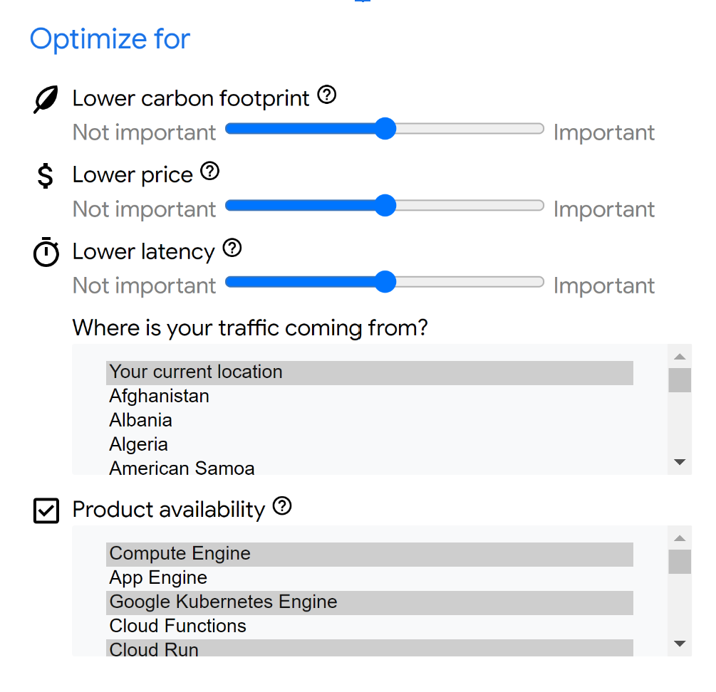
→Low carbon regional signals: Helps you pick the greenest region for your Google Cloud resources.
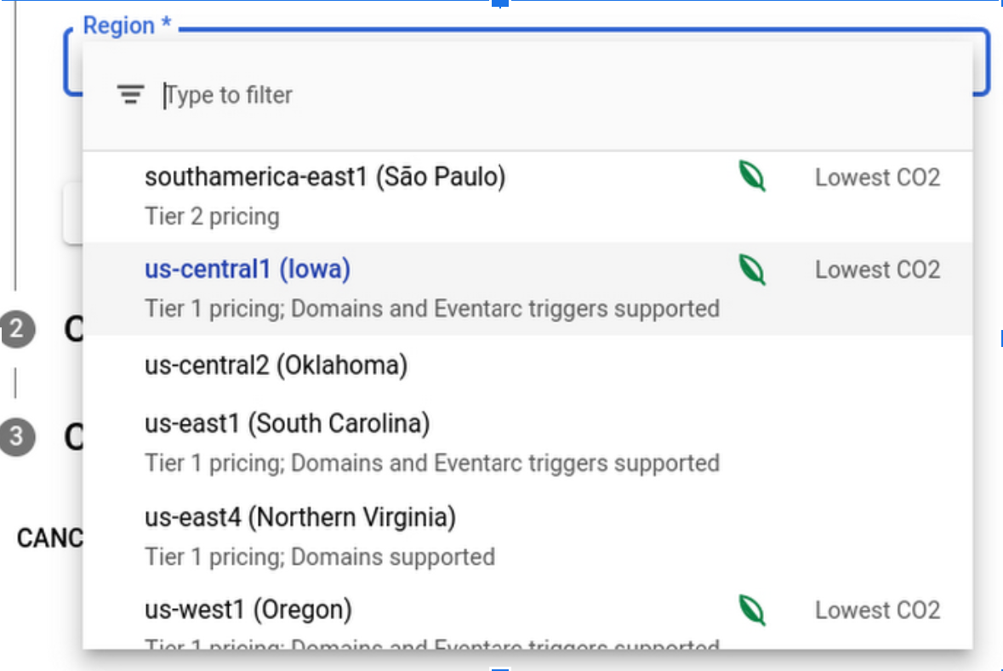
→Active Assist recommendations: a portfolio of tools to generate recommendations and insights to help you optimize your Google Cloud projects. This also includes recommenders that generate recommendations, insights and analysis tools. Those recommendations will help you save up on costs, mitigate security risks, maximize your performance through reducing the management your cloud configuration and this will overall make you more sustainable and reduce your carbon footprint.
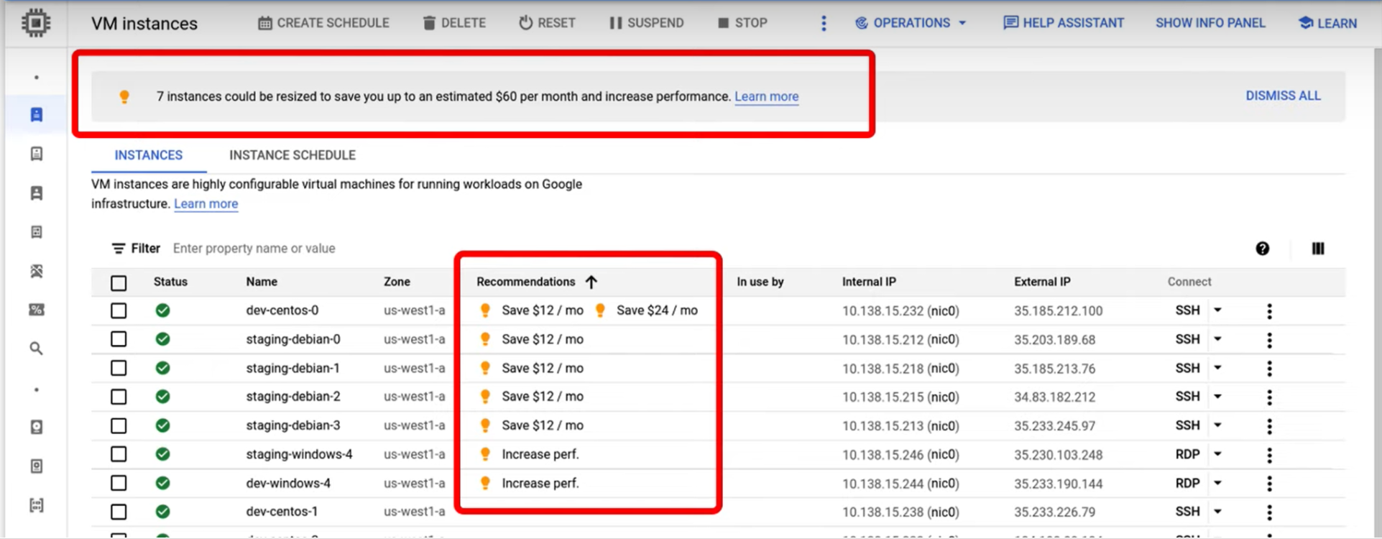
→Google Cloud Carbon Footprint: this tool helps you Measure, report, and reduce your cloud carbon emissions. And the key feature here would be the Inclusion of both location-based and market-based carbon emissions data in reports and disclosures which offers more transparency and comprehensive insights for varying use cases.
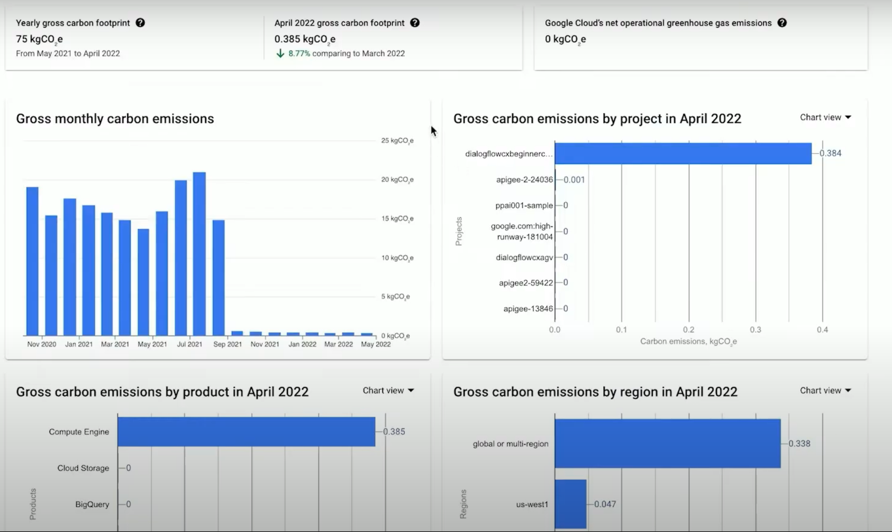
→Google Workspace Carbon Footprint: mostly for admin use on an organizational level. It can be used to understand the environmental impact of your organization’s use of Google Workspace products and know the total and monthly carbon footprint results.
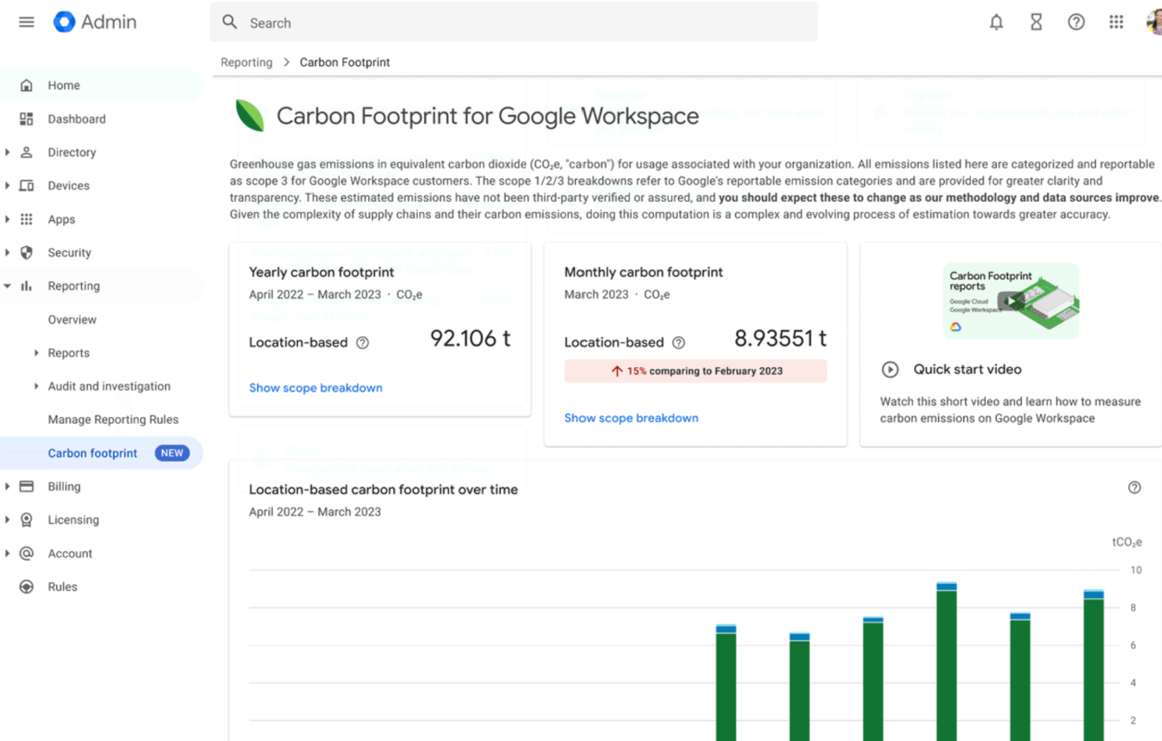
Tutorial: https://www.cloudskillsboost.google/focuses/32138?parent=catalog
All the tools are free of Cost!

