Lighthouse
Developed by Google and exists already included within dev tools. (right click on website → inspect element)
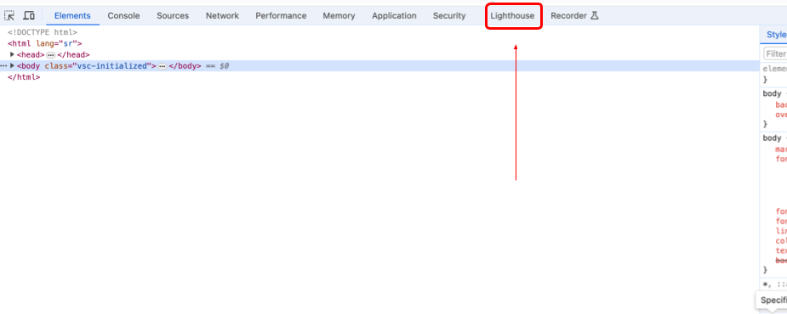
It is not a tool for specifically conducting carbon emission calculations, however it enables analyses and insights into most of the metrics. And most importantly it is easily available during the process of development of the frontend, with no need to leave the website or web app that you are developing. Therefore it can be used as the first tool while developing, to assess the general efficiency of the developed project. Later, other more environment-oriented tools could be used to conduct final assessment in the domain of carbon emission.
Benefit:
- Easy to use and understand
- Available inside Dev Tools of the browser
Pricing: Free
Result looks like:


