Power API
The goal of this project is to provide a set of tools to go forward a greener computing. The idea is to provide software-defined PowerMeters to mesure the power consumption of programs. The core of this project is the PowerAPI toolkit for building such PowerMeters.
You don't need any additional physical PowerMeter or hardware in order to estimate power consumption of your applications. PowerAPI toolkit allows you to use Software PowerMeters providing power consumption at different granularity levels: global, virtual machine, container, application, processus, code.
The Figure below depicts the global architecture of a software PowerMeter in PowerAPI and how it works:
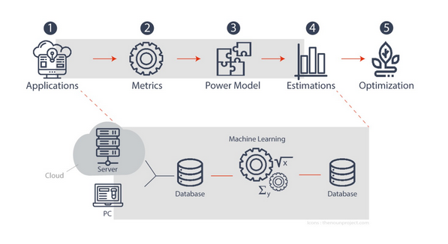

How it works?
PowerAPI measures power consumption using software-defined PowerMeters. It has two main components: Sensors and Formulas. Sensors gather raw data related to power usage, such as CPU activity or system metrics. This data is then processed by Formulas to estimate the actual power consumption of the software being monitored. The toolkit allows for both real-time and post-mortem analysis, enabling developers to understand and optimize the power efficiency of their applications.

Link
Click Here

