Sonar Qube
SonarQube is a powerful tool for ensuring code quality and security in software development projects. By integrating it into your development process, you can continuously monitor and improve your codebase, leading to more robust and maintainable software. The combination of static code analysis, quality gates, and seamless CI/CD integration makes SonarQube a good tool for modern software development practices.
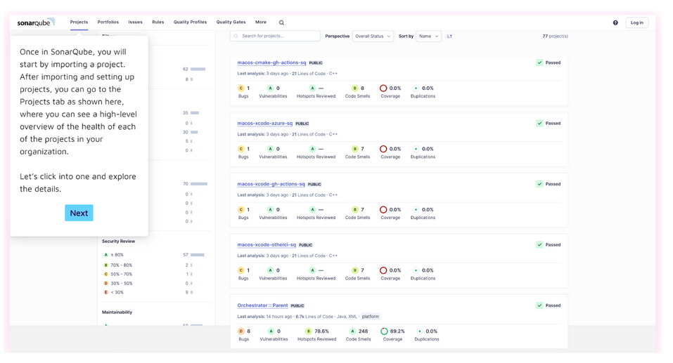

Link
Click Here

