How It Works:
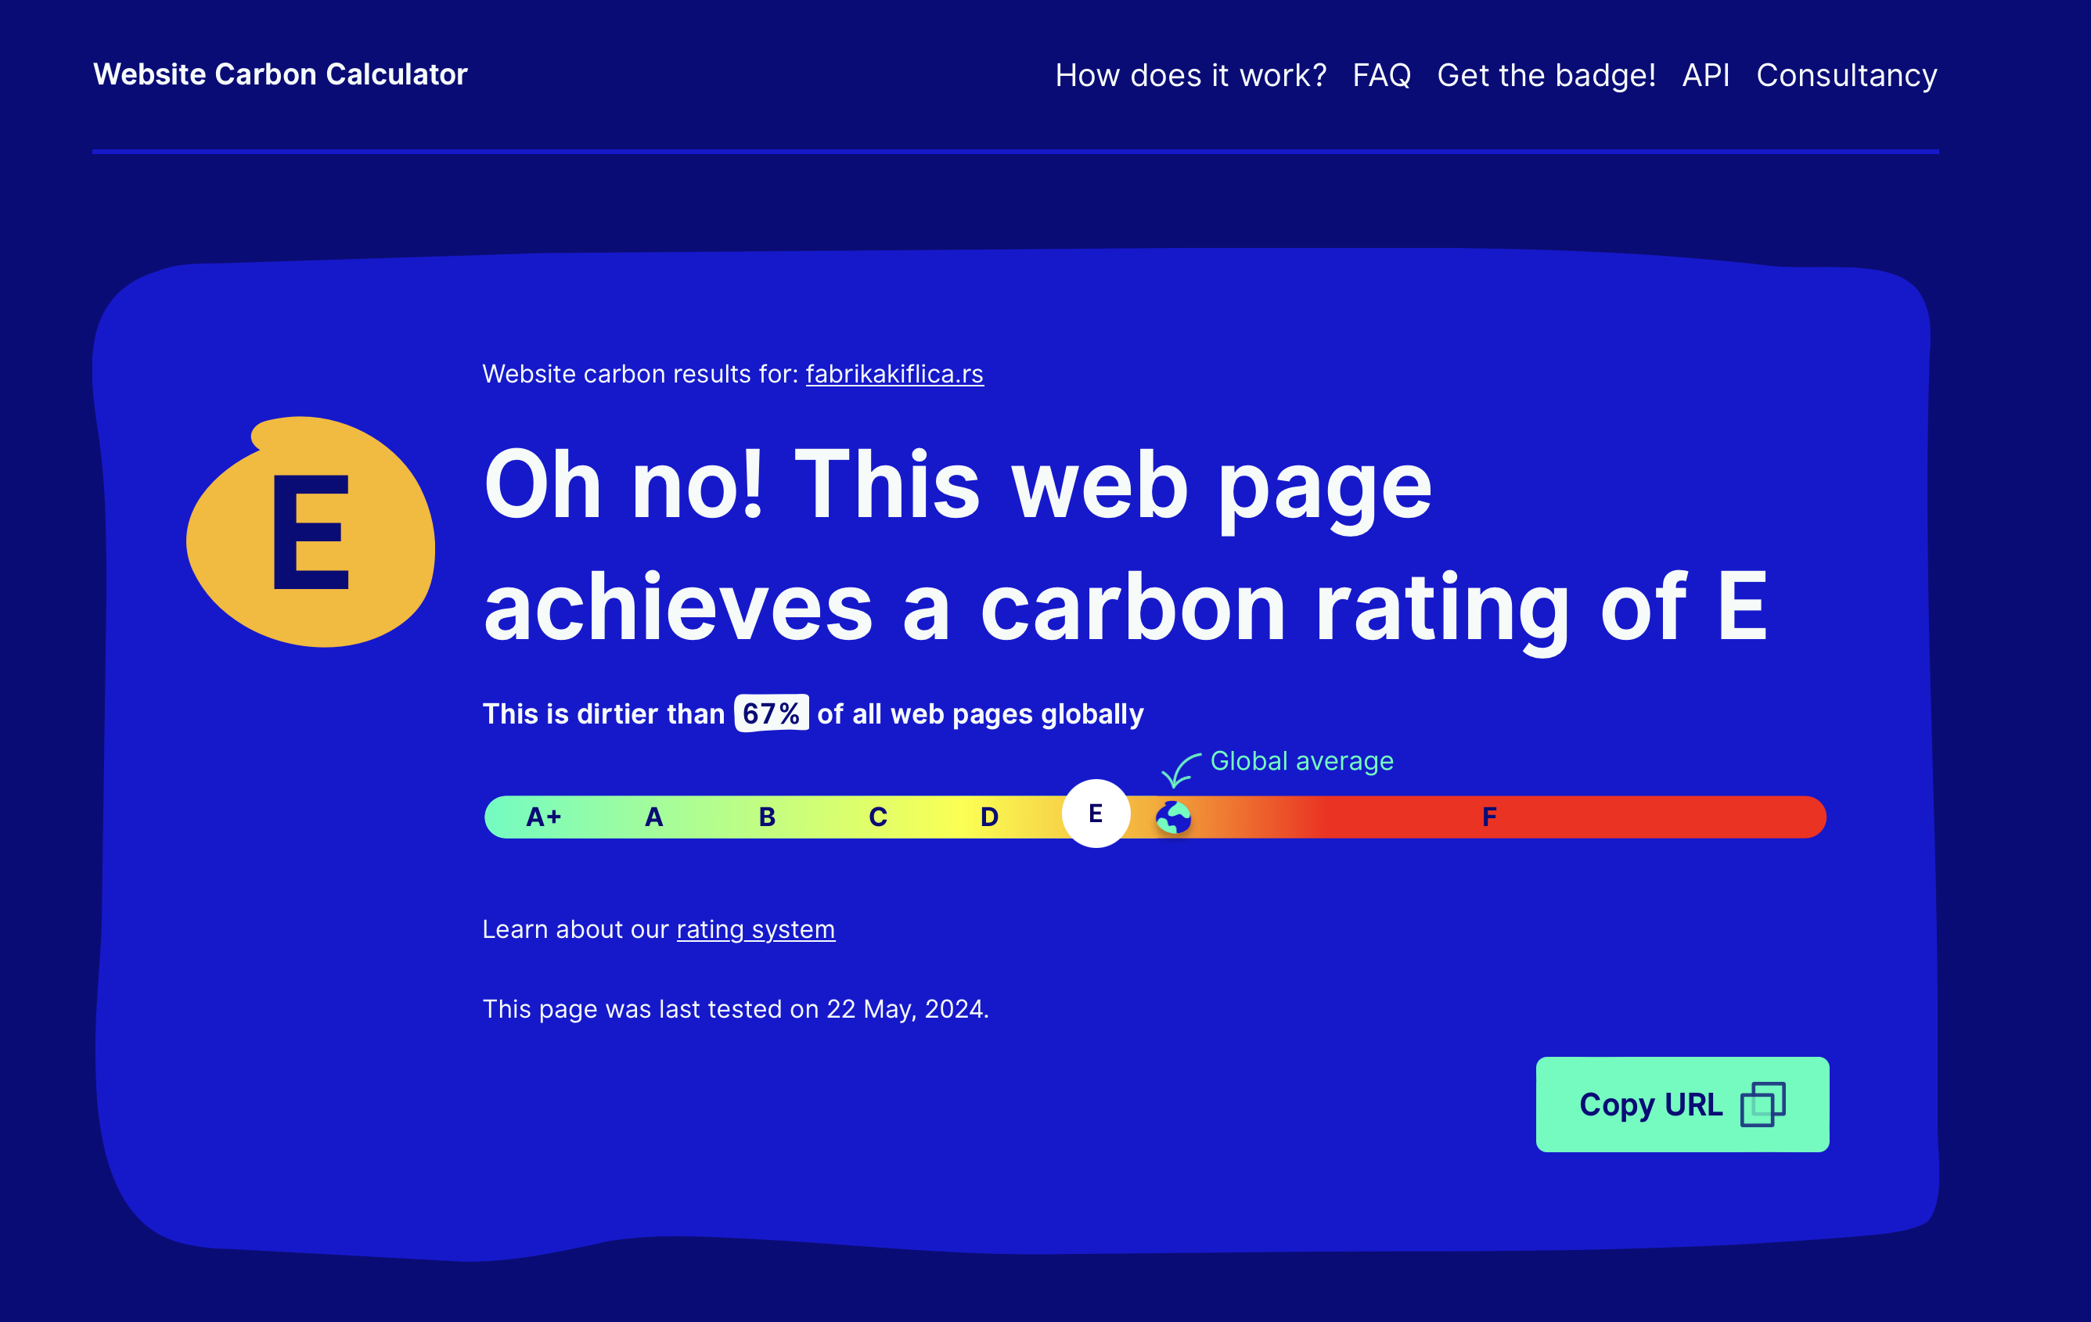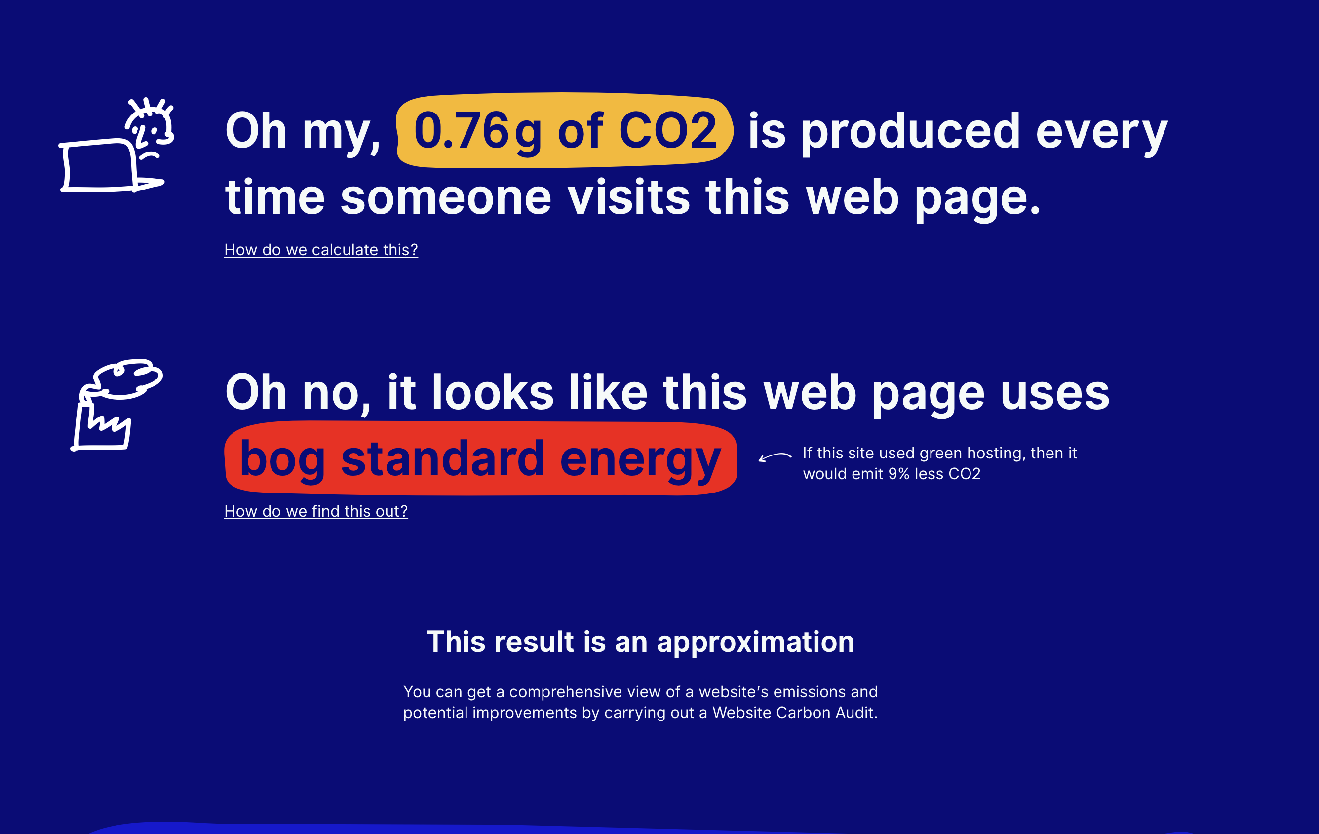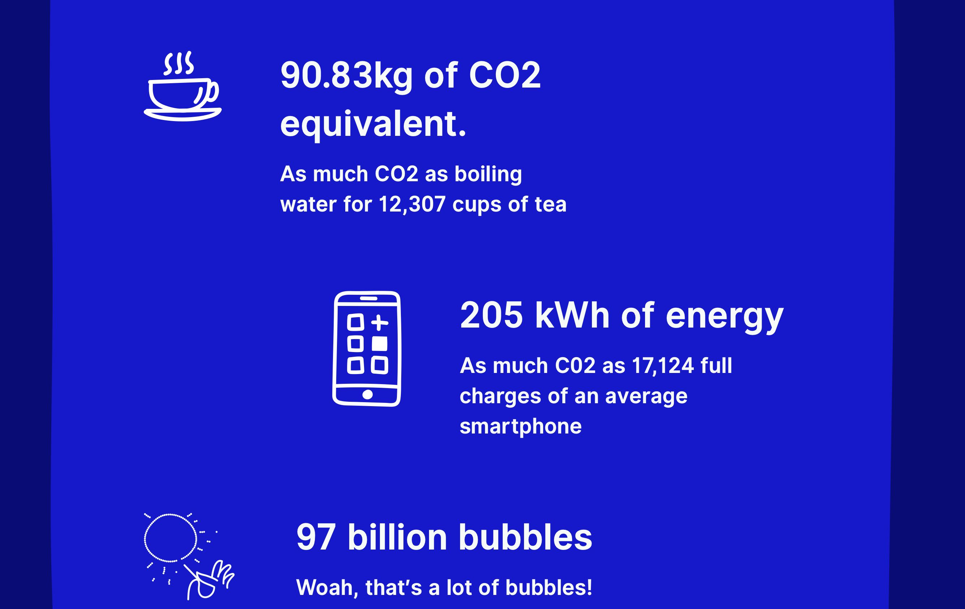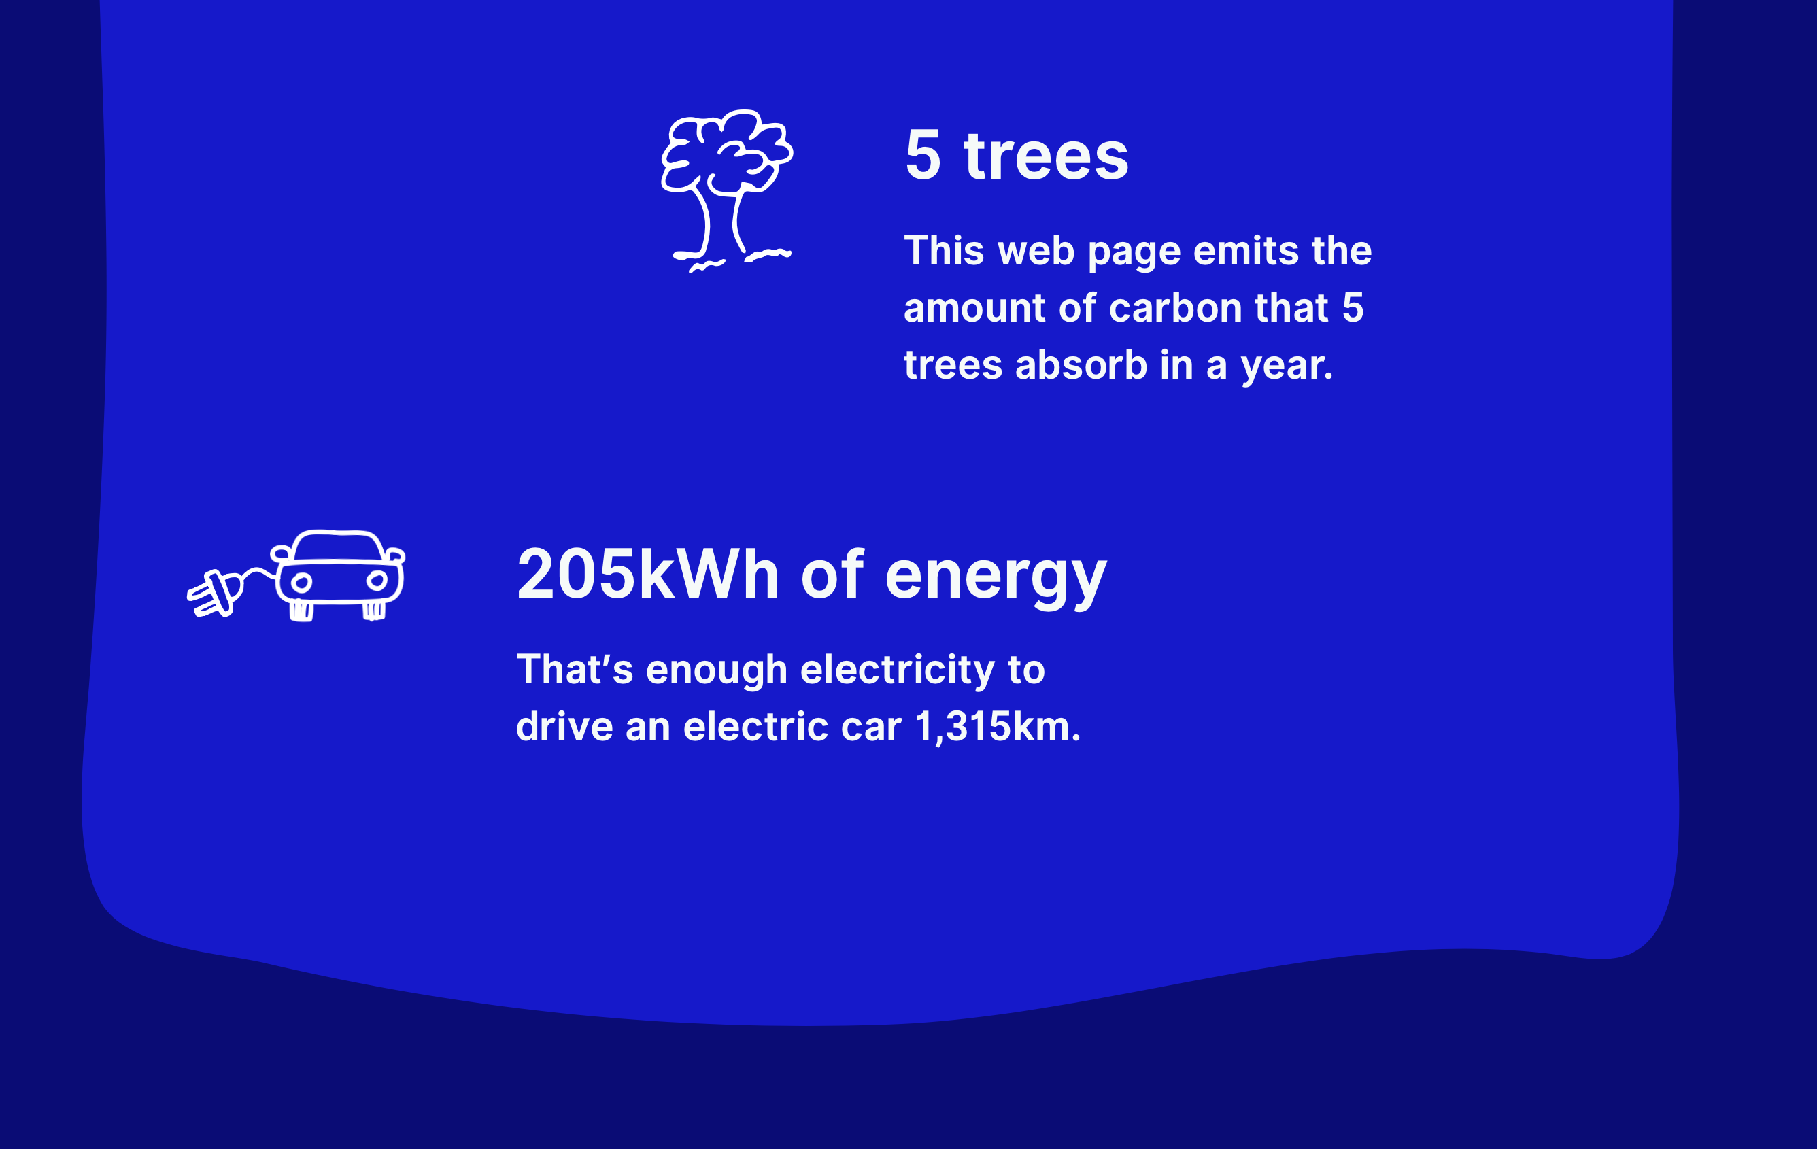
CAN BE EMBEDED IN OTHER WEBSITES
Calculating the carbon emissions of a website is a complex task. However, extensive work over the years has led to the development and refinement of a methodology designed to tackle this challenge. The primary goal of this effort is to raise awareness and promote eco-friendly practices within the web design industry.
The original website carbon calculator was developed several years ago, and since then, its methodology has undergone several iterations. The developers now aim to standardize the approach to website carbon calculations, hoping this will enhance clarity, understanding, and help prevent greenwashing. For the third version of their methodology, they partnered with industry peers to conduct research and develop an updated, coordinated approach.
One of its cool features is that it allows you to embed your carbon efficiency into your website to inform your users and make them more sustainability-aware

Summary:
To calculate the energy consumption and emissions of a web page, the following data points are considered:
- Data transfer over the wire: The energy used is roughly proportional to the amount of data transferred when a website is loaded. The data transferred over the wire is measured and multiplied by energy usage data, with adjustments for repeat visitors who may have website assets cached on their devices.
- Energy intensity of web data: Energy is used at the data center, through telecoms networks, and by the end user's device. Given the variability, an average figure is used.
- Energy source used by the data center: Assuming all websites use standard grid electricity for telecoms networks and end users, the energy source for data centers is verified using The Green Web Foundation (TGWF) database. If a data center uses green energy, the carbon emissions attributed to that portion are reduced. This includes data centers that offset emissions by purchasing standard grid electricity.
- Carbon intensity of electricity: The carbon intensity is based on the international average for grid electricity, with a lower carbon factor applied for renewable electricity used in data centers.
- Website traffic: By combining all this information, the emissions associated with an average user visit to a website are estimated. The total annual CO2 emissions are then calculated by multiplying the carbon per page view by the typical number of annual page views.

Testing Pages:
The public version of the tool is designed to provide a rough estimate of website efficiency by testing a single URL entered into the form, though multiple URLs can be tested individually. Websites included in the ranking tables must:
- Be accessible by the public through a standard web browser - Not require a login - Allow search engines - Contain unique content aimed at human visitors (excluding holding pages, error pages, server notification pages, demo pages, or generally useless pages) - Be free from illegal or explicit content

Link:
https://www.websitecarbon.com/

