ImpactXchange hackathon in Sunway University
Venue: Sunway University
Time: 19.8-30.8, divided into two parts

About ImpactXchange project
ImpactXchange is a Finnish National Agency for Education-funded project in the Team Finland Knowledge program that aims to build education collaboration between Finland and Malaysia. In particular, ImpacXchange aims to develop sustainability and IT-related courses that can be replicated in other regions/countries.
ImpactXchange project is conducted by the following universities (and persons)
- LUT University, Finland
  - Staff: Prof. Jari Porras, Dr. Shola Oyedeji
  - Students: Aleksa Stanivuk (web), Salsabeel Tantoush (web), Ruben Huygens (web), Arshia Saleem (mobile), Muhammad Sharjeel Maqsood (mobile), Jacob White (backend), Hiba Bouhlal (backend)
- University of Turku, Finland
  - Staff: Prof. Tuomas Mäkilä, …
- Sunway University, Malaysia
  - Staff: Prof. Sian Lun Lau, Prof. Tze Ying Sim

General structure of the hackathon
The ImpactXchange hackathon is divided into two closely linked parts.
- Sustainability Challenge hack
  - In the Sustainability Challenge hack, you will innovate and develop working software-based solutions for the sustainability theme selected for the hackathon. The outcome of this hack will be used as the basis for the second week's activities. You will be restricted to a particular technology stack so that the activities in the second week are possible. In the first week, the emphasis is more on a sustainability challenge level (what are the high-level impacts of your solution)
- Green Coding hack
  - In the Green Coding hack, you will focus on the implementation quality of your solution, i.e., its technical and environmental sustainability (what are the solution-level impacts).

Rough timetable of the ImpactXchange hackathon
The rough timetable of the ImpactXchange hackathon weeks is presented below:
- Week 1 - Sustainability Challenge hack
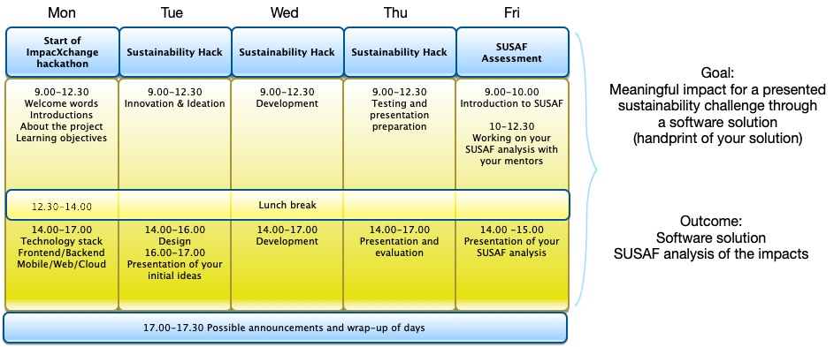Week 1 program
- Week 2 - Green Coding hack
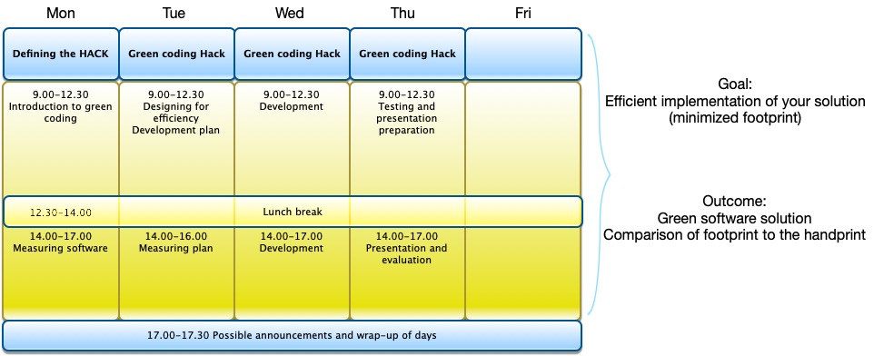Week 2 program

Hackathon theme & challenges
- Slides describing the hackathon theme and challenges
- Slide template for presenting the group challenge
- Green coding concepts and practices presentation
- Green coding energy measurements

Technology stack
Frontend Guideline
Backend Guidelines
Moblie Front End Guidelines

Groups and their TEAM WikiPages
Group | Application | Name 1 | Name 2 | Name 3 | Name 4 | Name 5 | Mentor
Easy clicks |  | Aura | Yusaf | Leanne
GBP |  | Jack | Irfan K | Diva | - | -
K.S.I |  | Kavi | Stephen | Irfan
Miners |  | Adam | Kar Yan | Jeanette
Add more table lines if those are needed for additional teams!

