Anemoi
“In ancient Greek religion and myth, the Anemoi (in Greek, Ἄνεμοι — “winds”) were
Greek wind gods who were each ascribed a cardinal direction from which their respective
winds came (see Classical compass winds), and were each associated with various seasons
and weather conditions.” -Wikipedia
Members
- Aidin
- Petri
- Sahar

Idea
Given an eterprise development project, intutively it it would be much easier to approach the whole project as independent sub-projects. This is the time when Agile methods become handy.
- codecamp_2012_assignment_01.pdf

Resources
- Resources at web

SCRUM status
* scrumbacklog.pdf

Screenshots
Upload and attach couple screenshots of application.  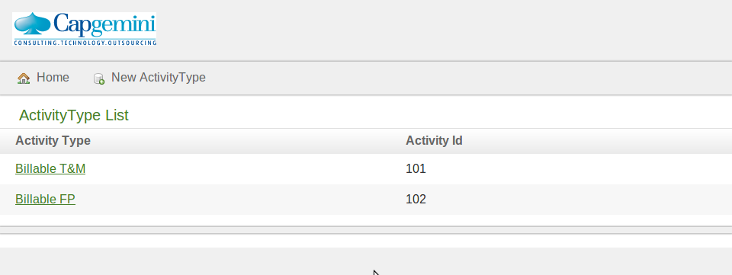 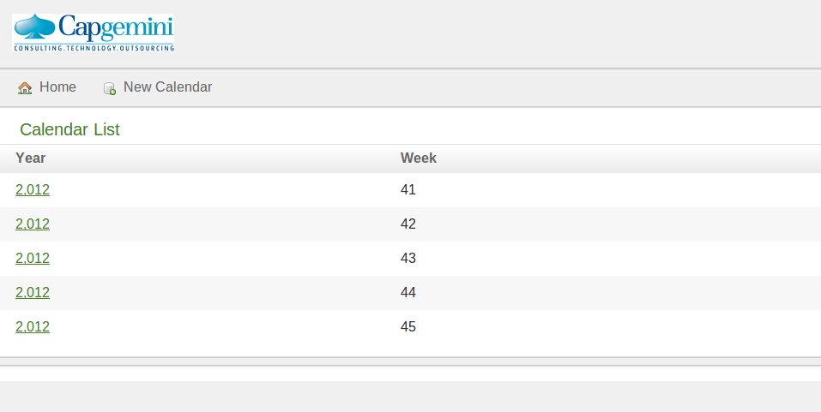 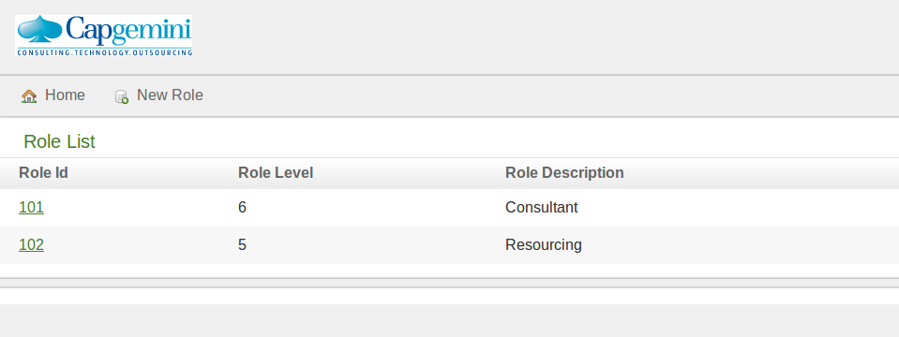 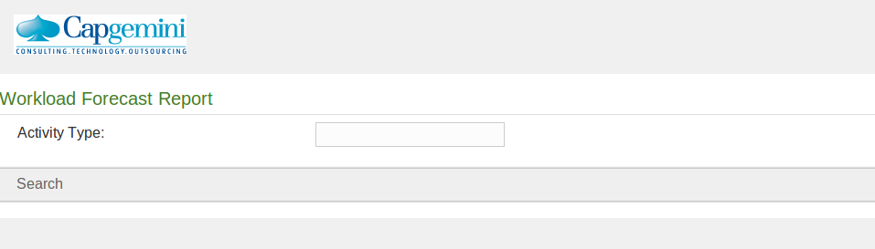

Code
Upload and attach the .war package for final delivery
Upload and attach your project source code package here.
- Clean up compiled binary files before making package
- Use .zip format

Conclusion
What was delivered, how. Your experiences on code camp. Final presentation slides.

