Work Forecast System

Members
- Saeedeh Mehrouzi
- Camilo
- Srikanth
- Joshua Twumasi Adomako

Idea
The situation at the moment is that, the company relies on excell sheets to forecast consultants workload; which has many usability problems and its also prone to errors. The idea of the workload forecast system is to address the usability issues by implementing user friendly system which allow Capgemini employees to forecast their workload efficiently.

Goal of the System
- Automate workload forecasting
- Easy to use
- Estensible solution

Feature List
Sprint backlogs can be found at: https://docs.google.com/spreadsheet/ccc?key=0AoktH7zaynG9dDJmUTZ6Y2pUWU1FUXlHckNBSlJnQ3c#gid=1
- The link contains four excell sheets for project backlog, sprint 1 & 2 backlogs and burndown chart.
- In the table is also the project backlog however more details can be found from the link
All features of the application are in the table.
Priority | User Stories
1 | I want to register to the workforecast system to use it
1 | As a user I want to log into system to use it
1 | As a user I want to logout
1 | As a manager I want to create activity
1 | As a manager I want to create project
1 | As a consultant I want to input forcast of project
1 | As a consultant I want to list forcasts I entered
1 | As a consultant I want to update forcasts
2 | As a consultant I want to delete forcast
2 | As a consultant I want to add TimeLine to forecast
2 | As a consultant I want to update timeline
2 | As a consultant, director, manager, controller, resource representative I want to view timeline
2 | System should log these user activities: date, username and changes made
3 | As a consultant I want to delete timeline
3 | As a controller I want to make instruction
3 | As a director I want to view the total revenue of consultants
3 | As a manager I want to view availability of consultants
3 | As a director I want to view projects
3 | As a director, manager, resourcing rep. I want to compare consultants forecasts
3 | System should allow simultaneous user updates
3 | System should log these user activities: date, username and changes made
3 | As user I want to print reports of forecast
3 | System support browser and mobile

SCRUM status
After our group meeting we give priority to some stories and just create a product backlog, and after this we create the sprint backlog. See attachment for sprintbacklog document. Our team has been have dairly stand ups at the beginning of every session.
- Project and Sprint Backlogs: https://docs.google.com/spreadsheet/ccc?key=0AoktH7zaynG9dDJmUTZ6Y2pUWU1FUXlHckNBSlJnQ3c#gid=1
- We report our progress on the tasks we are working on
- Also we discuss hinderances we face in the development and share ideas about how they can be overcome to allow work to continue
- Team members collaborate and support each other in their task.

Screenshots
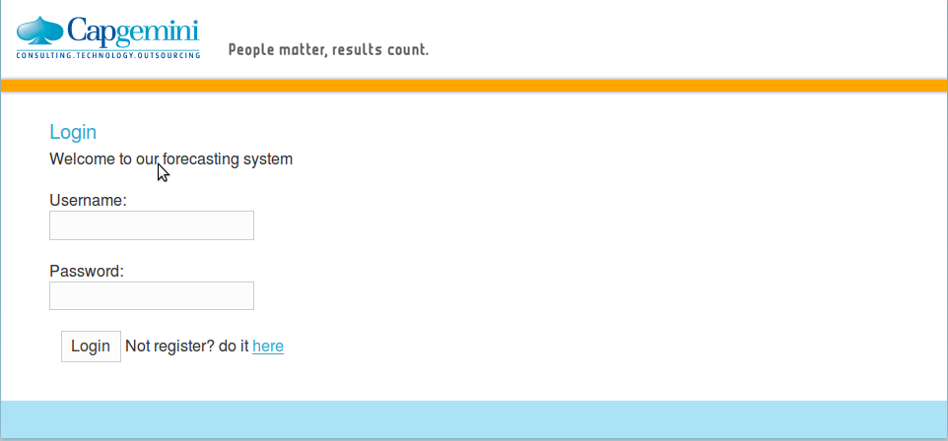
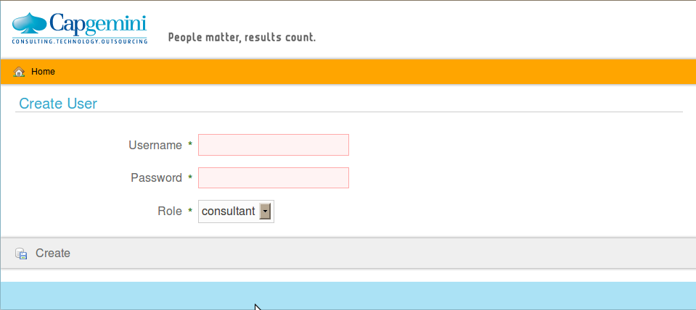
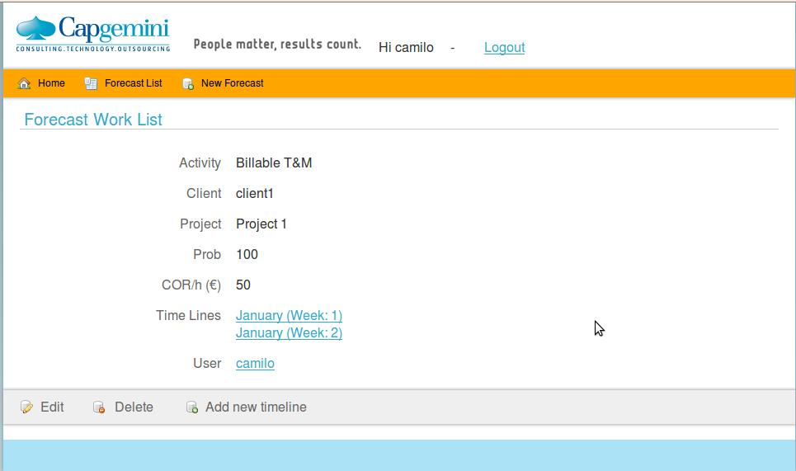
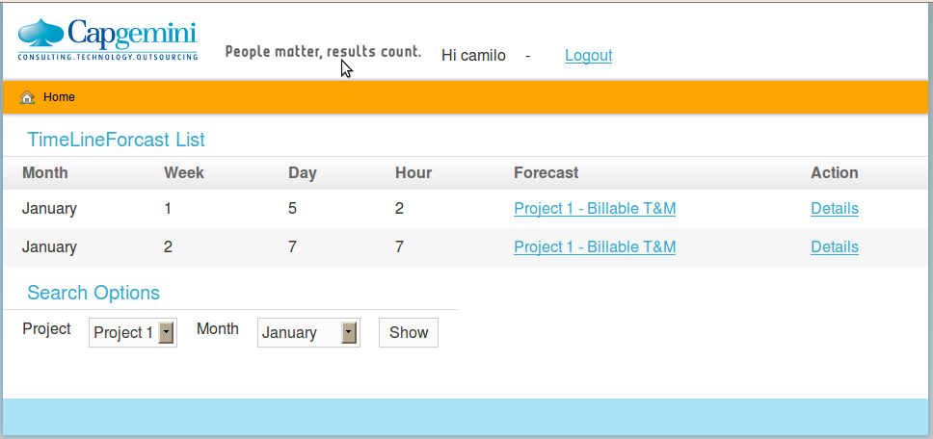
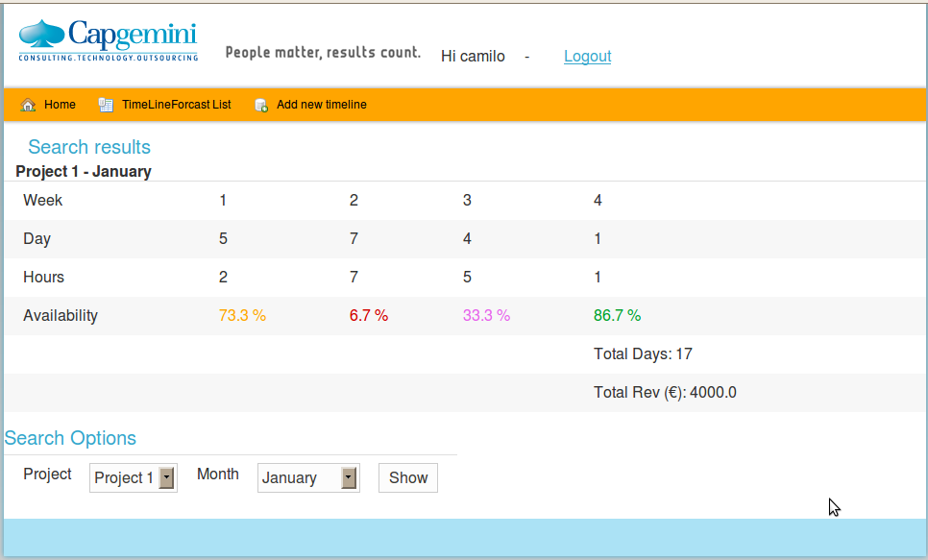
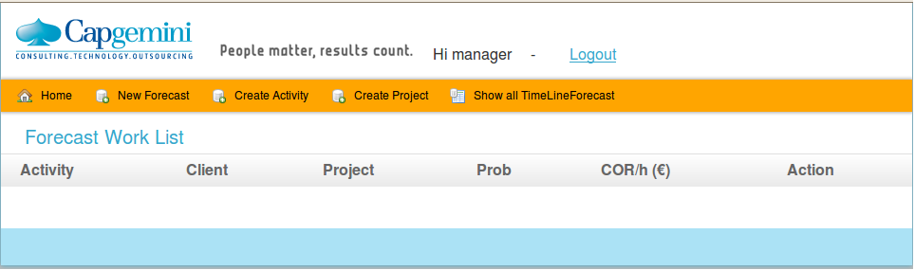

Presentation Slides
agile_java_codecamp.pptx

Code
Download it for free!

Conclusion
What was delivered, how. Your experiences on code camp. Final presentation slides: coming soon

