grp3 - Workload Forecast System
- Poorang Vosough
- Nikolaos Paraschou
- Negin Banaeianjahromi

Idea
After we received the requirement, we read it carefully and identified user stories. Then, we prioritized user stories into three levels based on their importance in our view of point and also based our time limitation. Later on, we discussed about list of works we were supposed to address during the next sprint so we identified product backlog. Finally we started our our one week sprint.

Scrum status

Product Backlog (User Stories)
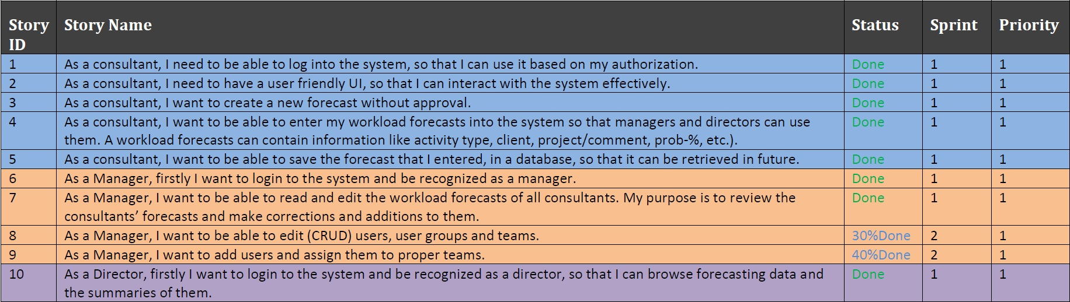
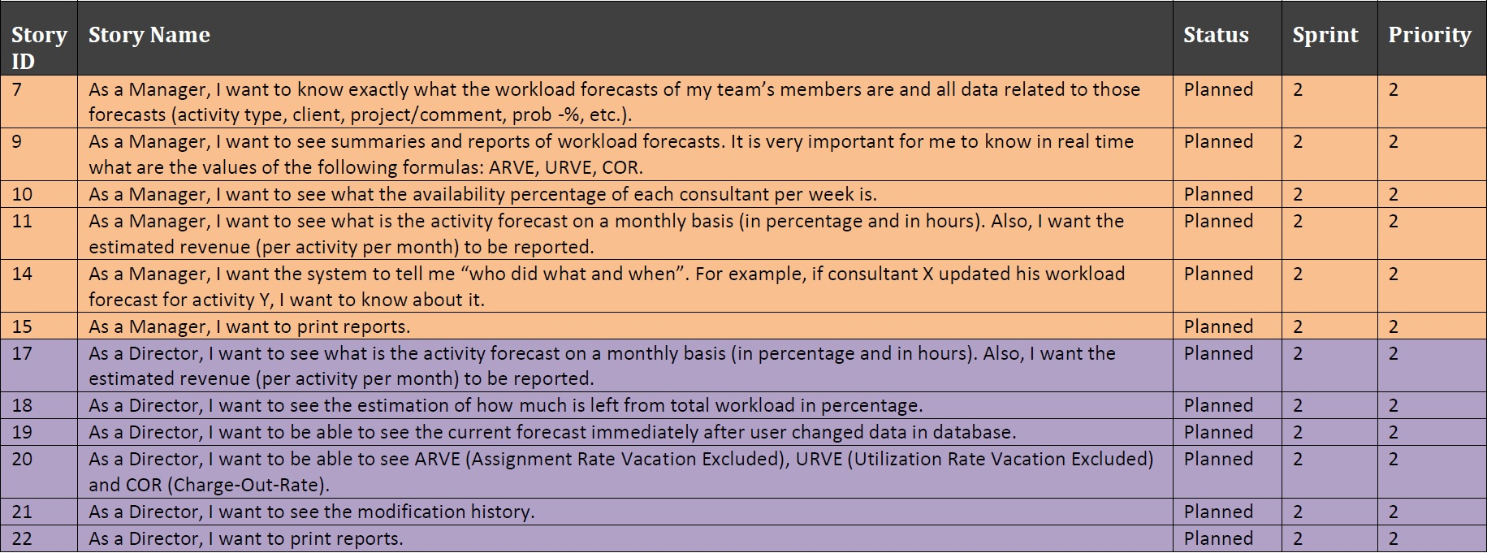

Sprint Backlog

What we planned and managed to do
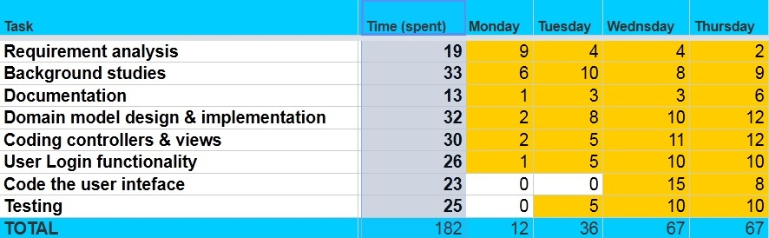
More precisely, the following elements were implemented:
- Domain Classes
  - User, UserRole, Forecast, Activity, Week, Client, Login
- Controller Classes
  - UserController, UserRoleController, ForecastController, ActivityController, WeekController, ClientController, LoginController
- Views
  - Appropriate views for the aforementioned classes.
- Login Functionality
  - The controllers and views were coded so that they support login functionality.

BurnDown Chart
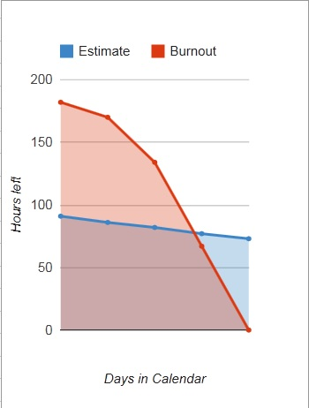

What we couldn't do and why
Due to lack of time and knowledge of the used framework and tools, we didn't manage to complete the following tasks (the unimplemented tasks are shifted to sprints 2 and 3):

Screenshots
Data base
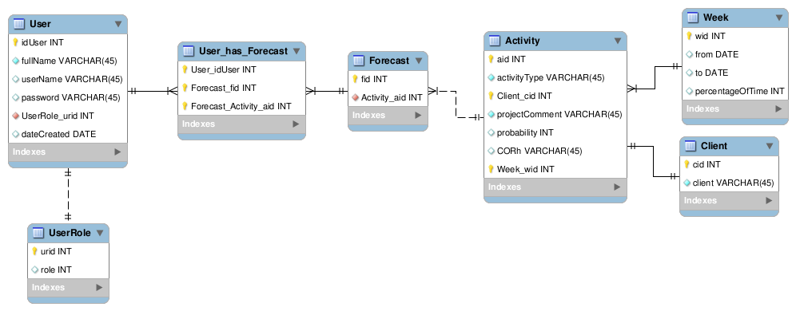
Application
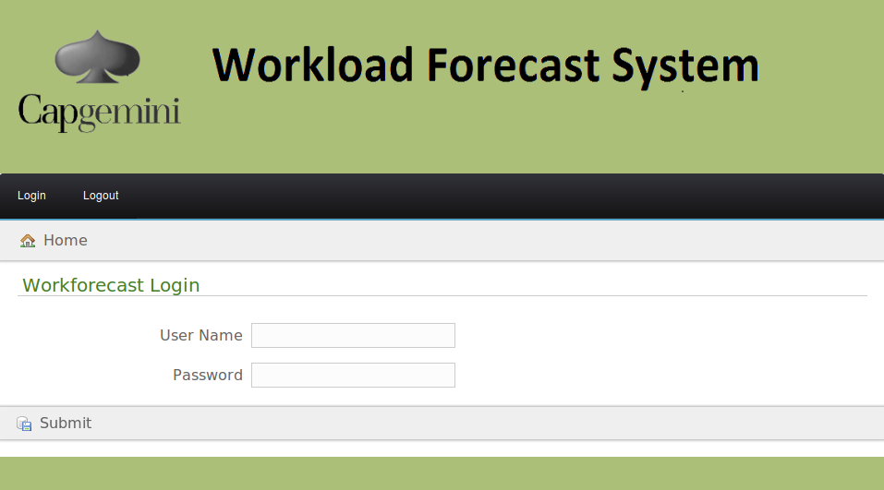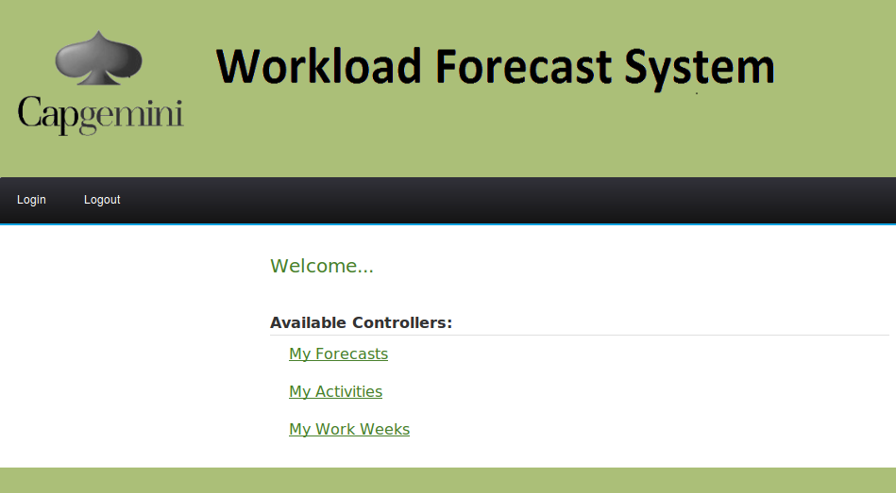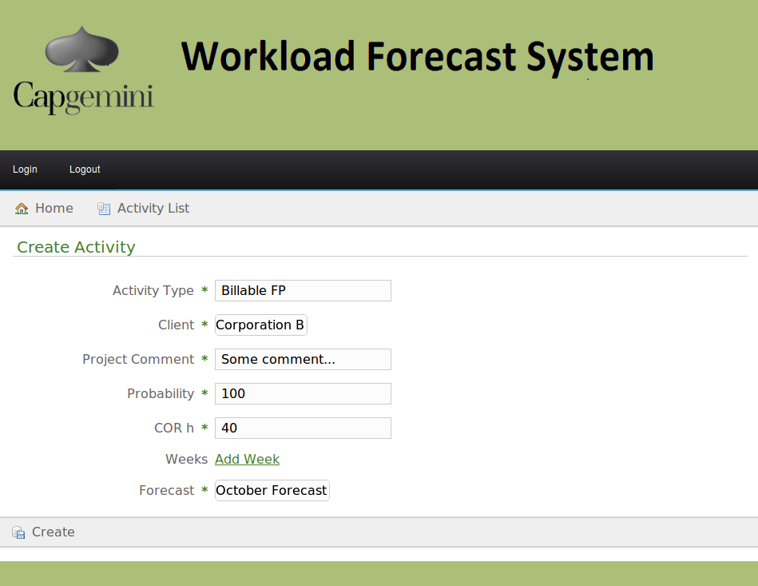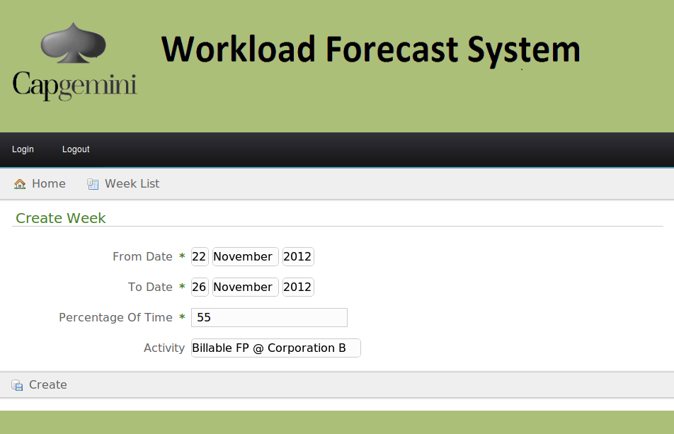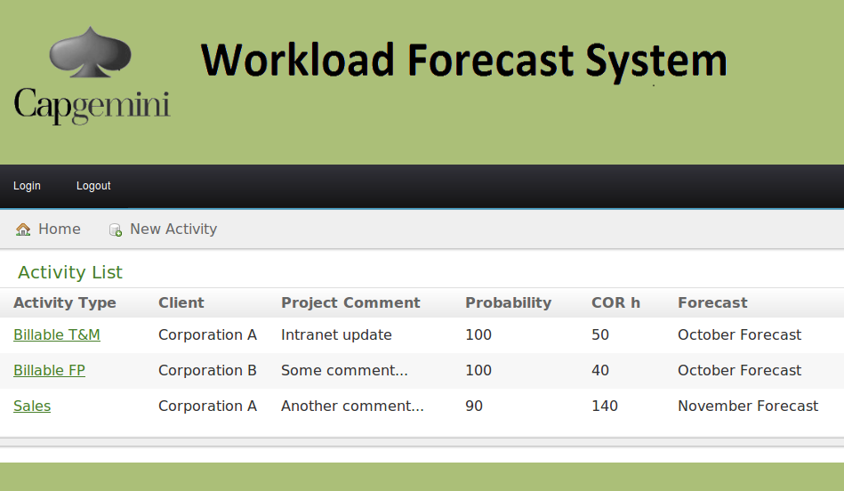

Code
Upload and attach the .war package for final delivery
Upload and attach your project source code package here.
- Clean up compiled binary files before making package
- Use .zip format
workforecast_2.zip

Final Report
finalreport.pdf

Conclusion
What was delivered, how
- Source code of the final application
- Documentation on this wiki including:
  - Product Backlog
  - Sprint Backlog
  - BurnDown chart
  - Database model
Our experiences on code camp
- Working as a team and trying to achieve a mutual goal.
- Working in a very limited period of time with a strict deadline.
- Competing with other teams and trying to be the best.
- Being familiar with new concepts such as Agile software development and Scrum methodology.
- Programming with a new tools such as Grails.
Final presentation slides
http://prezi.com/ybzumso1czyf/forecast-system/

