Jeewa
- Esa Hiiva
- Alexander Fürthmaier
- Mehar Ullah

Idea
As we have been given the requirements, first of all we change the requirements into stories, then we give priorities to those stories that were (according to our view point) important, then we discuss it in the group and after discussions we get a product backlog, and then we start our one week sprint.

SCRUM status
After our group meeting we give priority to some stories and just create a product backlog, and after this we create the sprint backlog.
User stories, priority 1
As a user I will be, see and edit forecast on browser
As a user I will be able to create, (edit and remove) an activity types
As a user I will be able to create, edit and remove an activity for distinct consultant
As a user I will be able to create weekly or monthly workload recordings for different timeframes
As a user I will be able to update the data at same time as other user is updating data
As a user I want my current forecast be loaded when I open forecast view
As a user I want be able to create a report
Resource management, priority 2
As a user I want to be able to manage users and teams
As a user I want to be able to link users to a teams
Special features, priority 3
As a user I will be able to go over 100% workload but I will be notified if I do so.
As a user I will be able to inspect forecasts which takes holydays into account
As a user I want be able to track all changes

Sprint Backlog
Sprint 1
# | Task | State | Assignee | Comment
1 | GUI - Login Screen | done
2 | GUI - Home Screen | done
3 | GUI - Create Forecasts | partly done |  | Missing dynamic table
4 | GUI - Browse Forecasts | done
5 | GUI - Manage Activity Types | done
6 | GUI - Reports | done
7 | Data structure - Domain classes | partly done |  | Skipped monthly based estimates
8 | Views and controllers | done
9 | Login / Logout Logic | done
10 | Logic - Workload Estimation | done
11 | Reports - Data extraction | partly done |  | ARVE and URVE done, but not COR
12 | Reports - Calculations | partly done |  | ARVE and URVE done, but not COR
13 | Reports - Presentation | done
Sprint 2
# | Task | State | Assignee | Comment
1 | Improve navigation and overall GUI
2 | Add availability information of consultants to the reports
3 | Implement roles
4 | Different views to the system depending on roles
5 | Teambased report
6 | Implement special queries to database
7 | Implement over 100% alert for forecast
8 | Implement week-intervall and year for forecast

Screenshots
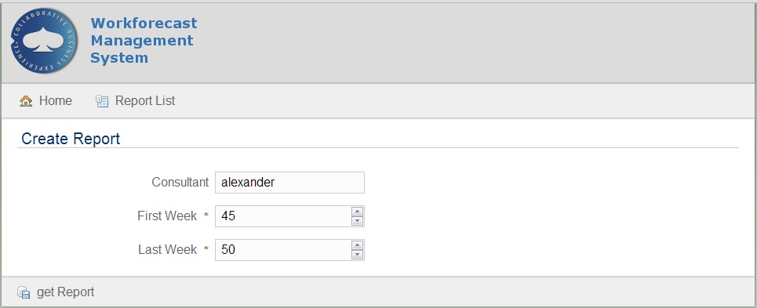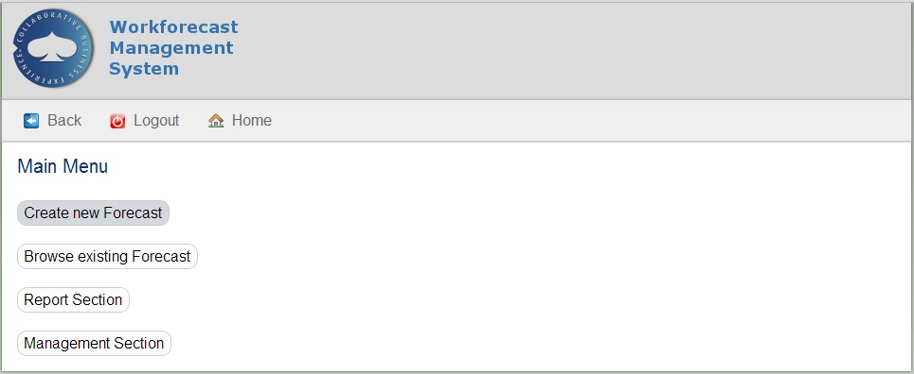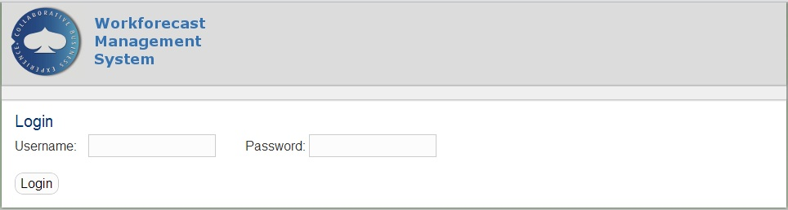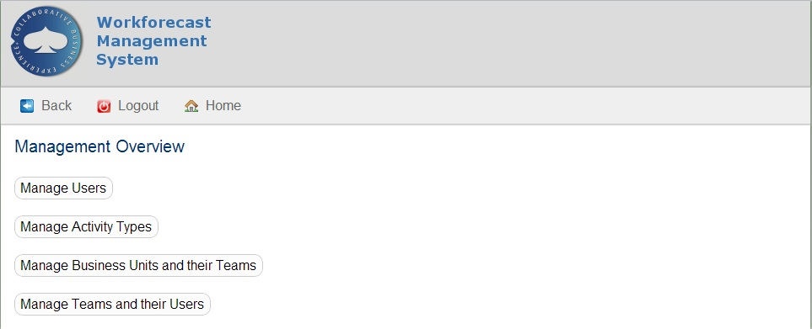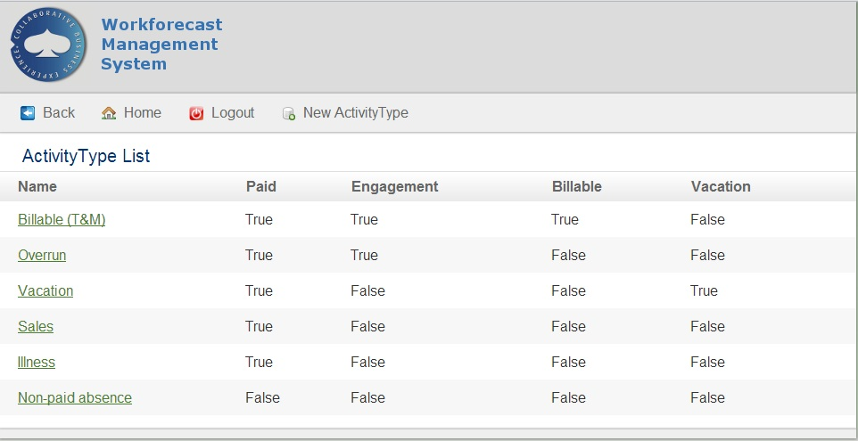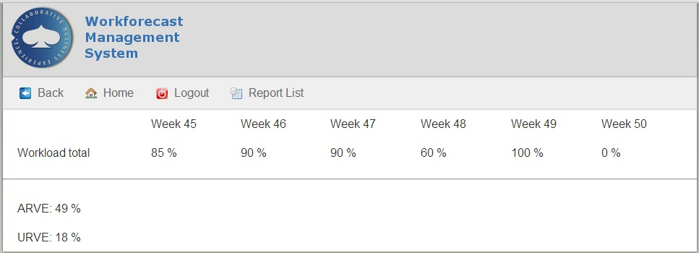

Code
Sprint 1 (Code Camp week)
gr4_workforecast_source.zip
This is a dev-version with a non-persistant file DB.
Test user is added in the bootstrap for testing purposes. Username: “test-user”, password: “password”

Conclusion
gr4_presentation.pptx

