Kinnostive
Group 1
Group Member | Main Responsibilities
Otto Laitinen | Finnkino
Tatu Virta | Netflix, Single Movie Pages, Graphics
Teemu Huovinen | UI, Finnkino Search Filtering
Tatu Huttunen | The idea, BluRay, JSON

Idea
We wanted to create an app which could help the user to find info about Finnkino's “Now Playing” movies with Jolla mobile device. We also added a possibility to browse Netflix's New Releases and recent BluRay releases.
The open data was delivered in XML by Finnkino and Netflix and in JSON by RottenTomatoes (BluRay).
Finnkino Oy is a Finnish film distributor and the biggest cinema chain in Finland. We don't have Finnkino theatre in Lappeenranta yet, but according to the news Finnkino will open a new theatre in Lappeenranta in 2016.

Timetable

Day | What to do
Monday | Setting up developing environment, config version control
Tuesday | More ideas, coding
Wednesday | Coding
Thurday | Coding, graphics, UI
Friday | Monkey Coding & Presentation

Motivation
Once again, all this info is available on the web (open data, d'oh), but you need to open your web browser and navigate to the web pages in order to get that info. We wanted a faster and easier way. We had many ideas, but wanted to keep it simple, because none of us had ever used QML.

Features
- Browse Finnkino “Now Playing” movies from any city in Finland with Finnkino
  - Lappeenranta will be added in 2016!
- Browse Netflix New Releases and recent BluRay releases
  - Nice info page for every movie.
- Sweet Jolla-style graphics!

Tech
We used Sailfish SDK (QML, JS) for developing. Application was tested on virtual machine and also with Jolla mobile device. For graphics we used CorelDRAW X6. Mercurial was used for version control.

Screenshots

Software Poster
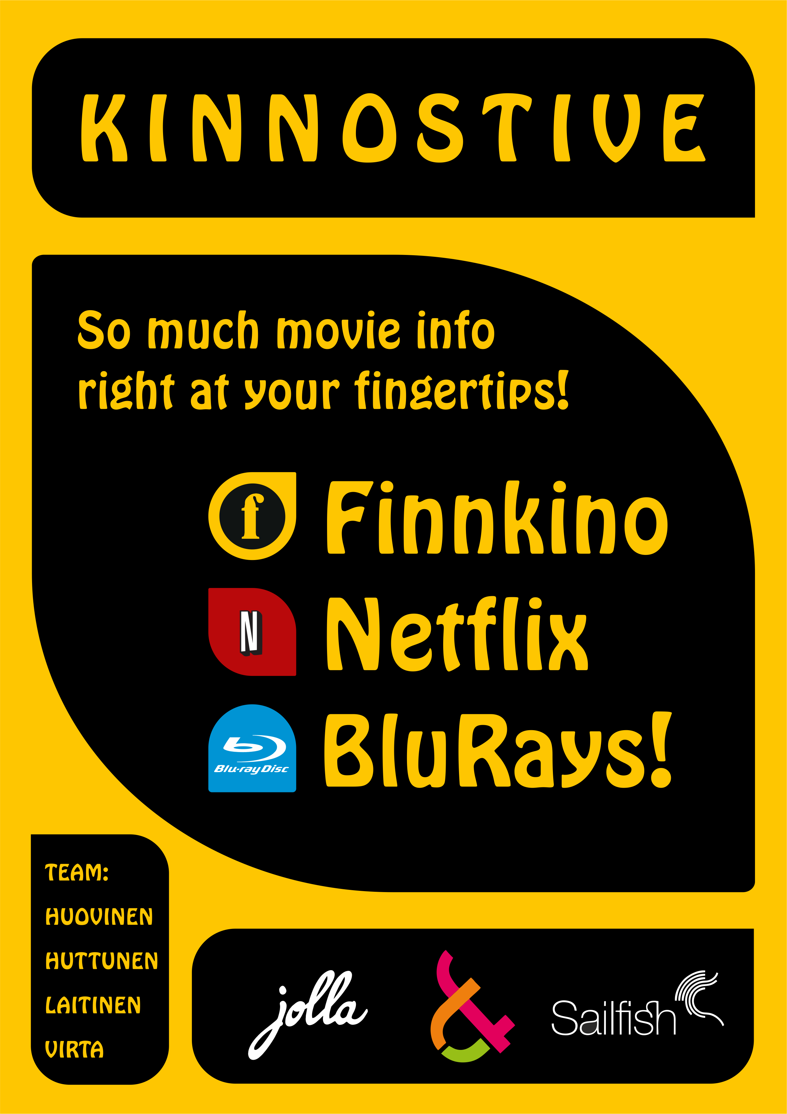

Source
https://bitbucket.org/TatuHuttunen/jollacc

