BusRoute
TEAM
- Behdad Soleimani 0384198
- Alireza Adli 0406160
- Fitsum Kiros Tsegay

GOAL
- To define bus routes for Lappeenranta
- Developing a mobile phone application which is actually a profitable service for people
- Challenging coding skills with coding for Sailfish OS

Idea
- In Google map bus timetable isn't available for Lappeenranta
- There are many new comers in each semester at Lappeenranta University of Technology

Problem
- Using bus service based on timetable booklet is time consuming and tricky in some points especially in Winter

What is BusRoute
- BusRoute defines bus timetable for Lappeenranta on Google map. User can find the nearest bus stop easily with entering source and destination. S/he can also choose date and time of the departure or arrival.

Features
- Finding nearest bus stop based on source and destination
- Selecting date and time of departure or arrival
- Calculating walking distance to next bus stop

Technologies
- Sailfish IDE
- Qt Framework
- Oracle VM VirtualBox
- Jolla Device

Data sources
Goggle Maps static API
Matka.fi API

Screenshots
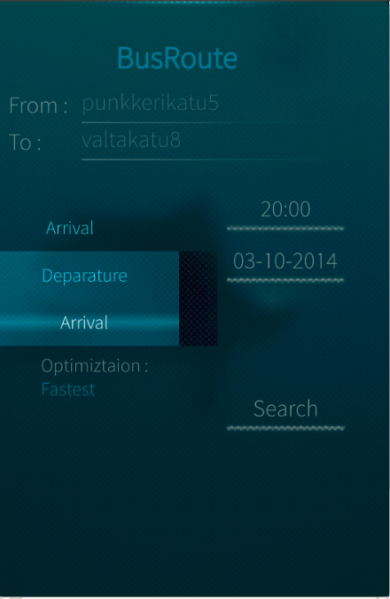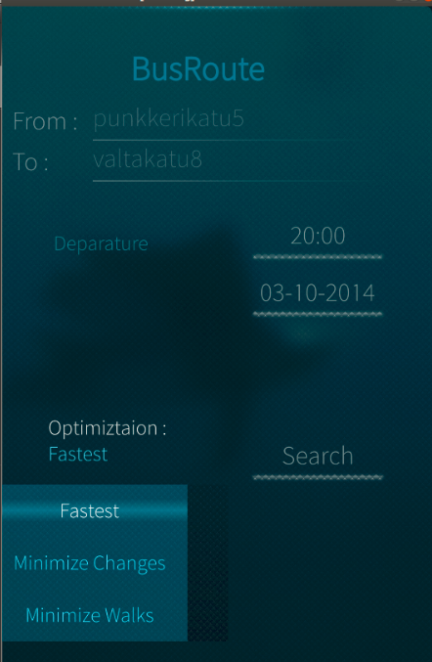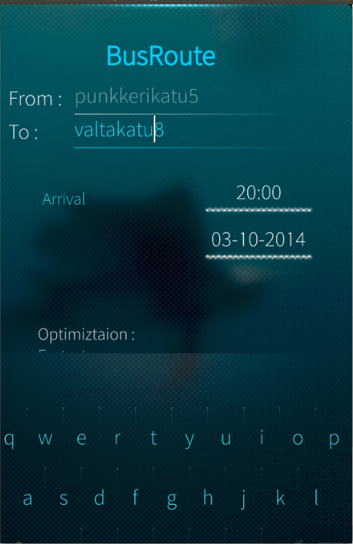
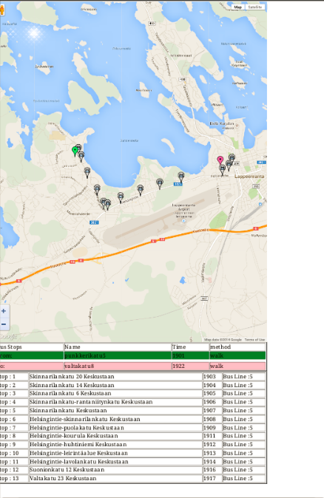

Poster
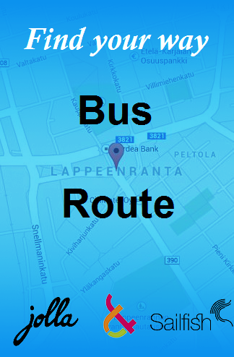

Presentation & report
presentation_busroute.pdf
report_group_10.pdf

Source
busroute.zip
http://svn.code.sf.net/p/publicroute/code/

