Fütböll Gibestive
Group 11
Group Member | Main Responsibilities
Esko Naski | The idea, implementation of new leagues, Graphics
Valtteri M | Parsing data, coding UI
Lassi Lääti | Cover, Creating and finding databases, coding

Idea
We wanted to do sports stat app, because we were using and in need of such in during sochi olympics. Original idea was to do NHL stats app, but there were no data available for it. So we switched to second best opinion, football

Timetable
Day | What to do
Monday | Setting up developing environment, config version control, first test on fetching data from servers
Tuesday | finishing the idea, start working
Wednesday | Coding
Thurday | Coding, graphics, UI
Friday | Presentation

Motivation
None of us had no earlier experience on QML/QT/Jolla development. Our motivation to come to codecamp was to learn Jolla app development, not to save kittens and small rabbits.

Features
- Active Cover
  - Shows upcoming games for bundesliga and barclays premier league
- Upcoming Games
- Past Game information
  - Score, shots, on target, fouls, referee, corners
- League ladders
  - Won, Drawn, Lost
  - Goals against, Goals for
- 3 Leagues Supported (atm)
  - La Liga BBVA
  - Barclays Premier League
  - Bundesliga

Tech
We used Sailfish SDK (QML, JS) for developing. Application was tested on virtual machine and Jolla mobile device. For graphics we used Gimp. Git/gitHub was used for version control.

Screenshots
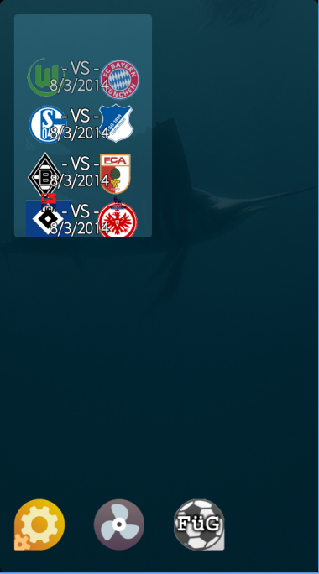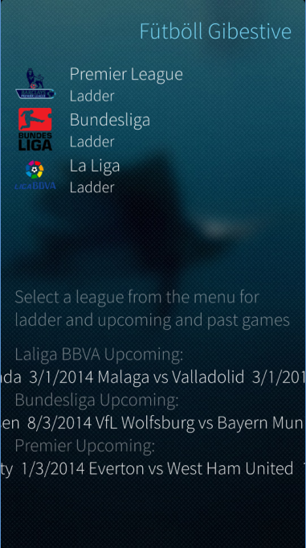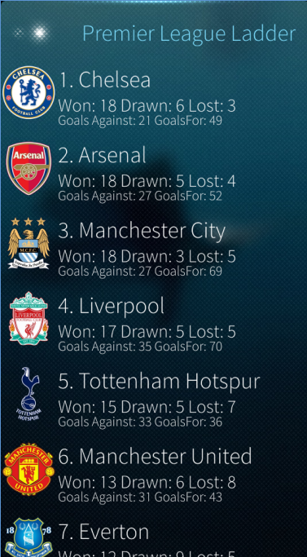

Software Poster

Source
https://github.com/lasshi/JollaCodecamp

