Introduction
The Jolla Winter 2014 Code Camp is aimed at enabling students to develop on the new Sailfish operating system as well as harnessing open data.
As a group, we have developed a Jolla mobile application on the QT platform. Keep reading below for a more detailed presentation of our ideas, motivation, and complete implementation of this project.

Team
Group 2 : We are three(3) students from the Erasmus Mundus Masters program in Pervasive Computing & Communications for Sustainable Development (PERCCOM).
Members | Std numbers
Vitalii Poliakov | 0424760
Ramya Narayanan | 0424728
Zainab Ifeoluwa Matemilola | 0424702

Idea & Motivation
In a bustling city such as Nottingham, a lot of road maintenance is necessary to keep things running smoothly on the roads and highways. Fore knowledge of these maintenance works could save a lot of time for busy city dwellers. We have designed our app to help navigate the city more efficiently by avoiding these repair sites when possible or take into account the delay when not possible so that destinations are reached safer and faster. The application also allows users to find available parking spaces in the city conveniently on their phones. We have done these by integrating both the UK government's available open data for Nottingham and Google maps.

Main Features
- GUI
- Map display
- Open data integration

Technologies Used
Microsoft Windows
Sailfish OS
Virtual Box
Qt Framework
Jolla
Ubuntu

Data Sources
Goggle Maps static API
Nottingham Street Works
Nottingham Travel Wise

Presentation
presentation.pdf

Screenshots
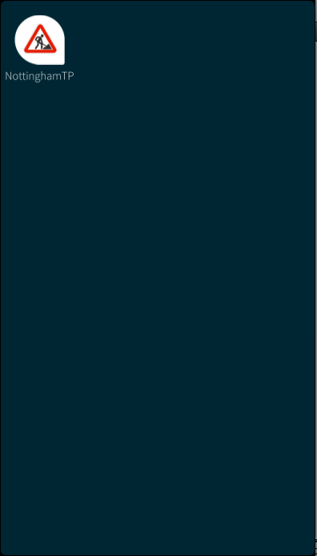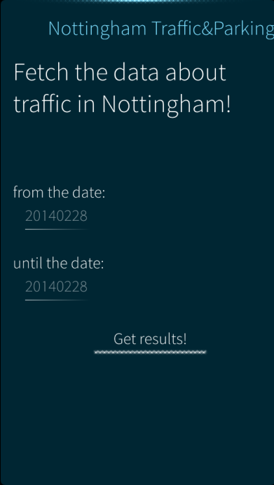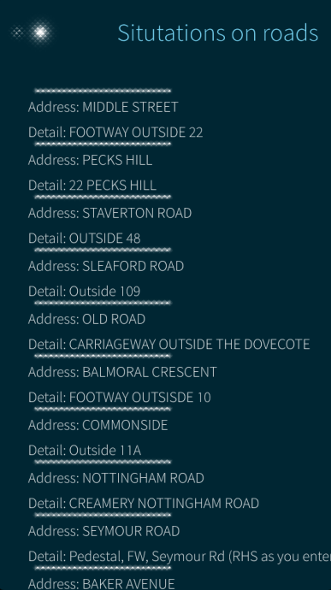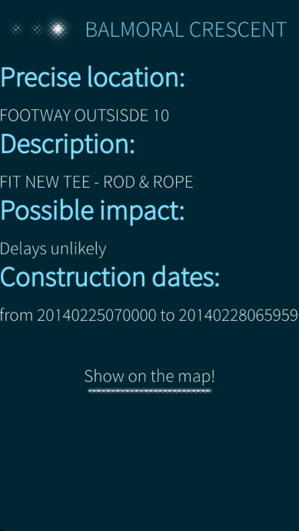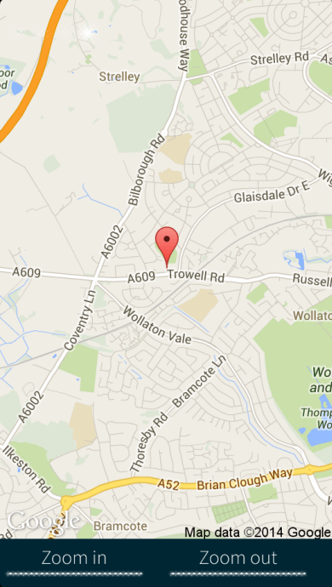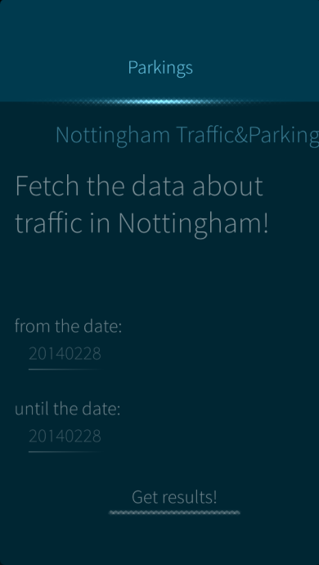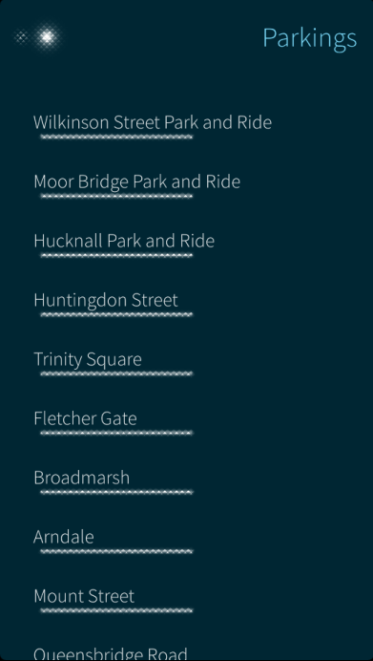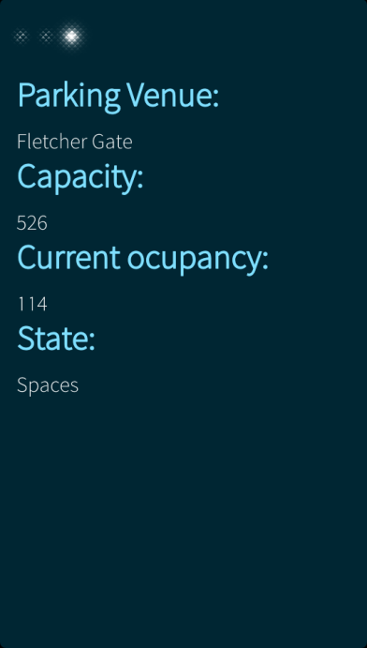

Source (at the moment in a .zip)
nottinghamtp_b1.zip

