Introduction
This page presents the “Cyriot-french Team” project developed during the jolla Code Camp [February 24-28, 2014]. Our report is available Online on Dropbox.

Presentation
We are three students from the Erasmus Mundus Master program in Pervasive Computing and Communications for Sustainable Development (PERCCOM). This master aims at combining advanced Information and Communication Technologies (ICT) with environmental awareness to enable world-class education and unique competences for ICT professionals who can build cleaner, greener, more resource and energy efficient cyber-physical systems.
This code camp gave us the opportunity to develop our first Green oriented application.

Team members
Stefanos GEORGIOU (0424676)
Alexandre DE MASI (0424650)
Baptiste LOUIS (0424692)

Code Camp experience
We have experienced our first code camp during this week, and we liked it!
We liked because we enjoy this method of studying: it's very different compared to traditional lectures with so many power-point slides. In 4 days, we created our own Green application for Jolla smartphone. It is an useful skill for our PERCCOM program. Furthermore, we liked to discuss together, to meet professional, but also the inspiring atmosphere, brain teasing challenges and of course the sauna-pizza party with all the code camp team. Learning should not be a dull task.
If you get students excited about things which are done, they will take pleasure to learn.

Project
Our presentation is available Online on Dropbox. You can promote our project using our poster

Context
Solar power for a home used to be an outlandish energy idea that was fraught with more issues in terms of getting it to work than results. However, those were the very early days of the industry. Unfortunately, until people actually see the results and potential benefits of today's solar power options for a home, many still refer back to those images from the 1980s when solar-powered homes were still on the drawing board, so to speak.

Motivation
The growth curve of our carbon footprint crossed a first critical point in 1970 and revealed the sad truth that our planet will not be sufficient to survive in the future. Today, we would need more than one planet and half and in 2050 we will need three. So we are all arrived at a new crossing point, where the business-as-usual drive us to self-destruction. We have to change the way, change our consumer society into a sustainable society.
We are the generation of tomorrow workers and as PERCCOM's students, we have to use our knowledge, our skills and our know-how to push forward our sustainable development.

Idea
SunPower application is a simple tool to evaluate your own solar potential in order to realize that nowadays, we have the technology to use sun power for home use effectively not only at the desert ! SunPower aims to be ergonomic, easy to use and understandable by everyone. SunPower is not a professional tool but can help to take a decision about the installation of photovoltaic panels for home.

Platform
We developed SunPower for SailfishOS. SailfishOS is a mobile-optimized OS with the flexibility, ubiquity and stability of the Linux core and a cutting edge user experience built with the renowned Qt™ platform. Currently, this OS is used by jolla phone. To develop this application, we used SailfishOS SDK. The source code of this application is available Online on Dropbox.

SunPower Application
SunPower application is available Online on OpenRepos. More information on OpenRepos.net/About

Moke Up
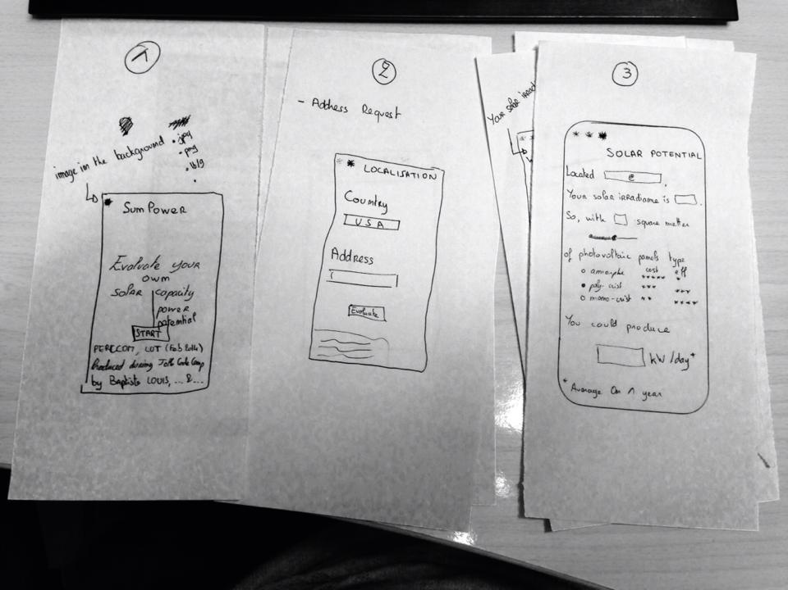

Screenshots
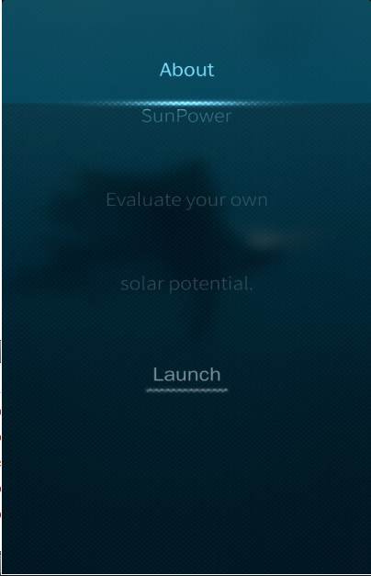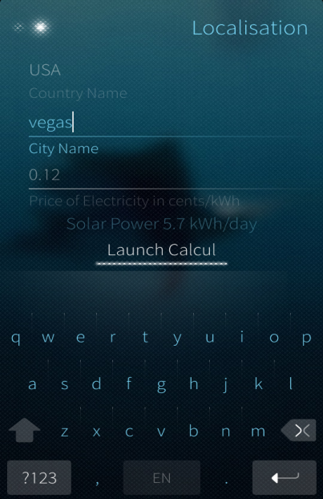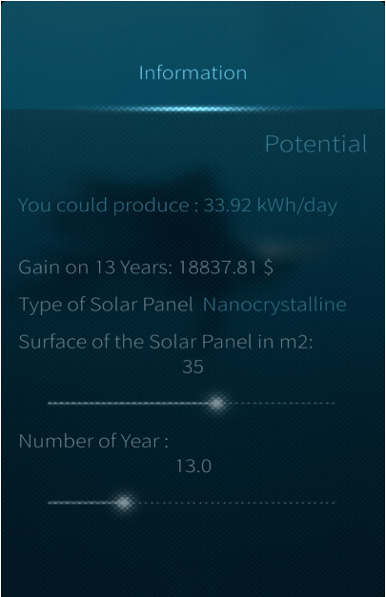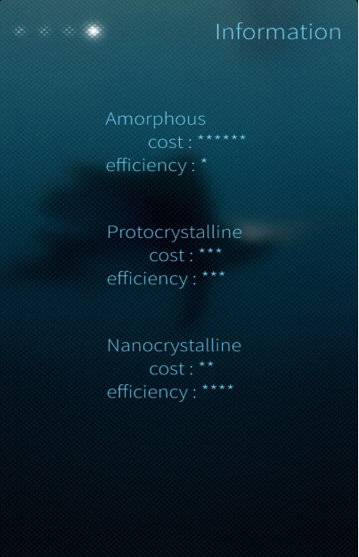

Features
- Photovoltaic panels type
- Photovoltaic cost/efficiency evaluation
- Annual gain [$]
- Modular photovoltaic panel size
- Solar irradiation [kWh/m^2/day]
- Annual production [kW/day]

Links
Jolla Code Camp information via http://www.codecamp.fi/doku.php/jolla2014/start.
Contact us by Facebook via https://www.facebook.com/mrlouisbaptiste.
Note: for Green considerations, all our documents are available via links. Thank you for you understanding.

