Introduction
This page presents the “Cyriot-french Team” project developed during the jolla Code Camp [February 24-28, 2014].

Presentation
We are three students from the Erasmus Mundus Master program in Pervasive Computing and Communications for Sustainable Development (PERCCOM) 1. This master aims at combining advanced Information and Communication Technologies (ICT) with environmental awareness to enable world-class education and unique competences for ICT professionals who can build cleaner, greener, more resource and energy efficient cyber-physical systems.
This code camp give us the opportunity to develop our first application oriented Green.

Team members
Stefanos GEORGIOU (0424676)
Alexandre DE MASI (0424650)
Baptiste LOUIS (0424692)

Code Camp experience
We have lived our first code camp experience during this week, and we like! We like because we enjoy this study method: it's very different to traditional lectures. We like to discuss together, to meet professional, but also the inspiring atmosphere, brain teasing challenges and the sauna-pizza party.

Project

Context
Solar power for a home used to be an outlandish energy idea that was fraught with more issues in terms of getting it to work than results. However, those were the very early days of the industry. Unfortunately, until people actually see the results and potential benefits of today's solar power options for a home, many still refer back to those images from the 1980s when solar-powered homes were still on the drawing board, so to speak.

Motivation
The growth curve of our carbon footprint crossed a first critical point in 1970 and revealed the sad truth that our planet will not be sufficient to survive in the future. Today, we would need more than one planet and half and in 2050 we will need three. So we are all arrived at a new crossing point, where the business-as-usual drive us to self-destruction. We have to change the way, change our consumer society into a sustainable society.
We are the worker's generation of tomorrow and as PERCCOM students, we have to use our knowledge, our skills and our know-how to push forward our sustainable development.

Idea
SunPower application is a simple tool to evaluate your own solar potential in order to realize that nowadays, we have the technology to use sun power effectively not only on the desert ! SunPower aims to be ergonomic, easy to use and understandable by everyone. SunPower is not a professional tool but can help to take a decision about the installation of photovoltaic panels.

Features
- Photovoltaic panels type
- Photovoltaic cost/efficiency evaluation
- Modular photovoltaic panel size
- Solar irradiation [kWh/m^2/day]
- Annual production [kW/day]

Platform
We developed SunPower for SailfishOS. SailfishOS is a mobile-optimized OS with the flexibility, ubiquity and stability of the Linux core and a cutting edge user experience built with the renowned Qt™ platform. Currently, this OS is used by jolla phone. To develop this application, we used SailfishOS SDK 2.

Screenshots
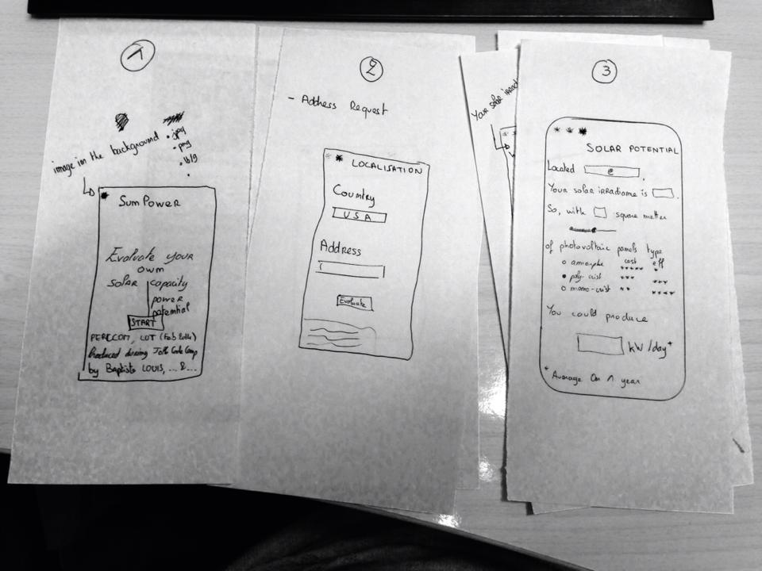

Links
1 more information on http://perccom.blog.univ-lorraine.fr/
2 more information on https://sailfishos.org/develop.html

