Automated Tutor
TEAM members ( Erasmus Mundus PERCCOM students)
Name | Student ID | Email
Fisayo Caleb | 0424773 | fisayocaleb@gmail.com
Iqbal Ahmed | 0424993 | Iqbal.Ahmed@lut.fi
Rohan Nanda | 0424715 | Rohan.Nanda@lut.fi
Ngo Manh Khoi | 0424731 | sirkhoi@gmail.com

Goal
The primary goal of this app is to give newly-arrived students in Lappeenranta necessary information. There are many ways to gather information, but one of the best way is to gather these information in an mobile app, which will display these information when the user need it. The app should be able to connect to various data sources, open to edit and have nice appearance.
The app should be also useful for university's tutors as well as the school's administrative personnel. They can create events and have a global view of all the tasks that new students have to complete before attending the first lectures
For students like us, this is an excellent opportunity to get experience on developing mobile app in a new environment. We can have new knowledge, new skills and memories together. We also enjoy the Codecammp spirit by sharing knowledge and having fun with each others.

Architecture
The KARF's 'Automated tutor' runs on Sailfish OS, which is a Linux-based mobile operating system developed by Jolla in cooperation with the Mer project and supported by the Sailfish Alliance. It is to be used in upcoming smartphones by Jolla and other licencees. The KARF's app is at the application layer, the topmost one in the stack. From the bottom up, the layers are: Hardware, hardware specific kernel adaptation, Mer Core, UI and Middleware and KARF's Automated Tutor
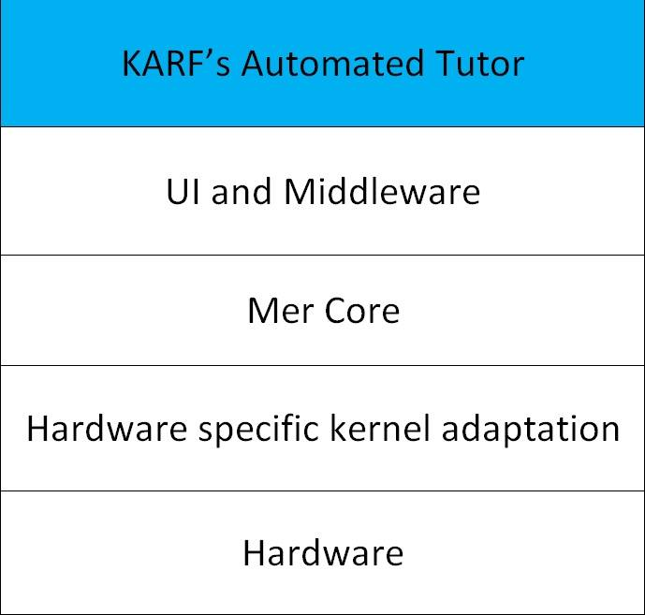

The 2014 Jolla Codecamp
The theme of this year's codecamp is Open Data. Open data is the idea that certain data should be freely available to everyone to use and republish as they wish, without restrictions from copyright, patents or other mechanisms of control. Rightnow, there are various sorce of Open data, like scienctific data, government data, geographical data, … etc. This movement is increasingly popular wordlwide, due to its openness and accessibility.
In response to this, the KARF's app should connect to a geographical Open data source (Google map in this case) and display the information according to the user's request. The app also included some information coming from other useful website, as listed in the Reference section.

Description
Our App, “Automated Tutor”, will have a map of Lappeenranta with all the pinned locations. These important locations are places that every student has to visit (Uni campus, LOAS Office, Railway Station, Supermarkets ,Magistrati , Pharmacy, Railway, Station, Hospital, Bank…), together with an additional note for each location.
Physically, the app's screen will have 3 parts: a big Google map of Lappeenranta, a list of events on the left side and lists of important locations for newcomers on the right side. When a user clicks on an object, certain information will appear on the screen.
In the initializing stage, the Google map centers at Lappeenranta, showing the whole city together with several markers. In order to see a marker in detail, the user should zoom in the map by clicking on the map area. Another functionality of the app is to show direction. It can show the direction from current location to the place of the marker

Data Source
- Google Map *
- Lappeenranta Tourism
- Finland Railway
- Police of Finland
- Wikipedia
- S market
- K Supermarket
- Prisma
- Data for the app
* means Open Data Source

Technologies used
* Sailfish IDE
* Oracle VM Virtual Box
* Qt Framework
* Jolla Device
* Ubuntu
* Java Script
* HTML

Poster
The official poster of our app comes here,
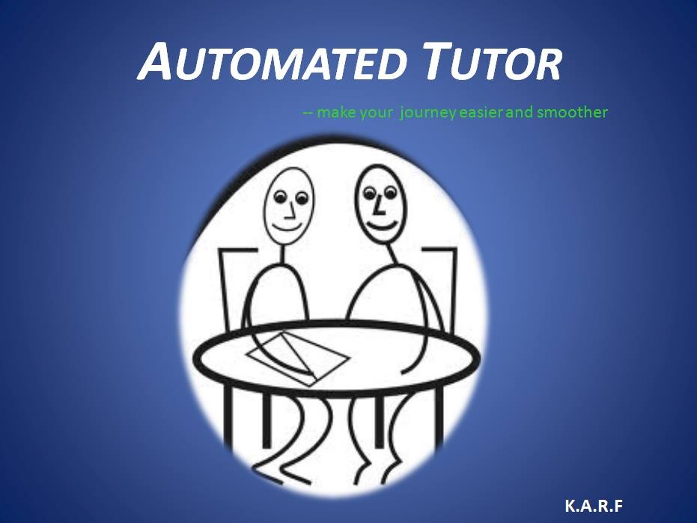

Screenshots of the app
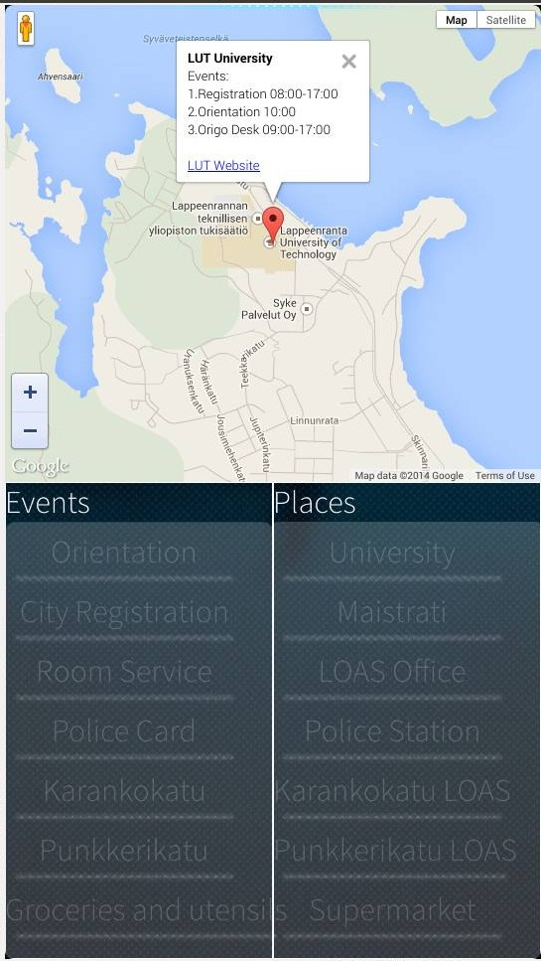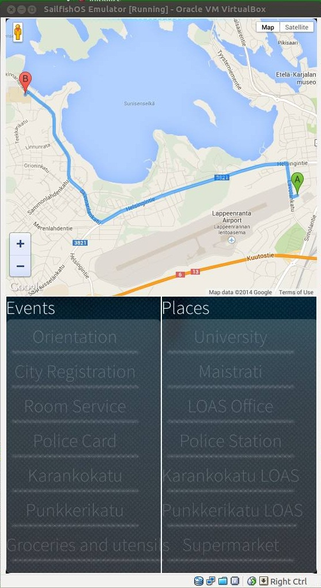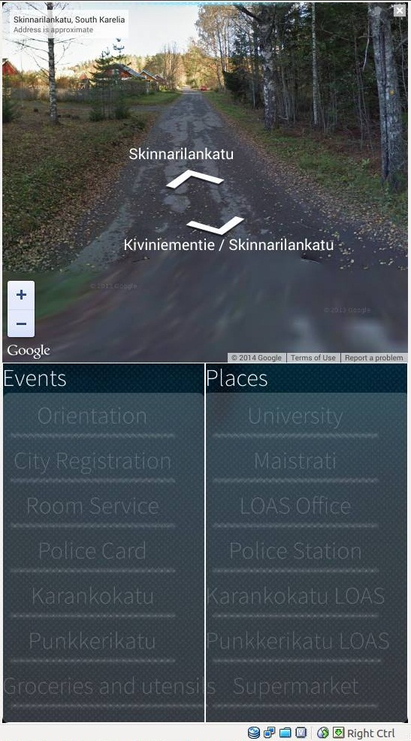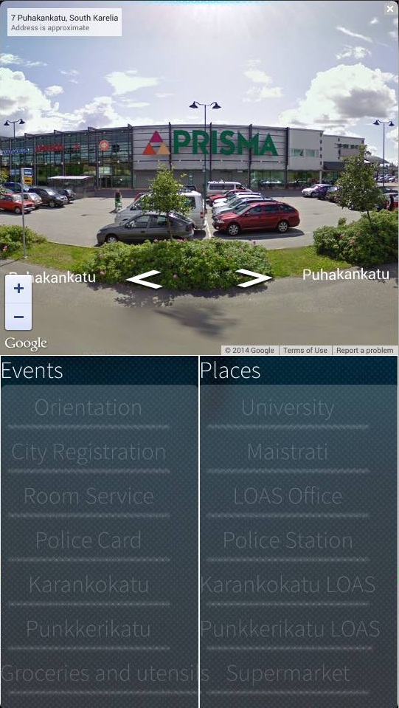

Parts of the Source Code
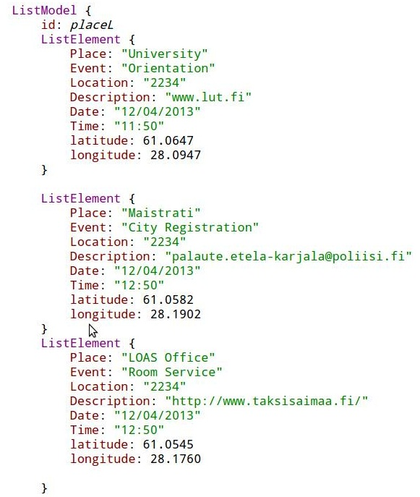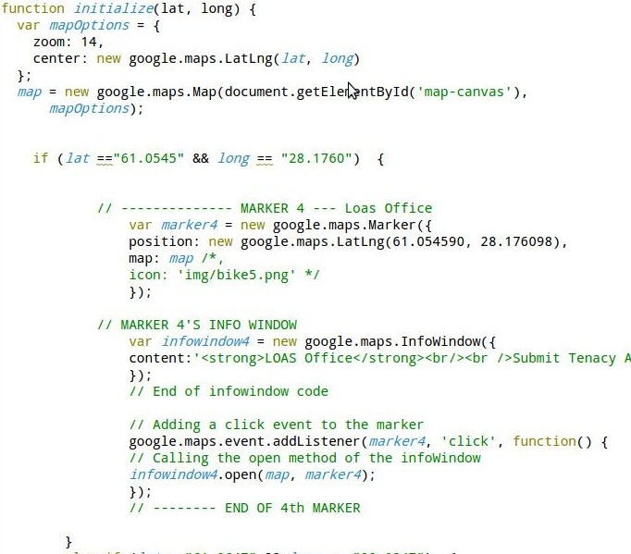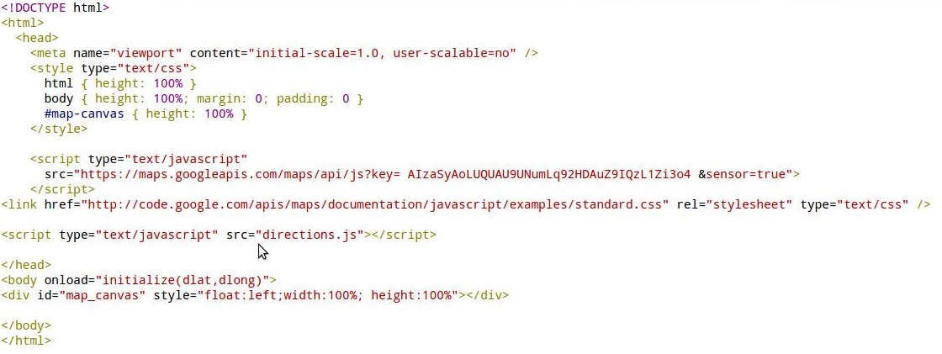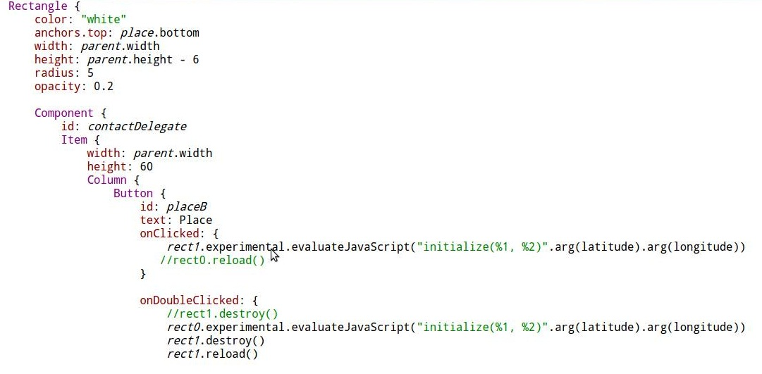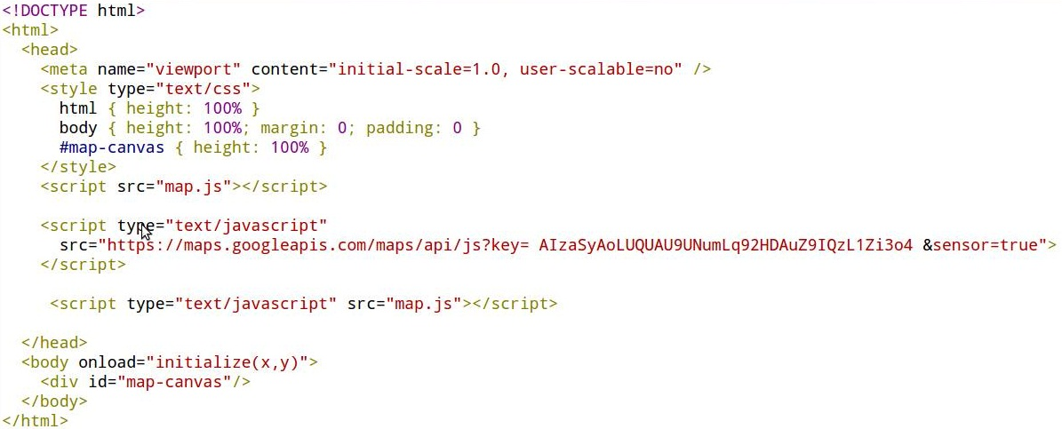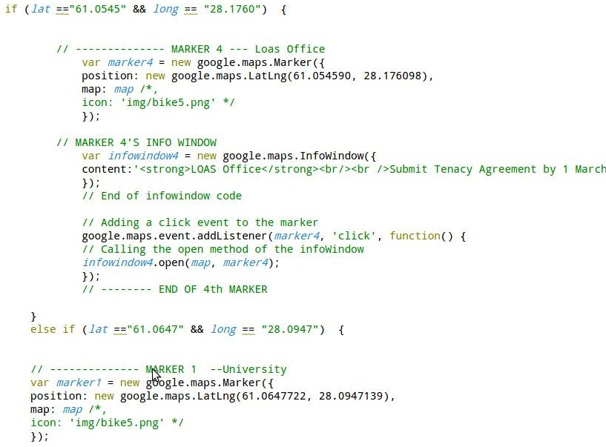
The source code of the App
The presentation slides
The report

Useful Links
Anyone who needs to get Google Maps on Qt platform can have a look at these links, they might be helpful :)
for Google Maps API: http://code.google.com/p/qml-google-maps/
http://www.geocodezip.com/
You guys can contact us for help, we are free to answer your questions

Reference
[1]: http://qt-project.org/doc/
[2]: http://www.w3schools.com/js/
[3]: http://www.w3schools.com/html/
[4]: http://codecamp.fi

