Easy Tourist
Team * Vlad Cristea: 0424647 | * Victoria Palacin: 0424744 | * Maike Schmidt: 0424799 |

Idea
What if you could have Helsinki in your hands? … Navigate through one app which will show you all the possible activities, attractions, events, accommodations, blog's recommendations and even more in Helsinki, according to your interests and constraints. Easy Tourist will be a Jolla App which provides you all of this information in real time and customized.

Context
- There is a lack of fully integrated Apps which help tourists to discover a city such as Helsinki.
- There is no such App for Jolla
- Finland is providing OpenData to allow the development of applications to face the challenge of mass tourism (They already released initiatives such as OpenHelsinki)

Technologies
- Windows OS
- Virtual Box
- SailfishOS Alpha SDK
- Qt Framework 5.2
- Sailfish Silica Library
- JavaScript

Data Sources
- Helsinki Tourism Open Data
- Open Weather Map
- Visit Helsinki Blog
- Maps API
- Helsinki|Public Transport Timetables of Helsinki region
- World Weather Online API

Screenshots
- Main Screen:
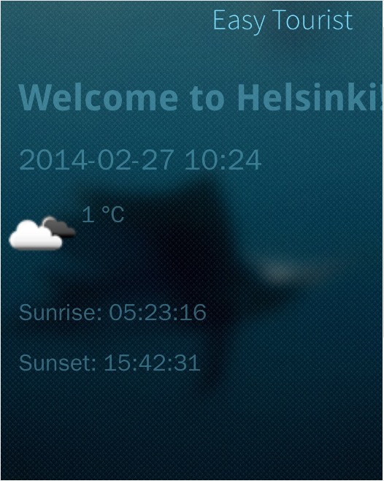
- Main Menu:
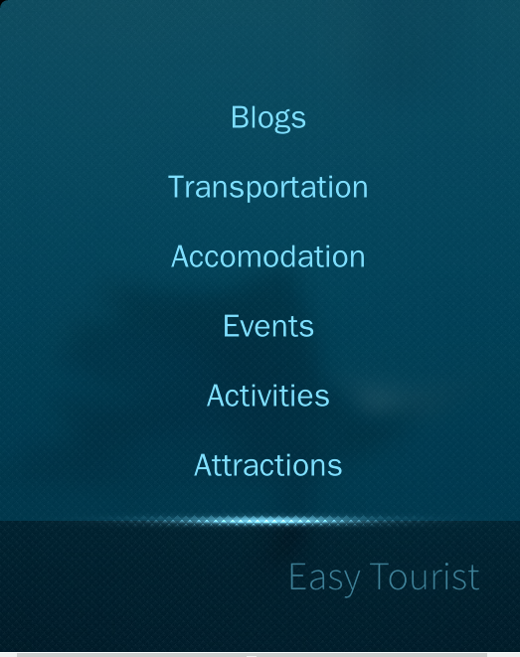
- Forescast:
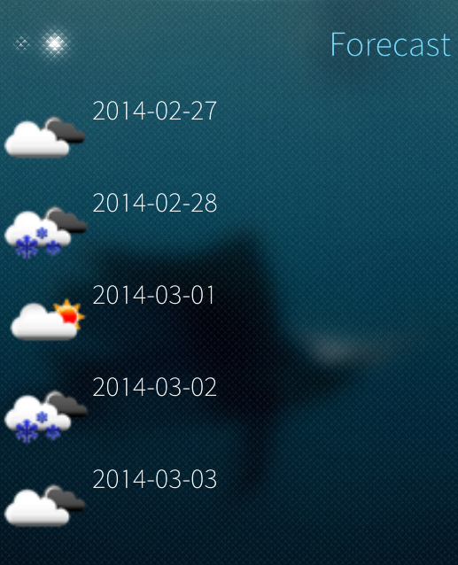
SubMenu Example (Accomodations)
- Sub Menu Accomodations:
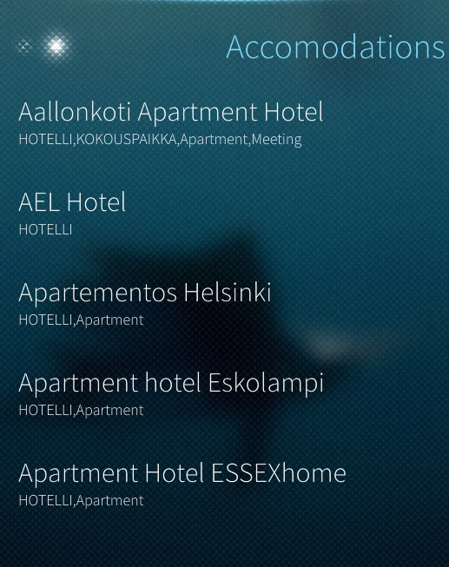
- Sub Menu Accomodation's Details:
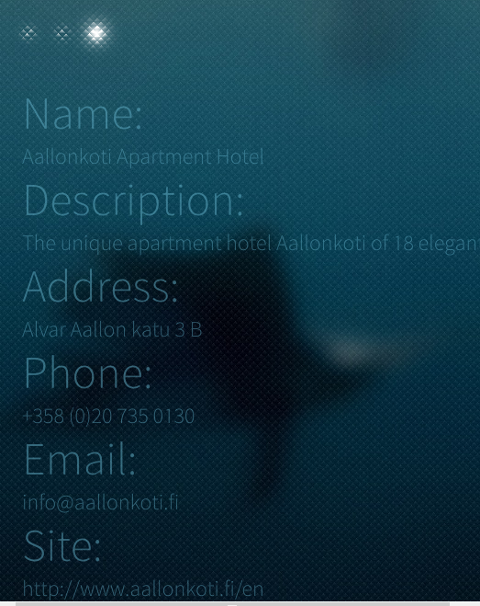
SubMenu Example (Attractions)
- Sub Menu Attraction's Maps:
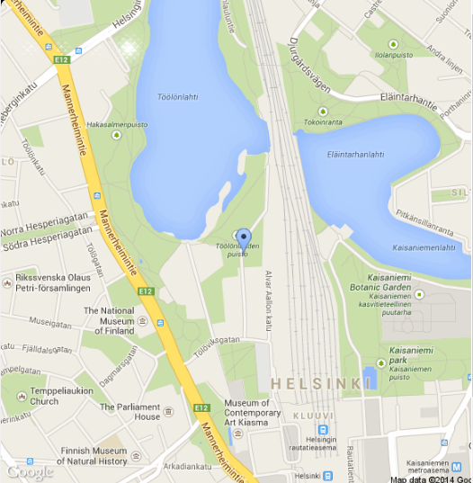
SubMenu Example (Transportation)
- Sub Menu Transport's Timetables:

Poster
* 

