grp12 - DrawingViewer
- Harri Hämäläinen – 0076075 – LUT
- Marko Ihonen – 0279076 – LUT
- Antti Knutas – 0279186 – LUT

Idea
- Motivation:
  - Visual information, drawings and details from a precast element is needed on all stages of a construction project.
  - The availability of printed documents is limited especially on a construction site
    - Number of parties require this information during a day so it should be accessible at all times.
- The usage of mobile device to download drawings and details from a BIM-model

Presentation
slides

Screenshots
Main screen
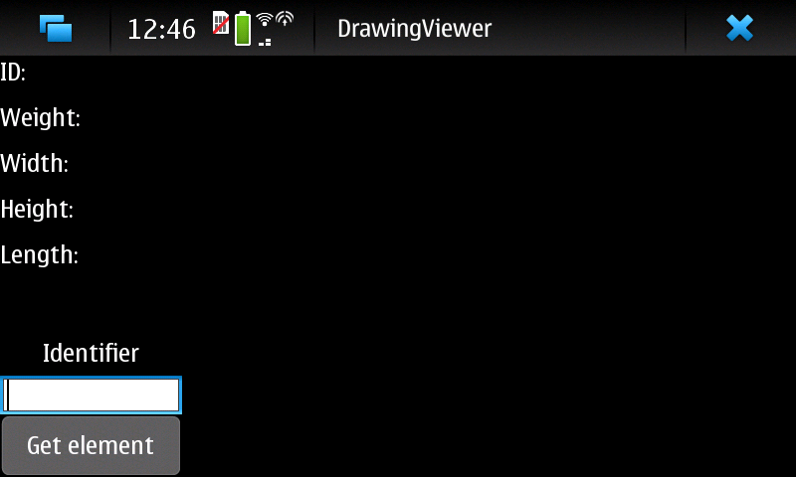
After successful download
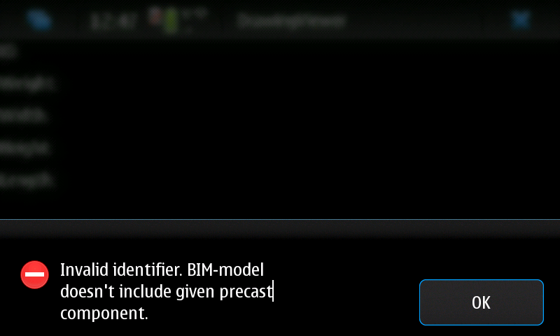
Invalid identifier
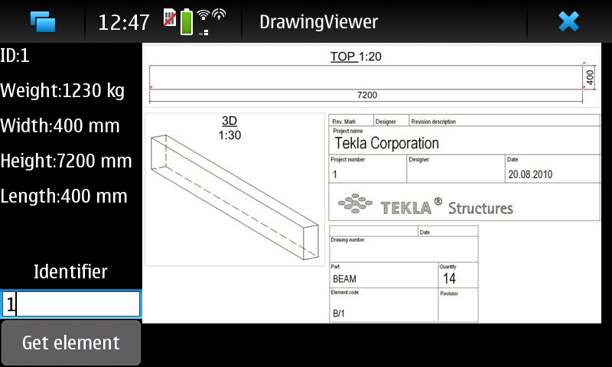

Code
Upload and attach your project source code package here.
- Clean up compiled binary files before making package
- Use .zip format
Server source

Conclusion
Your group comments and thinkings of developing you project in maemo environment.

