Project Name: Ageometer
Group 3
- Ananta Bhadra Lamichhane (LUT: 0331749)
- Nana Assyne (LUT: 0346792)
- Pankaj Jaiswal (University of Eastern Finland; Joensuu)

Idea
This application estimates the age of any construction based on observatory value and construction parameters. Since Construction Industry have variety of structures, so, primarily we will focus on bridge and consider expanding to other structure if time permits. The estimation is based on standard mathematical expressions for age calculations.

Motivation
Most construction projects are located far aware from organizations or companies promises. Construction Engineers when at site need to perform some test and get result immediately.
The only device that is appropriate for such test is our mobile that can make instant calculation on the site .It is in view of this that we are developing “Ageometer” whose main purpose is to help construction engineers to be able to perform test on concrete (bridge) to determine how long a concrete can stay (life expectancy) which include the ability to perform and get result on site everywhere without permanent physical connection to cable networks
- Evaluation and Simulation of life time of a construction design and structure have been always a huge burden in terms of time and resources.
- Solutions are always very complex in terms mathematical computation and modeling.
- Moreover, Code Camp is an excellent opportunity to be familiar with new tools and programming languages.

Inputs
- Crack information with Sensor/ Else picture processed with image processing techniques to detect the crack (obviously we are not proccessing the image now in this code camp)
- Bridge Information from Archieve or Database or manual input
- Cloride Ion Value of the Concrete Structure

Outputs
- Mathematically calculated estimated age of the construction.

Description
This application makes easier for Construction Engineers to make a estimation of age of a concrete structure. Since the variety of construction structure is very wide, we would focus on only few structures.
The formula given below is for calculating the estimation age of concrete structure but to make it easier for our application we have generalized the formula :- 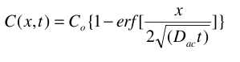
where:
C(x,t) = the measured chloride concentration at a desired depth,x;
Co= the surface concentration measured at 0.5 in below the deck surface, lbs/yd3 ;
t = the time in years; and
Dac= the diffusion constant, in in/yr.
The erf (y) function is the integral of the Gaussian distribution function from 0 to y.
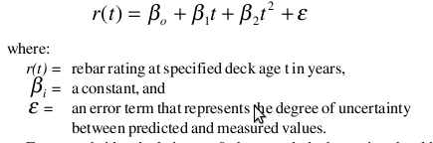

Features
1 = most critical or core .. 3 least critical or core feature
Feature | Priority | Status
input | 1 | done
Info Process | 1 | done
output | 1 | done
view report | 1 | done
File Storage | 1 | done

System Requirement
- Nokia N900 Tablet
- Maemo environment

Design
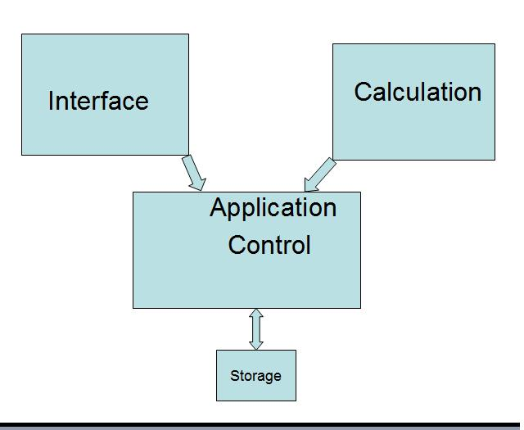

Screenshots
Input Interface
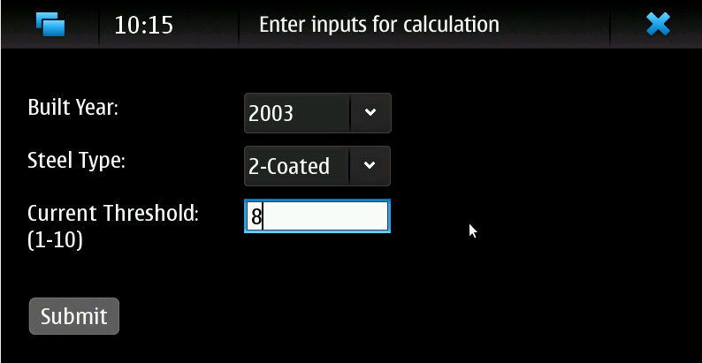Input Interface
Main Interface
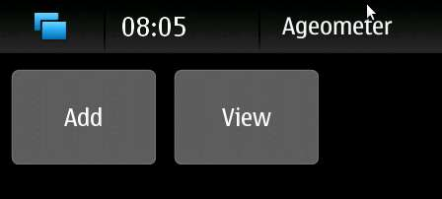Main Interface
Output Interface
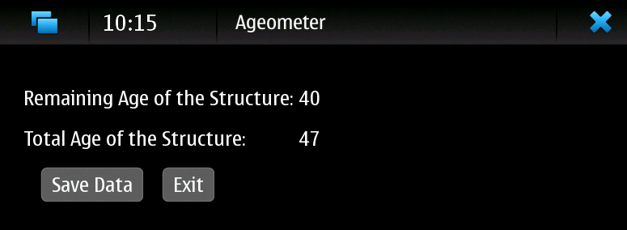Output Interface

Implementation Comments

Presentation
Idea Presentation: ageometer_-_idea_presentation.ppt
Final Presentation: ageometer_-_final_presentation.ppt

Package
ageometer_-_final_code.zip

How to run
It runs on the normal running procedural as other GTK files. It does not have any specific requirements.

Conclusion of your work
- Code Camp is wonderful experience in terms of learning and sharing knowledge; specially when code is working as the way we wanted.
- Building solution for the field which we are really not much familiar with, Construction Industry, is challenging while starting.
- Device Integration would have given much flavor to our application, but we are happy that at least we managed to make the framework while learning for a completely new tool.

