grp4 - INFO-PIC
- Karki Bandana – 0361959 – LUT
- Fatemeh ahmadi zeleti – 0361739 – LUT
- Tuomas Kuitunen – 0237788 – LUT

Idea
INFO-PIC WHAT: Is a Maemo application in which you can share information of any construction site (Ex: Broken Item, walls, and any other problem with the construction) and attached to its picture taken.
WHY: Save time and money, faster and effective communication, reduces an unnecessary queries, provides as clear as possible information
HOW: Picture of the item will be taken by the camera, and information will be attached as a comment to the picture and will be sent to the recipient. (Ex: Head engineer in charge, or any other trusted person who can give idea)

Introduction Presentation
info-pic-pdf.pdf
Final Presentation: info-pic_final.pdf

Screenshots
Upload and attach couple screenshots of application 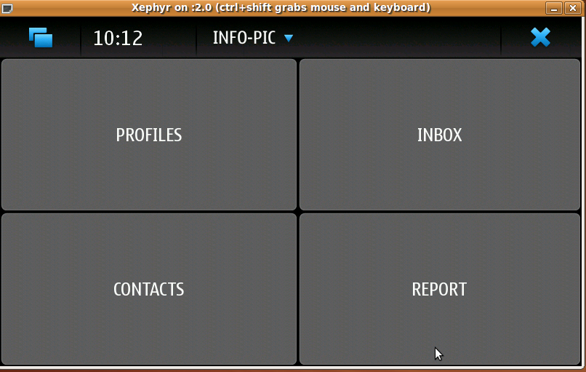 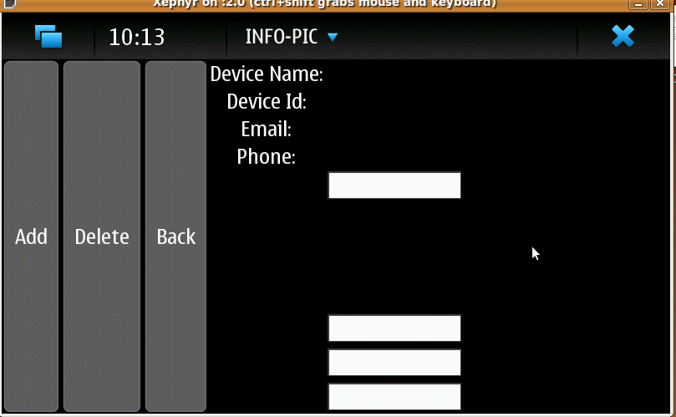 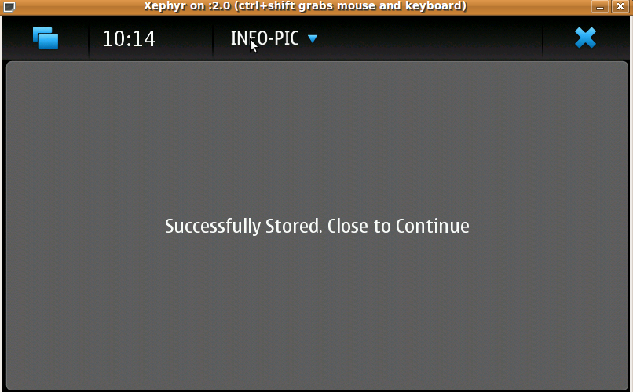 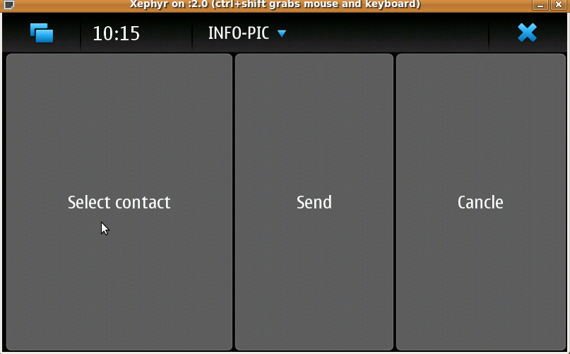

Code
Upload and attach your project source code package here.
- Clean up compiled binary files before making package
- Use .zip format
- infopic_forme.zip
- Document document_for_info-pic.pdf

Conclusion
24 Hours code camp is a very perfect and nice experience. working with the team members and other teams, staying for the night, and experiencing new programming language and sharing ideas makes it much more incredible as you can ever imagine.
Maemo doesnt seems to be hard and complicated, but its a nice programming environment that never let you feel bored.
Your group comments and thinkings of developing you project in maemo environment.

