grp6 - SHAKE IT
- Radim Svoboda – 185050 – University of Eastern Finland
- Liao Ding – 186109 – University of Eastern Finland
- Aiguokhian Efosa – 207798 – University of Eastern Finland

Idea
This application should help workers at a construction site who work with big gloves. Once they want to check something, it would be convenient by just shaking the phone to get the desired information instead of pushing those small keyboard buttons.
The first idea was to pickup the phone N900 by shaking it. Unfortunately, we discovered that it not possible to pick up a phone call within another application - probably because security reasons.
The other idea was to display the GPS coordinates, again by shaking the phone. However, we were coding in C, and it was really difficult to find the GPS coordinates without a change of location.
Eventually, we just display the date, and we notify to user by a beep sound. However, we can use the shaking to trigger any action.
shake_it.pdf

Detail Description
When this application is running, and the user shakes the phone, either up and down, or left to right, the phone/application is able to recognize the movement and triggers an action. Right now, it notifies the user by several beep sounds and displays the current date and time.
Some people may shake more than the others. Inside the source code, there is a variable that contains a value which is the minimal shaking limit(describes how much the user has to shake). Our application is just a prototype that shows some functionality, and it is not an end-user application. For that reason, there is no user interface to change the shaking limit.

Function Flow
Shake movement estimation ⇒ Trigger action ⇒ Press a full-screen button ⇒ Turn off the application

Achieved Functions
1.Shake movement estimation
2.Call up Date function(Encounter with unknown problem to call up the GPS function, so we use call up the Date function to instead of)
3.Shake/Touch to turn off the application
4.Beeping function(additional Mini function)

Screenshots
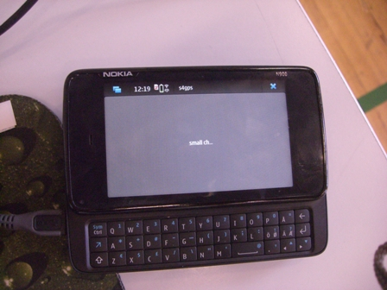
Estimation of shake movement return false.
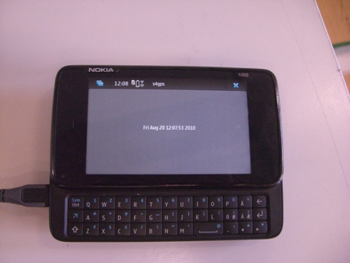
Call up the Date function successfully.
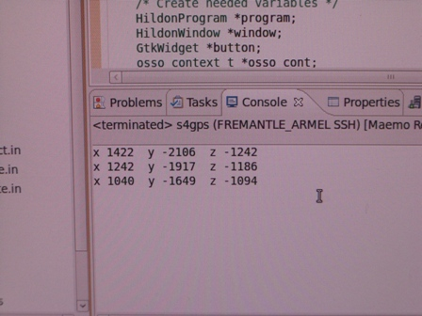
The data of accelerometers collected.

Code
shake4date.zip

Conclusion
What we have done so far is just prototype, we could not actually achieve all what we proposed in our plan but we were able to achieved shaking the mobile phone (i.e.N900) to display the date and time of the day to the construction workers and of course to notify them by a beep sound.
After experiencing the Maemo environment, we just feel that it's not as easy as Java. Also, we were not familiar with Maemo platform; this brings a lot of difficulties for the programming, developing, etc..

Reference
http://wiki.maemo.org/Accelerometers
http://wiki.maemo.org/Documentation/Maemo_5_Developer_Guide/Using_Connectivity_Components/Using_Location_API
http://maemo.org/development/

