Construction Monitoring System
grp 07
Group members:
Evgeni Kovalev (0500765)
Pavel Osipov (0600767)
Alexey Denissov (0346941)

Idea
Construction Monitor System is a tool for construction site inspector, which based on Maemo 5 software platform.
How it goes: construction site inspector loads into his Maemo based device information about construction sites, which contain GPS position and aspects to be inspected. After that he drives to the construction site and makes some inspections of the building to his inspection list, snapping some photos and so on. After that, the device synchronizes new inspection data with the server.

Presentation
cms.pdf

Features
Job | Priority | Status
Design Database | 1 | Done
GUI | 5 | Almost done
GPS | 4 | Never tried
MAPS | 6 | Tried
CAMERA | 3 | Never tried
LOGICS | 2 | Unfinished

Database
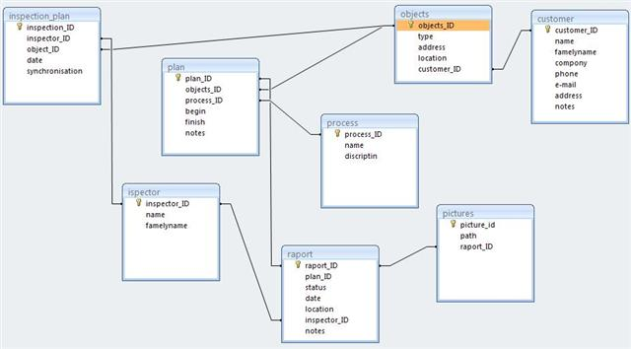

Screenshots
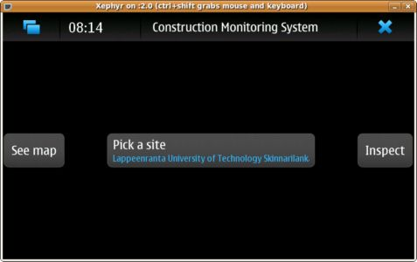
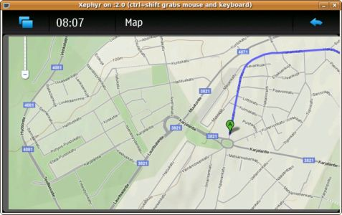
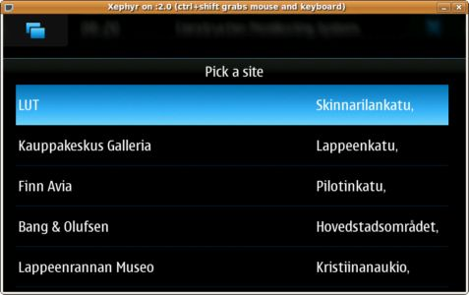

Presentation
cms_done.ppt
cms_done.pdf

Repository
CMS v 1.0.1.2
cms_pavelosipov_alexeydenissov_evgenikovalev.zip

Artifacts
CMS Brochure in both formats 1 page
brochure_grp7_kovalev_denissov_osipov.pdf
CMS Description in both formats ~6 pages
description_grp7_kovalev_denissov_osipov.pdf

