grp8 - MOCOP
- Fawad Ahmad – c0346705 – LUT
- Zahir ul Din Babur – c0346815 – LUT
- Sita Pun – 185048 – UEF

Idea
Project management is the discipline of planning, organizing, and managing resources to bring about the successful completion of specific project goals and objectives. It is equally important in construction industry just like in any other industry.
The basic idea of application is to facilitate the project manager to assign tasks to workers doing work on remote sites by mobile devices.
This thing will help both project manager and workers to save time while in synchronization as well having the archives of assigned tasks. The application will have server and client sides. Server will communicate with client and make the changes automatically into the client mobile device calendar.
The client will be notified with the Alarm which will ring on specified time before actual start time of task. Client will also be able to reply the project manager by the status of the task.
In bottom line idea is to safe time in communication and getting to be at the one point.
For this purpose Nokia Maemoo technology is used to make application for mobile devices.
construction_industry.ppt
final.ppt

Screenshots
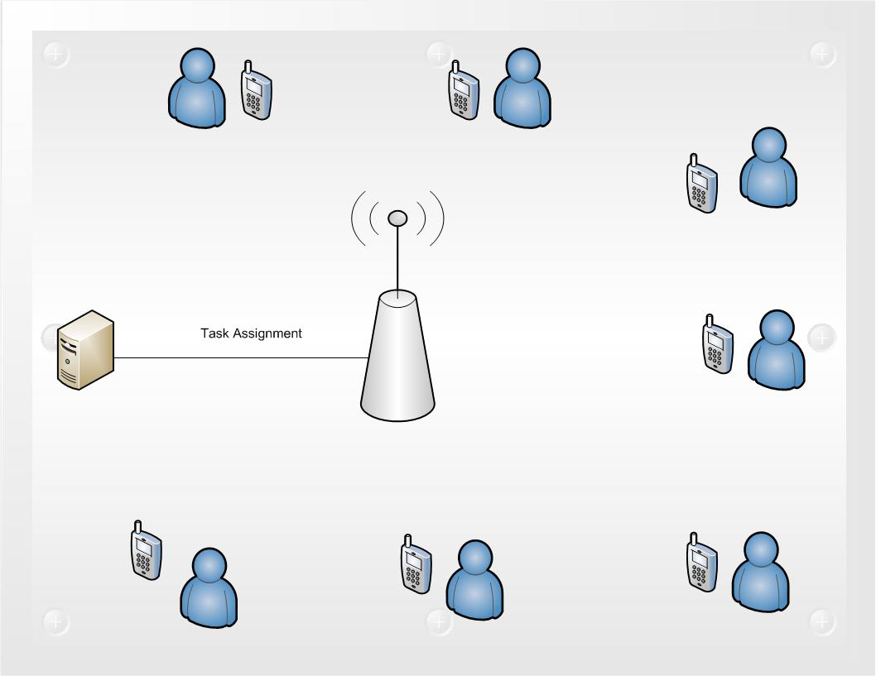

Code
newserver.tar.gz
server.tar.gz

Conclusion
Failures/ difficulties
- Getting started
- All planned features are not working as planned.
- Poor documentaion for Maemo API's.
Successes
- Work went well after initial problems .
- Implementation of core functionalities.
- Learning of work in intensive working environment.

