grp9 - Warehouse Management System for construction factory
- Barun Khanal – University of Eastern Finland, Joensuu, Finland
- Nina Korjus – Lappeenranta University of Technology, Finland
- Tania Belyaeva – St. Petersburg State Polytechnic University, Russia
- Natalia Tetervova – St. Petersburg State Polytechnic University, Russia
warehouse_management.pdf

Idea
→ When the product have to be kept in Warehouse the worker has to khoum where exactly the location. Where they have to keep the product.
→ After the product have been placed to correctly to its location, worker confirms. This information has to be added to stock of warehouse database.
→ The GPS location of product placed will be confirmed by system and misplaced it will be informed to workers informed to workers instantly .
→ When the order is made the system will notify workers (specific one) about the order to his mobile device .
→ Products that he have to transfer from warehouse to transport.
→ Each product transferred will be confirmed by workers or the whole order; which will be updated in database.

Screenshots
Upload and attach couple screenshots of application

Code
Upload and attach your project source code package here.
- Clean up compiled binary files before making package
- Use .zip format
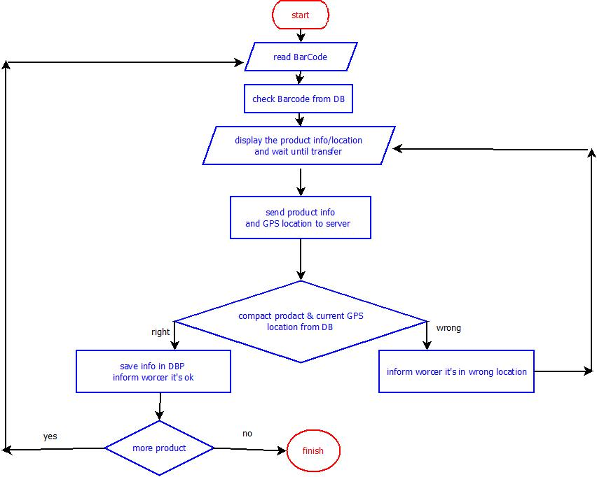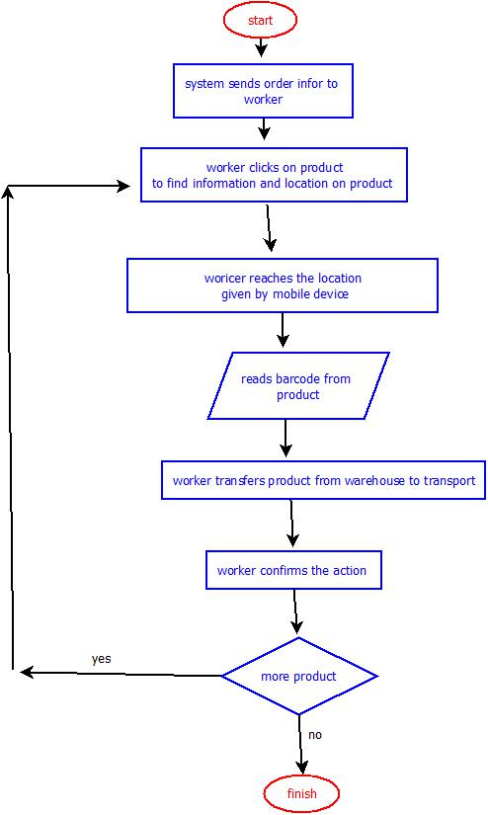

Conclusion
Your group comments and thinkings of developing you project in maemo environment.

