Group 2

Table of Contents

- Group members
- Ideas
- Motivation
- Features
- Technology, platforms and access methods
- Explanatory charts
- Project link and files

Group Members

Team name - The Hedonists
Abedin Md Anowarul
Adekola Adebayo
Rajeshwari Chatterjee
Sumeet Thombre

Ideas

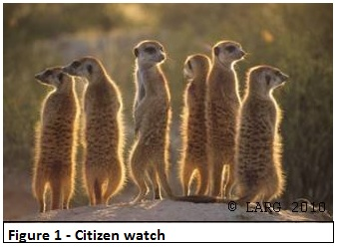Citizen watch?400x200
TheCitizenApp - Good governance through citizens' participation.
Netizens can report the safety and facility issues of their area along with an optional review for that area through TheCitizenApp, both in web and mobile platform. This application is more focused for the developing countries or regions where civil services(amenities) and security cannot be ensured due to inadequate resources, bureaucracy and corruption. An immediate option for reporting safety threats and common facility (electricity, water etc.) problems in the locality is available in TheCitizenApp.
People can, in real time, report incidents of crime, noise, traffic violations, hostility etc. These reports from the netizens will be open for all, that means our application will work as an Open Data source for individuals or organizations (including government). Thus the police stations, municipal offices, fire departments, other government offices, NGOs, international organizations etc will have access to these reports. It helps to increase the level of good governance. As an example, we can mention some reporting of violence in an area. As data and reports of violence in that area is available to everyone, there will be increased pressure on police stations of that area to do more patrolling or to take some measures. In addition, people can also report on issues related to general civic facilities such as electricity, water, roads, infrastructure etc. Here again, there is an option to give an optional description of incidents. In such cases, the problem will be considered urgently. If the number of reported incidents reach a particular threshold value it would add greater credibility to the incident reported, which would in turn encourage administrative agencies to take action for redressal.
The below table displays the categories of problems addressed by the app -
S/N | Safety | Facility
1 | Theft & robbery | Roads
2 | Violence | Electricity
3 | Sexual harassment | Water
4 | Suspicious behavior | Cleanliness
5 | Others | Others

Context of the Code-camp - This main focus of the codecamp is on Open Data, Citizen Science and implementing Green IT technology. TheCitizenApp address all three issues and therefore upholds the spirit of the code camp. focuses and thus goes well with the context of the codecamp.
TheCitizenApp addresses the context of Open Data by itself being an Open Data source. The application uses Open Data source such as Google Map, and it also exposes itself as as an open data source allowing integration scope by third parties. Any one can use it for further analytical/analysis reporting and display. Also, this data is open for all and an API is available for further integration by third parties.
Citizen Science is the collection and analysis of data related to the natural world by members of the general public, typically as part of a collaborative project. Crowdsouring is one of the primary implementations of Citizen Science.TheCitizenApp adopts the idea of crowdsourcing for data collection, analysis and making it available and open for future use and further analysis by other organizations. Thus this application is a good example of Citizen Science.

IT for Green -
- The CitizenApp could be used to ensure environmental cleanliness,promote citizen participation including their opinion for availability of better civic amenities.
- The CitizenApp could be useful platform for gathering statistical information and citizen’s opinion in a more resource efficient way.
- It is a platform for making an effort towards improving the quality of life of citizens

Motivation

Our project is named CitizenApp because we believe CitizenApp is of the citizen, for the citizen and by the citizen.
Of the Citizen: Like the internet does not belong to someone, it belongs to everyone involved, similarly, CitizenApp does not have one particular owner and is open for general use. Everyone will use it and with everyone’s use, it will flourish more and will improve everyone’s life.
For the Citizen: CitizenApp is made for the citizens, they will use it and they will get the benefit out of it. This is a good way/platform to express one’s grievances or report incidents of crimes while at the same time protecting the identity of the user. It also helps feel the strength of everyone’s participation on a particular cause.
By the Citizen: CitizenApp will be operated only by people, without their active participation it will not reap the benefits. The more they will use it, the more it will be effective.The backbone of our application rests on the data provided by citizens and therefore they remain our primary source for motivation.
Citizens often do not find a platform to voice their grievances or opinions freely. Even in a good democratic society, people get the option to voice their opinion only at the time for voting. This application provides a platform for participation of citizens to share their views across all strata s of the society , ensuring privacy and anonymity of the user's at the same time.The application demonstrates the importance of public opinion and involvement of citizens for ensuring good governance.
The CitizenApp will have a positive impact ensuring better transparency of opinions and makes and effort for improving the civil rights.A paper published by the World Bank [Bott et. al., 2014] stressed on the importance of crowd-sourcing for implementing good governance in fragile or in developing states. But the same method, could also be very effective in developed parts of the world as well.
With a focus to implement an application which is in line with “Green IT” and “IT for Green”, this application gives us further motivation since it implements a number of features concerning “IT for Green”.

Features

The following list describes the main features of the application -
- Incident Reporting.
- Scope for providing additional commenting for better insight.
- Viewing a detailed and comprehensive view of the status according to the problems divided into city/area.
- Poll of the Week based on a concurrent problem.
- Geo-location features which improves usability quotient.
- Statistical Report based on people’s feedback.
- An API for usage to retrieve number, area, type and category of reports
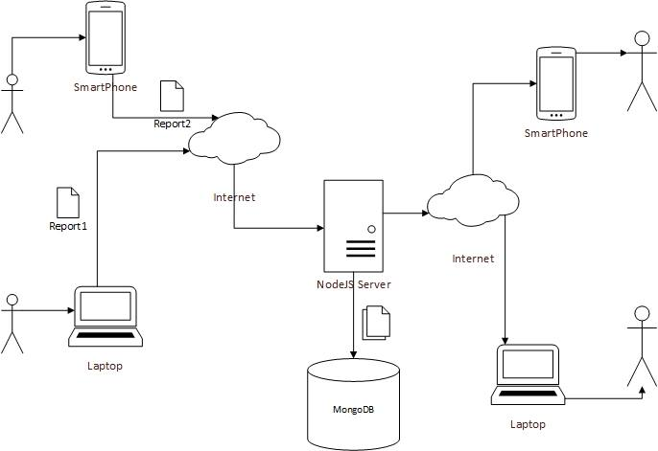
The table below summarizes the features of the web application and the API -
S/N | Feature | Category | Implemented
1 | Submit report at current location | Web app | YES
2 | Submit report at different location | Web app | YES
3 | View reports on current location | Web app | YES
4 | View reports on other location | Web app | YES
5 | View reports by category | Web app | NO
6 | View reports by distance | Web app | YES
7 | View reports by type | Web app | NO
8 | Get reports by ID | API | YES
9 | Get reports by type | API | YES
10 | Get reports by category | API | YES
11 | Get reports by location & distance | API | NO

Technology, platforms and access methods

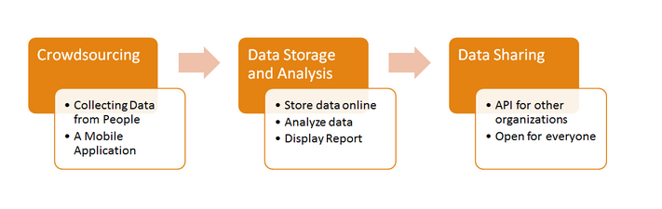
Fig: Process flow of Application.
For the purpose of web-development , we have implemented all the features in the MEAN stack.We have used Mongo DB for handling the database.In addition we have used Express for back-end web framework,AngularJS for the front-end framework. Finally we have implemented Node for back end web-platform. Apart from these we are using the Google MAP API,for location and area mapping.
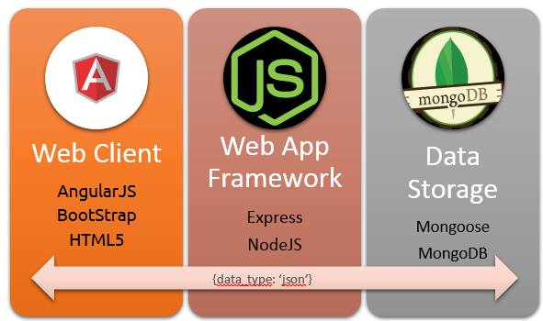
Details
The Citizen App offers its services through three major processes -
- Crowdsourcing
- Storing Data, analyzing and Displaying Reporting
- Sharing the data for future use
TheCitizenApp has two features presently -
- The Mobile App - At present the mobile application has only been partially implemented.
- The Web Platform –The web-application implements full features.

Explanatory charts

Figure - Interface of our web application
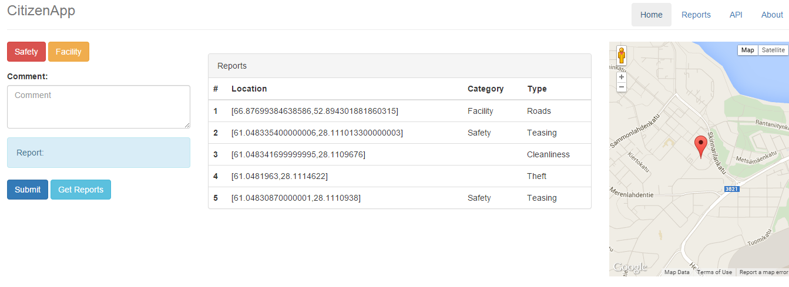
The list of reports according to the category can be accessed and viewed (screenshot below) -
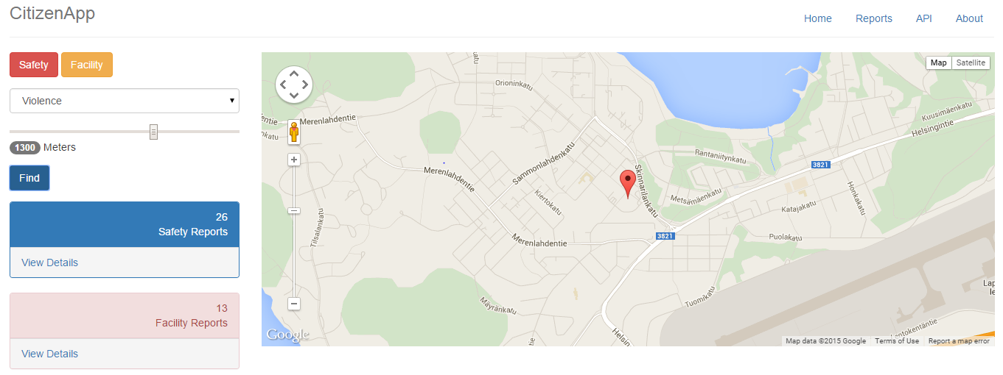
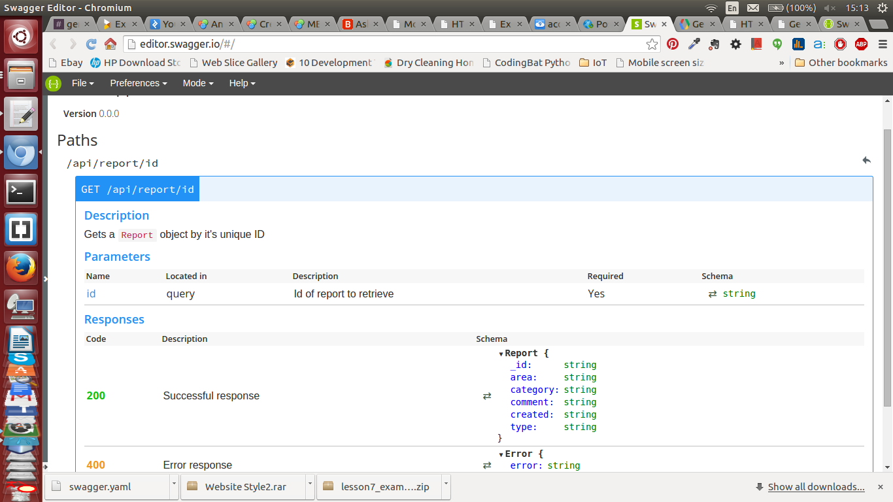
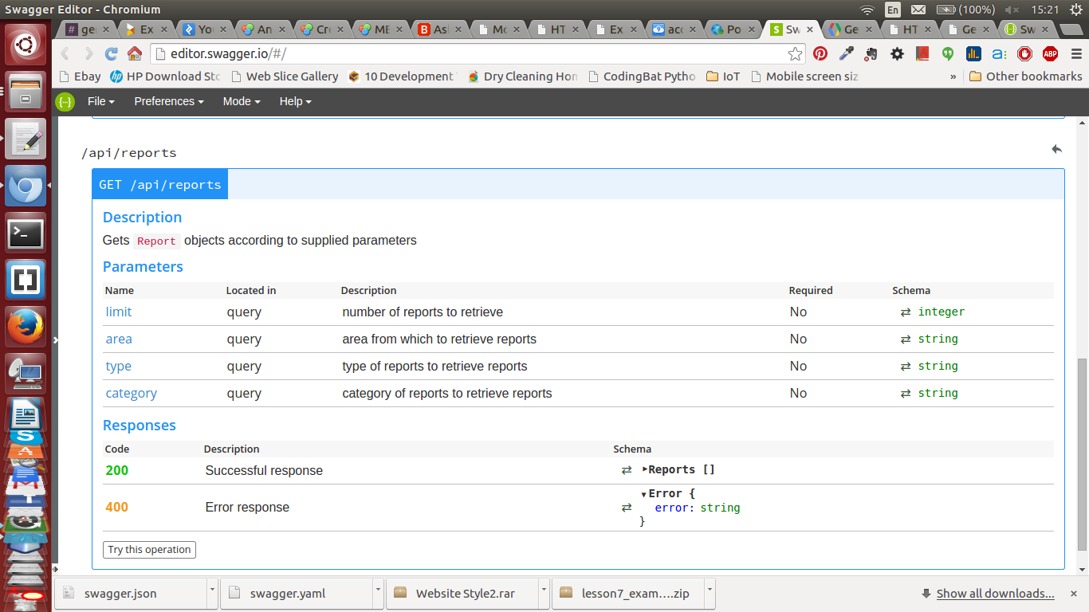
Figure - The API screenshots for the usage by others to query based on the type, category, area and number of reports is as shown above

Project link and files

The poster of our application is attached below,
poster-final.pptx
The presentation is attached below,
code_camp_presentation-_final.pptx
The source code can be found at GitHub External Link
The final report is attached as below,
the-citizen-app.pdf

