Group1
MINT - Move It Now & Then

Team members
Student Number | Member Name
0504606 | Sarah Kexel
0504305 | Carlos Gonzalez Juarez
460287 | Muninder Adavelli

Idea
We will create an application for companies that take care of their employees' health and want to motivate them through rewards. For the fitness, the amount of sleep, the adherence of breaks and the learning about health issues (how to treat sick colleagues) each worker gets points and will then be ranked among all employees and receive rewards for a certain amount of collected points. The app will receive data about the fitness and sleeping rhythm of the workers from their normally used fitness or running apps and sleeping tracker, since most of them have their own favourite app. The adherence of breaks will be checked through scanning a QR code next to the coffee machine or the bench outside. Workers can learn about what they should consider in case of a flu or about a sickness (like diabetics) of a colleague and get advises how to support him. Through the ranking workers can compete with their colleagues and get rewards from the company like a free day, free food at the canting, massages or books in order to motivate them to improve their health.

Motivation
Nowadays there are many applications that are related to tracking fitness and sport activities. Statistical findings show:
- Only around 20% of the population takes a lot of care about their health and around 50% of the population worry about their health –> hight potential to adress more people who are also willing to change something
- 33% of the 18-39 year old and 25% of the 40-59 year old would do more sport activities if it would be financially rewarded by the company
- 41% of the 18-39 year old and 36% of the 40-59 year old would do more sport activities if it would be financially supported by the heath insurance (→ provide the app to health insurances)
- 26% of the 18-39 year old and 19% of the 40-59 year old would do more sport activities for better carrier prospects
(https://de.statista.com)
Therefore we see a high potential in motivating people through company's rewards to use their own fitness, sport and sleeping apps in order to improve their health.

Features
Gamification
- Challanges among colleagues through rankings
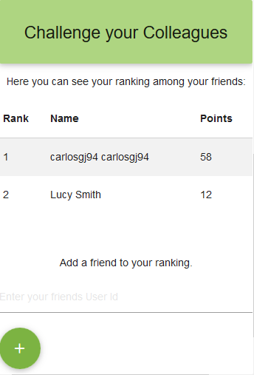
- Quizes to learn
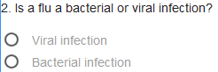
QR Code scanning and prove of breaks
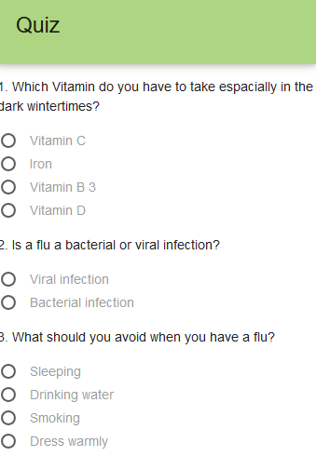
Fitness Tracking
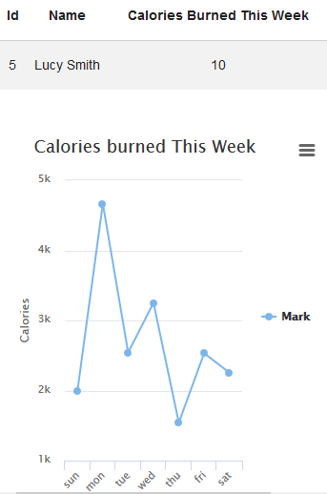

Technologies
Could9
Backend: Back&
Frontend: jQuery, Materialize
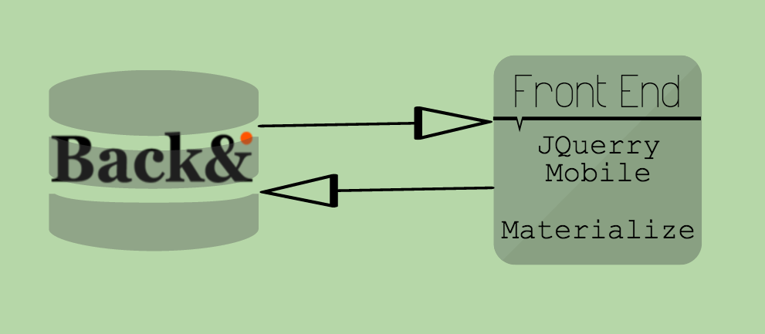
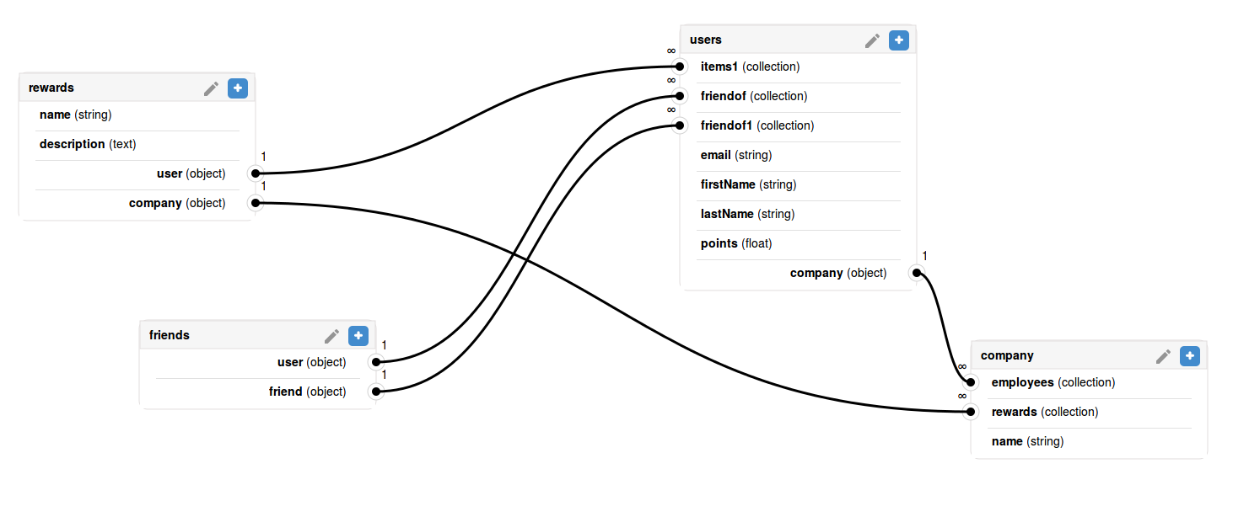

Schedule
Date | Activities
Day 1 | Define the idea and steps, set up brack- and frontend, build a snowman
Day 2 | Develop back- and frontend further
Day 3 | Develop back- and frontend further, gather customer feedback, prepare the presentation
}

Presentation
otso_case_code_camp_mint.pptx

App Functioning
https://www.youtube.com/watch?v=PfBkNdqt1UA&feature=youtu.be

Poster
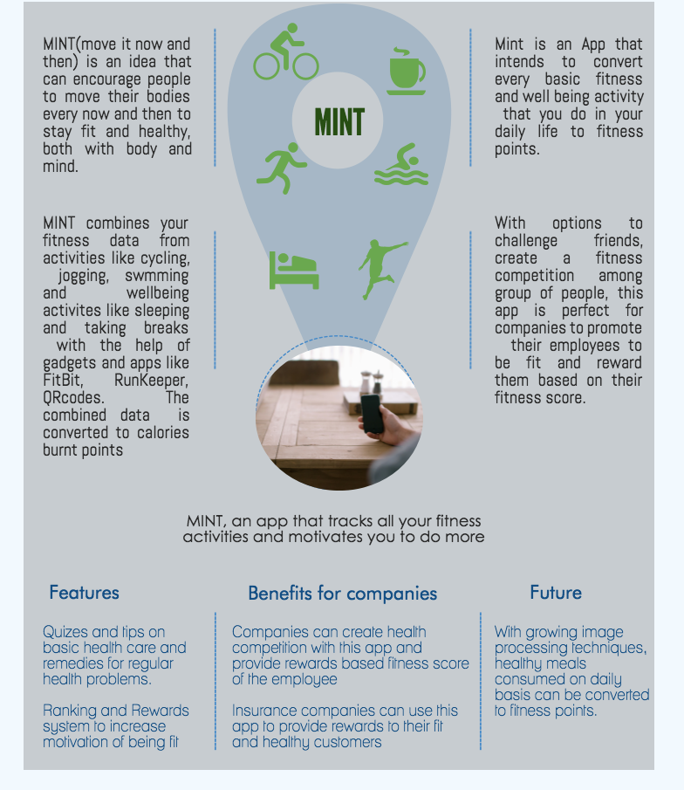

Final Report
final_report.pdf
final-report.pdf

Source code
[[https://www.sendspace.com/file/cufdek]

