PaavoInsurances
Group 1
Group Member | Main Responsibilities
Otto Laitinen | Lead front end developer
Joonas Pohjala | Special features, front end
Juhana Repo | UI, front end
Tatu Virta | UI, front end

Idea
Our idea was to create an insurance sale app which LTC-Otso wanted us to do. We managed to program all the three priorities. We also added possibility to make a new offer to the old customer. Our highly hyped special feature is barcode reader. Our app is able to read any kind of barcode, mainly social security number and S-bonus card.

Timetable
Day | What to do
Monday | Brainstorming and prototyping
Tuesday | Setting everything up, Coding, UI
Wednesday | Coding, UI
Thurday | Coding, UI, finish everything
Friday | Presentation

Motivation
We want to show what we can do. Paavos are two time Code Camp winners and we'll try to win this one also. We had a big group, so we need to do something special. As mentioned in the idea section, we were able to program the barcode-feature, which is kinda awesome.

Features
- Customers are able to make home insurance contracts with us. Data will be saved in Otso database.
- Customers are able to join “spam list”, so they will be contacted later about insurances they are interested in by email or phone.
- Old customers are able to do a new contract with us.
- We can recognize old customers by scanning the ID-card and they can join loyality program with S-card.
- Local database with social security numbers and bonus card numbers.

Tech
Visual Studio 2013 (C#, JSON.NET, XAML), GitHub, MarvelApp, Adobe Illustrator CC, CorelDRAW X6

Screenshots
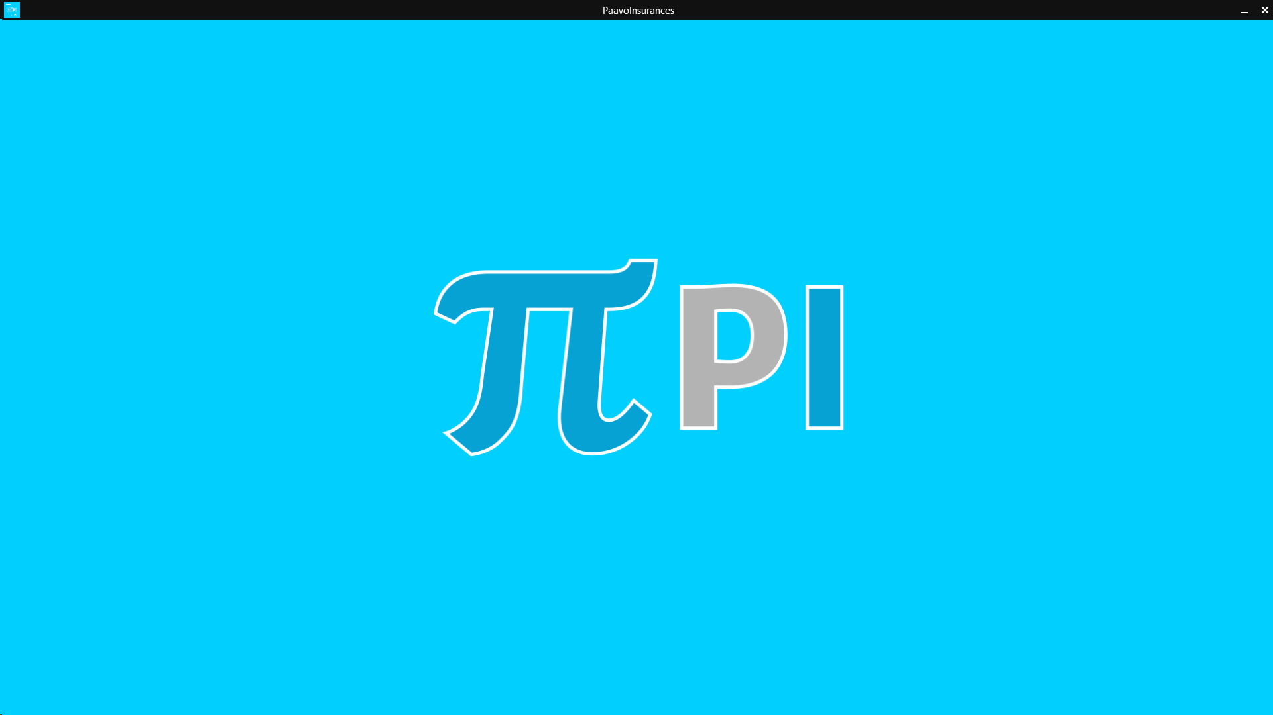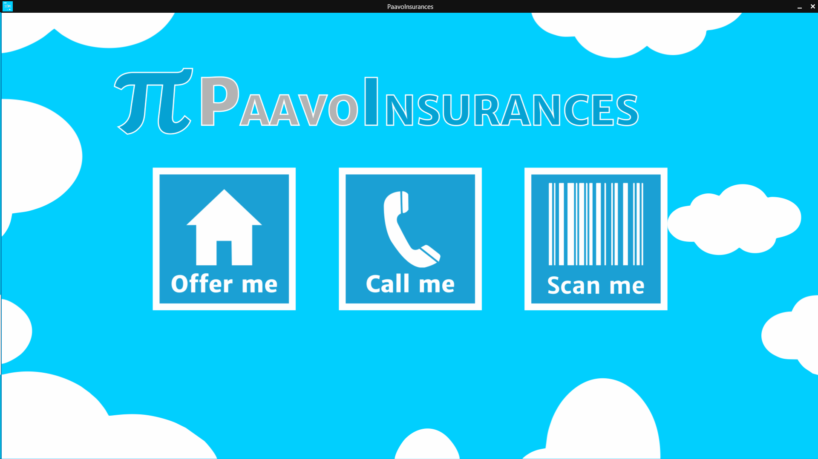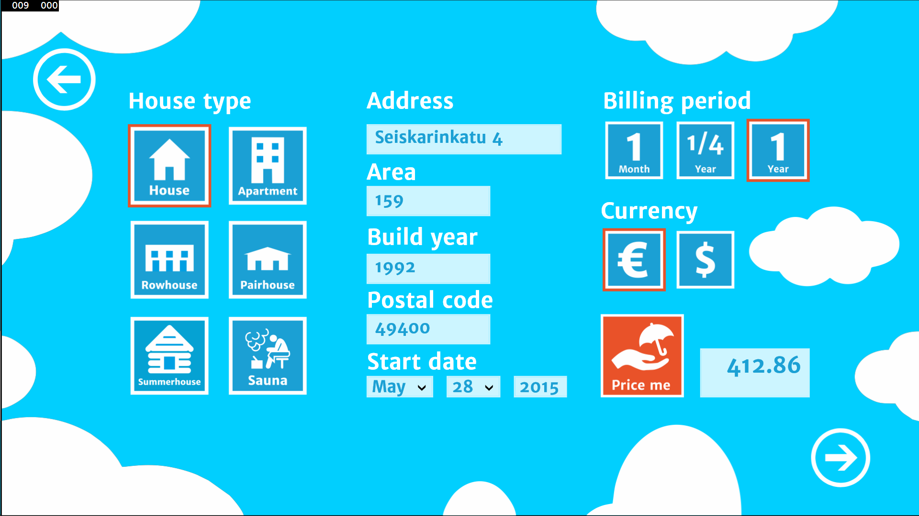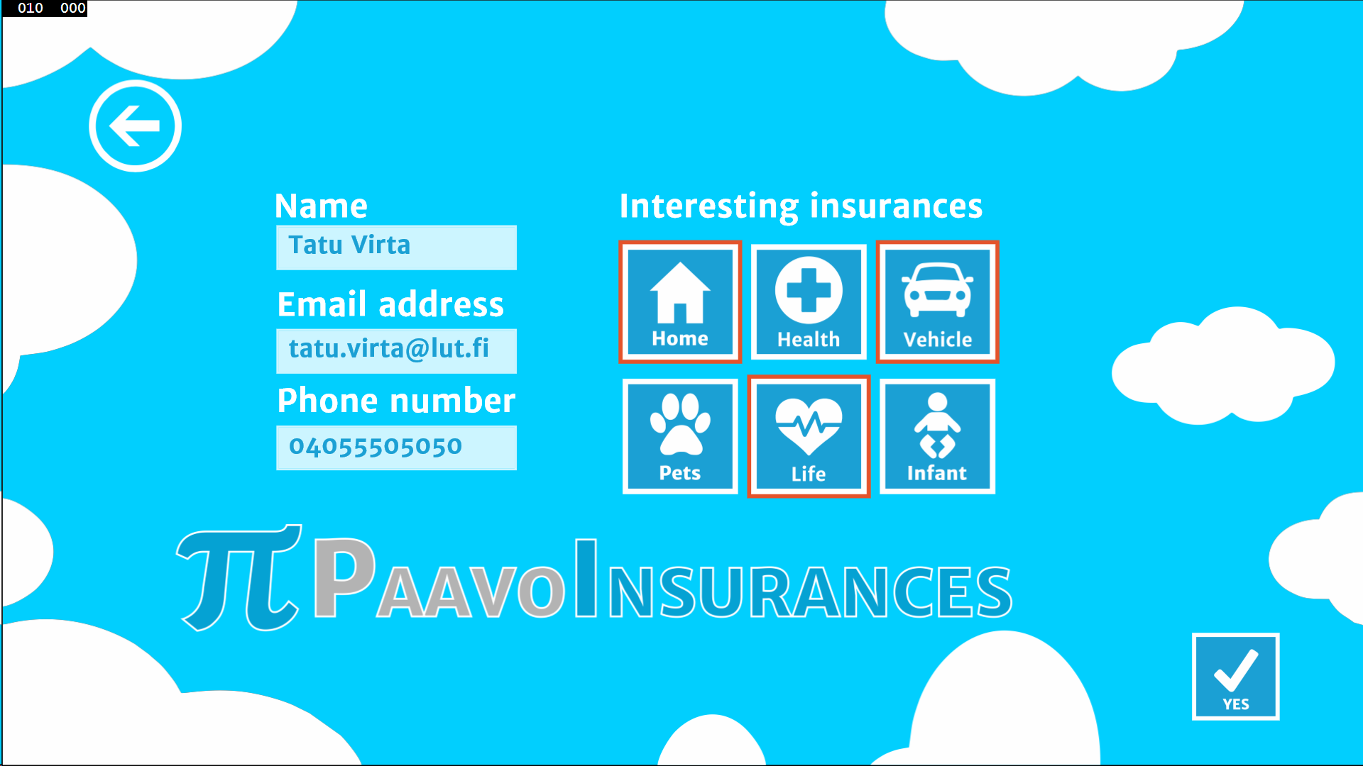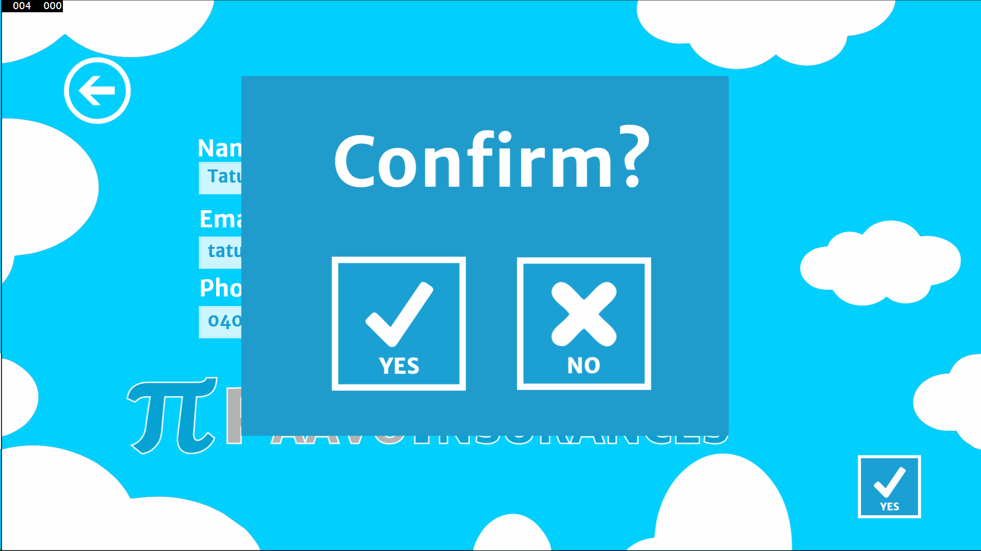

Software Poster and Demo Video
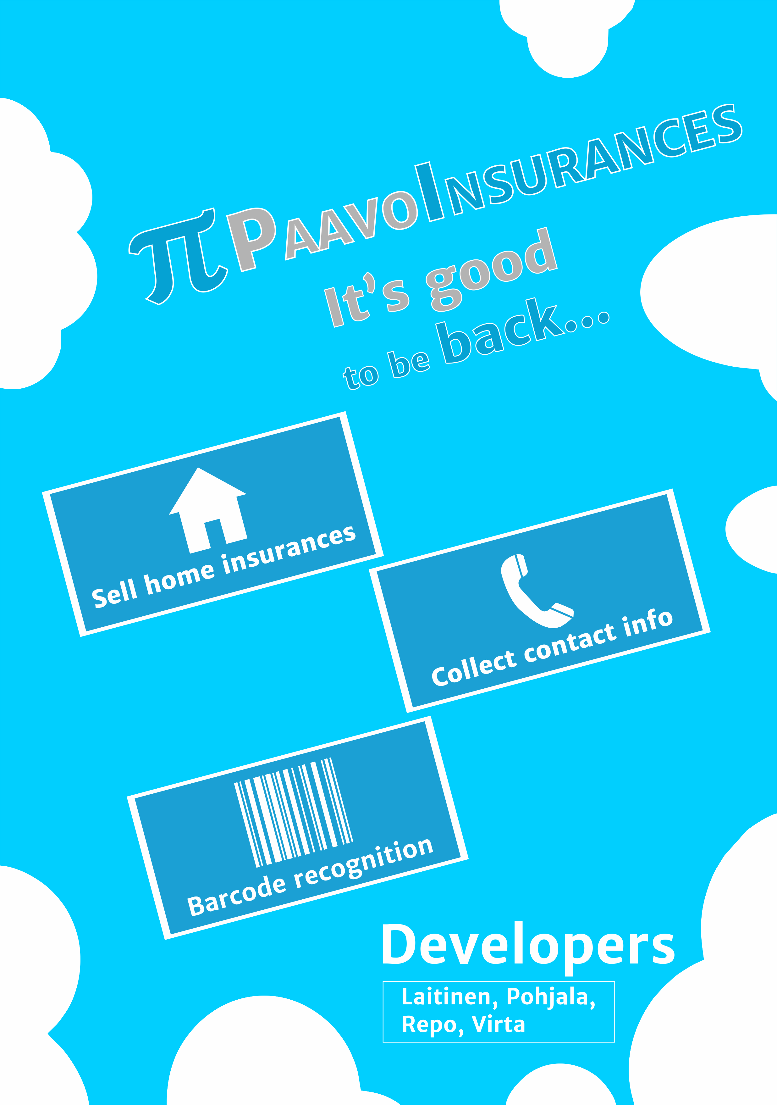
youtube>sPlyRNL51Js

Presentation and Project Report
Presentation (PPTX): paavoinsurances_slides.pptx
Presentation (PDF): paavoinsurances_slides.pdf
Project report (PDF): otso_project_report_group_1.pdf

Links
Source: https://github.com/Nathorr/PaavoInsurances
First mock-up: http://marvl.in/4cd81i

