Fixurance
Team Members
Group Member | Student Number
Manuel Delgado | 0385595
Alejandro Antillon | 0444627
Norismiza Ismail | 0406212


What is Fixurance ?
Grow your money and gain knowledge. With this main objective, the application is an attractive tool to estimate the insurance prices with minimum information for marketing purposes. It is specially designed for the mobile devices or tablet to support the mobility of sales representative in promoting insurance plans or as a stand alone application to the prospect customers. This application is designed to improve the usability and user-friendly.

Idea and Motivations
This document presents a project of Insurance Sales Tool that we called as Fixurance service in order to solve a business case with LTC-Otso in paving the future of customer management in paperless environment [1]. However, there are several challenges to achieve this goal. The challenges are: the difficulty to implement mobility in sales process, to support Partner Network Sales in any events and shopping malls and to create the more user-friendly and brief interactions with the prospect customers. The main idea of this tool is to: attract the customers as an attractive tool with the concept of “Grow your money and gain knowledge”, estimate the insurance prices with minimum information for marketing purposes, support the mobility of Sales Representatives in promoting Insurance plans; and support the prospect Customers to explore the tool as a standalone applications.
In brief, the business case is in needed of:
- Implement mobility in sales process.
- Support Partner Network sales in malls or events.
- User-friendly UI and brief interactions with the prospect customers.
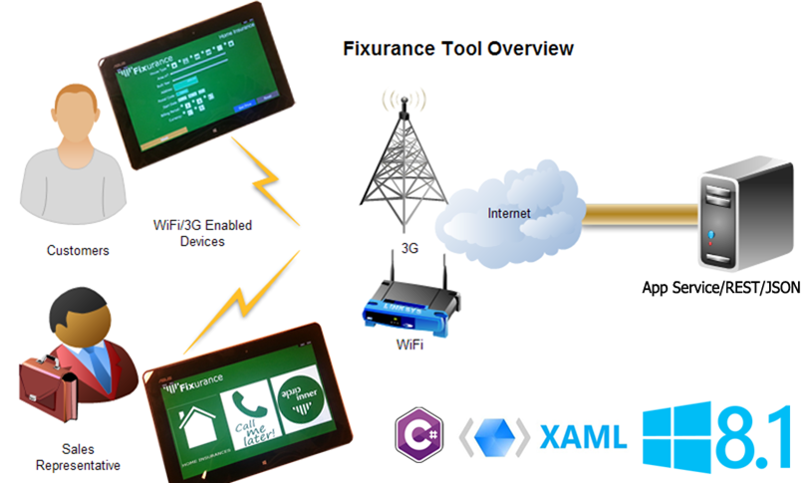

Goals
S/N | GOAL | Implemented
1 | Main GUI prototype | Yes
2 | Show the pricing estimations using REST | Yes
3 | Call me later feature | Yes
4 | Inner Circle (loyalty program) | No
5 | Application prototype | Yes
The main goal of the application was to be simple, usable and fast, and we think that we reached both of them.

Solutions
The mobile-based of Insurance Marketing tools.
- Invite the customers nearby to explore the applications and gain information
- We give you the great deal!
- Save your money for more benefits!
- Give us the chance and we prove it!
We protect and preserve income and quality of life for you and your family. Grow your money and gain knowledge.
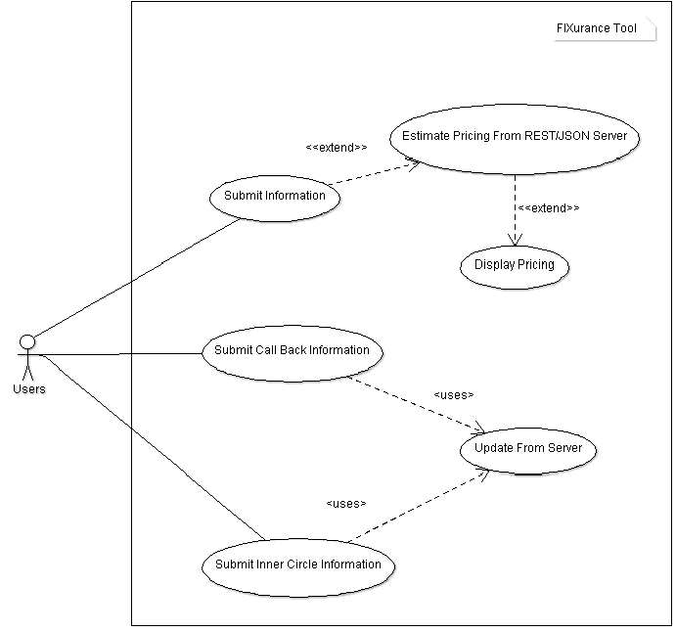

Features
5 = most critical or 1 least critical features
S/N | FEATURES | Priority
1 | Main Page | 5
2 | Collecting information GUI | 5
3 | Coding calculations | 4
4 | Show the pricing estimations | 5
5 | Creating schedule appointment | 5
6 | Call me later page | 2
7 | Call me later database | 2
8 | Creation of icons and layouts | 5
9 | Fixurance Inner Circle Page | 1
10 | Fixurance Inner Circle Database | 1
11 | Fixurance Inner Circle Database REST | 1
12 | Sharing buttons of Fb,Twitter,Ig, WhatsApp | 1
13 | Idea of attracting Customers | 1

Features Screen Shots
The application can provide a price for a home insurance asking for few data. The application is suitable for promoting due to its fast process to get the price and engage the client. The application can be installed in any Windows device, so the customers can use it as well.
Some screen shots of the application:

1. Main page.
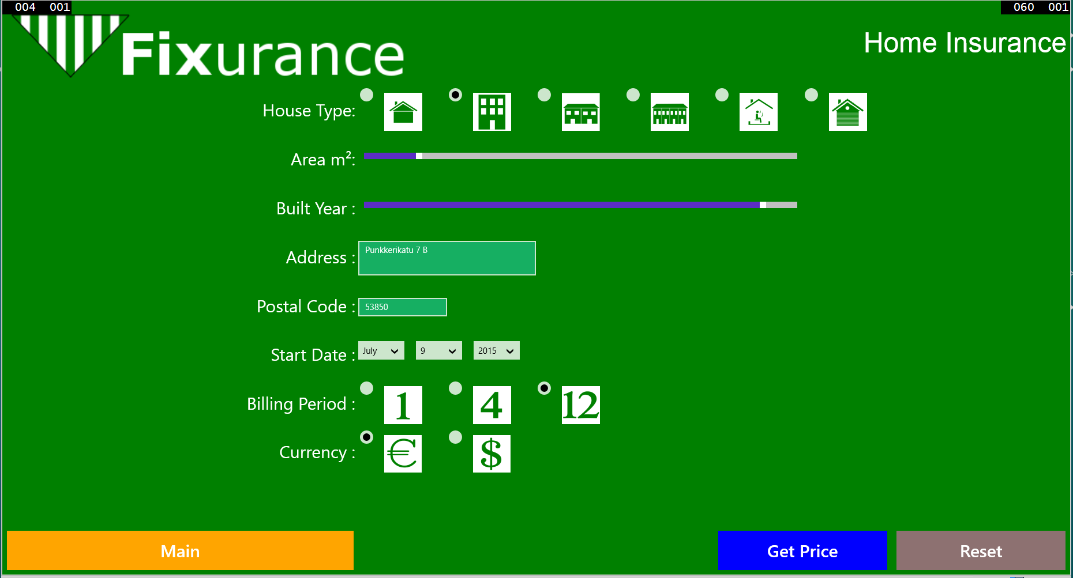
2. House form to get a price estimation.
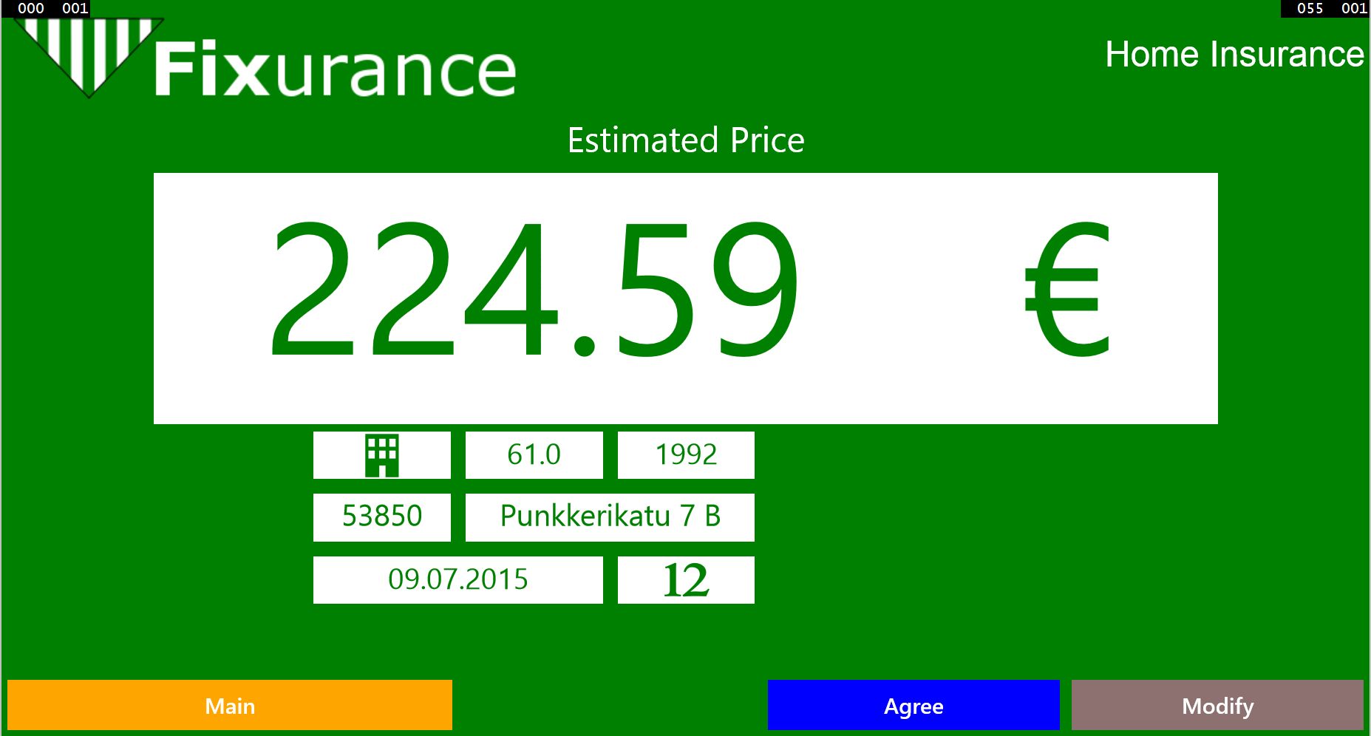
3. Price screen.
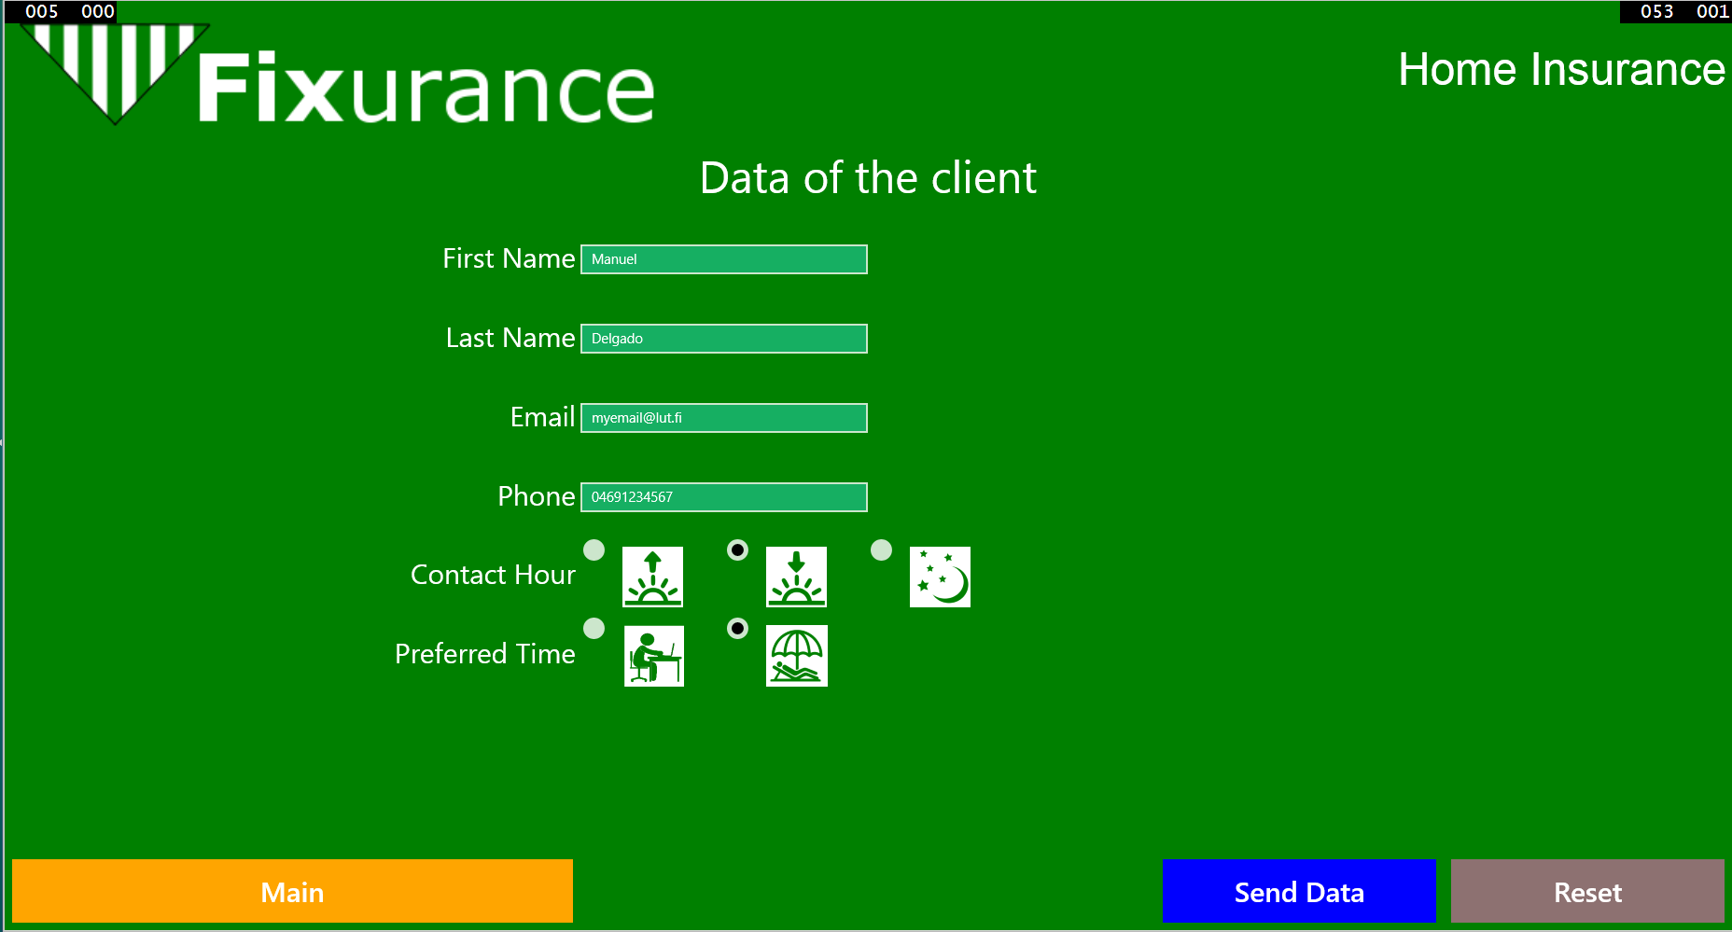
4. If the user agrees to be contacted later, he (or the sales representative) can fill in the form.
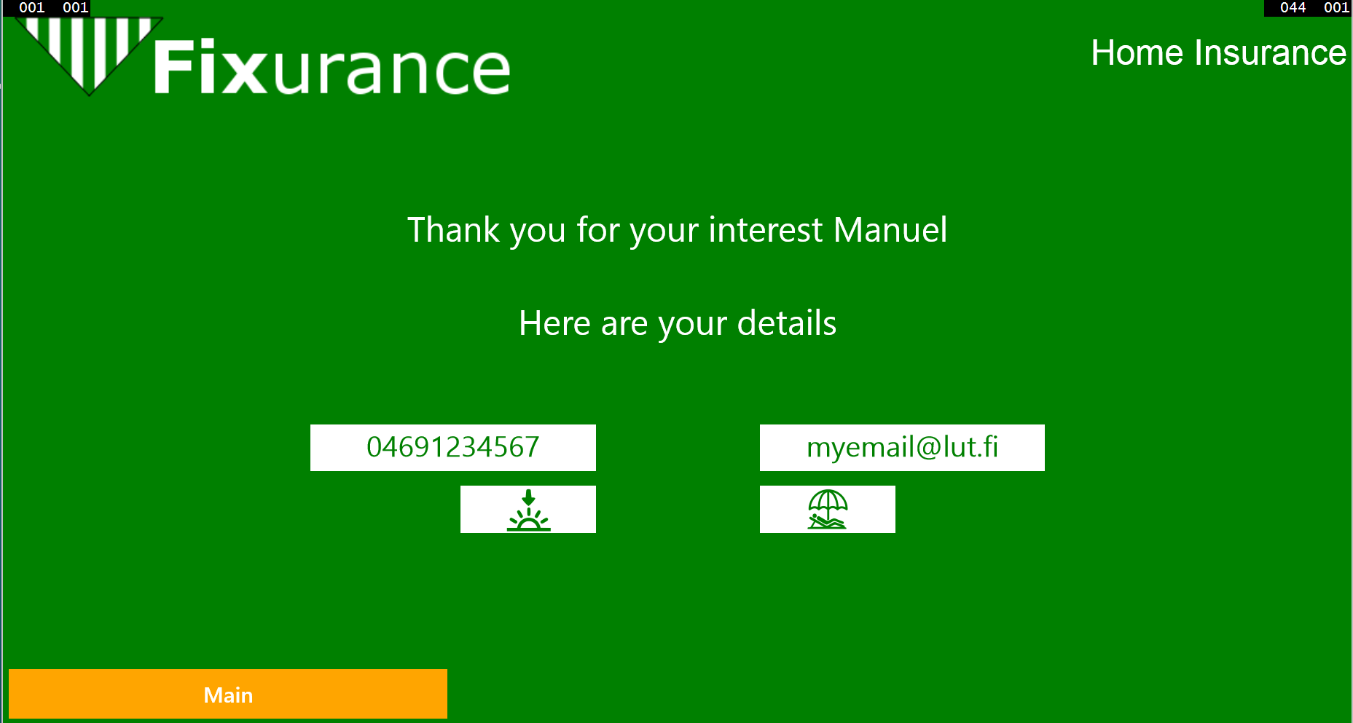
5. Confirmation page of the data.
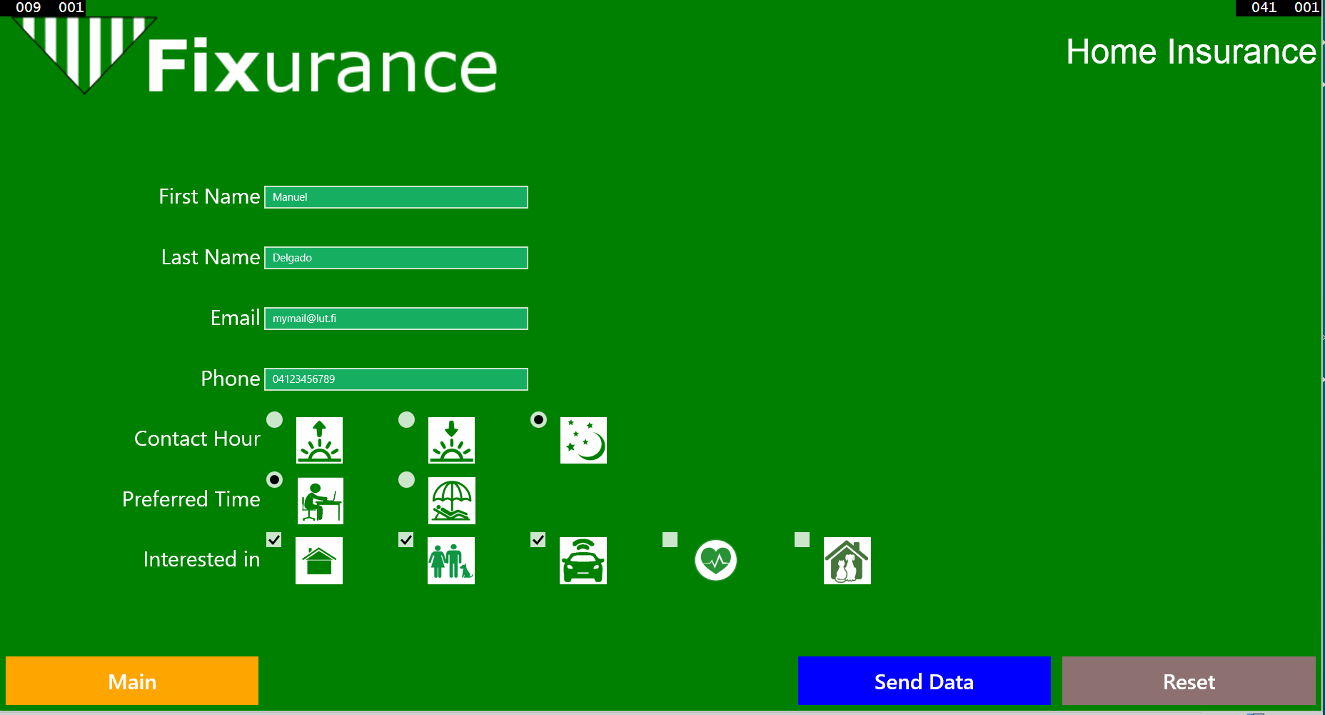
6. Call me later! feature. The client can indicate what he is interested in and the data will be recorded. A salesman can use that information later.
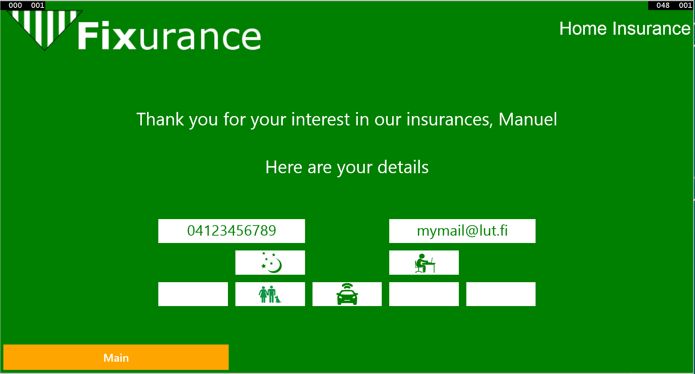
7. Call me later! feature. Confirmation page.

Technologies
- The logic of the application using C#.
- The UI using XAML.
- Microsoft 8.1 as OS.
- Visual Studio 2013 as IDE.
- INKScape for drawing the icons.
- Adobe Photoshop for creating the poster.
- GitHub as versioning tool.
- REST JSON to post and get the data (price) from the LTC-OTSO server.
- Scrum methodology to develop and divide the tasks. We succeed using it but the timing was not accurate.

SCRUM
Picture of scrum daily meeting of tuesday.
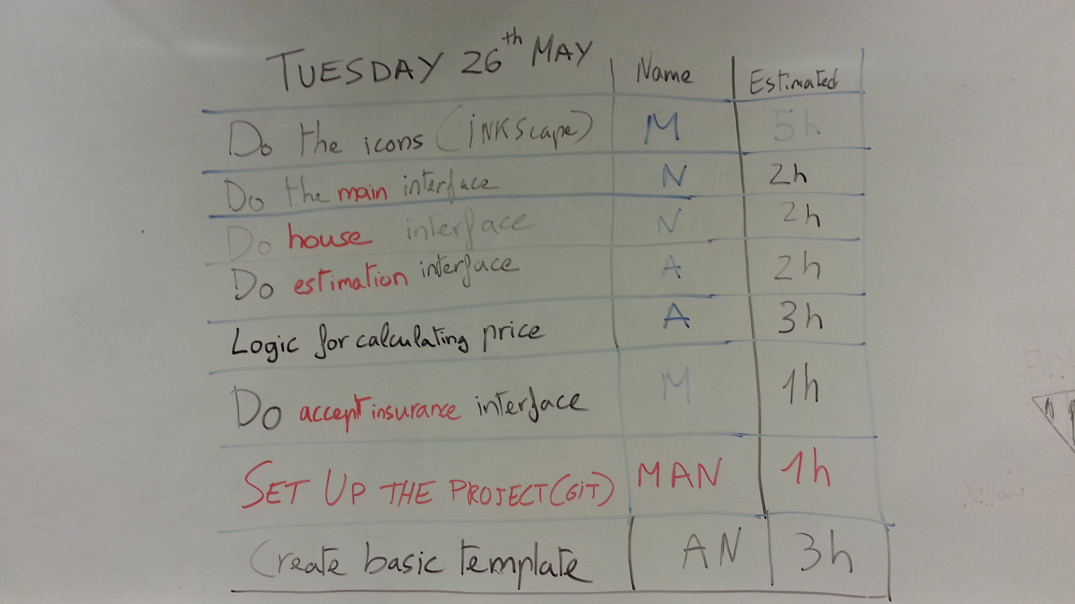

Tasks
TIME | GOAL | Implemented
3 hours | Brainstorming & Design | Manuel, Alejandro & Norismiza
1.5 hour | Report and wiki | Manuel, Alejandro & Norismiza
30 min | Make presentation with Marvel | Manuel
10 min | Set up the Git Hub project | Manuel
6 hours | Creating the icons and logo | Manuel
7.5 hours | Designing Templates & Main Interface | Norismiza, Alejandro, Manuel
3 hours | Designing Main Interface | Norismiza
2.5 hours | Developing reporting document & Project Poster template | Norismiza
2 hours | Creating the Home insurance interface | Norismiza and Alejandro
15 hours | Logic and Home insurance pricing interface | Manuel and Alejandro
2 hours | Logic and interface for client data collect | Norismiza, Manuel
3 hours | Logic and Interface for showing the data info | Alejandro
3 hours | Logic and Interface for call me later main screen | Alejandro
2 hours | Editing the wiki | Norismiza
3 hours | Creating the poster updating Presentation | Norismiza
— | — | —
— | — | —

Some future features and difficulties
- We did not manage to use the icons as radio buttons and check buttons due to lack of time.
- We did not manage to create the Loyalty program. This feature would consist on asking the ID to the customer and suggest him how to reduce the price of his insurance adding other ones.
- Facebook and Whatsapp share buttons.
- RFID reading.
- Create one new feature where the client/sales representative receive an accurate price depending on the client's necessities.
- Contracts can be digitally signedwith digital signature.

Prototype Design
- Prototype of the application

Development
- Sharing codes by using GitHub

Testing
We have tested the application using the emulator provided by Microsoft Visual Studio 2013 and a tablet ASUS TF600T (http://www.gsmarena.com/asus_vivotab_rt_tf600t-5083.php) with Windows 8.1.
We did not do unitary test, just whole application testing.

Documentation
- Project Presentation: fixurance_presentation_final.pdf.
- Project Report: fixurance.pdf
- Project Poster:poster_fixurance_final.pdf

Packages
- Git linkit: https://github.com/mdelsan/FixuranceProject.git

