Insurance
Group 3
Group Member | Main Responsibility
Mikko Turunen | Design, layout
Janne Salopaasi | Implementation, layout
Konstantin Taranov | Prototype (attented only in day 1)

Idea
LTC-Otso presented us 3 use cases which are related to insurance sales with a tablet device. Solving the given use cases could help insurance salesmen to gain new clients.
Use case 1, home insurance (highest priority):
Collect information from a client and calculate the price of a home insurance. Place an order to a REST-server if client wants to buy the insurance.
Use case 2, collect sales leads (medium priority):
If customer is in hurry collect basic contact info and insurance needs.
Use case 3, Customer loyalty program (lowest priority):
If the customer has an insurance in the company, ask if the customer would like to join the loyalty program.

Motivation
Solve the given use cases with C#, Xaml & JSON. Eventually we decided to focus only on UC1.
Solution should be simple and easy to use.
Solution should support a variety of different sized devices

Features
- Collect information for home insurance price calculation and for insurance application
- Uses REST-server with JSON-calls (POST:price calculation & storing application; GET: single application with ID; DELETE: single application with ID)
- Dynamic layout in portrait mode (app is locked into portrait mode, if landscape mode is enabled upon build it works properly with all resolutions except for 1024×768)
- Reset local data with a single button press

Screen shots
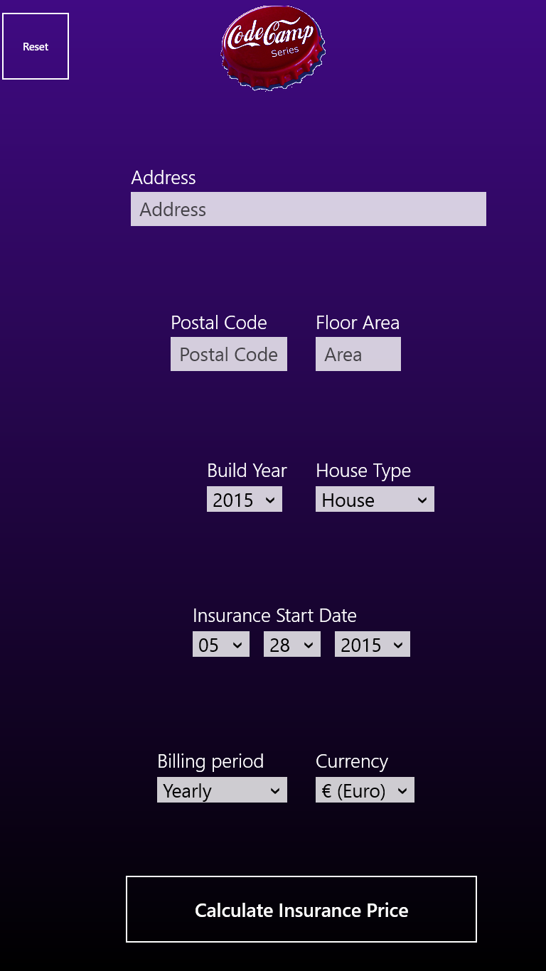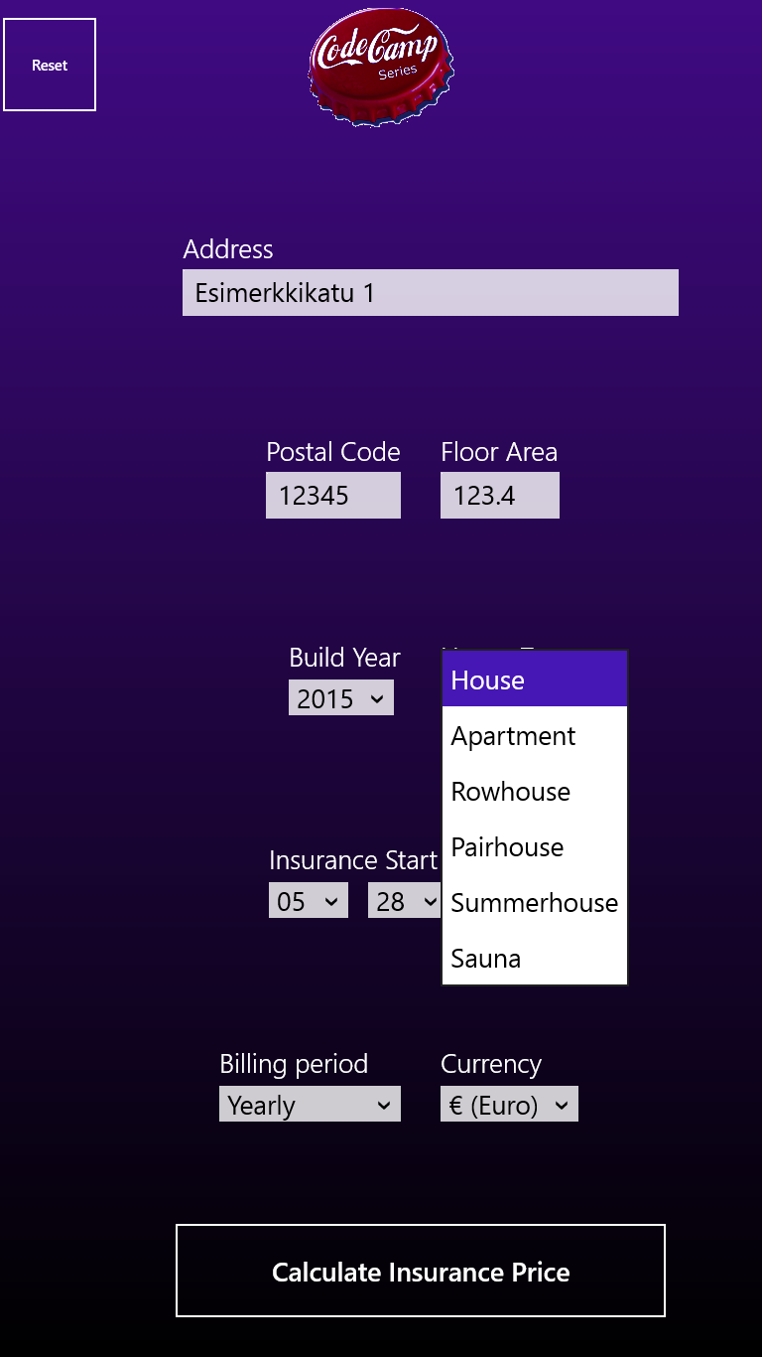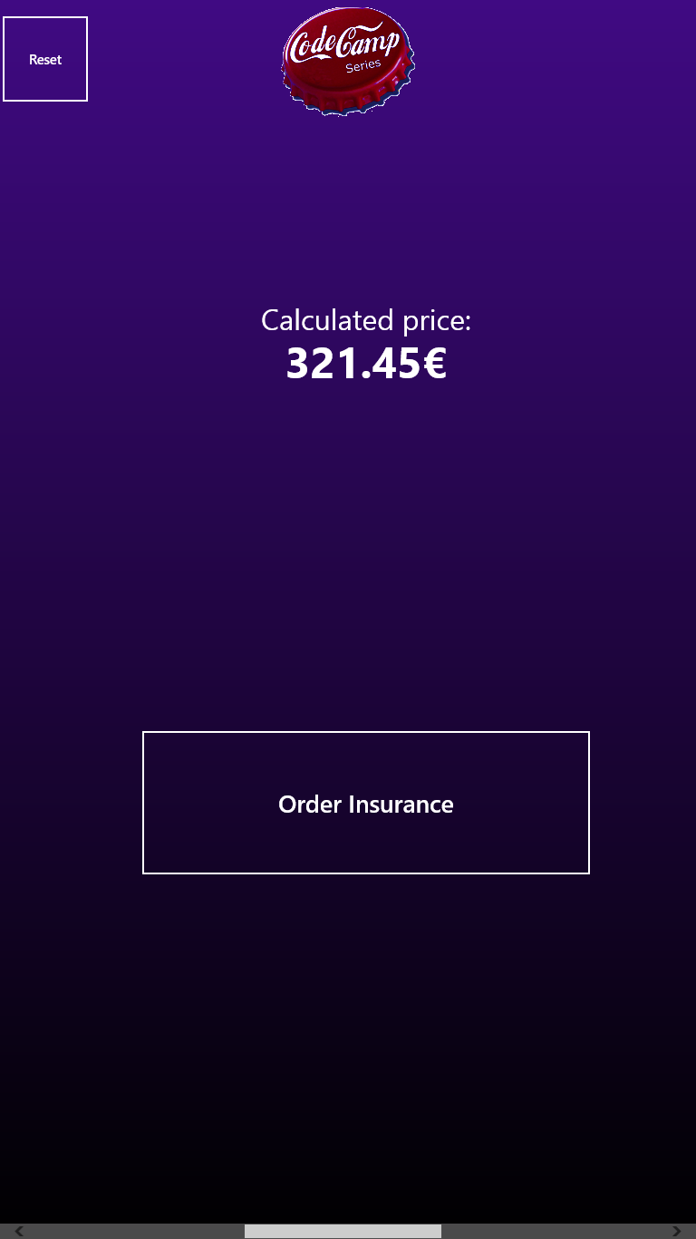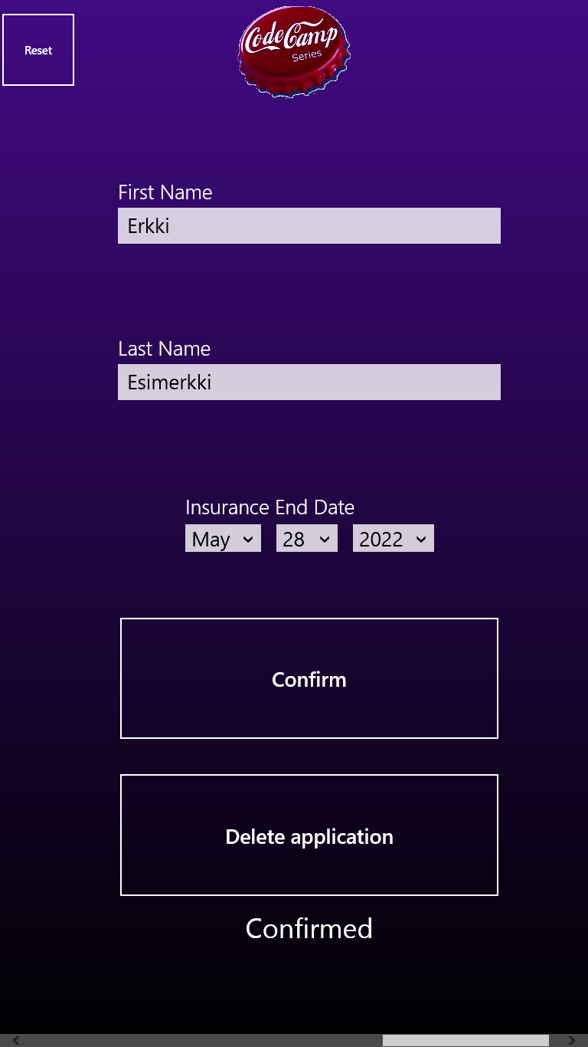

Technologies
C#
Xaml
JSON

Tools
Visual Studio 2013 Professional
Blend
Irfanview

Presentation & Report
Prototype: https://marvelapp.com/426fa0
Final presentation: codecamp_presentation_group_3.pdf
Report: code_camp_insurance_app_project_report.pdf
Poster: 

Package
insuranceapp_1.0.0.0_anycpu_test.zip

How to run
- Extract zip-file
- Right-click on “Add-AppDevPackage” PowerShell script
- Click “Run with PowerShell”
- Follow Instructions
- Find app in startscreen
Ref: https://msdn.microsoft.com/en-us/library/hh975356.aspx

Sources
insuranceapp_201505282030.zip

