Project Erlangen
Group 1
Group Members | Main Responsibility
Aitor Brazaola | Coding
Behnaz Norouzi
Eduard Telezhnikov
Rohan Durugkar
Repository can be found here: GitHub

Idea
Based on the second and third option listed by the organizers:
- Create a mobile app or web page for the customer to give feedback on his experience What does the feedback form look like?
- Create an app or a web UI where the manufacturer can manage his subcontractors
The mobile application is an assignment manager which ables to the manufacturers create customized assignments with many combinations of subcontractor companies and see in a friendly dashboard statistics about them and read the latest feedback given from the final customers depending the assignment selected.

Features
(Least Critical) 1-2-3-4-5 (Most Critical)
Feature | Priority
Assignment creation | 4
Subcontractors list | 3
Charts of subcontractors performance | 5
Listing recent customer feedback | 3
Native-like user interface | 2

Mini Goals

Design

Screen Shots
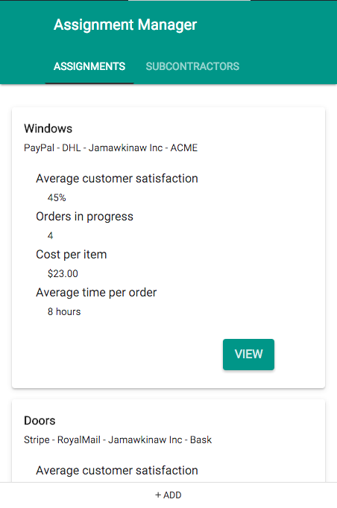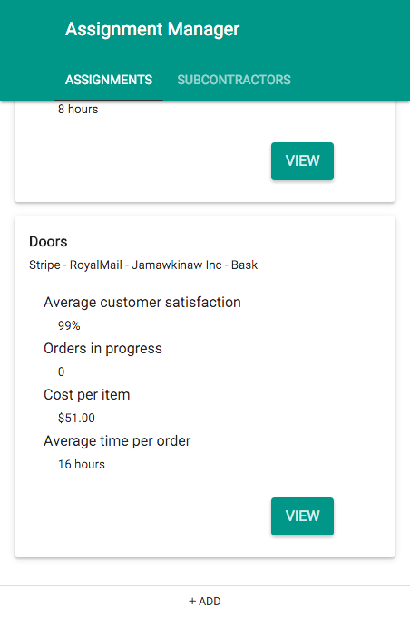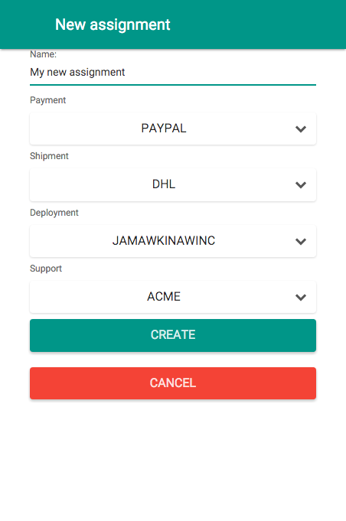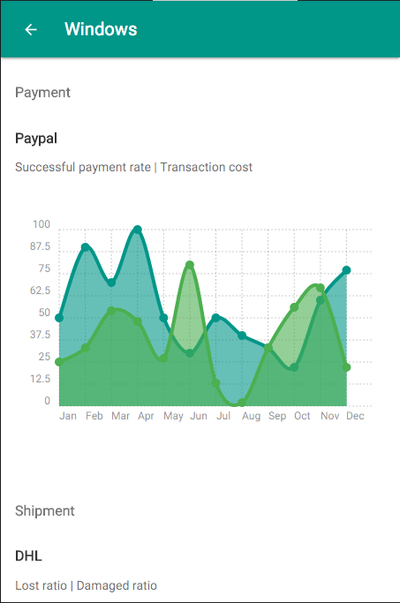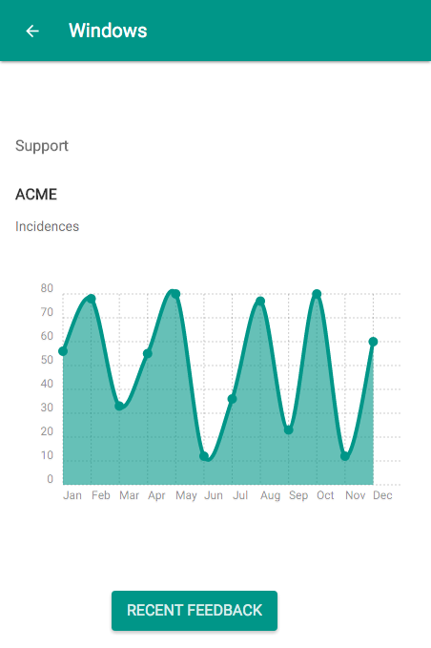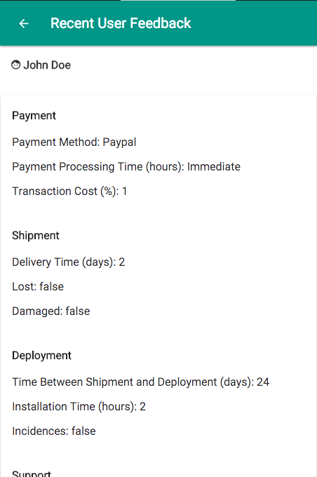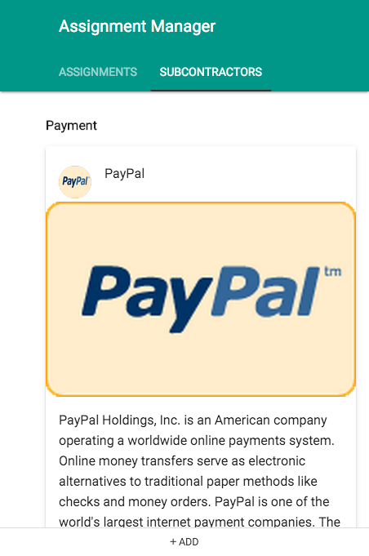

Implementation Comments
The application works with fake data stored in a JSON object, is supposed to be working with a REST-service backend not implemented at Code Camp.
The technologies used in the implementation are:
- PhoneGapfor multi-platform deployment.
- jQuery Mobile for handling the events and the UI structure.
- NativeDroid2 for an Adroid Native Look&Feel
- HTML5 for the front-end markup.

Presentation

Package

How to Run

Conclusion

