WeAreSmooth
Group 2
Group Member | Main Responsibility
Ilkka Tommola
Hatef Shamshiri
Michal Micor
Razaq Shonubi

Idea
Main idea of a project is to provide manufacturer app allowing to receive feedback from customers related to provided service and product quality. Performance of subcontractor is strongly affecting manufacturer opinion, as they are direct provider of service to customer. Therefore It is required to control subcontractor performance by collecting detailed feedback from customers.

Features
1 = most critical or core .. leats citical or core feature
Feature | Priority
- Does require any external library
- Colour sets to fit any design.
- Intuitive and friendly user interface.
- Extremely easy configuration – no need to edit any files to get it ready.
- No dependency on any database – it works with plain files as a storage.
- Built-in cloud9
- Detailed and designed installation instructions
- ……
- …..
- ….

Mini Goals
The goals for the project is to develop a mobile application or a web page for an insurance company in order for their customers to be able to give a feedback about their products and services. Aside from creating a UI for their customers, there will be a platform where the manufacturer can manage their subcontractors activities. In addition, the manufacturer will be able to create an assignments of adding/deleting subcontractors. And be able to choose a customer to give a feedback request. Also on the manufacturer page, there will be availability of a scoreboard in viewing the assignment and another for all their subcontractors. There will also be a platform where the subcontractor can as well browse through feedbacks for their services and see a “scorecard” of their performance.

Design

Screen shots
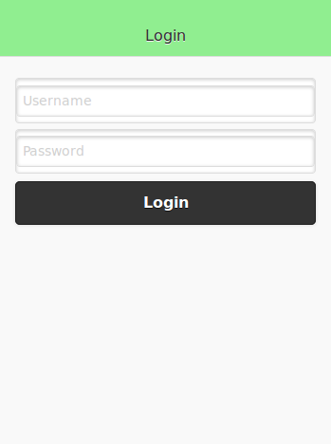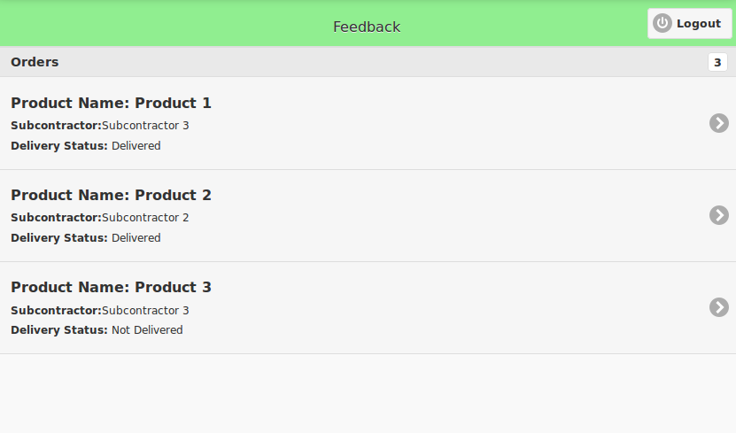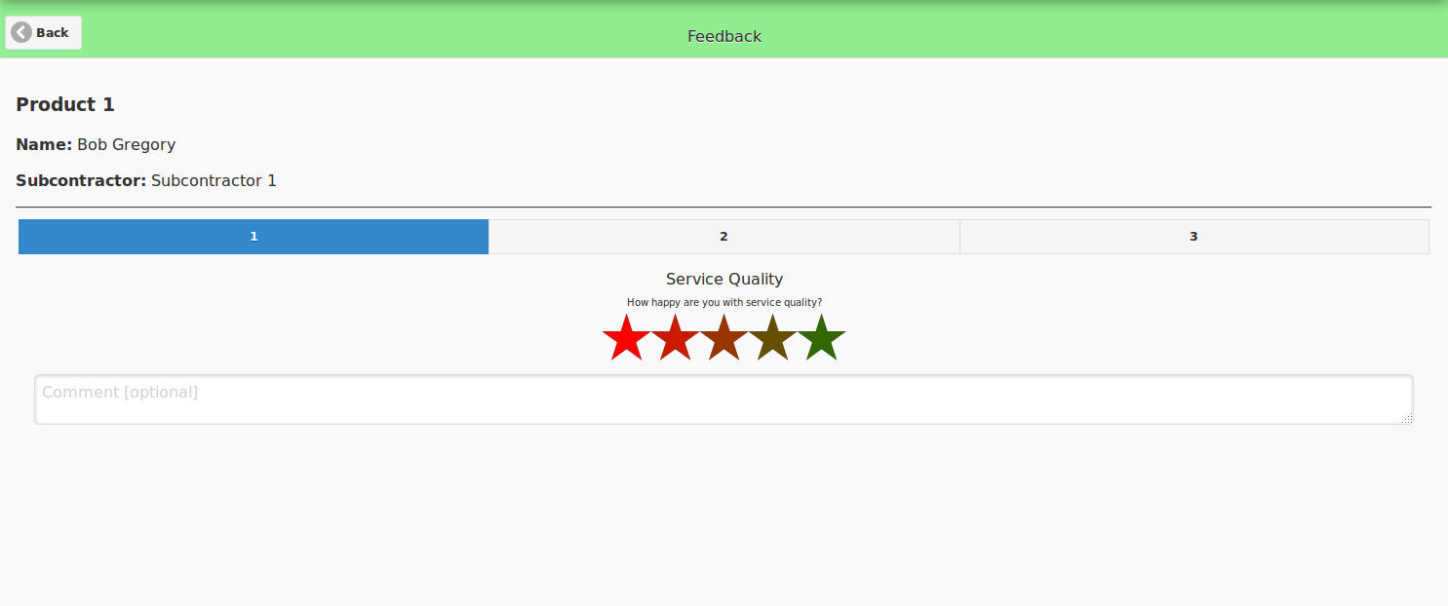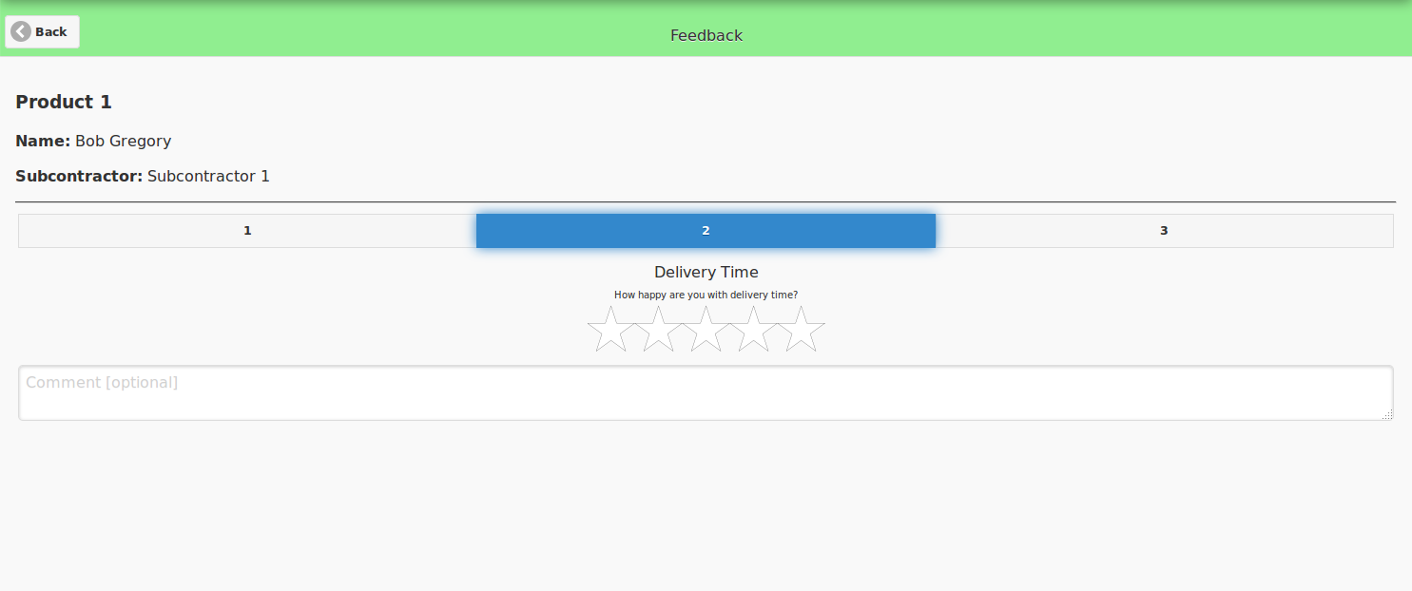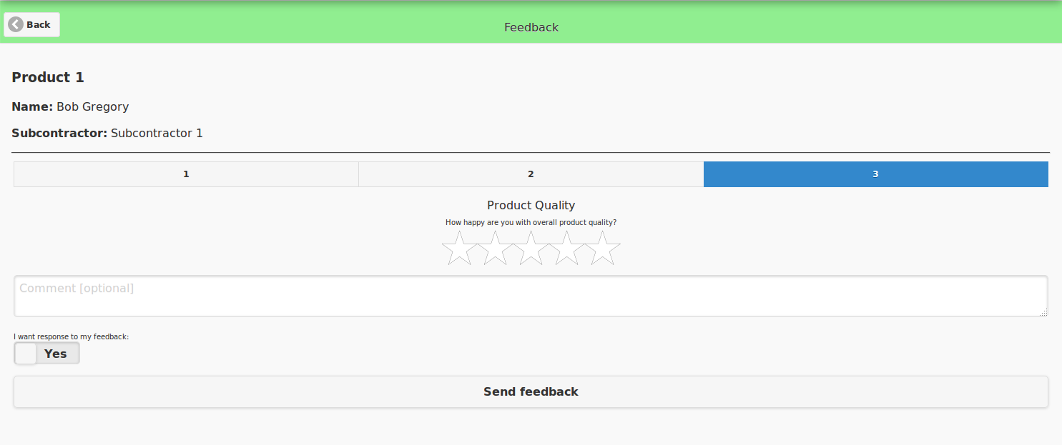

Implementation Comments

Presentation

Package

Conclusion

