WeAreSmooth
Group 2
Group Member | Main Responsibility
Ilkka Tommola | Backend
Hatef Shamshiri | Frontend
Michal Micor | App sketch & Presentation
Razaq Shonubi | Design & Documentation

Idea
Main idea of a project is to provide manufacturer app allowing to receive feedback from customers related to provided service and product quality. Performance of subcontractor is strongly affecting manufacturer opinion, as they are direct provider of service to customer. Therefore It is required to control subcontractor performance by collecting detailed feedback from customers. It is achieved by service based on app collecting feedback from customers and storing data in database for further analysis. Manufacturer can inspect subcontractor performance and based on that decide which subcontractors should provide service to customers.

Features
1 = most critical or core .. least critical or core feature
Feature | Priority
Intuitive and friendly user interface. | 1
Extremely easy configuration – no need to edit any files to get it ready. | 3
Built-in cloud9 | 3
Manufacturer can create assignments | 1
Manufacturer can add subcontractors to assignments | 1
Manufacturer can send feedback requests to customers | 1
Subcontractor can see a “scorecard” of his performance via app | 1

Design
The goals for the project is to develop a mobile application or a web page for a manufacturer in order for their customers to be able to give a feedback about their products and services. Aside from creating a UI for their customers, there will be a platform where the manufacturer can manage their subcontractors activities. In addition, the manufacturer will be able to create an assignments of adding/deleting subcontractors. And be able to choose a customer to give a feedback request. Also on the manufacturer page, there will be availability of a scoreboard in viewing the assignment and another for all their subcontractors. There will also be a platform where the subcontractor can as well browse through feedbacks for their services and see a “scorecard” of their performance.

Screen shots
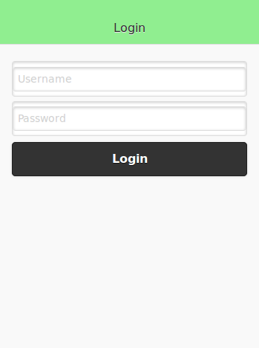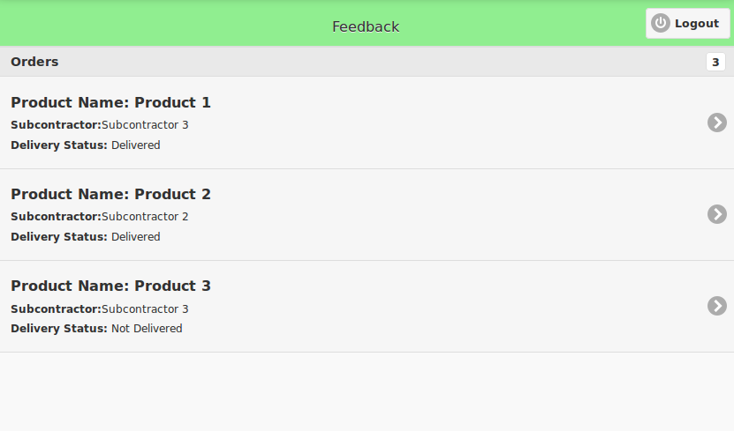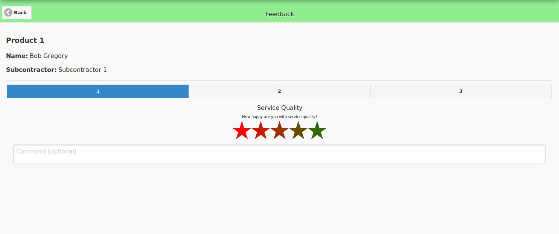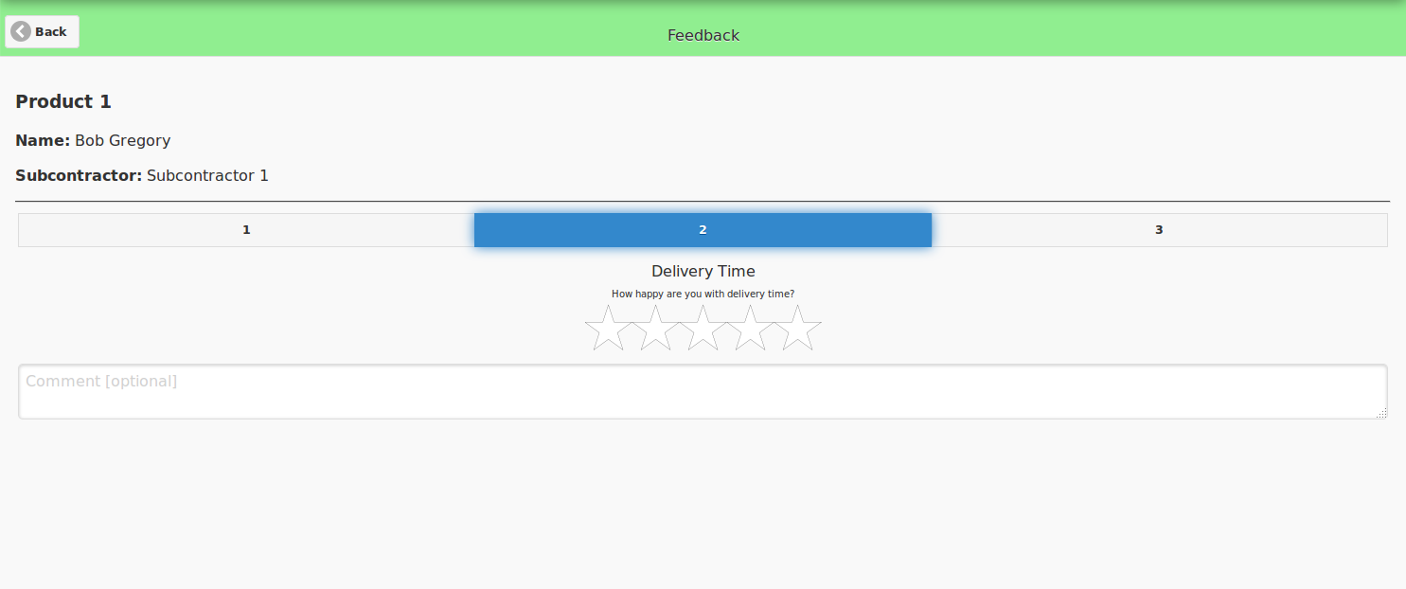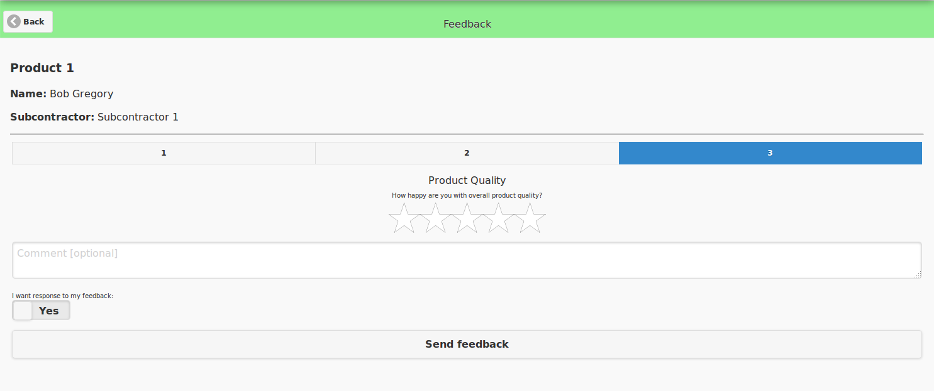

Implementation Comments
Included technologies:
- PhoneGap
- JavaScript
- JQuery Mobile
- JQuery
- PostgreSQL
- jRate
- CanvasJS
- PHP

Presentation

Package

Conclusion
We are glad that the aims and objectives was the project was achieved. A functional prototype was …..

