Past Code Camps

Otso Case Code Camp - Winter 2015
CT30A9301 Code Camp on Platform Based Application Development (4 cr)
Week 50, 7.12.2015 - 11.12.2015
Location: LUT computer lab 6218
Start: 7.12.2015 at 10AM
More information and schedule in the the course wiki.
Topic and theme: Otso Case CodeCamp! Solve a business case with LTC-Otso about the future of customer interaction for businesses.
Platform: PhoneGap and mobile devices.

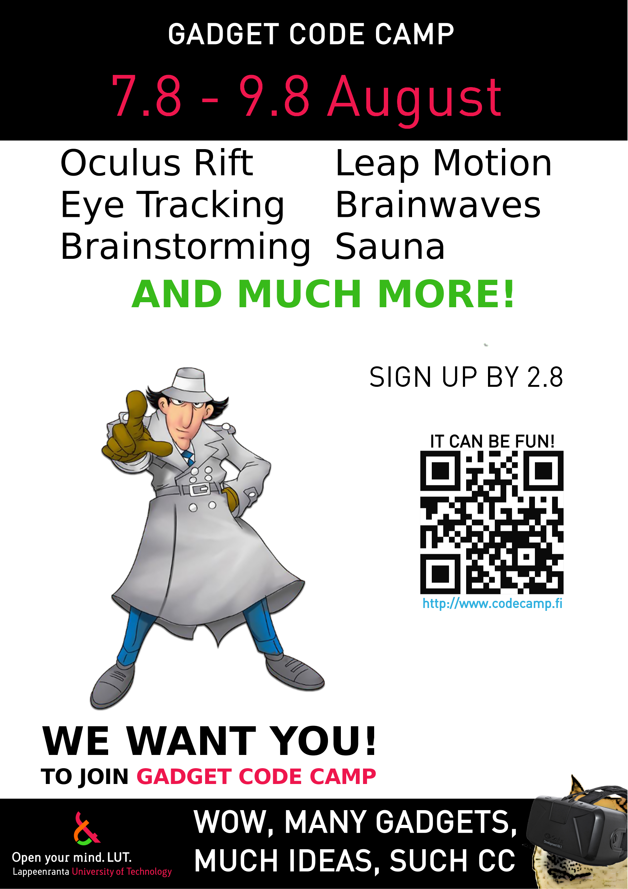

Gadget Code Camp - August 2015
Gadget Code Camp – Hacking Technology (1 cr)
72h weekend: 7.8. - 9.8.2015
More information and schedule: Gadget CodeCamp 2015 pages
Signup is open. Sign for the course HERE
There's a weekend-long Gadget Code Camp at Lappeenranta University of Technology! Brainstorm and bring out your most creative ideas! Develop for all sorts of gadgets from Arduinos to brainwave scanners. We will bring out all the exotic gadgets that the IT department has collected into its storage through the years. What's the most creative you can implement with these devices? The weekend event will be held at the university beachfront sauna.
Course arrangements and news, in brief:
- Location: LUT Beachfront Sauna
- Main contact persons are Antti Knutas / Rasmus Halsas (firstname.lastname@lut.fi)
- The course is held after the LUT Summer School on the weekend. The course arrangements and awarded credits are separate.
  - The code camp is open to all university and polytechnic students, not only summer school or LUT students. All Finnish and foreign students are welcome!
- More information from Antti Knutas / Rasmus Halsas (firstname.lastname@lut.fi)
- Confirmed devices:
  - NEW Google Glass
  - NEW Raspberry PI
  - MindWave brainwave scanner
  - Oculus Rift, 1st gen
  - Leap Motion motion tracker
  - TheEyeTribe eye tracker
- Possible devices:
  - Kinect devkit for PC
  - .NET Gadgeteer platform (equivalent to Arduino)
- Consider bringing your own laptop (limited amount of programming PCs available)
See the summer school description at http://www.lut.fi/web/en/admissions/lut-summer-school/academic-guidelines/courses . (For summer school participants - everyone can sign up for the Gadget Code Camp, even if you are not participating in the summer school!)

Wearables and Augmented Reality Project Course - Spring 2015
CT10A9520 Research project in software engineering (1-5 cr)
Course news
- Site open! Create your own team page.
- Technical day was held on 17.3. 10AM. Classroom will be the Innovation Factory (building 2, floor 3).
  - Technical day slides have now available HERE.
- Deadlines, checkpoints and checkpoints have been updated.

Upcoming deadlines
- When the course pages become available (by the 13th of February), create your team page (ready by 20.2.)
- First team checkpoint in 2nd week of April (6.4. – 10.4.)
- Second team checkpoint in early May (starting with exam week 4.5.)
- Final returns in early to mid-May (later if agreed)

What do I need to do right now?
- Team activity has been low. Contact the course assistant by email about the deadlines.

Course description
There's an upcoming project course about wearable computing, where the Google Glasses and Android smartwatch will be available as platforms! Introduction lecture will be on 6.2.2015 at 9.00 in Innovation Lab 2527. The course name is CT10A9520 “Research project in software engineering” and the credits vary depending on the selected project scope. Please enroll by clicking the “ENROLL” link on the course page. Course instructor will be Jari Porras.
If you have any further questions, don't hesitate to ask Antti Knutas . (firstname.lastname@lut.fi)
Access course pages at Wearables and Augmented Reality Project Course 2015

Otso Case Code Camp - Summer 2015
CT30A9301 Code Camp on Platform Based Application Development (4 cr)
Week 22, 25.5. - 29.5.2015
Otso Case CodeCamp. Solve a business case with LTC-Otso about the future of customer management in a paperless environment. More information at the course info page and the course wiki.

Open Data and Green IT CodeCamp - Spring 2015
CT30A9301 Code Camp on Platform Based Application Development (4 cr)
Week 10, 2. - 6. March 2015
- Location: Computer lab 6218 (Linux basement classroom)
- Course pages opening by 27th of February.
- Registration is open. ENROLL to the course right away!
- PERCOM program students - Please also register at the link above! We need student details in order to give ECTS credits at the end of the course.
- Return requirements have been updated! Please see exact details from the course page. (also remember to register for the return day)

Important Dates (all in December and in classroom 6218, except for sauna)
- Course starts on Monday 2nd of March at 10:00AM.
- First idea presentations are at 5PM on Monday at the LUT beach sauna
- There will be a sauna and social event on Monday at the LUT beach sauna, after the project presentations
- Project returns at 9AM on Friday (in the Code Camp week)
- Group project final returns on the following week (start of week 11)
Course topics: Learn to develop in a web and JavaScript environment and innovate on using open data sources or develop ideas on how IT could be green! Get a first touch on what the so called “big data” might mean. Create new data input environments or harness exisiting data sources for web mashups! This year's Open Data CodeCamp has a different topic from previous year, so both courses can be included in your curriculum (if your curriculum allows you to include multiple CodeCamp courses).
If you have any further questions, don't hesitate to ask Antti Knutas . (firstname.lastname@lut.fi)
Access course pages at Open Data and Green IT CodeCamp 2015

FGJ Lappeenranta Game Jam Code Camp - Winter 2015
Part of CT60A8000 Game Development Project (3 cr) (https://noppa.lut.fi/noppa/opintojakso/ct60a8000/etusivu)
Design and make games in 48h. No previous experience needed, on the spot training. Course “Fundamentals of Unity” (part of Game Development Project) recommended, but not necessary.
Game Jam weekend 23.-25.1.2015
- Course startup info in January, please follow page http://www2.it.lut.fi/GRIP for more info!

Copypaste Game Code Camp - September 2014
CT30A9301 Code Camp on Platform Based Application Development (4 cr)
Starting lecture & meetup mon 15.9
Midweek madness meetup wed 17.9
Code campu fri 26.9 - sun 28.9
Signup opens soon(ish)!
More information and schedule: Copypaste CodeCamp 2014 pages

Gadget Code Camp - August 2014
CT10A9701 Summer School on Software Engineering (2 cr)
72h weekend: 1.8. - 2.8.2014
More information and schedule: Gadget CodeCamp 2014 pages
There's a weekend-long Gadget Code Camp at Lappeenranta University of Technology! Brainstorm and bring out your most creative ideas! Develop for all sorts of gadgets from Arduinos to brainwave scanners. We will bring out all the exotic gadgets that the IT department has collected into its storage through the years. What's the most creative you can implement with these devices? The weekend event will be held at the university beachfront sauna and will connect through a video wall to a concurrent event that is held in Wernigerode, Germany. You will be able to use this international connection to discuss and present your projects.
Course arrangements and news, in brief:
- Location: LUT Beachfront Sauna
- Main contact person is Antti Knutas (firstname.lastname@lut.fi)
- The course is held after the LUT Summer School on the weekend. The course arrangements and awarded credits are separate.
  - The code camp is open to all university and polytechnic students, not only summer school or LUT students. All Finnish and foreign students are welcome!
- More information from Antti Knutas ( firstname.lastname@lut.fi )
- Confirmed devices: Microsoft PixelSense, motion detectors (Leap Motion, Kinect, Wii..), virtual headsets (Oculus Rift), brainwave scanners, embedded systems (Arduino), tablet and mobile devices (Android, iOS, Windows 8, Windows Phone).
- Consider bringing your own laptop (limited amount of programming PCs available)

24h Android Code Camp - Spring 2014
CT10A9701 Summer School on Software Engineering (2 cr)
The main theme of the Code Camp is to innovate on location services: What can you do with GPS and/or mapping services? Learn to utilize maps, locations and geocoding in your software and implement a new, innovative app based on those features.
Week 19, 6. - 7. May 2014
- Location: Computer lab 6218 (Linux basement classroom)
- The course will be arranged if six or more people sign up.
- Consider bringing in your own Android phone.
- PERCOM program students - Please also register at the link above! We need student details in order to give ECTS credits at the end of the course.
- SIGN UP HERE
Important Dates (all in May and in classroom 6218, except for sauna)
- Course starts on Tuesday 6th of May 10:00AM.
- First idea presentations are at 4PM in the classroom.
- Project returns at 10AM on Wednesday
- Group project final returns on the following week (end of week 20)
If you have any further questions, don't hesitate to ask Antti Knutas . (firstname.lastname@lut.fi)
24h Android Code Camp pages

Jolla Code Camp - Winter 2014
CT30A9301 Code Camp on Platform Based Application Development (4 cr)
Week 9, 24. - 28. February 2014
- Location: Computer lab 6218 (Linux basement classroom)
- Course pages opening by 3rd of February.
- Consider bringing in your own laptop.
- PERCOM program students - Please also register at the link above! We need student details in order to give ECTS credits at the end of the course.
Important Dates (all in December and in classroom 6218, except for sauna)
- Course starts on Monday 24th of February at 10:00AM.
- First idea presentations are at 5PM on Monday at the LUT beach sauna
- There will be a sauna and social event on Monday at the LUT beach sauna, after the project presentations
- Project returns at 9AM on Friday (in the Code Camp week)
- Group project final returns on the following week (end of week 10)
We have verified that we will get actual Jolla phones for development and that we will get a Jolla developer to introduce the platform. Sign up! This is an unique opportunity to learn from the people who developed the platform.
Learn to develop on the new Sailfish operating system and use your development skills to harness open web data from around the world! Challenge yourself and provide useful services to the users: Bus schedules, traffic information, weather.. Can you figure out new, innovative ways to combine the freely accessible data to make new services?
Get more information and get started with developing by downloading the Sailfish OS development tools at https://sailfishos.org/develop.html and read the tutorial at https://sailfishos.org/develop-overview-article.html . You can use JavaScript, QT or Android Java to develop for the platform. We have Jolla personnel arriving to the event, with phones, lectures and tutorials!
If you have any further questions, don't hesitate to ask Antti Knutas . (firstname.lastname@lut.fi)
Jolla CodeCamp 2014 Pages

Finnish Game Jam Code Camp - Winter 2014
January and February 2014, main event at 24.-26.1.
- Game planning and testing plus demo construction jointly with Finnish Game Jam Lappeenranta
- More information and sign up instructions at http://www2.it.lut.fi/project/SOCES/events

.NET Code Camp - Winter 2013
CT30A9301 Code Camp on Platform Based Application Development (4 cr)
Week 50, 9. - 13. December 2013
- Location: Computer lab 6218 (Linux basement classroom)
- Course pages opening by 9th of December.
- Sign up for the course HERE
- Consider bringing in your own laptop!
Important Dates (all in December and in classroom 6218, except for sauna)
- Course Signup opens on 19th of November
- Course starts on Monday 9th of December at 10:30AM.
- First idea presentations are at 5PM on Monday, in 6218
- There's sauna at the LUT rooftop sauna roughly 6pm on Monday 9th of December.
- Project returns at 9AM on Friday (in the Code Camp week)
- Group project returns 9AM - 3PM on Tuesday (17.12.)
  - Reserve your group project return time HERE
This course helps you prepare for the Imagine Cup 2014 or getting your own Windows 8 or Windows Phone 7/8 application prepared for publication in the marketplace. Two teams in past years from past Code Camps have gone to represent Finland in the world wide category in Egypt and Australia!
If you have any further questions, don't hesitate to ask Antti Knutas . (firstname.lastname@lut.fi)
Participate in the study, get pizza! Download the Belbin Team Role test HERE and email it to antti.knutas at lut dot fi!
dotNET 2013-14 Code Camp Course Page

24h Cross-Platform JavaScript Code Camp
CT10A9700 Summer School on Communications Engineering (2 cr)
17.9. AND 15.10. - 16.10.2013
- Theme: Cross-Platform JavaScript. (jQuery Mobile, Windows 8 JS, PhoneGap)
- Two-part course schedule:
  - Technology Seminar: Code-Ari Seminar 17.9.
    - Check seminar schedule at http://www.businessinnovations.fi/loader.aspx?id=8b227d7b-ae62-45f6-9407-6de2de2183ad
    - Location: Student Union Building Auditorium
  - 24h Code Camp and Workshop 15.10. - 16.10.2013
    - Starts 9AM in computer lab 6218
- Remember to register at both of the two following links:
  - Please sign up to the technology seminar at http://www.microsoft.com/finland/codeari/ (MS Technologies)
  - Workshop and Code Camp registration HERE
Learn how to use HTML5 and JavaScript to do your own mobile application and then to deploy it both on web pages and different mobile devices (Android, Windows)! The Code Camp starts with a Microsoft workshop where you can get familiar with different MS tablet devices. Note that the technology seminar that is part of the course is held a month earlier, on 17th of September.
More information the seminar and the workshop: http://www.microsoft.com/finland/codeari/
Participate in the study, get pizza! Download the Belbin Team Role test HERE and email it to antti.knutas at lut dot fi!
Cross-platform JS 2013 Course Page

24h HTML5+JS Game Code Camp - Summer 2013
CT10A9700 Summer School on Communications Engineering (2 cr)
24h weekend: 14.6.2013 - 15.6.2013
Learn to program HTML5 game for tablet devices and demonstrate your coding skills in an intense coding session! There will be demo projects for starting, technology tutorial and several tablets for testing. For advanced programmers there is the additional, optional challenge of multiplayer network programming using HTML5 websockets.
- Sign up HERE for the course
- Location: Computer lab 6218.
- Tutorial and introduction lecture will be 14.6. 10:00AM in the computer lab 6218.
  - The advertisement email had the wrong dates. The correct starting date is the 14th, Friday!
- Two person groups (three max).
If you have any further questions, don't hesitate to ask Antti Knutas . (firstname.lastname@lut.fi)
HTML+JS 2013 Course Page

Windows 8 Multitouch Code Camp - Spring 2013
CT30A9300 Code Camp on Communications Engineering (4 cr)
Week 20, 13-17 May 2013
Learn to use the multitouch and sensor features (acceleration or gyroscope) of the new Windows 8 platform and use these to implement a novel application or a game. There will be both a preinstalled development environment with Windows 8 desktops and some Windows 8 tablet devices for development and testing.
- Sign up HERE for the course
- Location: Computer lab 6218.
- Course pages opening on Friday before Code Camp, on the 10th of May
- Tutorial and introduction lecture will be 13.5. 9:00AM in the computer lab 6218.
- The course includes source control tutorial with Git and how to use source control tools in small team development.
- Prerequisite tasks
  - 1. Think of 2 to 4 concepts of what one could do with multitouch surfaces, from wall or table sized devices to tablets. Be creative, playful and think of the possibilities! Please return these ideas by weekend or early Monday latest. You don't have to be too specific, a couple of sentences or a short paragraph per idea will do.
  - 2. There are different kind of coders in our profession. Please fill out Belbin's Team Role test, note the results, and return the file for a survey. We will talk about the different roles on Monday and how they might impact groupwork. The test file is available HERE. The file is in Excel format, but it was tested to work on the most recent Libreoffice.
Multitouch 2013 Course Page
If you have any further questions, don't hesitate to ask Antti Knutas . (firstname.lastname@lut.fi)

Finnish Game Jam Code Camp - Winter 2013
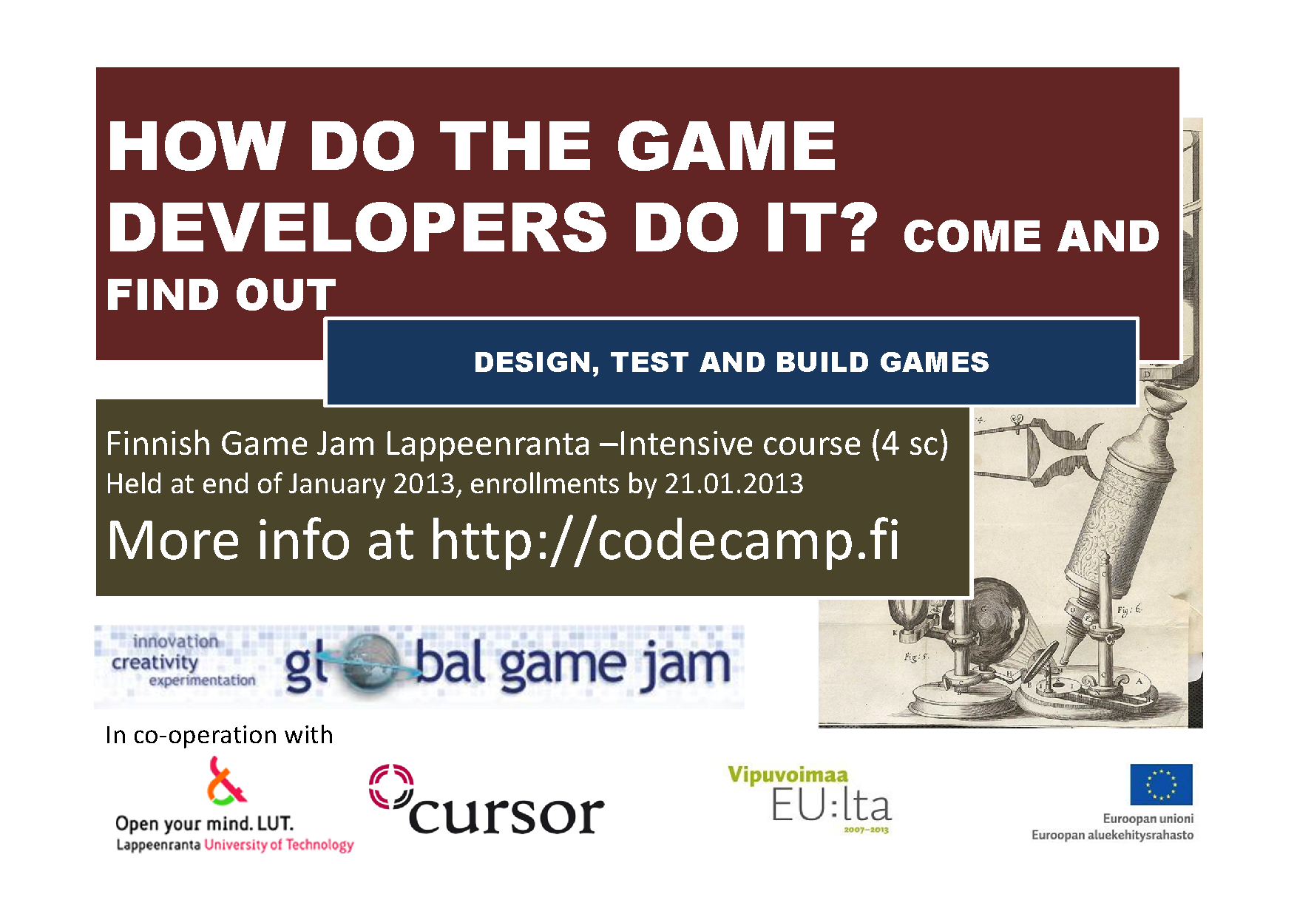
21., 25.-27. January and 15. February 2013
- FGJ Lappeenranta Code Camp is back!
- Game planning and testing plus demo construction jointly with Finnish Game Jam Lappeenranta
- FGJ Lappeeranta site this year will be at the LUT Tieto-Sähkötalo, 2nd floor.
- Get in for .NET, stay for Game Jam!
- More information at http://www2.it.lut.fi/project/SOCES/course3

.NET Code Camp - Spring 2013
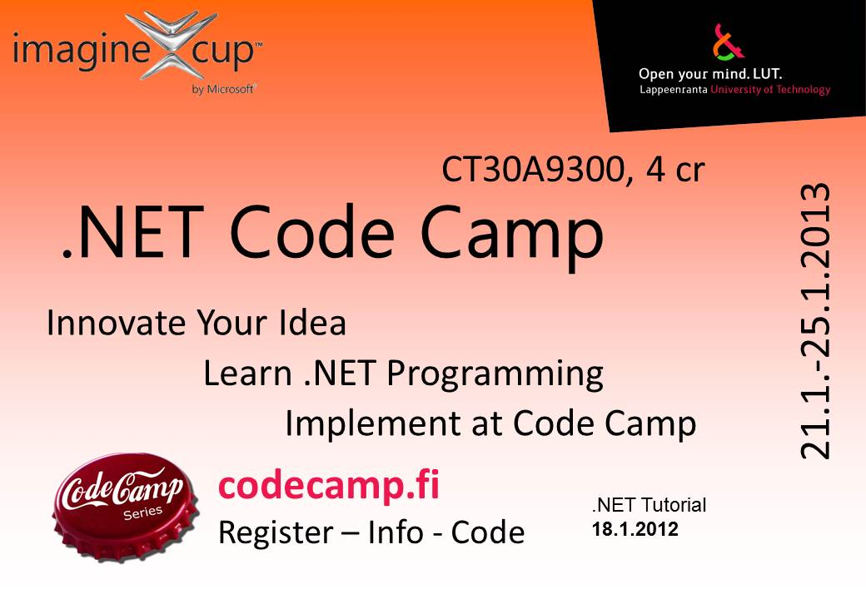
Week 4, 21-25 January 2013
- Register for the course in HERE
- Location: Computer lab 6218
- Course pages opening in first week of January.
- .NET tutorial lectures will be from 09:00 to 16:00 on preceding Friday the 18th in computer lab 6218
  - Learn web application and web service development
  - Silverlight will help put that final polish and impressive graphics on your web application development
Important Dates (all in January and in classroom 6218, except for sauna)
- .NET and Silverlight tutorial lectures: 09:00 to 16:00 on Friday 18th
- Actual Code Camp from 21st to 25th (9:00 - 16:00 each day)
- Group idea presentations at the end of Monday, 16:00.
- Brief Group Progress presentations in the Skinnarilan Sauna, starting at 17:15 on Tuesday 22nd. The sauna is warm from 18:00.
This course helps you prepare for the Imagine Cup 2013 or getting your own Windows 8 or Windows Phone 7/8 application prepared for publication in the marketplace. Two teams in past years from past Code Camps have gone to represent Finland in the world wide category in Egypt and Australia!
.NET Code Camp 2013 Course Page
If you have any further questions, don't hesitate to ask Antti Knutas . (firstname.lastname@lut.fi)

Code Camp on Agile Java Development by Capgemini - Fall 2012
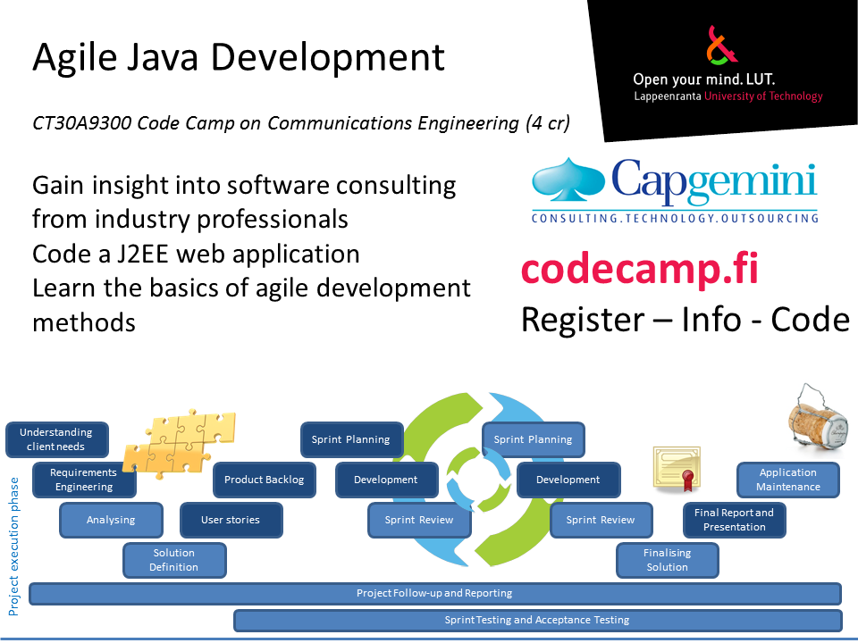
CT30A9300 Code Camp on Communications Engineering (4 cr)
Week 42: 15.10.2012 - 19.10.2012
Agile Java Development Code Camp 2012 pages
- Location: Skinnarila campus, LUT building, computer lab 6216
- The course begins at 9:00AM in the computer lab 6216. Further information and assignments will be made available then.
- Theme: Java Enterprise Edition development with agile methods. Development from a consulting point of view.
- Includes introduction, practical assignments and a series of mini-lectures by industry experts from Capgemini
- Main contact person is Antti Knutas (firstname.lastname@lut.fi)
- Course is full, with over 35 people registered. If you want a spare seat in case there are cancellations, give your details HERE
- The course is available for all polytechnic and university students!
- Prerequisite knowledge: Basics of programming. Basics of object-oriented programming. Some knowledge of Java is helpful.

48h Android Code Camp - Summer 2012
CT10A9700 Summer School on Communications Engineering (2 cr)
48h weekend: 6.7.2012 - 8.7.2012
Android Code Camp 2012 pages
- Location: Computer lab 6218
- Game and game innovation innovation related
- Main contact person is Antti Knutas (firstname.lastname@lut.fi)
- The course is held after the LUT Summer School. The theme matches with the Information Technology section of the Innovation Management in Practice. You can first go to the summer school and then to this code camp. (But the summer school is not mandatory)
  - The code camp is open to all university and polytechnic students, not only summer school or LUT students. Saimia and other students, welcome!
- Automatic signup for the course is closed because the code camp is running out of free computer seats. Please email the course assistant (Janne Parkkila, firstname.lastname@lut.fi) for signup and be prepared to bring your own laptop. Cancellation seats are probably available, so don't hesitate to write. Antti Knutas is also available for questions, but he is on a holiday so answers will be delayed.

.NET Code Camp - Spring 2012
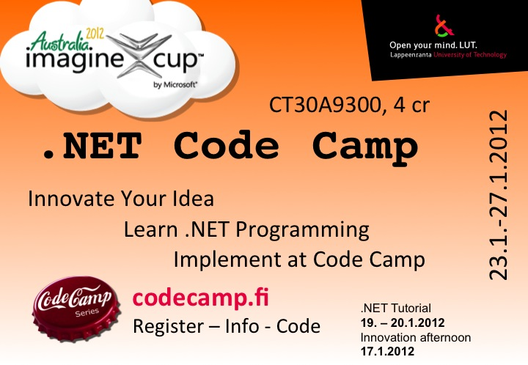
Week 4, 23-27 January 2012
- Register for the course in HERE
- Location: Computer lab 6218
- .NET tutorial lectures will be from 09:00 to 16:00 on 19th and 20th in computer lab 6216
  - Learn web application and web service development
  - Silverlight will help put that final polish and impressive graphics on your web application development
- There will be Imagine Cup briefing and idea brainstorming session on the same week as the .NET Tutorial lectures
  - 17th Tuesday 12:15 - 16:00, class class YO-204 (student union building, second floor)
  - Get more ideas
  - Fine-hone your idea with others
  - Hear suggestions and a lecture from an innovation professional
Important Dates (all in January)
- Innovation and idea brainstorming session: 17th Tuesday afternoon, class YO-204 (student union building, second floor) from 12:15 to 16:00
- .NET and Silverlight tutorial lectures: 09:00 to 16:00 on 19th and 08:30 to 15:30 20th, computer lab 6216
- Actual Code Camp from 23rd to 27th
- Brief Group Project presentations in the Skinnarilan Sauna, starting at 17:15 on Monday 23rd. The sauna is warm from 18:00.
.NET Code Camp 2012 Course Page
Imagine Cup 2012 competition finals will be in Australia!
The Imagine Cup will also have a Windows Phone semifinals in Finland this year. There'll be a WP7 tutorial session Monday 23rd.

WP7(Windows Phone 7) Code Camp
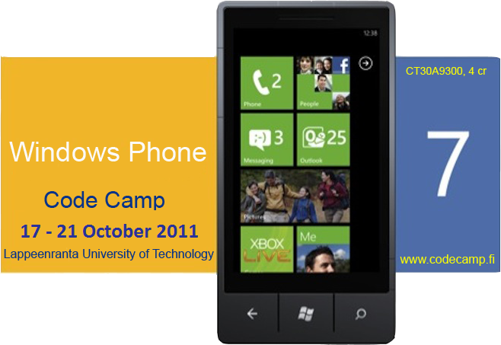
Week 17-21 October 2011
- WP7 Code Camp, Follow these pages.
- WP7 Code Camp registration is done during the first day of the course

20th Summer School on Telecommunications Code Camp -- Summer 2011
August 18-19, 2011 24h
- Will be arranged as part of 20th Summer School on Telecommunications
- SSOTC 2011 code camp

WP7(Windows Phone 7) Code Camp - 2011
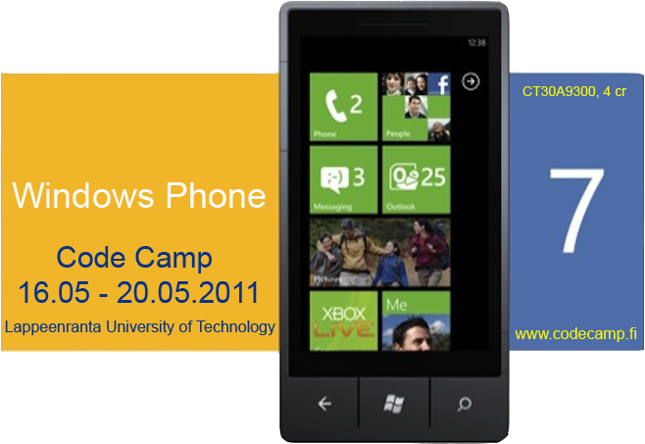
16-20 May 2011
- WP7 Code Camp 2011, Follow these pages.
- WP7 & XNA Code Camp registration open in few days.....
- Registration to the course http://www.webropol.com/P.aspx?id=545291&cid=35070198
- Feedback http://www.webropol.com/P.aspx?id=555025&cid=128883255

.NET Code Camp - Spring 2011
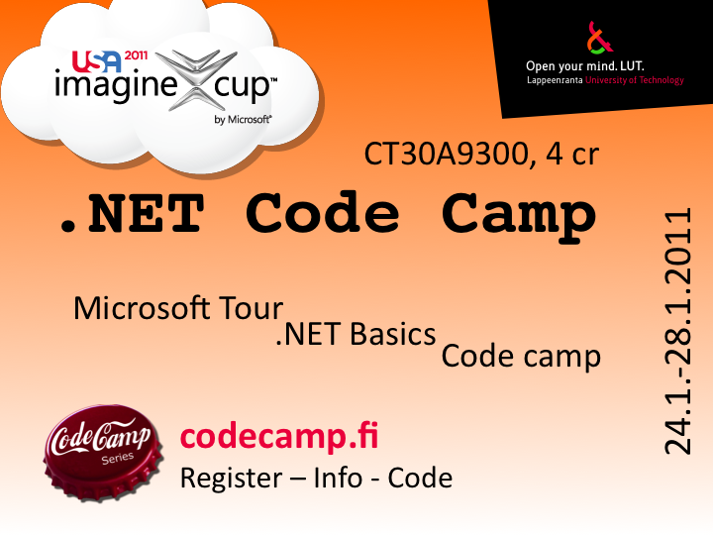
As usual in the beginning of the year 2011. Be there and fight for the ImagineCup
Important dates
- Microsoft tour Fri 14.1.2011 Room no: 2310 starts at 9:00
  - Register http://tinyurl.com/lpr14012010
- .NET Basics Thu 20.1. - Fri 21.1.2011
  - enroll http://www.webropol.com/P.aspx?id=509770&cid=148923921
- .NET Code Camp Mon 24.1. - Fri 28.1.2011
  - enroll http://www.webropol.com/P.aspx?id=509770&cid=148923921 (the same as one above)
Links
- .NET Code Camp 2011 Pages

QT Code Camp - Fall 2010
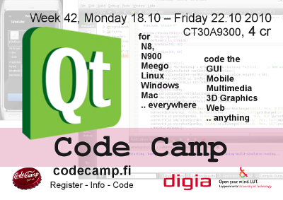
Week 42 18.10 - 22.10 2010 . Courtesy of Digia.
- Qt Code Camp 2010, Follow these pages.
- Qt code camp registration open in http://www.webropol.com/P.aspx?id=476063&cid=126126267
- Qt Coding
- Deadline 2010-10-31 Report & Brochyre (upload to wiki), wiki source code package all done and in wiki

Maemo Code Camp - Summer School on Telecommunications 2010
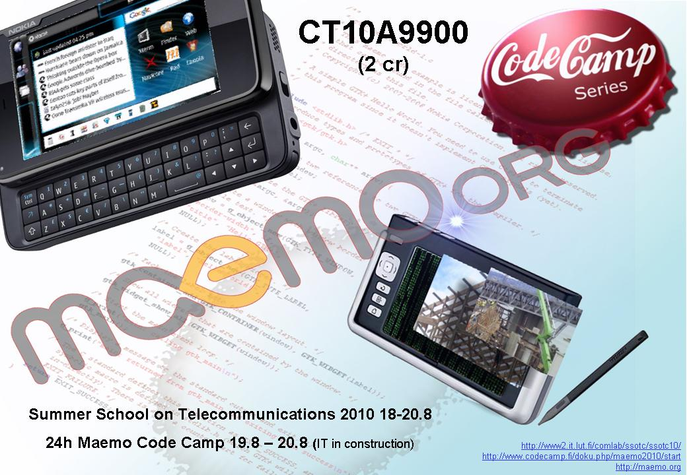
Thursday 19.8 - Friday 20.8.2010
- Maemo Code Camp 2010 Pages
- Maemo programming
- Summer School on Telecommunications 2010
  - Summer school registration

XNA Code Camp - Summer course 2010
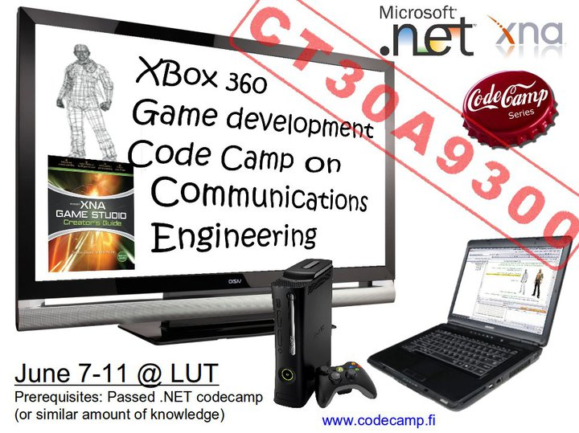
Monday 7.6. - Friday 11.6.2010 Requirements: Passed .NET code camp. This is true hacking event as lectures are minimal and effort is put on working.
- XNA Code Camp 2010 Pages
- Registration to the XNA code camp

Android Code Camp 2010
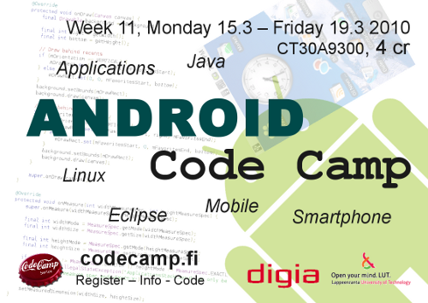
Monday 15.3 -- Friday 19.3 2010, 2nd week on 4. Period
- Android Code Camp 2010 Pages
- Android Coding
- after code camp actions, 28.3 deadline for material & 29.3 feedback

.NET Code Camp 2010 - Winter
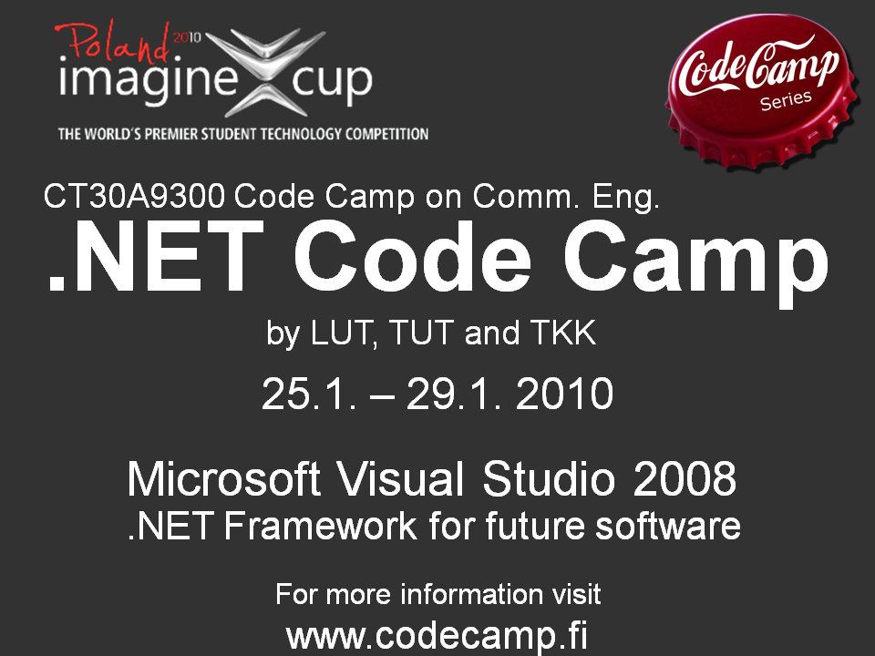
Week .NET Code Camp 2010

vaadin Code Camp 2009 - Fall
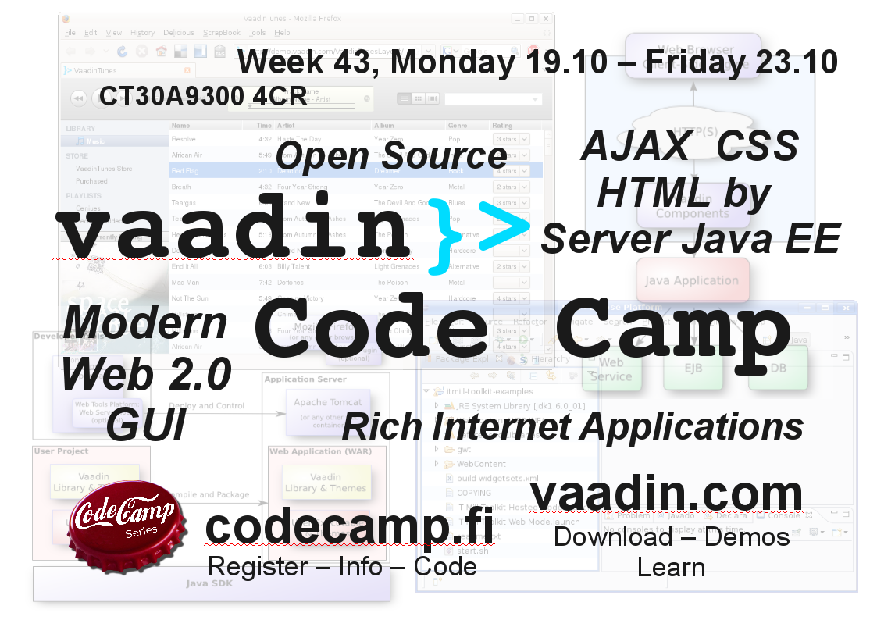
Week vaadin Code Camp 2009

The 18th SSOTC Camp 2009 - Summer
24 hours Summer School on Telecommunications Code Camp 2009
With Maemo environment.

.NET Code Camp 2009 - Spring
Week

SUN Lively Kernel 2008 - Fall
Week
SUN Lively Kernel code camp 2008 was part of the series of Code Camps arranged by the university consortium (Lappeenranta University of Technology, Tampere University of Technology and Helsinki University of Technology). The Lively Kernel is a web application development environment written entirely in JavaScript.

Maemo 2008 - Summer
24 hours Maemo 2008
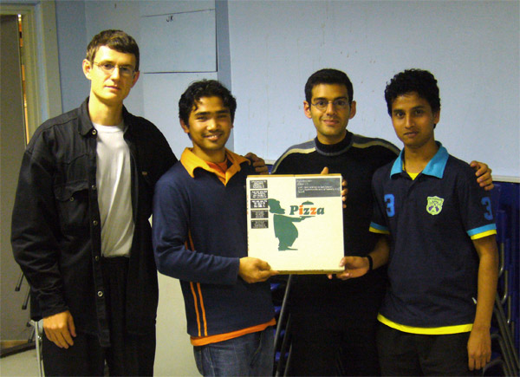Winners of the sought-after Codecamp trophy: Team file encryption/decryption (Andrey Naralchuk, Bal Krishna Shrestha, Neer Roggel, Ajaya Mishra)

.NET Code Camp 2008 - Spring
week

MUPE Code Camp 2007 - Fall
week
LUT & Misr International University

Maemo 2007 - Summer
24 hours Maemo 2007

.NET code camp 2007 - Spring
week
Many projects developed in code camp were submitted to Imagine Cup 2007.
Aali's blog: Code Camp viime viikolla Lappeenrannassa

Maemo 2006 - Summer
24 hours Maemo 2006

J2EE code camp 2006 - Spring
week J2EE code camp 2006
After successful first week long event, Context aware games code camp, J2EE code camp was organized a year later with similar structure. Week started with the lectures of the problem areas and the development environment, and continued with students grouping in small groups and defining their plans for the software. At the end of the week, students presented their software and the best projects were awarded by the jury.

PAN code camp 2005 - Summer
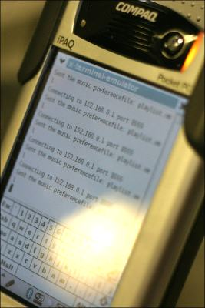
24 hours PAN code camp 2005
In PAN code camp 2005, organized as a part of the Summer school on telecommunications 2005, was the first code camp to offer software development on the Linux OS. Familiar Linux, running on HP/Compaq iPAQs was selected as a platfrom for the software. Later on, Maemo development platform has displaced familiar as the Linux platform for code camps.

Context aware games code camp 2005 - Fall
week Advertisement
Context aware games code camp in 2005, also based on MUPE application platform, was the first code camp organized as a one week event.

MUPE code camp 2004 - Summer
24 hours MUPE code camp 2004
MUPE is advertised as: “Multi-User Publishing Environment (MUPE) is an application platform for mobile multi-user context-aware applications. MUPE allows anyone to easily create their own mobile services, games and applications. To achieve these goals, MUPE uses a plethora of technologies to reduce the complexity of developing mobile services.”
Mr. Riku Suomela from Nokia gave introduction to Mupe platform and showed few examples how to use it. Mupe was seen as quite interesting possibility. As the result from intensive 24 hours programming, some interesting applications surfaced; Bomberman game, location based Doom, Worms game, Lovepiipper (notify that you have interesting people around you), and Viral tag game.

Symbian Code Camp 2003 - Summer
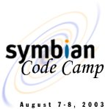
24 hours Symbian code camp 2003
The main topic of the first code camp was Symbian OS. Symbian is operating system used by many cell phones. Idea behind the code camp was that people who had not previous experience on programming for mobile phones, could get a crash start in this event. Code camp was arranged as part of International summer school of telecommunications. The code camp started on Thursday afternoon with an short lecture about Symbian programming and some examples. 24 hours later the best application was awarded. Those 24 hours included intensive collaboration with team mates and also with competing teams as co-operation was encouraged. If programming was not progressing participants could freshen up with sauna and discuss their ideas there also.

