Past Code Camps

XNA Code Camp - Summer course 2010
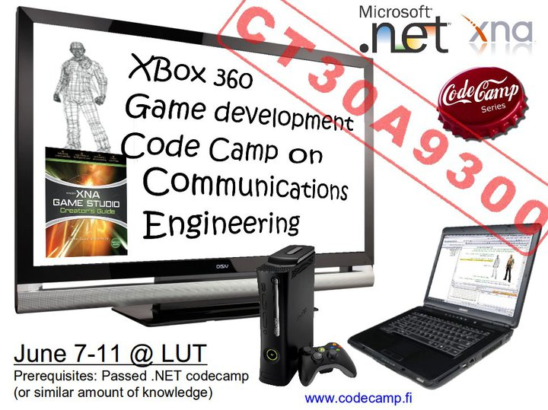
Monday 7.6. - Friday 11.6.2010 Requirements: Passed .NET code camp. This is true hacking event as lectures are minimal and effort is put on working.
- XNA Code Camp 2010 Pages
- Registration to the XNA code camp

Android Code Camp 2010
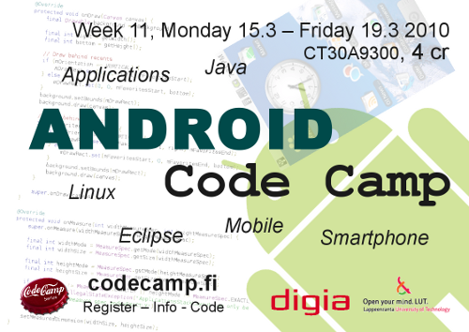
Monday 15.3 – Friday 19.3 2010, 2nd week on 4. Period
- Android Code Camp 2010 Pages
- Android Coding
- after code camp actions, 28.3 deadline for material & 29.3 feedback

.NET Code Camp 2010 - Winter
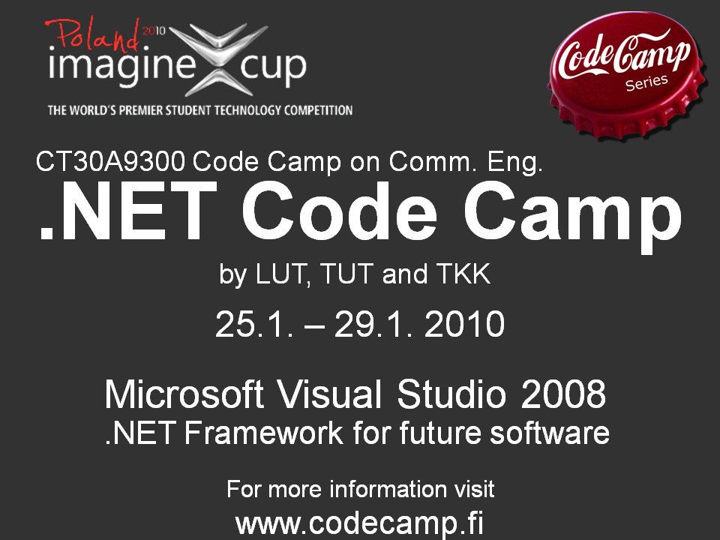
Week .NET Code Camp 2010

vaadin Code Camp 2009 - Fall
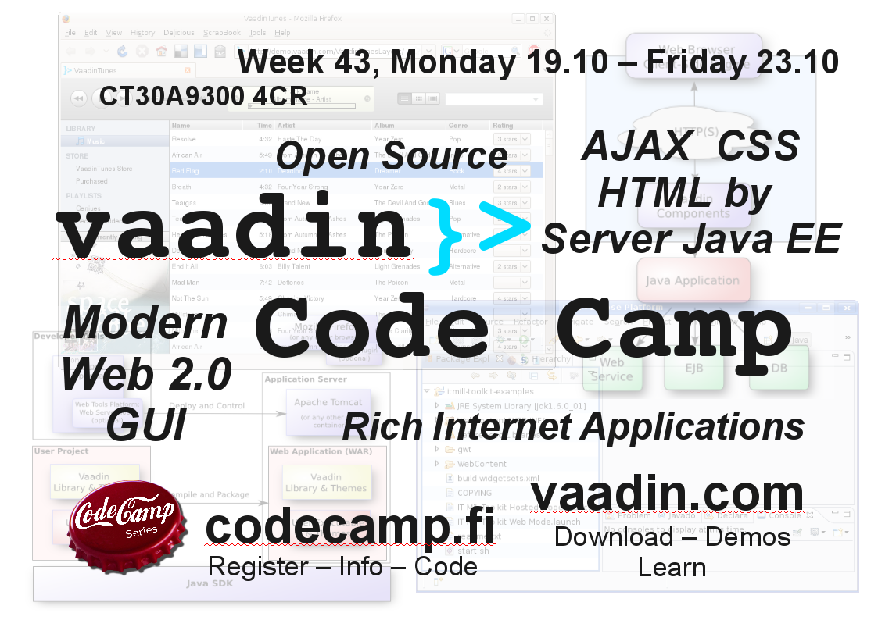
Week vaadin Code Camp 2009

The 18th SSOTC Camp 2009 - Summer
24 hours Summer School on Telecommunications Code Camp 2009
With Maemo environment.

.NET Code Camp 2009 - Spring
Week

SUN Lively Kernel 2008 - Fall
Week
SUN Lively Kernel code camp 2008 was part of the series of Code Camps arranged by the university consortium (Lappeenranta University of Technology, Tampere University of Technology and Helsinki University of Technology). The Lively Kernel is a web application development environment written entirely in JavaScript.

Maemo 2008 - Summer
24 hours Maemo 2008
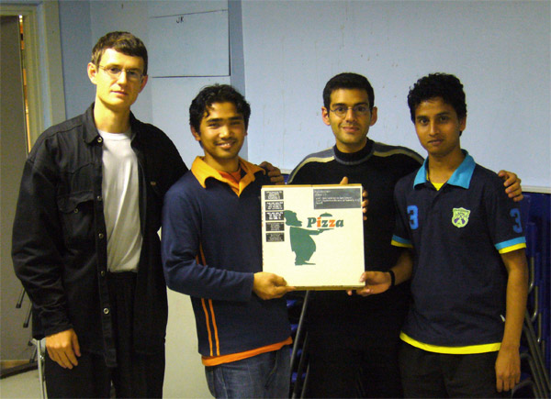Winners of the sought-after Codecamp trophy: Team file encryption/decryption (Andrey Naralchuk, Bal Krishna Shrestha, Neer Roggel, Ajaya Mishra)

.NET Code Camp 2008 - Spring
week

MUPE Code Camp 2007 - Fall
week
LUT & Misr International University

Maemo 2007 - Summer
24 hours Maemo 2007

.NET code camp 2007 - Spring
week
Many projects developed in code camp were submitted to Imagine Cup 2007.
Aali's blog: Code Camp viime viikolla Lappeenrannassa

Maemo 2006 - Summer
24 hours Maemo 2006

J2EE code camp 2006 - Spring
week J2EE code camp 2006
After successful first week long event, Context aware games code camp, J2EE code camp was organized a year later with similar structure. Week started with the lectures of the problem areas and the development environment, and continued with students grouping in small groups and defining their plans for the software. At the end of the week, students presented their software and the best projects were awarded by the jury.

PAN code camp 2005 - Summer
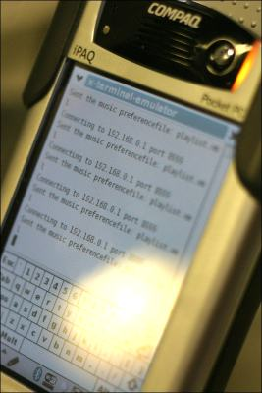
24 hours PAN code camp 2005
In PAN code camp 2005, organized as a part of the Summer school on telecommunications 2005, was the first code camp to offer software development on the Linux OS. Familiar Linux, running on HP/Compaq iPAQs was selected as a platfrom for the software. Later on, Maemo development platform has displaced familiar as the Linux platform for code camps.

Context aware games code camp 2005 - Fall
week Advertisement
Context aware games code camp in 2005, also based on MUPE application platform, was the first code camp organized as a one week event.

MUPE code camp 2004 - Summer
24 hours MUPE code camp 2004
MUPE is advertised as: “Multi-User Publishing Environment (MUPE) is an application platform for mobile multi-user context-aware applications. MUPE allows anyone to easily create their own mobile services, games and applications. To achieve these goals, MUPE uses a plethora of technologies to reduce the complexity of developing mobile services.”
Mr. Riku Suomela from Nokia gave introduction to Mupe platform and showed few examples how to use it. Mupe was seen as quite interesting possibility. As the result from intensive 24 hours programming, some interesting applications surfaced; Bomberman game, location based Doom, Worms game, Lovepiipper (notify that you have interesting people around you), and Viral tag game.

Symbian Code Camp 2003 - Summer
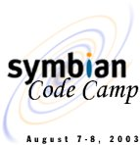
24 hours Symbian code camp 2003
The main topic of the first code camp was Symbian OS. Symbian is operating system used by many cell phones. Idea behind the code camp was that people who had not previous experience on programming for mobile phones, could get a crash start in this event. Code camp was arranged as part of International summer school of telecommunications. The code camp started on Thursday afternoon with an short lecture about Symbian programming and some examples. 24 hours later the best application was awarded. Those 24 hours included intensive collaboration with team mates and also with competing teams as co-operation was encouraged. If programming was not progressing participants could freshen up with sauna and discuss their ideas there also.

