LUT Parking Map
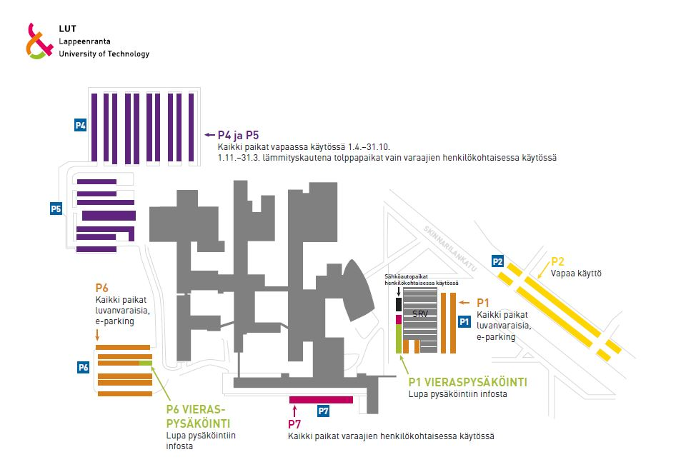
During the summer school you may park your car in the purple areas. Below a map of the parking spaces at LUT.

