QuTe Translation
Team:
- Rostislav Malevich
- Oskar Sonninen
- Petri Ryhänen

Idea
QuTe Translation is targeted on people that are living abroad and on those who doesn't handle local language. QuTe Translation provide them an integrated tool for their mobile phones to translate incoming messages to language user handle. Also, QuTe Translation make it easier to response for those kind of messages, that are written on foreign language. All use needs is to write message in his own language, and it will be delivered to receiver in a language receiver use.
QuTe Translation is daemon styled application, that waits for a incoming message, that user might not understand. By this approach low user interruption is achieved.

Features
- Incoming translation
- Outgoing translation
- Daemon style

Implementation Plan and Goals
- Environment and language are QT creator and QT using C++.
- Translation is made using Google translate, connection provided by network module and QHttp class.
- User interface is QT based.
Feature | Priority | Status
GUI | 1 | Done
Translation | 1 | Done
Daemon implementation | 2 | Done
Language detection | 3 | Done
User data saving | 3 | Done

Design

Screen shots
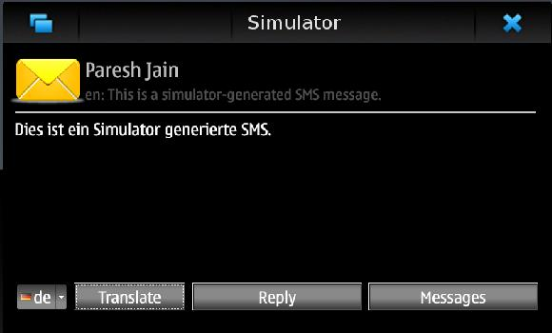
- Screen-shot 1: New incoming message and it's translation is shown to user.
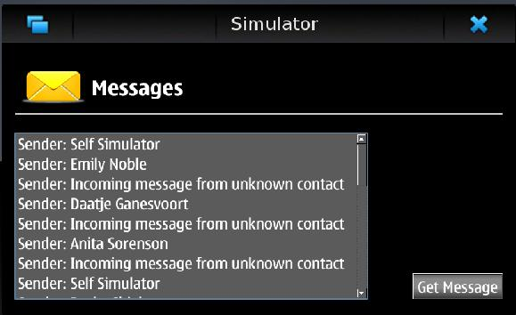
- Screen-shot 2: View for searching already received messages user want to translate.
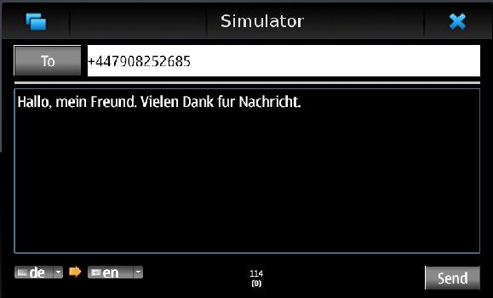
- Screen-shot 3: User is sending reply in German, that will be delivered in English.

Project Artefacts

Presentation slides
- Short idea presentation: qtst_app_n_ever.ppt
- Final presentation:qute_translation.ppt
- Final presentation:qute_translation.pdf

Report document
- Brochure codecamp_brochure.pdf
- Technical report qtcodecamp_report.pdf

Source Package
qt_codecamp_0.7b2.zip

How to run software
- Open project in QtCreator
- Deploy it to the phone
- Wait for incoming message
OR
- Open project in QtCreator
- Build and run project in simulator
- Simulate incoming sms with simulator control panel

Conclusion
QT was not very clear to start with. Signal and slots took time to understand.But as it becomes clear, they are really handy to use and data can be delivered through classes that are no time synchronized. But we are positively surprised with QT, with it we've managed to get all information we wanted from device, messages, contacts, etc.
During week of studying and coding, we've successfully done all our major tasks within project.

Usefull links
- NetworkAccessManager + QNetworkReply
- http://stackoverflow.com/questions/1205419/writing-a-qnetworkreply-to-a-file
- http://doc.trolltech.com/4.7/qnetworkreply.html
- Receiving Sms
- http://wiki.forum.nokia.com/index.php/CS001617_-_Receiving_an_SMS_in_Qt
- http://qt.nokia.com/products/appdev/add-on-products/catalog/4/Utilities/qtservice/

