Smart Alarm
- Mihai Iusan
- Camilo Cifuentes
- Bhupesh Mudari

Idea

Problem
In our times people usually use their mobile phones too wake them up.
But stopping the alarm can be a problem:
- The phone can be too far away
- Other times it can get damaged (doping the phone on the floor, hitting it…)
- Or we just cannot touch it (dirty hands, has fallen under the drivers seat…)
- If just you want to stop it in a fancy way and press no button.
- Or you cannot press the button.

Solution
» Stop your phone alarm using Sound, Shake or Flip it!!! «

Features

At the end the Sound Controlled Alarm will be able to:
- Setup the alarm
- Stop it using sound

Other Features/Further improvements
- Stop it by shaking the phone » implemented «
- Flip the device to stop » implemented «
- The alarm should act differently according to you the location you are situated

Implementation Plan and Goals

Development process
For creating the application we are using the spiral model.

Increment | Description | File
First | Creating the basic alarm application | first_iteration.zip
Second | Adding the microphone input feature | second_iteration.zip
Third | Reading the sound level | third_iteration.zip
Forth | Integrating the features to stop by sound | forth_iteration.zip
Fifth | Save settings to file | fifth_iteration.zip
Sixth | Testing the application and repairing bugs | sixth_iteration.zip
Seventh | Stop by Shake functionality | seventh_iteration.zip
Eighth | Stop by Flip functionality | eighth_iteration.zip
Ninth | Beta version | ninth_iteration.zip
Tenth | Beta 2, if no alarm sound found, a browser appears | tenth_iteration.zip
Eleventh | Beta 3, bug fixed | eleventh_iteration.zip

At the end we should have:

Voice Controlled Alarm should have
- Time reading
- Sound playback
- Sound reading
- Sound analysis

Optional Features/Further improvements
- Using calendar for alarm decisions
- Location recognition
- Movement

Design

Class Diagram
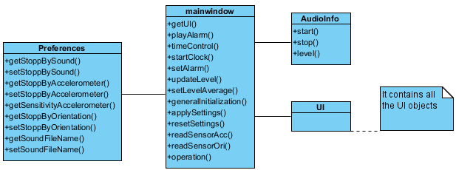

Sequence Diagram
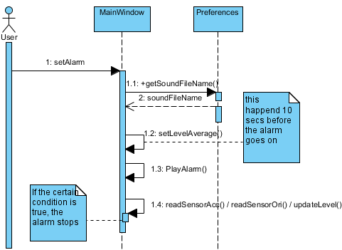

Screen shots
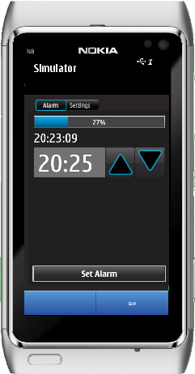 | 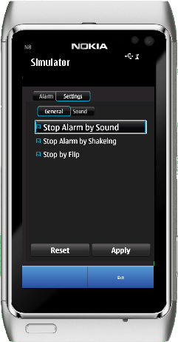 | 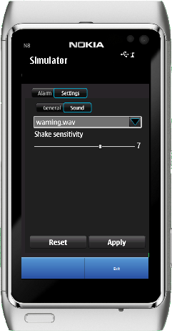

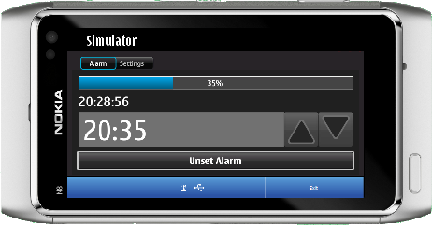 | 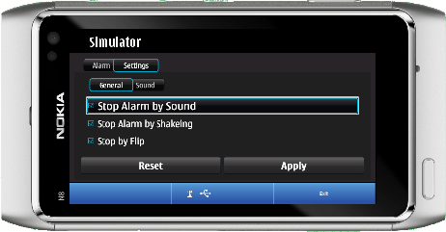
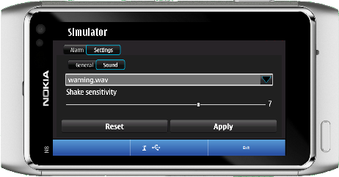

Project Artefacts

Presentation slides
sound_controlled_alarm_presentation.pdf
final_qt_codecamp_presentation.pdf

Report document

Source Package
Initial release
rc1.zip

How to run software
You need to open the project file in the Qt Creator. in the simulation folder you need a folder with sounds and the name of the sounds should be warning.wav and ringin.wav. When installing on phone, you need to select a *.wav file from the browse if it doesn't find the sound automaticaly.
Note: you can copy the wav files from the package. They are located on the sounds folder from any of the root folders of the archive.
Note: If you do not have the *.wav file the application lets you choose a file, but this will appear only if the configuration is wrong. You need to select *.wav files for the sound to work.
Note: if you just want to install on a Symbian phone, you can just install it using ovi and uploading the sys file from the project folder.

Conclusion

